
Annual Analytical Progress Report

Year 3 (January to December 2025)

Sustainable Livelihoods Development for the Gorongosa Buffer Zone Communities
(SLD Gorongosa)

An initiative by the Gorongosa Restoration Project in collaboration with:
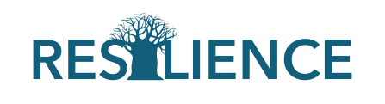 | 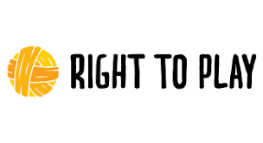
Chitengo, April 2026

Project Status Information

Program Name: | Sustainable Livelihoods Development for the Gorongosa Buffer Zone Communities  (SLD Gorongosa)
Activity Start Date and End Date: | 1 August 2022 to 31 July 2027
Project Duration | 5 years
Leading Partner: | Gorongosa Restoration Project
Name of Partners | Resilience & Right to Play
Geographic Focus: | Gorongosa National Park and surrounding buffer zone, Sofala Province, Mozambique.
Reporting Period: | January to December 2025

2025 Annual Budget | Expenses as of: 31 Dec’25 | expenses  (% of annual budget)
EUR 6,337,225.22 | EUR 5,299,666.01 | 84%

Program Cumulative Budget  (EUR) to date | Program expenses  (US$) | Program Balance  (US$) | Total expenses  (% of total budget)
EUR 14,760,414.33 | EUR 13,722,855.12 | EUR 1,037,559.21 | 93%

.

Program description

Executive Summary
Guiding notes
- The Executive Summary is ¼ to ½ a page that summarizes the most important achievements of Program during the reporting period and key elements from the detailed report below. Highlight in the summary, the elements of the main report that must be considered to be the most critical to be included in the annual report.
- Provide a high-level narrative of the program results and successes as well as major challenges, constraints and lessons learned

The 2025 reporting period represented a critical phase of consolidation and performance strengthening for the Sustainable Livelihoods Development for the Gorongosa Buffer Zone Communities Program (SLDP). Building on previous investments and responding to ongoing climatic, economic, and social challenges, the program advanced its integrated model linking sustainable livelihoods and ecosystem restoration, nutrition, water and sanitation (WASH), and Sexual Reproductive Health and Rights (SRHR). The results achieved demonstrate clear progress toward reducing poverty and vulnerability across communities living in and around Gorongosa National Park (GNP).
At its core, the SLDP continues to demonstrate that sustainable socioeconomic transformation is most effective when agricultural productivity, environmental stewardship, and human development interventions are delivered in an integrated and community-driven manner. Across all components, the program has contributed to improving incomes, strengthening household resilience, enhancing nutrition practices, and restoring degraded ecosystems.
Component 1- Livelihoods and Biodiversity
Under component 1, the program has performed strongly across all key indicators, with significant progress in reaching farmers, adopting improved practices, increasing incomes and integrating into markets, confirming that the project is on track to achieve its intended outcomes.
One of the main highlights of the reporting period is the substantial expansion of the program reach, having directly reached 6,705 smallholders in 2025, more than double the annual target. Cumulatively, the project has reached 11,146 farmers, representing 74% of the total target. This accelerated reach reflects a deliberate implementation strategy and is already translating into tangible improvements in productivity and income among beneficiaries.
These gains are closely linked to the high uptake of improved agricultural practices, with around 55% of all trained farmers applying at least two key techniques, such as improved seeds, mulching, pest management and crop rotation, etc. In irrigated systems, 2,130 farmers are now consistently applying environmentally sustainable practices, indicating a significant behavioral shift and greater resilience of production systems.
In terms of results, the program is making notable progress towards improving farmers’ incomes. By 2025, 2,290 producers had reached the defined threshold of a decent income (a minimum increase of 10%), with a cumulative total of 3,787 beneficiaries, showing steady progress towards the overall target. It is important to note that the available data indicate that farmers have, on average, doubled or even tripled their incomes compared to baseline levels, demonstrating the effectiveness of the interventions.
However, the report also highlights variations between districts, with some areas performing better in terms of productivity and diversification than others. Whilst districts such as Gorongosa and Nhamatanda demonstrate higher average agricultural incomes of around 27,000 MZN and 36,000 MZN respectively, and greater diversification, others such as Dondo (with an average income of 7,000 MZN) continue to face structural constraints, pointing to the need for more targeted support.
At the same time, the program has made significant progress in strengthening market systems and value chains. More than 3,100 farmers benefited from improved market linkages in 2025, supported through producer groups, storage infrastructure, agricultural distributor networks and better access to market information. These investments are beginning to transform local economies, reducing post-harvest losses, improving product quality and increasing farmers’ participation in markets.
The report also demonstrates progress in sustainable land management strategies, with thousands of hectares under improved agricultural practices, and the development of agroforestry systems that contribute to reducing environmental pressure and increasing climate resilience.
Reforestation efforts exceeded annual targets, with more than 330,000 native seedlings planted across 268.78 ha in degraded landscapes, supported by strong community uptake and the growing leadership of Forest Guardians, reforestation facilitators, and local committees.
Despite these achievements, several operational and systemic challenges remain. Data collection and validation, particularly for monitoring yields, continue to limit the comprehensive measurement of results. Market systems are still under development, with limited competition among buyers affecting farmers’ bargaining power. Furthermore, constraints such as pest management costs and variability in access to irrigation continue to affect some producers.
Looking ahead, the program will focus on strengthening monitoring systems, expanding market opportunities and consolidating gains in productivity and income, particularly in the districts with the weakest performance. It is expected that the planned improvements to data systems, combined with more frequent assessments of productivity and yield, will strengthen evidence-based decision-making and ensure more robust monitoring of impact in the final years of implementation.
Overall, the results achieved in 2025 demonstrate that the program is effectively improving livelihoods, promoting sustainable agriculture and building more resilient rural economies, whilst laying a solid foundation for achieving its long-term objectives.
Component 2 – Nutrition, WASH and SRHR
During Year 3, the Nutrition component delivered significant progress in improving the health, nutrition, and well-being of communities across the Gorongosa Sustainable Development Zone. Interventions were anchored in a strong community-based approach, combining behaviour change strategies, service delivery support, and strengthened local systems to promote sustainable outcomes.
Through school- and community-based interventions, Model Mothers & Fathers, and coordinated SBCC strategies, 46355 individuals were reached with health and nutrition counselling—exceeding targets by 44%. Of these, 25,553 people adopted improved nutrition and hygiene practices, reflecting sustained behavior change.
A network of 200 Model Mothers and Fathers conducted 14,499 household visits across six districts, providing targeted counselling on dietary diversity, hygiene, sanitation, and safe water practices. These efforts strengthened behavior change at the household level and contributed to improved awareness and adoption of nutrition-sensitive practices.
The Program scaled up Social and Behavior Change Communication (SBCC) interventions, integrating gender-sensitive messaging and community engagement platforms. Over 400 Information, Education and Communication (IEC) materials were distributed, while 390 awareness campaigns and radio program reached more than 1,100 women with key messages on nutrition, hygiene, and environmental sanitation. Complementary radio programming and outreach activities reinforced community-level understanding of health and nutrition priorities.
Practical nutrition interventions were a central pillar of the component. A total of 48,211 individuals participated in food preparation demonstrations, supported by 1,394 sessions promoting balanced diets, food processing, and preservation techniques. In addition, 16,421 households were trained in home gardening and small livestock production, strengthening access to diversified and nutritious food sources. The development of a locally adapted recipe book further supports the sustainability and replication of improved dietary practices.
In the WASH sector, the Program expanded access to safe water and strengthened community governance systems. A total of 10 new water points were established (83% of the annual target of 12 boreholes), providing reliable access to safe drinking water for approximately 13,881 people, including school populations and surrounding communities. To ensure sustainability, 12 WASH committees were established and trained to manage water infrastructure and promote hygiene practices, reinforcing community ownership and accountability. A total of 53118 people achieved open defecation free status—surpassing the project’s lifespan target by 26%. These improvements contributed to reduced waterborne diseases, fewer school absences (especially among girls), and more time for women to participate in economic activities.
SRHR interventions continued to expand, particularly among adolescents and youth. A total of 9,657 young people were reached through youth-friendly services and mobile outreach (SAAJs), surpassing the annual target of 7940 by 24%. The SAAJS services were complemented by 177 radio programs addressing critical issues such as STI prevention, early pregnancy, early marriage, and gender-based violence. In parallel, 149 teachers were trained and supported to deliver gender-responsive, play-based learning approaches, integrating life skills and SRHR education within schools.
Overall, Component 2 has demonstrated strong progress in improving health and nutrition outcomes through integrated, community-driven approaches. The combination of behavior change, service delivery, and local capacity strengthening has created a solid foundation for sustained improvements in nutrition, hygiene, and adolescent health. Moving forward, the focus will be on deepening quality, strengthening service linkages, and ensuring long-term sustainability of community structures and behavioral gains.

Implementation Progress – Year 3 (January to December 2025)

Component 1

Result | Progress made (implemented activities and achievements) | Status
Project outcomes : Livelihoods & Biodiversity
Small-scale food farmers doubled productivity and income | Indicator: # of small-scale food producers that progressively realize a living income (cumulative)  Cumulatively, a total of 3,758 farmers income records had been updated and entered into the system, representing 25% of the overall project target. In 2025, 3,537 producers achieved the defined income threshold, exceeding the annual target of 3,000 farmers (118% achievement). The average annual farm income recorded among producers was 21,195 MZN. It is important to note that this figure is derived from production and sales data recorded in the FMIS, which is the focus the project, and therefore represents an approximation of agricultural income, rather than total household income.  While the number of validated income records has increased substantially, the dataset remains partial relative to the total number of beneficiaries reached. Current results are based on a subset of farmers with complete and verifiable records, reflecting persistent challenges in capturing reliable income data at the household level, ensuring consistency in farmer reporting, and managing the time and resource burden associated with data collection.  To address these constraints, a sampling-based approach has been applied to complement individual farmer records. However, this introduces limitations in terms of representativeness and comparability across districts. Strengthening data collection protocols, improving FMIS integration, and expanding coverage remain key priorities for the remaining implementation period.  Productivity improvements have been a central driver of income growth among supported farmers, as reflected in both FMIS data and field-level evidence. The increase in income is not isolated, but rather the result of a combination of higher yields, improved production efficiency, and enhanced market participation.  Income measurement was based on a comparative analysis between baseline data (collected through the initial market assessment) and current income estimates derived from production and commercialization data captured through the Farm Management Information System (FMIS Income and Production Dashboard: https://sldproject.com/fmis/). This includes:  - Crop production volumes (average 2,095 kg/ha)  - Sold quantities (average 641 kg)  - Market crop prices (Average 64.86 MZN/kg)  The indicator is calculated using individual farmer records available. These figures illustrate a clear link between increased production volumes and higher market engagement, which directly translates into improved income levels.  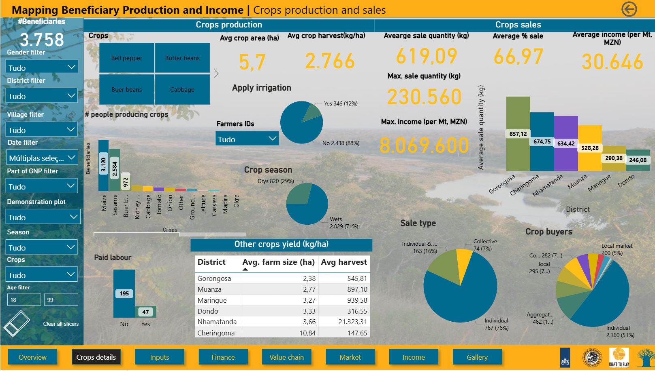Figure 1: Crop production and sales details. See HERE  A key contributing factor has been the adoption of improved agricultural practices, including the use of certified seeds, line planting, appropriate spacing, crop rotation, and integrated pest management. As can be observed in # of short-cycle crop farmers using environmentally sustainable forms of production) outcome, more than 70% of trained farmers adopted at least two improved practices, significantly enhancing both yields and production reliability. These practices have reduced losses, improved crop quality, and increased marketable surplus.  This progress has been sustained through a gradual extension approach that combines direct training with ongoing support. For farmers previously covered by the program, technical assistance is provided through remote SMS-based advisory services, supplemented by mass extension sessions where videos on good agricultural practices are shown and explained using mini-projectors at the community level. This approach allows the technical team to continue supporting farmers who have already completed the program, although with less frequency. These farmers are also encouraged to participate in training sessions organised for newly enrolled producers, provided they belong to the same communities, ensuring continued exposure to improved practices. In addition, refresher training is regularly provided to lead farmers, who subsequently support peer-to-peer knowledge transfer within their groups.  In addition, the expansion of irrigation systems - including the use of solar-powered pumps (more than 250 co-funded solar-powered pumps)- has enabled farmers to move from purely rainfed production to more stable and intensive production cycles, reducing climate-related risks and allowing for off-season production. This has not only increased overall productivity but also improved farmers’ ability to respond to market demand, particularly for high-value horticultural crops.  The available data show a positive trend in income growth across all intervention areas. When compared to the baseline market assessment (Figure 1), current data (Figure 2) indicate that farmers have, on average, doubled or even tripled their income levels. This suggests meaningful progress toward achieving a living income.  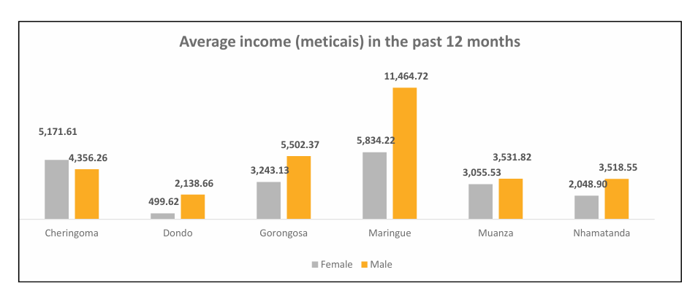  Figure 2:Baseline Average income  Figure 3: Actual Average income  Concerning gender, it is clear that, following the intervention, although men continue to have slightly higher absolute income levels (with an average of 23,030 MZN), women have made significant relative gains (with an average of 17,036 MZN), suggesting that they are indeed benefiting from the project’s interventions. This suggests that the project is not only increasing income levels but also contributing to more inclusive economic growth by enabling women to participate more actively in productive, market-oriented agriculture.  Beyond quantitative results, significant qualitative changes have been observed across intervention areas, particularly in terms of increased productivity and diversification. For example, in Dondo district, there has been a notable increase in the production of horticultural crops such as cabbage, onion, tomato, kale, pepper, and green beans. Onion production stands out as a key success, given its strong commercial value and resilience within the buffer zone, where it is less affected by wildlife, particularly elephant attacks that continue to impact other crops. As a result, onion productivity increased significantly, from approximately 0.5 ton/ha to 1.5 ton/ha in 2025, marking a substantial improvement in yields and income potential for farmers.  In the Cheringoma district, a shift in production systems has also been observed. Previously, farmers relied predominantly on rainfed agriculture and were largely limited to lettuce production due to limited knowledge and a lack of irrigation infrastructure. Through project support, producers have diversified their horticultural production and adopted improved practices. Cabbage has emerged as a key promoted crop, with farmers reporting earnings of approximately 50,000 MZN in 2025 from its production. This additional income has been critical in supporting household expenditures during high-demand periods, particularly in December, and in covering essential costs such as school enrolment for children.  These results highlight that, in addition to expanding outreach, the project is effectively contributing to enhanced productivity, income generation, and livelihood resilience among smallholder farmers.  A production and productivity assessment scheduled for 2026 will provide more robust data for each district by correlating production, productivity and income.
  Results | Achievement (%) | Achieved/Targeted
  Year 3 (2025) | 118% | 3,537/3,000
  Cumulative  (2022-27) | 25% | 3,758/15,000
Decreased deforestation, enhanced sinks and increased climate resilience of ecosystems and livelihoods | Indicator: # of hectares of forest(ed) land under sustainable forest management or other improved practices contributing to decreased deforestation, enhanced sinks and increased adaptive capacity of ecosystems and livelihoods (total).  This indicator reflects the program ’s integrated landscape approach, combining sustainable agriculture, reforestation, and agroforestry interventions to reduce pressure on natural forests while enhancing carbon sequestration and ecosystem resilience.  Initially, the target for this indicator was defined exclusively under subcomponent 1.4 - Reforestation, with a goal of 1,000 ha by the end of the program. However, given that sustainable agricultural practices and agroforestry systems also contribute directly to reduced deforestation pressure and improved carbon sinks, the target has been revised to better capture the integrated landscape approach adopted by the program.  The overall target of 14,000 hectares has been revised to better capture the contribution of multiple subcomponents to deforestation reduction and landscape restoration:  - 12,500 hectares under sustainable agricultural practices (Best Agricultural Practices – BAPs)  - 1,000 hectares under reforestation  - 500 hectares under agroforestry systems (primarily coffee-based systems)  The table below presents the annual distribution of targets per subcomponent:  During Year 3 (2025), the program achieved significant progress in promoting sustainable land management practices across the Sustainable Development Zone. A total of 6,081.9 hectares were brought under improved management, representing 2889% of the annual target (3,112 hectares). Cumulatively, 6,200.9 hectares have been reached between 2022 and 2025, corresponding to 44.2% of the overall program target of 14,000 hectares.  Progress by Intervention Area  1. Sustainable Agriculture (BAPs)  By the end of Year 3, 5,386.9 hectares of farmland had adopted Best Agricultural Practices for short-cycle crops. These practices—such as soil conservation, improved crop management, and climate-smart techniques—reduce the need for agricultural land expansion into forested areas while enhancing productivity and resilience.  2. Reforestation and Ecological Restoration  Under subcomponent 1.4, the program restored approximately 290 hectares of degraded land during the reporting period through the planting of native tree species. Cumulatively, 409 hectares are now under restoration and sustainable forest management. These efforts contribute to:  - Recovery of degraded ecosystems  - Increased biodiversity  - Strengthening of ecosystem services such as soil stabilization and water regulation  3. Agroforestry (Coffee Systems)  The program continued to promote shade-grown coffee systems as a key agroforestry intervention in Mount Gorongosa. To date, 1,597,534 coffee seedlings have been planted, covering approximately 405 hectares of land.  These systems play a dual role by:  - Providing sustainable income opportunities for farmers  - Reducing deforestation pressure through tree-based production systems  - Enhancing carbon storage and long-term ecosystem resilience  The strong performance achieved during the reporting period underscores the effectiveness of the program’s integrated landscape management approach. By combining agricultural intensification, forest restoration, and agroforestry diversification, the program is addressing both the drivers and impacts of deforestation.  Key contributions include:  - Reduced pressure on natural forests due to improved farm productivity  - Restoration of degraded ecosystems and expansion of forest cover  - Increased carbon sequestration and contribution to climate mitigation  - Strengthened resilience of rural livelihoods through diversified production systems  At the same time, the results highlight the importance of continuous target refinement and monitoring, particularly to better capture the full contribution of agroforestry systems within the overall framework.  With nearly 6,200 hectares already under improved management, the program is on a strong trajectory toward achieving its long-term goal of transforming land-use systems across the Sustainable Development Zone. Continued acceleration of agroforestry and restoration efforts will be essential to meet overall targets and sustain gains in biodiversity, climate resilience, and livelihoods.
  Results | Achievement (%) | Achieved/Targeted
  Year 3 (2025) | 209.7% | 6,081.9/2,112
  Cumulative  (2022-27) | 44.2% | 6,200.9/ 14,000
  Subcomponent | Target | Y1 | Y2 | Y3 | Y4 | Y5
  Agriculture | 12,500 | 2,500 | 2,500 | 2,500 | 2,500 | 2,500
  Reforestation | 1,040 | 104 | 156.26 | 312 | 312 | 156.25
  Agroforestry | 500 | 100 | 200 | 300 | 400 | 500
Objective Status colour : completed in progress yet to start

Outcome (Result) |  | Progress made |  | Status
Intermediate outcomes
Small scale food farmers benefitting from activities to improve performance | Indicator 1: # of small-scale food producers directly reached with activities to increase productivity/income (cumulative)  During Year 3 (2025), the program achieved substantial outreach, directly reaching 6,676 small-scale food producers, representing 222.5% of the annual target (3,000 producers). This strong performance reflects a deliberate implementation strategy that accelerates farmer engagement in later program phases to ensure achievement of cumulative targets.  Cumulatively, 11,782 producers have been reached between 2022 and 2025, corresponding to 78.5% of the overall target of 15,000 farmers. This continued expansion of outreach is steadily translating into improved productivity, income generation, and livelihood resilience across participating districts.  Income data collected from approximately 3,700 beneficiaries provides a representative basis for assessing program impact. The analysis reveals significant variation across districts, reflecting differences in agroecological conditions, access to markets, and levels of practice adoption.  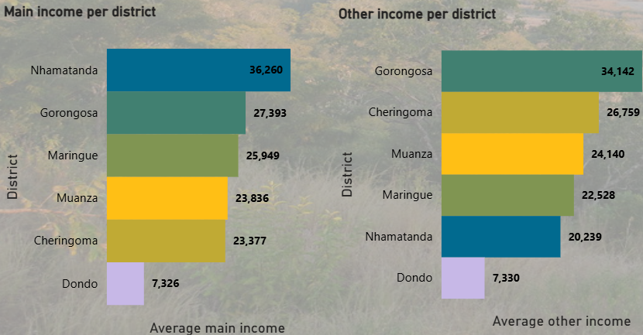  Figure 4: Income per district  - Nhamatanda records the highest average agricultural income at 36,260 MZN annually, indicating strong productivity gains and effective uptake of improved farming practices.  - Gorongosa ranks second in agricultural income (27,393 MZN) but shows the highest diversification of income sources, with 34,142 MZN from non-agricultural activities, highlighting the importance of diversified livelihood strategies.  - Dondo records the lowest income levels—7,326 MZN from agriculture and 7,330 MZN from other sources—pointing to structural constraints and the need for targeted interventions to stimulate productivity and economic opportunities in the district.  These disparities reinforce the importance of adopting context-specific approaches to income generation, including tailored support for productivity improvement, diversification, and market integration.  Findings from the internal mid-term evaluation indicate that participating producers have achieved an average income increase of 33% since the start of the program . This demonstrates the tangible impact of integrated interventions combining improved agronomic practices, access to inputs, extension support, and market linkages.  While these results are encouraging, they also highlight the need to further strengthen monitoring systems to ensure greater data accuracy, coverage, and consistency across districts.  To improve the quality and relevance of income data, the program has adjusted its evaluation approach. Rather than conducting assessments at fixed calendar intervals, income and productivity evaluations will now be aligned with agricultural production cycles, allowing farmers to provide more accurate and timely information.  Evaluations will be conducted twice per year:  - May, following the main harvest period  - October, at the end of the second production cycle  This approach will enable more precise tracking of seasonal income variations, strengthen evidence for program decision-making, and support more responsive adaptation of interventions.  The results achieved during the reporting period demonstrate the program ’s growing effectiveness in improving the economic performance of small-scale producers. Increased outreach, combined with rising incomes and expanded livelihood diversification, is contributing to:  - Enhanced household economic resilience  - Reduced vulnerability to production and market shocks  - Improved capacity of farmers to invest in productive assets  At the same time, district-level disparities highlight the importance of targeted, context-specific strategies to ensure that all communities benefit equitably from program interventions.  With more than 11,700 farmers reached and clear evidence of income growth, the program is making strong progress toward its goal of enabling small-scale producers to achieve sustainable, improved livelihoods. Continued expansion of outreach, combined with strengthened monitoring and tailored district-level support, will be essential to consolidate gains and ensure long-term impact.
  Results | Achievement (%) | Achieved/Targeted
  Year 3 (2025) | 222.5% | 6,676/3,000
  Cumulative  (2022-27) | 78.5% | 11,782/15,000
Indicator 2: # of small-scale food producers indirectly reached.

Results | Achievement (%) | Achieved/Targeted
Year 3 (2025) | 200% | 20,037/10,000
Cumulative  (2022-27) | 70.7% | 35,346/50,000

The program continues to demonstrate a strong multiplier effect through indirect adoption of improved agricultural practices. Based on the program ’s influence model—where each directly supported farmer is estimated to positively impact at least three additional producers in their community—an estimated 20,037 small-scale food producers were indirectly reached during the reporting period.

By the end of 2025, the cumulative number of indirectly reached producers reached 35,346 farmers, representing 70.7% of the overall target of 50,000 indirect beneficiaries. This substantial spillover effect reflects the program ’s success in promoting peer-to-peer learning, strengthening local innovation networks, and fostering widespread uptake of improved agricultural practices beyond direct beneficiaries.

The strong indirect reach illustrates the transformative influence of community-embedded interventions, where trained farmers share knowledge on improved agronomic techniques, climate-smart practices, seed use, and market information with their neighbours. This dynamic contributes significantly to scaling sustainable agriculture practices across the buffer zone and supports long-term livelihood resilience for a broader population of smallholder farmers.

Farmland benefitting from activities to strengthen ecological sustainability |  | Indicator 1: # of new hectares of farmland directly reached with activities to improve eco-efficiency  During Year 3 (2025), the program achieved strong progress in expanding eco-efficient agricultural practices, reaching 4,464.7 hectares, equivalent to 178.6% of the annual target (2,500 hectares). This performance reflects sustained farmer engagement and the accelerated uptake of improved agronomic practices across the Sustainable Development Zone.  Cumulatively, 5,552.6 hectares of farmland have adopted at least two improved practices since program inception, representing 44.4% of the overall target of 12,500 hectares. In line with the indicator definition, only hectares where two or more practices are applied simultaneously are counted, ensuring that reported results reflect meaningful and sustained improvements in eco-efficiency rather than partial adoption.  Table 1: Adoption level per District  Note: “The scale (Highest, High, Moderate, Solid, Lowest) reflects both the average adoption area per farmer and the total area reached in each district. It indicates the relative scale of land use under improved practices, where Highest and High represent districts with larger farm sizes and wider coverage, Moderate and Solid indicate steady but more constrained expansion and lowest reflects districts with small plots and high land pressure, where adoption is mainly through intensification rather than area expansion.”  This district-level variation underscores how structural factors—such as land access, irrigation potential, and climate variability—shape adoption patterns, requiring tailored implementation approaches across locations.  Adoption levels across districts reflect both:  - the average land area under improved practices per farmer, and  - the total area reached within each district.  Higher adoption levels (e.g., Gorongosa, Nhamatanda, Cheringoma) indicate greater potential for land expansion and stronger resource availability, while lower levels (e.g., Maringue, Muanza) suggest land constraints and a stronger reliance on intensification strategies.  To maintain progress toward the overall target of 12,500 hectares, the program will continue expanding farmer registration and adoption tracking. During the 2025/26 rain-fed season:  - 5,175 new farmers are expected to be engaged, and  - an additional 2,395.9 hectares are projected to adopt eco-efficient practices.  This will increase cumulative coverage to approximately 7,948.5 hectares by early Year 4, maintaining alignment with program targets and implementation timelines.  The results achieved to date demonstrate the program ’s growing effectiveness in scaling eco-efficient agricultural practices across diverse agroecological contexts.  Key contributions include:  - Expansion of climate-resilient and sustainable farming systems  - Improved productivity without increasing pressure on natural ecosystems  - Strengthened farmer capacity to manage land more efficiently  - Progress toward landscape-level environmental sustainability  Overall, the program is on a strong trajectory to achieve its medium-term targets while reinforcing sustainable land use and long-term resilience across participating communities.
  Results | Achievement (%) | Achieved/Targeted
  Year 3 (2025) | 178.6% | 4,464.7/2,500
  Cumulative  (2022-27) | 44.4% | 5,552.6/12,500
  District | Average adoption area per farmer (ha) | Reached Area per district (ha) | OBS
  Gorongosa | 2.13 | 996.84 | Strong adoption, driven by high farmer engagement and availability of cultivable land. Expansion is largely rain-fed, complemented by selective small-scale irrigation.
  Nhamatanda | 1.19 | 1,149.5 | High total area reached, supported by better access to land and water resources, and strong uptake of irrigated and semi-irrigated production systems.
  Cheringoma | 2.21 | 941.3 | Moderate to high adoption, reflecting mixed production systems and gradual scaling by farmers depending on seasonal water availability.
  Muanza | 1.36 | 590.2 | Lower adoption levels due to smaller landholdings and higher climate risk, with farmers prioritizing incremental expansion and risk-management strategies.
  Maringue | 1.47 | 201.39 | Lowest adoption area, associated with higher land pressure and limited resource availability, with a focus on intensification rather than expansion.
  Dondo | 0.94 | 718.2 | Solid adoption performance, linked to relatively larger farm sizes and strong participation in program activities, particularly in rain-fed cropping systems.
Indicator 2: # of new hectares of farmland indirectly reached with activities to improve eco-efficiency

Results | Achievement (%) | Achieved/Targeted
Year 3 (2025) | 178.6% | 13,394/7,500
Cumulative (2022-27 | 44.4% | 16,657.8/37,500
Note: It is estimated that each producer influences at least three producers in their community

Building on the program ’s influence model—where each directly supported farmer is expected to influence at least three additional producers in their community—the reporting period showed strong indirect uptake of eco‑efficient agronomic practices. In 2025, an estimated 13,394 new hectares of farmland were indirectly reached, reflecting the diffusion of improved practices through peer‑to‑peer learning, community demonstration effects, and farmer‑to‑farmer extension networks.

By the end of 2025, the cumulative area of farmland indirectly adopting eco-efficient practices reached 13,394 hectares, representing 178.6% of the annual target of 7,500 hectares and 44.4% of the overall program target of 37,500 hectares.

These results demonstrate the strong multiplier effect of the program ’s interventions. As directly supported farmers adopt and model improved practices—such as soil conservation, climate‑smart crop management, and integrated pest management—neighbouring producers increasingly replicate these techniques on their own fields. This pattern of adoption highlights the importance of community-based extension, social learning, and visible productivity gains as drivers of large‑scale behaviour change.

The sustained expansion of eco‑efficient farmland through indirect reach underscores the program ’s capacity to influence farming systems well beyond its direct beneficiary cohort, contributing meaningfully to broader landscape‑level transformation, increased climate resilience, and improved agricultural sustainability across the region.

Short-cycle crop farmers use environmental-ly sustainable forms of production |  | Indicator: # of short-cycle crop farmers using environmentally sustainable forms of production (cumulative)  During the reporting period, the program recorded strong progress in promoting environmentally sustainable production practices among short-cycle crop farmers. A total of 975 farmers met the indicator criteria, achieving 177.3% of the annual target (550 farmers). Cumulatively, 2,130 farmers have adopted at least two sustainable practices under irrigated production systems, representing 85.2% of the overall target of 2,500 farmers  This sustained progress reflects the program ’s growing success in integrating farmers into climate-smart and resource-efficient production systems, particularly under irrigation.  The indicator tracks only those farmers who consistently apply at least two environmentally sustainable practices under irrigated conditions, ensuring that results reflect meaningful and sustained changes in production systems.  Key practices promoted include:  - Mulching  - Integrated Pest Management (IPM)  - Water-use efficiency and irrigation management  - Crop rotation  - Use of improved and certified seeds  This approach ensures that reported adoption translates into enhanced productivity, reduced environmental impact, and improved resilience to climate variability  Beyond the indicator scope, monitoring data across both rain-fed and irrigated systems show widespread uptake of improved practices. A total of 3,653 farmers—equivalent to 72% of all trained farmers—have adopted at least two essential agricultural practices.  Adoption levels by practice include:  - Improved seed use: 3,465 farmers  - Integrated pest management: 2,945 farmers  - Mulching: 2,809 farmers  - Crop rotation: 2,733 farmers  - Water management practices: 1,987 farmers  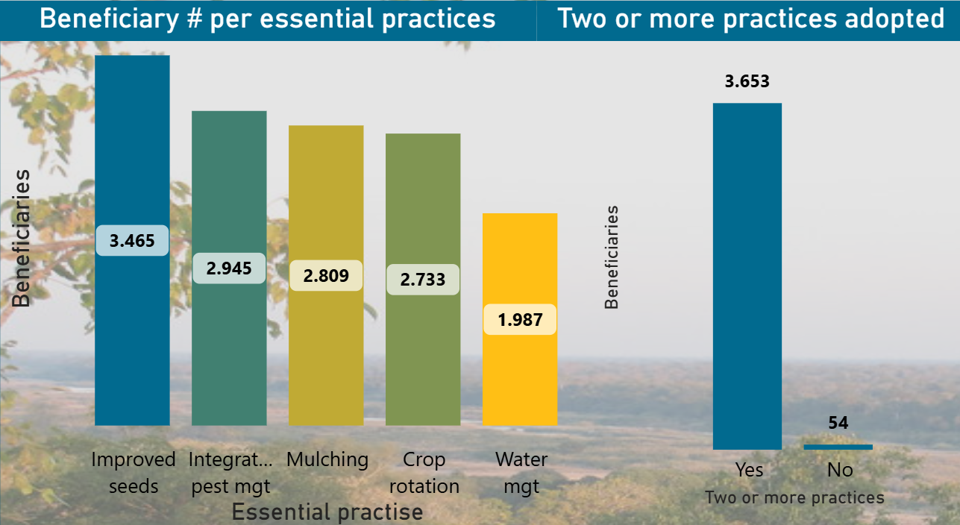  Figure 5: Adoption of the essential agriculture practises  These trends demonstrate high relevance of the promoted technologies and confirm the effectiveness of farmer field demonstrations and practical extension approaches in driving behavioural change.  Field evidence highlights several factors contributing to the strong uptake of sustainable practices:  - Increased awareness of improved inputs: Farmers are actively seeking access to certified seeds, recognizing their contribution to higher yields and crop quality.  - Introduction of solar-powered irrigation systems: These systems have reduced operational costs while enabling reliable water access, significantly driving adoption of irrigated production.  - Visible productivity gains: Farmers link improvements in yields to practices such as line planting, proper spacing, intercropping, and effective soil and water management.  These factors collectively reinforce confidence in improved production systems and encourage continued adoption and scaling.  Despite these positive trends, some constraints remain:  - Limited financial capacity among farmers to purchase pest control inputs  - Continued challenges in effective pest and disease management  - The need for sustained access to inputs and technical support  Addressing these gaps will be critical to sustaining adoption rates and maximizing the long-term benefits of environmentally sustainable practices  The results demonstrate that the program is successfully driving the transition toward environmentally sustainable, climate-resilient agricultural systems among short-cycle crop farmers.  Key contributions include:  - Improved soil and water management practices  - Enhanced productivity under both irrigated and rain-fed conditions  - Reduced environmental degradation through sustainable practices  - Strengthened resilience of farming systems to climate shocks  Continued investment in irrigation, input access, and farmer training will be essential to consolidate gains and ensure that sustainable practices are widely adopted and sustained over time.
  Results | Achievement (%) | Achieved/Targeted
  Year 3 (2025) | 177.3% | 975/ 550
  Cumulative  (2022-27) | 85.2% | 2,130/ 2,500
Development of sustainable value chains |  | Indicator: # of farmers benefitting from improved market linkages  In 2025, the program continued to strengthen market participation among small-scale producers, with 3,112 farmers benefiting from improved market linkages, achieving 94.3% of the annual target (3,300 farmers).  Cumulatively, 4,491 farmers have been supported between 2022 and 2025, representing 29.9% of the overall target of 15,000 farmers. This gradual expansion reflects the program ’s phased market integration approach, whereby farmers first build production capacity and product quality before transitioning into structured market systems.  Market linkage support was delivered through a combination of:  - Facilitated connections between farmers and buyers  - Promotion of collective marketing arrangements  - Improved access to real-time market information  - Training on post-harvest handling and quality standards  For example, the use of improved technologies—such as maize threshers—has enhanced grain quality and reduced post-harvest losses, increasing the competitiveness of farmers in local markets.  Table 2: Distribution of market-linked beneficiaries by district  Market engagement was recorded across all program districts, demonstrating broad coverage and inclusivity. Participation reflects varying levels of market maturity, access to buyers, and engagement with commercialization activities.  - Nhamatanda (1,061 farmers): Highest participation, supported by strong buyer presence and market activity  - Cheringoma (808 farmers): High engagement with growing female participation  - Gorongosa (779 farmers): Balanced participation with strong youth representation  - Dondo (739 farmers): Expanding market engagement, with growing buyer–farmer interactions  - Muanza (692 farmers): Moderate engagement with room for further market integration  - Maringue (412 farmers): Lower participation reflecting constraints in market access  Across all districts, 2,124 women, 1,524 youth, and 844 adult men have benefited from market linkages, reflecting strong inclusion of women and young people in commercialization activities.  The program has made notable progress in developing local market systems by strengthening linkages between key actors, including:  - Agrodealers and input suppliers  - Large-scale buyers and traders  - Farmer groups and cooperatives  In districts such as Nhamatanda and Dondo, agrodealers and bulk buyers have become central actors in value chains, particularly for commodities like sesame. These actors are increasingly:  - Purchasing produce directly from farmers  - Facilitating direct commercial relationships  - Providing inputs on credit, allowing farmers to invest at the start of the season and repay after harvest  This model has significantly improved farmers’ access to inputs, liquidity, and market participation, reducing financial barriers to production.  The program has made significant efforts to strengthen local market systems by ensuring the active participation and connection of key actors. This includes supporting agrodealers, improving access to inputs, and establishing storage and processing facilities, which together enhance farmers’ ability to engage with markets more effectively.  Despite strong progress, structural market limitations remain:  - Limited number of buyers in some areas reduces competition  - Price negotiation power often remains with buyers  - Uneven development of market systems across districts  These constraints highlight the need to:  - Expand the network of buyers, traders, and agrodealers  - Strengthen competitive market environments  - Further support farmers’ negotiation capacity and market literacy  To address this, the program plans to identify and engage additional market actors in local markets, with a focus on improving pricing conditions and strengthening value chain resilience.  The results achieved to date demonstrate that the program is effectively supporting farmers to transition from subsistence production to market-oriented agriculture.  Key contributions include:  - Increased farmer participation in structured markets  - Improved product quality and reduced post-harvest losses  - Enhanced access to inputs and financial mechanisms  - Strengthened linkages between producers and market actors  - Greater inclusion of women and youth in commercialization  Looking ahead, the program will scale up market integration by incorporating 6,605 newly engaged farmers from the 2025/26 season into structured market linkages. This expansion is expected to significantly accelerate progress toward the overall target while strengthening value chain sustainability.  Continued investment in market system development, combined with expanded buyer networks and farmer capacity building, will be critical to accelerating scale and ensuring long-term income gains for small-scale producers.
  Results | Achievement (%) | Achieved/Targeted
  Year 3 (2025) | 94.3% | 3,112/3300
  Cumulative  (2022-27) | 29.94% | 4,491 /15,000
  Distrito | Market linkages
  Distrito | Total | youth | Female | Male  (>35)
  Gorongosa | 779 | 371 | 377 | 31
  Nhamatanda | 1061 | 452 | 547 | 62
  Muanza | 692 | 232 | 257 | 203
  Cheringoma | 808 | 256 | 446 | 106
  Maringue | 412 | 102 | 201 | 109
  Dondo | 739 | 111 | 296 | 333
  Total | 4491 | 1524 | 2124 | 844
Increased resilience and strengthened livelihoods of forest-dependent communities and small farmers (m/f) |  | Indicator: # of beneficiaries supported by programs on sustainable agriculture and/or forestry practices in the landscape / jurisdiction (total) (cumulative)  During Year 3, the program supported 3,234 beneficiaries, exceeding the annual target by 194%  representing 24.4% of the overall target (15,000) and demonstrating continued expansion of climate-resilient and environmentally sustainable livelihood practices across the Sustainable Development Zone.  The program ’s resilience strategy is anchored in an integrated landscape approach, linking agriculture, forestry, and restoration. Within this framework, farmers are supported to adopt complementary practices that enhance both productivity and ecosystem sustainability, including:  - Conservation agriculture and soil fertility management  - Climate-smart irrigation and water-use efficiency  - Agroforestry and tree-based systems  - Crop rotation, intercropping, and mulching  - Integrated pest and disease management  To ensure robust reporting, each beneficiary is counted once, even when adopting multiple practices, maintaining alignment with donor standards while reflecting meaningful behavioural change.  Subcomponent 1.4 is a cornerstone of resilience building, focused on strengthening community capacities and linking livelihoods with conservation outcomes. Each year, 1,178 community volunteers receive structured support—including basic food kits and cash incentives—enabling them to actively participate in environmental protection and restoration efforts.  These community actors include:  - 352 community rangers, responsible for monitoring forests and preventing illegal activities such as deforestation and unsustainable land use  - 375 community animators, leading environmental awareness campaigns and promoting sustainable behaviours  - 293 reforestation facilitators, coordinating tree planting and ecosystem restoration activities  - 68 forest guardians, focused on protecting and restoring forest areas in the Gorongosa Mountains  - 15 community leaders and 75 facilitators, strengthening coordination, mobilization, and community engagement  This structured and inclusive model has been instrumental in strengthening local ownership, building human capital, and promoting a culture of environmental responsibility while directly supporting community livelihoods.  The program further strengthened resilience through targeted training in sustainable coffee production. A total of 1,437 farmers participated in technical trainings covering key aspects of coffee value chain development.  Training Areas and Participation  - Harvesting best practices: 472 participants (202 women, 290 youth)  - Stumping and pruning: 849 participants (377 women, 570 youth)  - Soil management (liming): 849 participants (377 women, 570 youth)  - Compass marking and plot design: 454 participants (185 women, 301 youth)  - Gender awareness: 541 participants (263 women, 378 youth)  Women represented approximately 38% of participants, while youth engagement was particularly strong, reflecting the program ’s commitment to inclusive and future-oriented capacity development.  Training sessions combined theoretical instruction with practical field demonstrations, allowing farmers to apply new techniques directly within their coffee plots. These efforts are expected to enhance productivity, improve resource management, and strengthen long-term resilience of farming systems.  To further strengthen program impact, ongoing improvements are being made to monitoring and evaluation systems. Efforts include:  - Updating beneficiary data for improved accuracy and consistency  - Introducing qualitative assessments to better understand the depth of adoption  - Evaluating how sustainable practices contribute to income, productivity, and resilience  These enhancements will enable more evidence-based planning and ensure that interventions respond effectively to the evolving needs of communities  The results achieved demonstrate the program ’s growing effectiveness in strengthening both livelihood resilience and ecosystem sustainability.  Key contributions include:  - Increased adoption of climate-smart and sustainable agricultural practices  - Strengthened community capacity for natural resource management  - Enhanced livelihood diversification and income stability  - Greater community ownership of conservation and restoration initiative  The program ’s integrated approach—combining agricultural development, community engagement, and environmental stewardship—is delivering tangible improvements in resilience across forest-dependent communities. As adoption continues to scale and systems strengthen, the program is well positioned to accelerate progress toward its long-term targets while sustaining both livelihoods and ecosystems.  At present, the program is in the process of updating information to ensure greater accuracy and consistency in reporting. In addition, a qualitative assessment is planned to evaluate the impact of adopting sustainable practices in greater depth, not only in terms of numbers but also in how these practices contribute to improved productivity, resilience, and farmer income. This process will be essential to better understand the effects of the intervention and to guide future support strategies.
  Results | Achievement (%) | Achieved/Targeted
  Year 3 (2025) | 194% | 5849/3,000
  Cumulative (2022-27 | 39% | 5849/ 15,000
Improved public and private governance (conditions) which enable halting deforestation, forest restoration and forest conservation |  | Indicator: # of participants sustainably managing and governing forest resources  During Year 3 (2025), the program recorded strong progress in strengthening community-based forest governance, with 1,480 participants actively engaged in sustainable forest management, achieving 148% of the annual target (1,000 participants). Cumulatively, 4,100 individuals have participated since 2022, representing 82% of the overall target of 5,000 participants.  This performance reflects the program ’s success in mobilizing diverse community actors and strengthening local governance systems for sustainable natural resource management.  A central pillar of this outcome is the establishment of a robust, community-driven governance network. During the reporting period, engagement was driven by a coordinated group of local actors, including:  - 352 community rangers, responsible for monitoring forest use and preventing illegal activities  - 375 community animators, leading environmental awareness campaigns and behavioural change initiatives  - 293 reforestation facilitators, supporting restoration and tree planting activities  - 68 forest guardians, protecting critical forest ecosystems  - Approximately 460 community leaders, facilitating coordination, local decision-making, and community mobilization  Community-led governance structures have translated into tangible environmental outcomes:  - 409 hectares of degraded land restored through reforestation  - 300 km of firebreaks established and maintained, reducing the risk of uncontrolled wildfires  - Enhanced surveillance and prevention of unauthorized agricultural expansion into forested areas  In addition, communities actively promoted:  - Planting of native and fruit-bearing tree species in degraded areas and homesteads  - Awareness campaigns on fire management and environmental protection  - Adoption of sustainable natural resource management practices  These results highlight the effectiveness of linking governance structures with practical conservation actions  Together, these actors have played a critical role in strengthening local ownership, accountability, and enforcement of sustainable practices.  The results achieved demonstrate significant progress in strengthening forest governance systems and promoting sustainable environmental management. Key contributions include:  - Enhanced community ownership and stewardship of forest resources  - Strengthened local governance structures and collective action mechanisms  - Reduced pressure on forests through better monitoring and land-use control  - Improved ecosystem restoration and biodiversity conservation outcomes  - Increased capacity for fire prevention and environmental protection  The integration of governance strengthening, restoration activities, and inclusive participation is driving meaningful progress toward reduced deforestation and improved ecosystem resilience.  Continued investment in local governance capacity and inclusive engagement—particularly of women and youth—will be essential to sustain and scale these gains, positioning the program as a model for community-based forest management and conservation in the region.
  Results | Achievement (%) | Achieved/Targeted
  Year 3 (2025) | 148% | 1,480/1,000
  Cumulative (2022-27 | 82% | 4,100/ 5,000
Wide Scale community adoption of reforestation and natural forest regeneration efforts |  | Indicator: # of hectares reforested with native species  During the reporting period, the program achieved strong progress in landscape restoration, with 290 hectares of degraded land reforested using native species, representing 193% of the annual target (150 hectares).  Cumulatively, the program has restored 409 hectares since inception, reaching 32.7% of the overall target of 1,250 hectares. This steady progress reflects growing community engagement and the effective scaling of participatory reforestation approaches across the Gorongosa National Park Buffer Zone and surrounding landscapes.  Reforestation activities were implemented through a participatory, community-driven model, supported by trained reforestation facilitators who provided technical guidance on species selection, planting techniques, and site preparation. This approach ensured both the quality of interventions and the strengthening of local skills in ecosystem restoration.  Community members—including women and youth—played an active role in all stages of the process, from seedling production to planting and maintenance. Their engagement has been critical in building a sense of ownership and reinforcing long-term commitment to sustainable natural resource management.  To ensure effective restoration outcomes, the program incorporated continuous monitoring of planted areas, focusing on:  - Seedling survival rates, to assess planting success  - Identification of gaps and replacement needs  - Ongoing maintenance to improve long-term establishment of trees  The results achieved demonstrate the program ’s effectiveness in scaling community-led restoration efforts, with key contributions including:  - Increased adoption of reforestation and natural regeneration practices  - Strengthened local capacity for ecosystem restoration  - Expanded forest cover and improved ecological resilience  - Enhanced participation of women and youth in restoration activities  Continued investment in community engagement, technical support, and post-planting management will be essential to further accelerate progress and achieve long-term targets.  The approach demonstrates a sustainable model for restoring degraded land while strengthening community ownership, environmental stewardship, and resilience across the Sustainable Development Zone.
  Results | Achievement (%) | Achieved/Targeted
  Year 3 (2025) | 193% | 290/150
  Cumulative (2022-27 | 32.7% | 409 /1,250
Objective Status colour : completed in progress yet to start

Component 2 – Nutrition

Result | Progress made (implemented activities and achievements)  Guiding notes  Outcomes are the  This document doesn't have any headings. To add headings to your Table of Contents, go to Home > Styles  strategic, higher level of change that the Program is aiming to contribute towards. Provide a summary of progress made by the Program in relation to planned outcomes from the Project Document / AWP, with reference to the relevant indicator(s) in these documents. Describe if any targets were achieved or explain any variance in achieved versus planned results during the reporting period. Explain who the main beneficiaries were. | Status
Outcomes : Nutrition & WASH
People lifted out of undernourishment | Indicator: # of people with a more diverse adequate diet  During Year 3 (2025), the program achieved strong progress in improving household nutrition, with 25,553 people adopting more diverse and adequate diets, representing 142% of the annual target (18,000).  Cumulatively, this corresponds to 85% of the overall program target (30,000 people), reflecting sustained progress toward reducing undernourishment across the Sustainable Development Zone.  Building on nutrition platforms established in previous phases, the program reached 46,355 individuals across 7,601 households through structured home visits led by 200 trained Model Mothers and Fathers.  These visits focused on strengthening:  - Dietary diversity and food consumption practices  - Food hygiene and safe preparation  - Environmental sanitation and water use  - Sexual and reproductive health and family planning  - Household food production (home gardens)  This integrated approach significantly exceeded the annual outreach target and highlights the effectiveness of community-based behaviour change models in influencing household decision-making.  Table 3: Beneficiaries with adequate and diversified diets  The program reinforced household-level behaviour change through multiple complementary activities:  - 1,394 cooking demonstration sessions, reaching 48,211 people, focused on practical skills in food preparation, processing, and preservation  - 4,537 individuals directly reached with nutrition education and counselling  - 1,106 children trained on nutrition and dietary diversity  - 1,111 pregnant and lactating women trained on nutrition and exclusive breastfeeding  - 16,421 individuals reached through home-garden and sustainable food production activities  These interventions strengthened the link between nutrition knowledge, food availability, and actual dietary practices at household level.  Moving forward, the program will strengthen:  - Household follow-up systems to ensure sustained behaviour change  - Monitoring and documentation of dietary practices over time  - Targeted support for districts with lower adoption rates  This will ensure that gains achieved translate into long-term improvements in nutrition, health, and household resilience  With more than 25,000 people now consuming more diverse and adequate diets, the program is demonstrating a strong impact on reducing undernourishment. The continued integration of behaviour change, food production, and community engagement positions the program to sustain and scale these gains in the coming years.
  Results | Achievement (%) | Achieved/Targeted
  Year 3 (2025) | 142% | 25,553/ 18,000
  Cumulative  (2022-27) | 85% | 25,553/ 30,000
  ​​Districts | ​Number of registered families | ​Agriculture household beneficiaries | ​Beneficiaries from the SDD (Agriculture Sector) | ​Families with adequate* and diversified diets | ​Individuals with adequate and diversified diets
  ​Gorongosa | ​2,560 | ​17,920 | ​2.426 | ​1,250 (49%) | ​9,712
  ​Nhamatanda | ​1,208 | ​7,452 | ​434 | ​745 (62%) | ​4,168
  ​Cheringoma | ​1,461 | ​7,556 | ​406 | ​568 (39%) | ​2,971
  ​Muanza | ​282 | ​2,243 | ​130 | ​260 (92%) | ​2,064
  ​Maringue | ​1,318 | ​10,900 | ​570 | ​510 (39%) | ​3,860
  ​Dondo | ​732 | ​3,311 | ​300 | ​585 (80%) | ​2,778
  ​Total | ​7,561 | ​49,382 | ​4,266 | ​3,918 (52%) | ​25,553​
People use safe drinking water and adequate sanitary facilities | Indicator 1: # of people using safely managed drinking water services  During the reporting period, the program achieved outstanding progress in expanding access to safe drinking water, reaching 13,881 people, equivalent to over 275% of the annual target (5,000 people).  Cumulatively, between 2022 and 2025, 17,120 people have gained access to safely managed drinking water, representing 69% of the overall target of 25,000 beneficiaries.  Table 4: Distribution of the boreholes and beneficiaries  Improved access to safe drinking water is generating wide-ranging benefits across communities:  - Reduced time burden for women and girls, enabling greater participation in education, health services, and economic activities  - Improved school attendance and academic performance, as students spend less time collecting water  - Enhanced maternal health outcomes, with increased likelihood of women accessing health facilities for safe deliveries  - Reduced exposure to water-related risks, including a notable decrease in crocodile incidents, particularly in high-risk areas such as Nhamacaza (Nhamatanda District)  These outcomes demonstrate the critical role of water access in improving health, safety, and overall wellbeing.  With nearly 17,000 people already benefiting from improved water access, the program is delivering transformative impacts across communities. Continued investment in water infrastructure and service sustainability will be essential to achieving full coverage and securing long-term benefits for health, livelihoods, and resilience.
  Results | Achievement (%) | Achieved/Targeted
  Year 3 (2025) | +100% | 13,881/5,000
  Cumulative  (2022-27) | 69% | 17,120/25,000
  District | Locations where boreholes were built | # of boreholes | Beneficiaries
  District | Locations where boreholes were built | # of boreholes | # of Students | # of Community Members | Total ( Students+Community Members( | Total Number of Beneficiaries by Genders
   |  |  |  |  |  | Female | Male
  Gorongosa | Pavua and Nhangeia Schools, Mucodza, Djujenge Health Centers and Nhanguo Community | 5 | 1124 | 8642 | 9766 | 5860 | 3906
  Nhamatanda | Divinhar and Mucharuenhe Schools, Tchiro and Nhamacaza Communities | 4 | 684 | 2960 | 3644 | 2186 | 1458
  Maringue | Nhabombue School | 1 | 392 | 79 | 471 | 282 | 189
  Total |  | 10 | 2200 | 11681 | 13881 | 8328 | 5553
Indicator 2: # of people using safely managed sanitation services

Results | Achievement (%) | Achieved/Targeted
Year 3 (2025) | 97% | 4,863/5,000
Cumulative  (2022-27) | 177% | 53,118/30,000

In 2025, the program continued to consolidate sanitation gains across the Sustainable Development Zone, reaching 4,863 people, equivalent to 97% of the annual target (5,000).

Cumulatively, the program has reached 53,118 people, significantly surpassing the life-of-project target of 30,000 and achieving over 100% performance. This strong result reflects sustained investment in community-led sanitation approaches and the successful scaling of behaviour change interventions.

Improved sanitation services are contributing directly to safer and healthier living environments, particularly for vulnerable groups. For the population reached in 2025, outcomes include:
- Reduced exposure to waterborne diseases
- Improved household hygiene conditions
- Enhanced protection for children under five, pregnant women, and other at-risk groups
- Safer domestic and communal environments

These benefits highlight the critical role of sanitation in improving public health and reducing preventable illness at community level.

To ensure that sanitation improvements are sustained over time, the program has strengthened its monitoring systems through the introduction of household-level registration using the KOBO platform.

This initiative will:
- Track whether households maintain ODF status and hygiene practices
- Provide real-time data to identify gaps and trigger follow-up actions
- Support evidence-based planning for future sanitation interventions

The registration process is ongoing and expected to continue into early 2026, with adjustments made to address access challenges in flood-prone areas during the rainy season.

Continued focus on monitoring, follow-up, and community engagement will be essential to ensure that sanitation gains are maintained and further strengthened, contributing to long-term improvements in health, dignity, and quality of life across the Sustainable Development Zone.

Better information and greater freedom of choice for young people about their sexuality | Indicator: # of youth using SRH services  During Year 3 (2025), the program significantly expanded access to youth-friendly SRHR services, reaching 9,657 adolescents and young people, achieving 121% of the annual target (7,940).  Cumulatively, 13,717 adolescents and youth have accessed SRHR services since program inception, representing 69% of the five-year target (20,000). These results demonstrate steady progress in addressing critical service gaps for young people across the Sustainable Development Zone.  The strong performance achieved in 2025 is largely attributed to the deployment of 293 mobile SAAJ (Youth-Friendly Service) brigades, which delivered services directly in schools, communities, and health facilities.  Table 5: young people using sexual and reproductive health services  This outreach model was designed to overcome persistent access barriers, particularly for adolescents living more than 5 km from formal health facilities. By bringing services closer to users, the program :  - Reduced geographic and transport barriers  - Increased confidentiality and comfort in accessing services  - Created safe and youth-friendly entry points for SRHR care  Services provided through these platforms included:  - Family planning and contraceptive counselling  - STI prevention, testing, and referral  - SRHR information and education  - Guidance on healthy relationships and decision-making  Beyond improving physical access, the program effectively addressed less visible barriers that limit adolescent use of SRHR services, including:  - Stigma associated with seeking SRHR services  - Lack of privacy and confidentiality  - Limited knowledge and misinformation  - Low confidence among youth to access services  These challenges were addressed through multi-stakeholder engagement involving:  - Health professionals  - Girls’ club facilitators  - Community health promoters  - Child protection committees  - Partner organizations such as Right To Play  Together, these actors created safe, supportive environments where adolescents could openly discuss topics such as sexuality, contraception, STI prevention, identity, and respectful relationships.
  Results | Achievement (%) | Achieved/Targeted
  Year 3 (2025) | 121% | 9,657 / 7,940
  Cumulative  (2022-27) | 69% | 13,717/20,000
  Districts | # of adolescents and young people using sexual and reproductive health services
  Districts | # of mobile brigades | Women | Man | % women | Total
  Gorongosa | 57 | 838 | 643 | 57 | 1481
  Nhamatanda | 45 | 842 | 725 | 54 | 1567
  Cheringoma | 60 | 805 | 769 | 51 | 1574
  Muanza | 40 | 823 | 623 | 57 | 1446
  Maringue | 51 | 844 | 932 | 48 | 1776
  Dondo | 40 | 1151 | 662 | 63 | 1813
  Total | 293 | 5303 | 4354 | 55 | 9657
Objective Status colour : completed in progress yet to start

Outcome (Result) | Progress made  Guiding notes  For each outcome (intermediate and immediate), partners will:  1. Analyze the data in the Outcome Reporting Worksheet  2. Describe the cumulative progress from project inception to date  3. Explain any variances  4. Describe any unexpected outcomes. | Status
Intermediate outcomes
Undernourished people benefit from activities to improve nutrition | Indicator: # of people (adolescents, particularly girls, pregnant women & recent mothers) directly reached with activities to improve nutrition  During Year 3 (2025), the program successfully reached 4,537 individuals with targeted nutrition interventions, achieving 100% of the annual target (4,000). Cumulatively, 20,987 individuals have been reached since program inception, representing 105% of the life-of-project target (20,000).  This strong performance reflects the effective scaling of Social and Behaviour Change Communication (SBCC) approaches, combining training, community engagement, and practical demonstrations to improve nutrition outcomes among vulnerable populations  Nutrition outreach activities were implemented in collaboration with nutrition technicians and APE coordinators, focusing on practical, context-appropriate knowledge and behaviours. A total of 4,537 community members were trained on key nutrition topics, including:  - Food processing and preservation techniques  - Dietary diversification and improved meal composition  - Storage of perishable foods, particularly vegetables  - Infant and young child feeding practices  Table 6: People benefiting from nutrition interventions  Despite strong outreach, communities continue to face external constraints, particularly:  - Limited and inconsistent access to diverse foods  - Climatic shocks, including drought, affecting food availability  The program addressed these challenges by focusing on knowledge-based solutions, including food preservation, dietary diversification, and improved use of locally available resources—ensuring that households can make better nutritional choices even in constrained environments.  The integration of training, community dialogue, and practical behaviour change interventions has proven highly effective in promoting improved nutrition practices, particularly in resource-constrained settings. Continued focus on reinforcing these behaviours—alongside improved food access—will be critical to sustaining long-term nutrition outcomes.
  Results | Achievement (%) | Achieved/Targeted
  Year 3 (2025) | 100% | 4,534/ 4,000
  Cumulative  (2022-27) | 105% | 20,987 / 20,000
  Districts | Girls | Boys | Youth | Women | Man | % women | Total
  Gorongosa | 63 | 98 | 44 | 358 | 146 | 59% | 709
  Nhamatanda | 100 | 77 | 6 | 350 | 184 | 63% | 717
  Cheringoma | 75 | 100 | 62 | 310 | 160 | 54% | 707
  Muanza | 104 | 79 | 52 | 327 | 148 | 61% | 710
  Maringue | 107 | 131 | 120 | 432 | 155 | 57% | 945
  Dondo | 118 | 54 | 45 | 352 | 180 | 63% | 749
  Total | 567 | 539 | 329 | 2129 | 973 | 59% | 4,537
Increased availability of water and sanitation services | Indicator 1: # of climate-resilient drinking water points constructed  The program continued to scale water infrastructure development, achieving 14 operational water sources, equivalent to 70% of the life-of-project target of 20 systems.  In 2025 alone, 10 new water sources were completed, including:  - 9 boreholes equipped with Afridev hand pumps  - 1 mechanized water supply system with a submersible pump and elevated reservoir  These water systems were strategically distributed across:  - Gorongosa District: 5 systems  - Nhamatanda District: 4 systems  - Maringue District: 1 system  Sites were selected to maximize impact and included:  - 5 schools,  - 2 health centres, and  - 3 community locations,  ensuring that both institutions and surrounding households benefit from improved water access.  To complete the infrastructure target, the program plans:  - Completion of 3 additional water sources currently under construction (delayed due to seasonal rains), and  - Construction of 3 further systems in 2026,  bringing total coverage to the planned 20 water sources and enabling the program to reach its full beneficiary target.  The results demonstrate strong progress toward universal water access within the program area, with key contributions including:  - Expanded availability of safely managed water services  - Reduced health risks and improved hygiene conditions  - Strengthened education and healthcare outcomes  - Enhanced safety and quality of life for vulnerable populations  Continued investment in water infrastructure and service sustainability will be essential to achieving full coverage and securing long-term benefits for health, livelihoods, and resilience.
  Results | Achievement (%) | Achieved/Targeted
  Year 3 (2025) | 83% | 10/12
  Cumulative  (2022-27) | 70% | 14/20
Increased availability of water and sanitation services | Indicator 2: # of health centres with improved drinking water and sanitary facilities  During Year 3 (2025), the program achieved 100% of its annual target, improving water and sanitation services in 2 health centres. Cumulatively, 2 out of 3 targeted health centres (67%) have now been upgraded between 2022 and 2025, demonstrating steady progress despite early implementation constraints.  In 2025, new water supply systems were installed in Gorongosa district:  - Mucodza Health Centre  - Djuuchenge Health Centre  These facilities now have access to clean drinking water and improved sanitation, directly benefiting an estimated 90 patients per day per facility, including women, children, and vulnerable individuals.  The upgrades significantly enhance the ability of health centres to deliver safe, hygienic, and continuous care, particularly in rural and underserved areas.  Improved WASH infrastructure in health centres is generating critical health and social benefits:  - Increased likelihood of women attending antenatal care and institutional deliveries  - Reduced risk of maternal and neonatal mortality associated with unsafe births  - Improved infection prevention and control within health facilities  - Enhanced patient trust and utilization of health services  Access to clean water also enables better hygiene practices for both patients and healthcare staff, contributing to overall improvements in quality of care and patient outcomes.  The program’s investments in health centre infrastructure are delivering systemic improvements across the local health system, including:  - Strengthened service delivery capacity of rural health centres  - Improved maternal and child health outcomes  - Increased utilization of healthcare services, particularly by women  - Integration of WASH and health interventions to improve overall wellbeing  By achieving full annual targets and upgrading critical health facilities, the program is making a meaningful contribution to safer and more accessible healthcare in underserved areas.  Continued investment in health facility WASH infrastructure—combined with strengthened community engagement—will be essential to further improve service quality, reduce preventable health risks, and support long-term health outcomes across the Sustainable Development Zone.
  Results | Achievement (%) | Achieved/Targeted
  Year 3 (2025) | 100% | 2/2
  Cumulative  (2022-27) | 67% | 2/3
Increased availability of water and sanitation services | Indicator 3: # of students / pupils with improved drinking water and sanitary facilities in schools  During reporting period, the program achieved 50,43 students reached, exceeding the annual target (5,000) and achieving over 100% performance.  Cumulatively, 14,830 students have benefited from improved water and sanitation services between 2022 and 2025, representing 59% of the overall program target (25,000 students).  The program continued to strengthen WASH conditions in schools through targeted infrastructure investments:  - 5 boreholes constructed across 5 schools:  - 2 in Nhamatanda  - 2 in Gorongosa  - 1 in Maringue  These systems provide safe drinking water to 2,200 students, including 396 girls. In parallel, through USAID support, 20 sanitation facilities were constructed in 10 climate-resilient schools, benefiting 2,843 students, including 1,193 girls.  Together, these investments enabled 5,043 students—including 1,589 girls—to access improved water and sanitation services within their school environment  The program ’s investments in school WASH infrastructure are delivering integrated benefits across multiple sectors:  - Improved student health and hygiene  - Enhanced school attendance and retention, especially for girls  - Strengthened gender equality in education  - Increased access to safe and inclusive learning environments  - Stronger alignment between WASH and education outcomes  Sustained investment in school WASH—combined with targeted gender-sensitive approaches—will be critical to further improving education outcomes, supporting child wellbeing, and strengthening long-term human capital development across the Sustainable Development Zone.
  Results | Achievement (%) | Achieved/Targeted
  Year 3 (2025) | 100.8% | 5,043/5,000
  Cumulative  (2022-27) | 59% | 14,830/25,000
Increased availability of water and sanitation services | Indicator 4: # of people living in open defecation-free communities  During Year 3 (2025), the program reached 4,863 people living in ODF communities, achieving 97% of the annual target (6,000 people).  Cumulatively, the program has reached 53,118 people, exceeding the life-of-project target of 30,000 and achieving over 100% performance. This strong result demonstrates sustained progress in eliminating open defecation and promoting safer, healthier living environments across the Sustainable Development Zone.  The program has surpassed its original target of 25 ODF communities, with a total of 126 communities now declared open defecation free, benefiting 10,223 households ( 53,118 individuals). This substantial overachievement reflects strong community ownership, behaviour change, and local leadership engagement in improving sanitation practices.  To ensure sustained results, the program initiated a household-level registration exercise using the KOBO COLLECT platform in late 2025.  This system will:  - Track individuals and households living in ODF communities  - Monitor continued adherence to safe sanitation practices  - Enable targeted follow-up and support where needed  The program aims to complete registration by July 2026, strengthening accountability and long-term sustainability of ODF status  The strong results achieved demonstrate the program ’s effectiveness in scaling community-led sanitation improvements, with key contributions including:  - Large-scale elimination of open defecation  - Strengthened community systems for sanitation governance  - Improved health and hygiene practices at household level  - Enhanced community ownership of sanitation outcomes  - Reinforced linkages between sanitation, health, and overall wellbeing  Continued investment in monitoring systems, community engagement, and behaviour change reinforcement will be essential to ensure that these gains are maintained and further expanded—contributing to long-term improvements in health, dignity, and environmental sustainability across program areas.
  Results | Achievement (%) | Achieved/Targeted
  Year 3 (2025) | 97% | 4,863/6,000
  Cumulative  (2022-27) | +100% | 53,118/30,000
Promoted good quality, gender-transformative, comprehensive sexuality education that encourages healthy sexual behavior, that reaches all youth | Indicator: # of people (adolescents, particularly girls, pregnant women & recent mothers) reached with comprehensive, correct information on sexuality, HIV/AIDS, STIs, pregnancy and contraception  The program reached 28,954 people with comprehensive and accurate information on SRHR, HIV/AIDS, STIs, contraception and pregnancy, exceeding the annual target of 5,000 and bringing cumulative reach to 39,354 people against the five-year target of 25,000. As shown in Table 4, the intervention reached all six districts, with the highest numbers reported in Dondo (5,557), Marínguè (4,925) and Gorongosa (4,789). The table also shows that women represented 38% of those reached, with 3,745 girls, 5,535 youths, 6,106 women and 5,318 men engaged during the year.  This result reflects the expansion of school- and community-based SRHR education through trainings, dialogues, campaigns, mobile SAAJ brigades, teachers, school boards and community child protection committees. These platforms helped address persistent gaps in access to accurate information on sexuality, contraception, STI prevention, pregnancy and reproductive rights, especially among adolescents and young people who often face stigma, misinformation and limited confidence to seek services.  The strong district coverage suggests that SRHR messaging is increasingly reaching both school and community spaces. The involvement of teachers, health promoters, girls’ clubs, community child protection committees and SAAJ brigades helped create safer entry points for discussion and referral, while also linking information with access to youth-friendly services. This is important because improved knowledge alone is not enough; adolescents and young people also need trusted spaces where they can ask questions, receive counselling and make informed decisions about their health.  Table 7: People reached with comprehensive and accurate information on sexuality, SRHR
  Results | Achievement (%) | Achieved/Targeted
  Year 3 (2025) | +100% | 28,954 / 5,000
  Cumulative  (2022-27) | +100% | 39,354 / 25,000
  Districts | Girls | Youth | Women | Men | % women | Total
  Gorongosa | 658 | 633 | 1,007 | 884 | 38% | 4,789
  Nhamatanda | 692 | 1,572 | 1,004 | 875 | 38% | 4,762
  Cheringoma | 693 | 1,126 | 925 | 945 | 37% | 4,665
  Muanza | 259 | 553 | 948 | 706 | 38% | 4,256
  Maringue | 783 | 987 | 951 | 1,036 | 37% | 4,925
  Dondo | 660 | 664 | 1,271 | 872 | 38% | 5,557
  Total | 3,745 | 5,535 | 6,106 | 5,318 | 38% | 28,954
Objective Status colour : completed in progress yet to start

Possible risks & mitigation measures
Guiding notes:
Explain how risks and risk events affected the project, how those risks were managed, and the impact of risk management on project implementation and outcomes.
Risk  (Description) | Potential impact on output  of activity  (Low/Medium/High +  explanation) | Risk Assessment  (Low/Medium/High) | Mitigation measures and residual  risk ( incl. appreciation)
Pest Outbreaks (Elegant Grasshopper) | Recurrent infestations of the Elegant Grasshopper created significant pressure on production fields, resulting in localized crop losses and disruptions to planting cycles. The speed and scale of pest spread often exceeded farmers’ capacity for early response. | High | -Strengthened routine field monitoring systems—conducted jointly by extension staff and lead farmers—to ensure earlier detection of emerging infestations.  -Promoted the timely use of recommended biopesticides and environmentally safe chemical treatments, reducing crop vulnerability while maintaining ecological balance.  -Intensified community awareness campaigns, ensuring farmers understood how to identify early signs of attack and report cases quickly through local networks.
Flooding and Excessive Rainfall in Production Areas | Heavy rainfall during peak agricultural periods caused flooding in low-lying fields, damaging crops, increasing soil erosion, and disrupting planting schedules. These events undermined productivity and reduced farmers’ ability to take full advantage of improved technologies. | High | -Guided producers in selecting production areas less susceptible to flooding, minimizing crop exposure to high-risk areas.  -Expanded the use of raised beds and improved water-drainage designs for sensitive horticultural crops, reducing waterlogging and improving survival rates.  -Strengthened climate-smart agriculture messaging to reinforce practices suitable for increasingly unpredictable rainfall patterns.
Crop Losses Caused by Elephant, Buffalo, and Other Wildlife Incursions | Recurring incursions from elephants, buffalo, and other large wildlife continue to destroy smallholder crops, resulting in severe food insecurity, income loss, and disruption of household livelihoods. Communities situated near wildlife corridors remain disproportionately affected, heightening both economic vulnerability and human-wildlife conflict. | Medium | A set of practical, community-driven mitigation measures is being implemented to reduce wildlife pressure on farms. These include:  - Organizing family patrol groups to safely deter wildlife during high-risk periods.  - Planting piri-piri (chili) along field boundaries as a natural, low-cost deterrent.  - Installing mobile electric fences to provide targeted and flexible crop protection.  Together, these interventions aim to protect food production, enhance community safety, and reduce environmentally damaging coping mechanisms.
Regulatory Bottlenecks and Environmental Setbacks in Seed Production | Licensing delays within the national seed inspection system, coupled with wildlife incursions and pest damage, significantly affected the performance of early seed production trials. | High | -Initiated closer coordination with government seed inspectorates to secure timely licensing and inspection schedules.  -Supported farmers in implementing basic protective measures—including fencing, field patrols, and early pest-management interventions—to reduce wildlife-related losses.  -Conducted technical training for GRP staff to strengthen internal capacity for future seed production cycles.
Community Dynamics and Political Interference in Reforestation Areas | In some communities, political tensions and misinformation led to vandalism of seedlings and disrupted reforestation activities. | Low | -Deepened engagement with local leaders and traditional authorities, who played a key role in mitigating conflict and reinforcing community accountability.  -Increased community sensitization efforts to strengthen understanding of reforestation benefits and reduce susceptibility to misinformation.  -Diversified nursery species—including fruit trees—to align ecological goals with tangible community benefits, enhancing cooperation and participation.
Increased Hunger and Expansion of Mining Hotspots | Severe hunger across the Gorongosa Mountain communities and the Buffer Zone has intensified reliance on informal mining as a coping mechanism. These mining hotspots accelerate deforestation and environmental degradation, directly undermining restoration efforts and placing Program outcomes at risk | Medium | To counter this trend, the Program has prioritized intensive awareness campaigns and technical support for the production of short-cycle and drought-tolerant crops—offering vulnerable households faster, more resilient food sources. In parallel, financial investment is being channelled into alternative livelihood models, including beekeeping, poultry farming, fish farming, ecotourism, and orchard development. These complementary income-generating pathways are designed to reduce dependence on environmentally damaging activities and strengthen long-term community resilience.
Delays in Agroforestry Seed Procurement | Delays in procuring Agroforestry seed materials slowed the start of seedling production. Missing optimal planting windows compromises growth performance and reduces seedling survival rates, constraining the scale and success of reforestation activities | Low | A key corrective measure is improved annual alignment between procurement processes and the agricultural calendar, ensuring seedlings are produced earlier and ready for planting at the optimal time. Strengthening forward planning, initiating procurement well ahead of the rainy season, and securing management capacity earlier in the year will reduce future delays and safeguard restoration outcomes

Monitoring Plan Updates
Guiding notes
MEL Updates which outlines challenges and successes related to data collection and quality, efforts to document lessons learned, impact pathways and anticipated revisions to indicators or the MEL plan.

During 2025, the Monitoring, Evaluation and Learning (MEL) component focused on strengthening evidence generation, improving data quality, and supporting learning and adaptive management processes across the program. A central priority throughout the year was the preparation of the Mid-Term Evaluation (MTE), alongside continued efforts to strengthen the monitoring system and plan additional assessments related to production and income indicators.

At the beginning of the year, the MEL team concentrated on developing the internal Mid-Term Evaluation report. The initial analysis was primarily based on qualitative data collected through appreciation surveys conducted in three buffer zone districts (Gorongosa, Nhamatanda and Muanza), Impact pathway reflection sessions with technical specialists from the agriculture, agroforestry and reforestation components, as well as discussions with the program management team and complementary short surveys. These exercises were instrumental in validating and refining the program’s results chain and in identifying key changes and progress associated with program interventions.

In parallel, quantitative data collection was completed through 637 surveys conducted with project beneficiaries and with a comparable external group selected based on similar characteristics. The integration of these results provided an additional layer of evidence to complement the qualitative findings. However, the analysis also revealed important limitations in the quality and consistency of productivity data. These challenges were largely linked to adjustments in the data collection strategy during the implementation period, as well as inconsistencies in the reporting of agricultural production indicators. As a result, deeper analysis of productivity indicators remained limited to the scope of the internal MTE process.

Another significant limitation identified during the evaluation was the absence of baseline data on agricultural production and productivity, resulting from the limited scope of the original baseline study conducted during the program’s initial phase. The preliminary internal evaluation report was subsequently shared with technical and management teams for review, and feedback received was progressively incorporated into the document.

Throughout the year, the MEL team also contributed to program learning and coordination processes by facilitating discussions around emerging findings and recommendations from the internal evaluation. In preparation for the external Mid-Term Review, reflection sessions were organised during the Program Management Unit (PMU) meeting. These sessions created space for component teams to review the evaluation recommendations and reflect on how they were being integrated into ongoing implementation. Component leaders were encouraged to assess whether recommendations had already been incorporated into their activities or to identify concrete steps for their future integration. This process helped strengthen program alignment and ensured that evaluation findings effectively informed program management and decision-making.

Additional efforts were undertaken during the year to improve the quality and consistency of monitoring data. The MEL team worked closely with the FMIS and Agriculture teams to review and validate system data following the identification of inconsistencies and the need to update program dashboards. This collaborative process aimed to improve coherence between reported totals and district-level visualisations, while strengthening the reliability of data used for reporting and decision-making. The review of data collection practices and monitoring tools remains an ongoing effort to further strengthen the quality and robustness of the monitoring system.

Towards the end of the year, the draft report of the external Mid-Term Evaluation was received and is currently under internal review. This process aims to align the recommendations presented in the report with the program’s different intervention areas and identify priorities for follow-up actions. Initially, a workshop to review and update the program’s Impact Pathway was planned for early 2026 to support this process and further strengthen the program’s learning approach. However, given that several of these issues were already discussed during the development of the 2026 annual plan, the workshop has been rescheduled to take place after the initial phase of the plan’s implementation. This timing will allow the program to incorporate early implementation evidence and emerging results into the reflection and review process.

In addition, the MEL team reviewed the methodology for assessing production and income indicators to ensure more accurate and reliable results in future evaluations. It was concluded that these assessments should take place immediately after production cycles and following the commercialization period, allowing for the capture of more up-to-date data. Based on this adjustment, future data collection rounds have been scheduled for May–June and September–October 2026, aligning monitoring activities more closely with agricultural cycles and market dynamics. The results will also be shared and discussed during upcoming Impact pathway learning sessions.

Stakeholder Participation and Involvement
Guiding notes
Updates on Program Management Unit meetings, Program Steering Committees, Community Engagement, etc
Throughout the second half of 2025, stakeholder coordination remained a key factor in ensuring the effective implementation of the Sustainable Livelihoods Development Program (SLDP) in the Gorongosa Buffer Zone. The Program Management Unit (PMU) played a central role in providing strategic guidance, strengthening operational coordination, and ensuring alignment among implementing partners.
Strong collaboration between the PMU and program partners (Gorongosa Restoration Project (GRP), Resiliência Moçambique, and Right To Play) continued to be a critical success factor. This partnership enabled coordinated planning and implementation across the program’s main intervention areas, including agricultural production, market access, agroforestry, reforestation, digital systems (FMIS), and community engagement. The close technical collaboration among partners supported a more integrated territorial approach and improved coherence across program components.
Regular planning, coordination, and monitoring meetings were held to review progress, address operational challenges, and align priorities across partners. These platforms strengthened collective decision-making and ensured that program adjustments were based on evidence and field realities. The increasing use of program data, including FMIS records, beneficiary registration progress, georeferenced polygon mapping, and dashboard analytics, allowed partners to better track implementation progress, identify bottlenecks, and agree on corrective actions when needed.
In addition, strong coordination between technical and financial management structures contributed to balanced budget execution and more effective use of program resources, particularly within the co-financing mechanisms supporting productive investments. Community engagement processes and feedback channels facilitated through field teams and digital platforms also helped improve responsiveness and accountability in program implementation.
Overall, stakeholder engagement during the second half of 2025 demonstrated a high level of institutional cohesion and shared ownership among partners. This collaborative approach strengthened the program’s capacity for adaptive management and created a solid foundation for effective implementation and sustained impact in the Gorongosa Buffer Zone.

Program Management and Administrative issues
Guiding notes
Updates on HR (changes on Staff), Major Procurement issues, Security concerns, Challenges in managing the partnership, Management Structure and Operational setting (offices)
Throughout 2025, program management focused on strengthening coordination, accelerating implementation, and improving data management systems to support effective delivery of activities across all intervention districts.
At the beginning of the year, a strategic planning and coordination meeting was held with implementing partners of Component 1 to review progress, reassess targets, and align operational priorities for the remaining project cycle. As a result of these discussions, the program decided to accelerate beneficiary outreach. Initially, the program planned to reach 6,750 beneficiaries by the end of Year 3, with additional beneficiaries to be gradually integrated until Year 5. However, considering the pace of implementation and operational readiness across districts, it was agreed that beneficiaries originally scheduled for Year 5 would be integrated earlier into the implementation pipeline for 2025 and 2026. This adjustment increased the cumulative target for Year 3 to approximately 10,700 farmers and allowed the program to concentrate future efforts on technical assistance, consolidation of results, and sustainability.
This revised implementation timeline also required adjustments to the co-financing scheme for productive equipment. Equipment originally planned for distribution in 2027 will now be procured and delivered during 2025 and 2026, ensuring that farmers receive the necessary tools during the active implementation phase and avoiding delays in the deployment of productive technologies.
Throughout the year, program management conducted regular supervision visits to intervention districts to monitor progress and support field teams. These visits confirmed a generally satisfactory level of implementation while also identifying operational areas requiring adjustment. To strengthen monitoring of productive areas and improve data accuracy, the program initiated the recruitment of 12 interns to support beneficiary registration and the collection of georeferenced farm data. These internships are expected to contribute to closing information gaps related to the productive area indicator and strengthen the overall monitoring system.
Significant progress was also made in the procurement and distribution of productive equipment under the program’s co-financing mechanism. Procurement processes for approximately 500 units of equipment were completed, and distribution began based on predefined criteria aligned with the program’s sustainability strategy. Feasibility assessments were conducted at district level to ensure that local structures—particularly agrihubs—have the capacity to manage, maintain, and effectively utilize the equipment as aggregation and, in some cases, processing centres.
During the year, the program also addressed several technical and operational challenges related to information management and system integration. A comprehensive verification and cleaning process was conducted within the Farm Management Information System (FMIS) to identify and correct duplicate beneficiary records. Although this process temporarily slowed beneficiary registration, it was essential to ensure the integrity and reliability of program data across different value chains and intervention components. Additional measures, including the introduction of new beneficiary identification codes and strengthened digital verification mechanisms, were implemented to improve data consistency and support more reliable monitoring of program indicators.
Operationally, increased demand for irrigation kits and agricultural machinery required adjustments in logistics and additional coordination with suppliers to ensure the continuity of implementation. In response, program management ensured the timely mobilisation of financial, material, and human resources, maintaining the pace of field activities while addressing emerging operational constraints.
Regular management and technical coordination meetings, as well as Steering Committee sessions, played an important role in supporting adaptive management throughout the year. These platforms enabled program leadership and partners to review progress, address implementation challenges, adjust operational plans, and strengthen coordination across program components, including the digital monitoring systems.
Overall, program management in 2025 demonstrated a proactive and adaptive approach, strengthening operational coordination, improving the reliability of information systems, and creating more robust conditions for effective program implementation and monitoring in the coming years.

Integration of cross-cutting issues – Gender & Youth
Gender Equality and Youth Empowerment

Please specify results achieved this reporting period that focus on increasing gender equality and the empowerment of women and youth.

Please explain how the results reported addressed the different needs of youth and women, changed norms, values, and power structures, and/or contributed to transforming or challenging gender inequalities and discrimination
Throughout 2025, the program’s gender component focused on promoting more equitable social norms, strengthening women’s participation in decision-making, and expanding economic opportunities for women and youth. The approach combined capacity building for field teams, community dialogue, peer learning, and targeted economic empowerment initiatives.
At the beginning of the year, the SLDP technical team received training to facilitate structured community dialogues on gender norms and beliefs. The workshop, delivered with the support of Right to Play and Resiliência Moçambique, introduced participatory and experiential facilitation techniques to support the program’s showcasing methodology. Through role-playing and interactive exercises, technicians strengthened their capacity to lead discussions on gender roles, decision-making within households, and youth participation in agriculture. The training also reinforced collaboration between implementing partners and helped align facilitation approaches for community engagement.
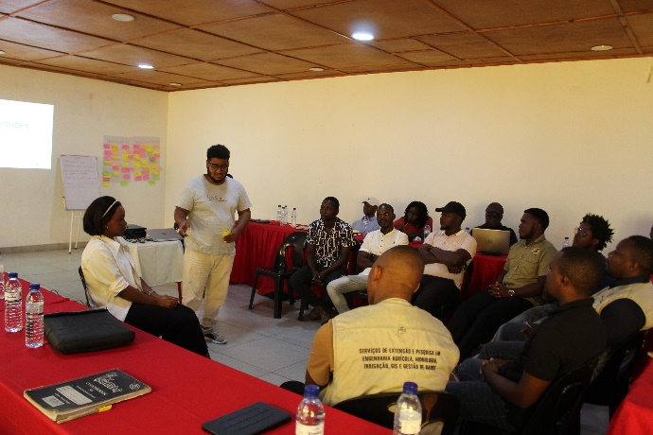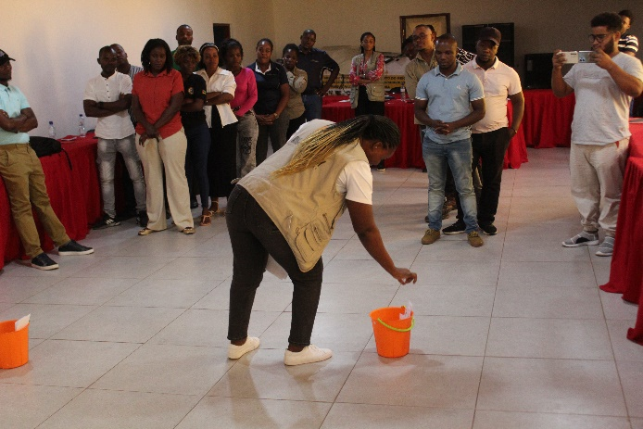
Figure 16: Facilitation of dialogue training session for the SLDP technical Team
Following this preparation, a series of showcasing sessions was conducted in the districts of Gorongosa, Nhamatanda, Dondo, and Cheringoma. These sessions highlighted local individuals and families who demonstrate more equitable practices within their households and productive activities, presenting them as positive role models capable of inspiring change. Each session gathered approximately 30 participants and presented 11 reference cases (eight men and three women) who illustrated practical shifts in gender relations, particularly in shared household responsibilities, joint income management, and inclusive decision-making. The discussions generated strong engagement and encouraged participants to reflect on how more collaborative relationships between men and women can strengthen household well-being and productivity.
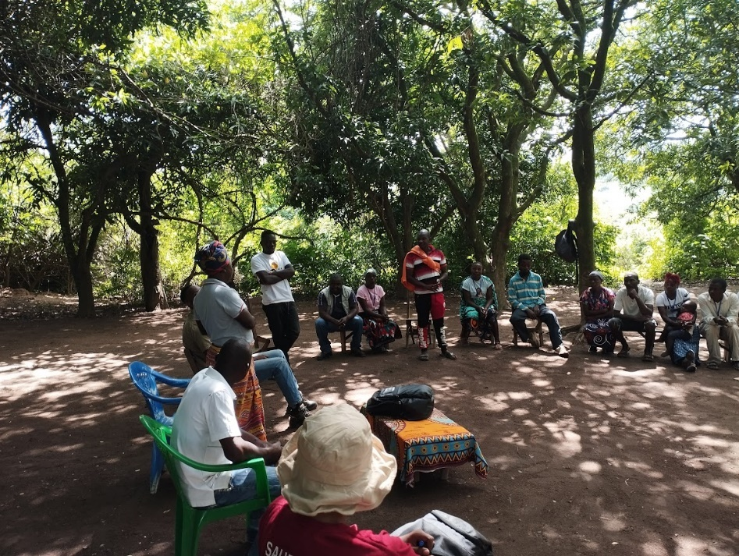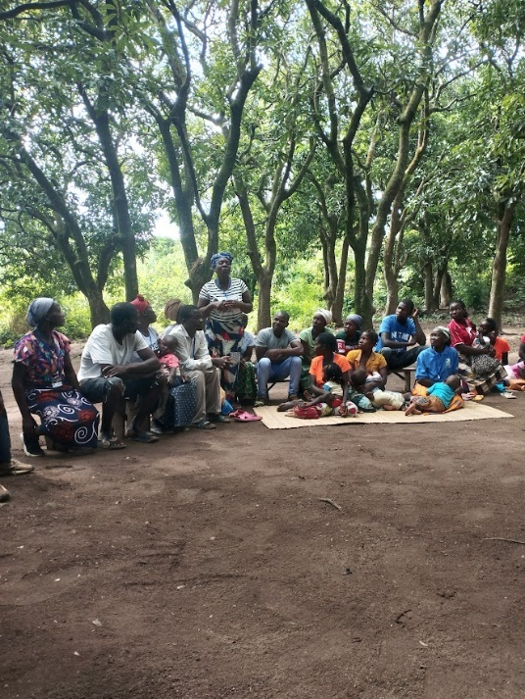
Figure 17: Showcasing session with the community of Cilindro in Gorongosa
Testimonials:
“These discussions are important for our community and should take place more often.” – Farmer, Dondo (2025).
“For a person to develop, they must make a plan together with their family.” – Farmer, Gorongosa (2025).
“It is important to save money to improve financial management and family investments; otherwise, you could lose money. Saving money is not easy; it requires determination and clear investment priorities.” – Female farmer, Nhamatanda (2025).
“It is important and acceptable for a woman to have her own resources, such as money and land, but she must respect her husband and make decisions with him.” – Farmer, Nhamatanda (2025).
Peer learning and experience-sharing activities remained an important element of the gender strategy, enabling women and youth to exchange experiences, challenges, and good practices. Although the regularity of these activities was occasionally affected by the availability of technical teams, they continue to be recognised as valuable platforms for reinforcing support networks and promoting positive social norms. In line with the Mid-Term Review (MTR) recommendations, these community dialogues will continue to be strengthened in the coming years, with greater emphasis on promoting shared household responsibilities, encouraging the active participation of men in discussions on gender equality, and expanding the scope of dialogue to include issues related to women’s safety in daily activities.
To support inclusive participation in program activities, more visual and participatory training approaches were introduced throughout the year. These methods proved effective in facilitating learning among participants with different literacy levels and helped increase the active engagement of women and youth in discussions related to agricultural production, financial management, and small business development.
In parallel, the program initiated the development of a women-led poultry value chain aimed at strengthening income generation and market participation. The initiative progressed through the preparation of infrastructure and organisational arrangements, with an expected participation of 45 women and 41 young people. By the end of the year, the initiative had entered a planning and alignment phase, with implementation expected to advance further in 2026 once participation criteria and operational modalities are finalised.
More broadly, the program continued implementing its co-financing mechanism for productive equipment, including solar irrigation systems, threshers, and processing units. This mechanism has contributed to increased productivity, reduced operational costs, and strengthened beneficiaries’ sense of ownership over program investments. However, monitoring also indicated that some beneficiaries (particularly women) face challenges in meeting the required contributions, highlighting the need to review payment modalities to ensure equitable access to these opportunities.
Overall, the activities implemented during 2025 contributed to strengthening dialogue around gender equality, promoting more inclusive participation in productive activities, and laying the foundations for future economic opportunities for women and youth across the program’s intervention areas.

Lessons learned
Please provide a few examples of highlights of project learning. These can either be successes or failures but show how adaptive learning is used in the program to improve implementation.

Below are some of the general guidelines that can help you to come up with good lessons learned points. Focus on these five bold key questions:
- What obstacle did you face that challenged your team’s original assumption(s) during the implementation?
- How did your team respond to this obstacle? What activity, strategy, methodology, approach, system, process, technique, policy, or tactic did you use to deal with this obstacle?
- What effect did your team’s response or action have on the obstacle? Did your response overcome the obstacle?
- How many times did you experiment your response and get the same results?
- What new understanding/knowledge did you draw from this experience?

Over the course of the 2025 implementation year, the SLDP program delivered strong results across agriculture, natural resource management, nutrition, and WASH. These achievements offer valuable learning about what enabled success, where bottlenecks emerged, and how future phases should be adapted to sustain performance.

Component 1
The effectiveness of lead farmers, community rangers, reforestation facilitators, and CBNRM committees demonstrates that decentralized leadership is essential for behavior change, early problem detection, and rapid scaling, proving that investing early in community leadership systems yields high returns in adoption, stewardship, and sustainability.

Where training was hands-on (e.g., post-harvest handling, beekeeping, horticulture kits, agroforestry diagnostics), adoption was faster and results more visible, which made the program realize that adult learning anchored in demonstration and practice consistently outperforms theory-only approaches.

The experience confirmed that empowering successful local producers as demonstration farmers is one of the most effective behaviour-change strategies. Their visible results, accessible role-modelling, and trusted presence within communities significantly reduced hesitancy and encouraged wider farmer uptake of improved practices. This peer-to-peer mechanism builds confidence faster than external training alone and should remain a cornerstone of future extension approaches.

Regular, practical training in soil management, climate-smart practices, water conservation, and simple technologies improved farmers’ ability to make sound agronomic decisions. This recurring capacity-building model enabled producers to adapt more quickly to variable climate and market conditions—demonstrating that frequency and continuity of training are as important as content

While central nurseries serve GRP-managed plots efficiently, they are less suited for broader outgrower needs. Transporting seedlings long distances reduces survival rates, increases operational costs, and complicates logistics. Community-based nurseries, on the other hand, ensure timely availability, better seedling quality, lower costs, and stronger community ownership. Moving forward, decentralised nursery systems should be prioritized as the foundational model for agroforestry expansion.

Attempting to georeference every individual seedling proved technically impractical and resource-intensive. A shift toward permanent sample plots (20 x 50 m) offers a more realistic, scalable, and accurate monitoring method. Simplifying monitoring systems without compromising data integrity is essential for large-scale restoration initiatives

Introducing fruit trees into nursery production increased community interest in restoration activities by linking environmental efforts to clear livelihood benefits. Species diversification can transform reforestation from a conservation-only activity into a livelihood strategy, enhancing participation and long-term stewardship

Involving community leaders from the Gorongosa Mountains played a decisive role in mitigating politically motivated sabotage in community nurseries. This demonstrates that local governance structures are indispensable stakeholders—not only for mobilization but also for safeguarding investments and ensuring Program continuity.
The showcasing approach confirmed the value of using local role models to stimulate reflection and behavioural change around gender norms. When community members observe peers adopting more equitable practices—such as sharing household responsibilities or making joint financial decisions—the messages resonate more strongly and are perceived as achievable. The sessions also demonstrated that meaningful change requires sustained engagement; regular community dialogues are essential to reinforce learning and gradually shift perceptions.
Integrated approaches combining training, demonstrations, and practical tools improved participation and knowledge retention, especially among participants with varying literacy levels.The program observed persistent barriers to women’s participation, particularly related to household responsibilities and limited time availability. These constraints highlight the need for more flexible engagement strategies and continued efforts to ensure that program activities are accessible and inclusive for women.
From an operational perspective, the year reinforced the importance of strong coordination across technical, monitoring, and digital teams. Early alignment in the design of data collection tools and ongoing improvements in digital data integration helped reduce duplication and strengthen the reliability of information used for program management and decision-making.
Regular joint reflection spaces among partners and district teams supported adaptive management, better workload distribution, and reduced operational bottlenecks.

Component 2
Effective program implementation requires strong communication systems and the flexibility to adapt to operational realities. During the reporting period, scheduling conflicts between RTP and GRP teams—particularly for joint activities such as Training of Trainers—highlighted the risks associated with rigid planning. By strengthening communication channels and adopting a more flexible coordination approach, the program was able to overcome delays and ensure continuity in implementation. This experience reinforces the critical importance of proactive engagement and adaptive planning in maintaining momentum, particularly in multi-partner environments where competing priorities can easily disrupt timelines.
Another key lesson is the value of structured and regular coordination platforms in driving performance alignment. Initially, limited interaction among field teams led to inconsistencies in planning and progress tracking. The introduction of quarterly face-to-face coordination meetings created a space for joint planning, performance review, and problem-solving. This approach significantly improved coherence across implementation areas, strengthened accountability, and ensured better alignment with annual targets. It is evident that structured coordination mechanisms are not optional—they are fundamental to maintaining consistency, improving execution quality, and enabling timely course correction.
The program also demonstrated that collaboration with local partners is essential for overcoming resource limitations and achieving scale. The reliance on a cascading Training of Trainers model alone proved insufficient, particularly in the context of limited transport and a small supervision team. By adopting a joint implementation approach with GRP staff, the program was able to extend supervision coverage, strengthen technical support, and reach all six districts effectively. This collaborative model highlights that partnerships, when strategically leveraged, act as force multipliers—enhancing both efficiency and impact while ensuring that interventions reach even the most remote communities.

The nutrition program realized that radio is an important medium for promoting and influencing behavioral change, where it can strengthen young people's abilities to produce and develop nutrition and wellness programs, aiming to share relevant information and provide a platform for them to express their opinions.
The program determined that in the future, before contracting companies to drill water wells, it should contract a company to conduct geophysical studies of potential locations, so as not to waste effort and time searching for water. This will reduce the risk of unsuccessful wells and contribute to the timely delivery of projects

Success story
Tell us the story of the program focusing on how the program has helped to improve people’s lives and/or how the program is contributing to behavior change.

A story is a broader description of a change that includes a variety of people and experiences, using a mixture of quotes and facts, and figures to describe the ‘before’ and ‘after’, and the process of change.
Below are some of the guidelines to help you develop your story.
Make sure your story covers the 5 ‘W’s’ and 1 ‘H’ in your questions: WHO, WHAT, WHERE, WHEN, WHY, and HOW
- Who questions record basic information about a person – full name, age, children, and marital status. Taking a genuine interest in someone helps them to feel valued and more likely to share their experiences and opinions.
- What questions can be used to highlight the change brought about by the partner’s work, and the impact on individuals, families, and communities? They can show individual and community participation in a project, and convey a sense of local ownership and pride – as well as highlighting what the partner is doing to empower people to help themselves, e.g. What do you think caused this to happen?
- Where questions a locality and can help to create a sense of place, e.g. where is the work taking place?
- When questions can show the pace of change and highlight what a situation was like before compared to now, e.g. when did you first start learning to read and write?
- Why questions usually require a person’s opinion. They can be difficult questions to answer especially when asked out of context. Small questions such as why is that? Why now? Why did you say that? or Why do you think... can deepen a conversation without disrupting its flow.
- How questions usually provide the all-important detail. Like why questions, they can be used to deepen a conversation, e.g. How did that happen? How do you feel about that? Emotion is the vital ingredient of a good story so be sure to include the subject’s hopes, worries, and feelings of satisfaction. Try to get people to talk about how their hopes and attitudes have changed – rather than just their physical situation. The most important thing about a story of change is to ensure that the real voice of the communities/individual subject comes through i.e through quotes.
Annexes shared separately

