WORK PLAN WL 2024 Ethiopia

Name of TBI partner | The Pastoral and Environmental Network in the Horn of Africa (PENHA)
Location of TBI partner | Addis Ababa, Ethiopia, and Hargeisa, Somaliland (regional headquarters)
Email address | penhasom@gmail.com
Primary Contact person for WL | Amsale Shibeshi, PENHA regional programmes coordinator, Amsale.shibeshi@penhasom.org , +252 634416203
Location of activities | Tigray-Afar Border Landscape, Ethiopia, Working Landscapes/Restoration
Project Title | Dryland restoration and dry forest management in Ethiopia  – Sharing knowledge to meet local needs and national commitments

List of abbreviations________________________________________

ANR Assisted natural regeneration
CBOs Community Based Organizations
CIFOR Center for International Forest Research
DRS Drylands Restoration Strategy
EFCCC Environment, Forest, and Climate Change Commission
EFD Ethiopian Forestry Development
FAO Food and Agriculture Organization of the United Nations
FFPOs Forest and farm producer organisations
FGD focus group discussion
FLR Forest Landscape Restoration
FMNR farmer managed natural regeneration
FFS Farmer Field School
FTC Farmer Training Center
GERD Grand Ethiopian Renaissance Dam
GLI Green Legacy Initiative
ICIPE The International Centre of Insect Physiology and Ecology
ICRAF International Centre for Research in Agroforestry (World Agroforestry)
IFAD International Fund for Agricultural Development
ILM Integrated Landscape Management
M&E Monitoring & Evaluation
MoA Ministry of Agriculture
MODIS Moderate Resolution Imaging Spectroradiometer
MSP Mult-Stakeholder Platform
MU Mekelle University
NDCs Nationally determined contributions
NDRS National Drylands Restoration Strategy
NGO Non-Government Organizations
NTFPs Non-Traditional Forest Products
PENHA Pastoral and Environmental Network in the Horn of Africa
PPR Participatory Productive Restoration
RRC Rural Resource Center
TARI Tigray Agricultural Research Institute
VCs value chains
VSLA Village Savings & Loan Association
WGCF&NR Wondo Genet College of Forestry and Natural Resources

Important Ethiopian terms
Kebelle – The lowest level of local government (equivalent to county-level), very close to the communities and the principal actor in local-level development and environmental management activities.
Woreda – A higher level of local government, equivalent to district or regional administrations elsewhere.
Regional Government – The sub-national level of government, in a federal system. Regional governments have a degree of autonomy in setting policies and regulations.
The Federal Government – the central government.

Note: British English predominates, but many have adopted American spellings in naming their organizations. (Hence, “Rural Resource Center”.)

PART ONE: Key outcomes and strategies for 2024
In this part, describe (1) contextual changes, opportunities & risks that might have an influence (positive or negative) on the results and implementation of the programme in 2023; (2) the latest version of your ToC and clarify any adaptations made; (3) to which themes you expect to contribute; (4) your key outcomes and intervention strategies including gender equality and youth engagement strategies, and (5) your organizational G&Y mainstreaming plans.

Contextual and other changes, opportunities and risks
Highlight changes in the programme context (e.g. political, environmental, economic, the Covid-19 situation,) and/or organizational/programmatic changes that can either provide opportunities or risks for a successful implementation or for achieving the intended outcomes of your 2023 work plan. Include how you intend to minimize or mitigate possible negative effects or take advantage of opportunities (NB when relevant include it in the work plan).

Political and security context: Development and humanitarian programs are moving forward, in an improving, if still difficult political and security context.

Following the December 2022 Peace Agreement between the Government of Ethiopia and the TPLF (Tigrayan People’s Liberation Front), an interim government was established in Tigray and development activities resumed, with a focus on humanitarian aid alongside rehabilitation and recovery efforts. Aid diversion has continued to be a significant problem, causing the suspension of humanitarian aid. But in December 2023, aid agencies resumed support, with new control measures, amid a deteriorating humanitarian situation. As 2024 begins, there are reports that hunger and famine have claimed lives in Tigray, while a stepped-up humanitarian response is beginning to address the situation.

With peace, development agencies are returning to Tigray and Afar regions with new programs. The on-going PENHA-TBI program has been complemented by major new restoration programs (World Vision and Menschen fur Menschen), with similar approaches and goals, in line with the Drylands Restoration Strategies, developed with PENHA-TBI and adopted by the governments of the Tigray and Afar regions.

However, political and security challenges remain. The governments of Tigray and Afar regions are at loggerheads, and official travel and communications have been suspended, while informal trade and interaction continue. A new armed conflict has emerged in Amhara Region, to the west of Tigray, with a popular movement contesting the legitimacy of the Federal Government, and also claiming disputed territories from Tigray. While the ruling party dominates the federal government, unrest and insecurity is widespread across the country. Still, international development agencies, bilateral and multilateral, continue to have significant leverage.

Regional governments are strongly supportive of restoration efforts on the Tigray-Afar border landscape, and there is broad popular support for a green agenda, initiated by the previous government, that is also politically useful to the ruling party.

Economic context: Nationally, there has been a sharp rise in the cost of living over recent years, accompanied by a growing debt crisis, deepened by the two-year war in northern Ethiopia. Severe drought and a missed planting season (due to conflict) have aggravated the situation in the drylands. Two decades of strong economic growth, under a state-led development model, have led to modest increases in living standards, undercut by rapid population growth and unevenly distributed. Industrial development is hampered by inadequate power supply, which government has sought to address through a domestically-financed hydropower scheme, the Grand Ethiopian Renaissance Dam (GERD), located in the northwest, near the Sudanese border. Dependence on wood and charcoal to meet growing energy demand remains the principal driver of deforestation, alongside the expansion of low-productivity agriculture. Government aims to pursue economic liberalization, with a cautious opening up to foreign investment, which remains limited, and dominated by Chinese and Arab investment. Government is the ultimate owner of all land. Private land “owners” have use rights and large areas are communally owned or managed. Government can expropriate land “for the common good”. In practice, politically connected domestic and foreign investors can readily acquire land. In the face of sharply rising food prices, government aims to increase agricultural production, with irrigated wheat production in the drylands, risking salinization and potentially threatening pastoral livelihoods. Mining has huge potential, if it can be transparently regulated and conducted sustainably. Government is also, tentatively, opening up telecoms and
banking to competition. Access to finance is a constraint for local enterprise and the country lags behind others in the region who have successfully promoted financial inclusion through mobile money, for payments and savings. Mobile money has long been well established in neighbouring Somaliland, and across East Africa. It is growing in Ethiopia’s Somali Region, but remains limited across the rest of Ethiopia. For women in particular, mobile savings facilities represent an under-exploited opportunity for financial inclusion. A Kenyan service provider, newly licenced to operate in Ethiopia, is now competing with government’s Ethio Telecom. In response, Ethio Telecom has now introduced a women’s empowerment package. Government also aims to address the pressing issue of youth unemployment - a political imperative, given Ethiopia’s demographics. Job creation is emphasised in Ethiopia’s Green Economy Strategy, and is one element in the Prime Minister’s massive tree planting program, the Green Legacy Initiative (GLI), which employs a large number of youth.

Environmental context: Two years of war, during which the curtailment of electricity supplies led to an increased reliance on wood to meet energy needs, reversed much of the gains of two decades of restoration efforts in Tigray. Traditional institutions, across Tigray and Afar regions, were able to cooperate to limit the damage to the environment and the shared Desa’a Forest. Water flows down from the Tigrayan highlands to the plains of Afar Region. Rainfall is erratic, but when the rains come, they are often heavy, bringing destructive floods to Afar Region. More effective water management is, thus, crucial, for livelihoods and the environment. Increasingly frequent and severe drought presents major challenges, for livelihoods, the environment and tree planting/restoration efforts, and necessitates greater attention to water harvesting and management. Population and economic pressures have been drivers of serious land degradation and deforestation, making wider economic development and rural-urban interaction important aspects of integrated landscape management.

1.2 Theory of Change
Add a figure of the latest version of your ToC, and explain/justify the changes with the previous version in case it changed.

https://miro.com/app/board/uXjVNW_S7aA=/?share_link_id=626188616585

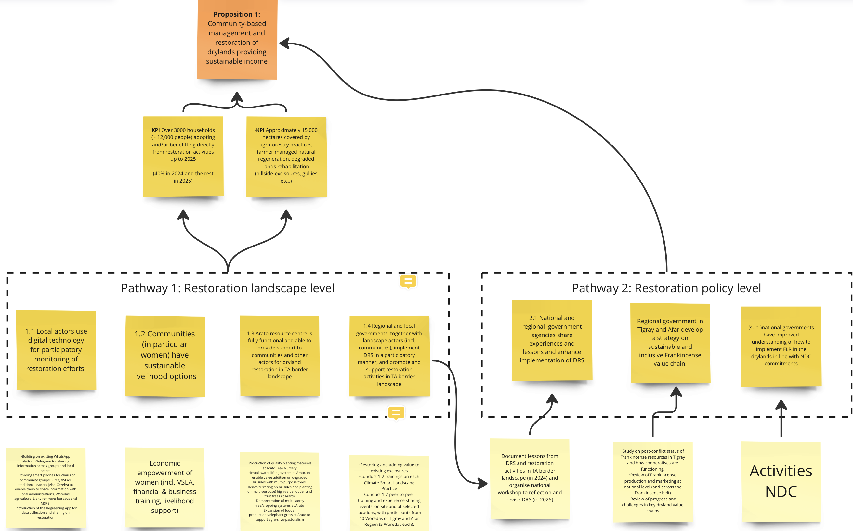

A previous version of the ToC was based on the need to “make forests pay”, with changes in policy and programs that enable local people to earn incomes in and around conservation areas, offsetting the opportunity costs of exclosures and forest protection. The revised ToC builds on this, with Pathway 1 based on landscape-level restoration and Pathway 2 on restoration at policy level, supporting and enhancing the implementation of strategies developed with regional governments. Pathway 1 involves a greater emphasis on G&Y, as well as a new focus on the opportunities provided by digital tools.

Pathway 1 is also based on a scaling strategy that involves active collaboration with a Consortium of partners at the Arato site, including the local Kebelle Administration and its extension agents, as well as Farmer Training Centres across the region. This is reinforced by the backing of the Abogerebs, a highly influential association of traditional leaders, who oversee natural resource management and conflict resolution.

By the end of 2025, the degraded landscape around Arato will have been restored, local women and youth will have strengthened livelihoods based on climate-smart practices, and the Arato Rural Resource Center will have the capacity to drive the scaling out of Participatory Productive Restoration activities across the broader Tigray-Afar Border Landscape, collaborating actively with multiple stakeholders under the Regional Drylands Restoration Strategy (DRS). Mechanisms will have been established for the implementation of the DRS in a participatory and inclusive manner.

Additionally, in Pathway 2, we aim to ensure that Federal and regional governments adopt strategies for inclusive drylands/gums and resins value chain development and the conservation of Frankincense tree resources. This outcome flows from reviews of the status of Frankincense resources post-conflict and of value chains for Frankincense and gums and resins, and workshops in 2023 with government and other stakeholders.

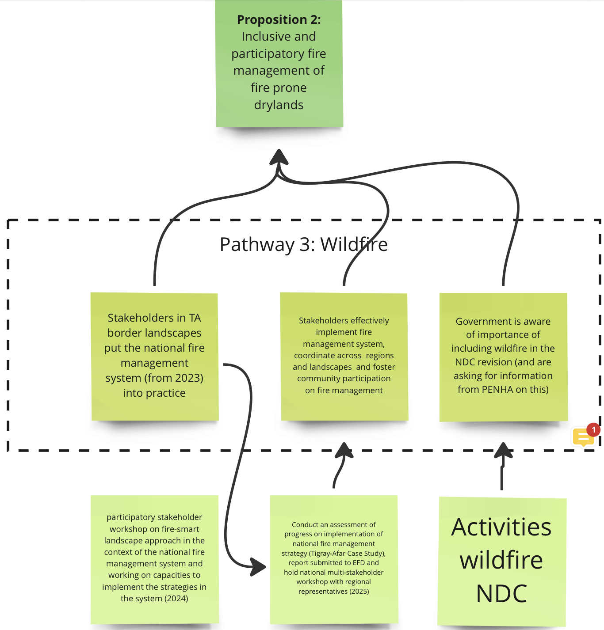

Pathway 3 involves a revised ToC on fire management, taking successful strategy development at the national level down to the regional level, in collaboration with stakeholders on our TA Border Landscape. By organising 2-3 awareness raising and sensitisation consultation and training workshops at local levels by bringing key actors including women and youth representatives, a common vision on how to manage fire in the TA border landscape particularly in the Desea Forest will be in place, bringing together all stakeholders, Woreda and Kebelle administrations, relevant bureaus, community representatives and traditional institutions, with agreed principles, roles and responsibilities, so that local actors can effectively mitigate fire impacts on Desea Forest and nearby landscapes, communicating efficiently with regional and Federal authorities, including FSTU, which will provide basic equipment for community fire brigades.

1.3 Contributions to WL network themes & cross cutting issues
To which WL network themes do you expect to contribute and how: NDCs; Restoration; Agro-Commodities/Agroforestry; Business & Finance; Inclusive Governance; and/or Fire Programme (please include your contributions to the Fire Programme if you are engaged in that programme.
……………

How we will contribute to the restoration impact area, lessons we want to share with the network, and what we hope to learn from the network.

Restoration: This is the core of our program. Following a very useful Stocktake exercise, we are actively working with the Restoration Team to apply specific tools and develop Restoration Impact Area KPIs.

The PENHA-TBI program in Ethiopia can share the lessons from the TA Border Landscape with the TBI Network, for example on the operation of the Rural Resource Center (RRC) business model, on the application of FMNR on hillsides, farmlands and grazing areas as a tool/approach for land restoration and biodiversity enhancement, and on the rehabilitation of degraded gullies for income generation for women and youth. PENHA has established a Consortium of collaborating actors at the Arato site, which includes formal partners CIFOR-ICRAF and Mekelle University, as well as local government and NGOs. Consortium members will contribute in different aspects and to on-site learning. PENHA and partners will also learn from the TBI network on various aspects of participatory productive landscape restoration, and on other TBI themes, including fire management and real-time monitoring and reporting, as well as agro-commodities, business & finance and inclusive governance. The opportunity to exchange ideas and experience internationally through the TBI Network is attractive to Ethiopian partners, both in written reports and through Network presentations and discussions.

NDC:
Our 2022 study on the integration of forest landscape restoration in Ethiopia’s NDC, conducted with the senior program manager at EFD, contributed to the revision of Ethiopia’s NDC, presented at the Glasgow COP. An estimated 70% of Ethiopia’s carbon sequestration potential is in the drylands. Ethiopia’s NDC is based largely on FLR. But historically, government has lacked a clear understanding of how to promote restoration in the drylands, where standard afforestation and forest protection approaches are not suitable. We sought to develop that understanding through our NDRS. There is a recognition of the importance of the drylands in achieving the NDC, and funds have been allocated to support the implementation of the NDRS across the country. Still, NDC commitments are not well understood or integrated across government, at the national or sub-national levels. At the local/regional level, few people even heard of the NDC and the Paris Agreement. So, we will hold a workshop with all stakeholders in Tigray-Afar in 2024, to raise awareness and understanding. We expect that new government and international NGO programs at landscape level, guided by our Strategy, will have significant impact through FLR and FMNR, advancing NDC achievement. With partners, we have discussed the need to develop a monitoring framework for NDC delivery. The regional workshop will generate ideas. After further discussions, we will produce a concept note and seek funding for a dedicated effort.

Fire Management:
Limited resources dictate a scaled-down program. By organizing local level sensitization and training workshops, we aim to support, at the regional level, the Integrated Fire Management System that was developed with CIFOR-ICRAF and EFD at the national level. The focus will be on how the Abogerebs (a local platform led by elders) and local stakeholders can cooperate and coordinate to implement a fire-smart approach on the TA Border landscape and in the management of the Desa’a Forest. Lessons will be shared across the Network.

Agro-Commodities/Agroforestry: Agroforestry is a central element of our landscape level restoration efforts, with support for homestead agroforestry, with a Farmer Field School approach, promoting on-farm trees that contribute to resilient livelihoods, food security and nutrition, and climate change mitigation, as well as biodiversity conservation. In our livelihoods work, we also emphasize dryland value chains and forest products, notably honey and Frankincense. New EU legislation is likely to have an impact on Ethiopia’s important coffee exports and we will address this in our work, drawing on discussions within the Network.

Resource limitations have forced us to “de-emphasize” the business & finance and inclusive governance thematic teams, but we will continue to engage on these fundamental aspects in our discussions with government and MSPs.

Business & Finance: Here we will focus on the development of a strategy for inclusive and sustainable Frankincense value chains in Tigray and Afar regions, linked to work in Somali Region and at national level. This is an international trade, with an important centre in Holland.

Inclusive Governance/Community Forest Management: In much of our work, we will continue to promote inclusive governance, which is one of the four themes in our Dryland Restoration Strategy. We will promote inclusive governance, working with traditional institutions and regional governments and pushing for the implementation of positive policy and regulatory changes.

Participatory Productive Restoration under the PENHA-TBI Program
From our base at the Arato Tree Nursery, we are operating across the Tigray-Afar (TA) Border Landscape, promoting participatory productive landscape restoration and climate-smart practices, with the aim of strengthening livelihoods and creating green jobs for women and youth, while conserving and enhancing biodiversity. We aim to build local capacity and increase incomes for women and youth, engaging with public and private actors to achieve impact at scale.

Innovative and cost-effective practices, building on and enhancing local knowledge, will be demonstrated across the area surrounding the Arato Tree Nursery, which will be established as a Rural Resource Centre (RRC). The site will serve as a learning hub for good practices, involving: i) the RRC business model - a revenue-generating centre that responds to identified local demand, producing quality planting materials and agribusiness inputs, sold to farmers and government programs ii) Farmer Managed Natural Regeneration (FMNR) as a tool/method of land restoration on the surrounding hillsides and landscape, restoring degraded areas with native trees including on grazing areas and farmlands; iii) women-oriented homestead agroforestry- increasing household incomes and food security; iv) and other associated locally owned solutions and approaches.

Some important elements of our PPR activities at landscape level:
- Local women and youth are being trained and supported to carry out specific activities. A women’s group is being supported to manage the nursery. A women and youth group will be supported to rehabilitate gullies passing through the side of the Arato nursery and convert the gully/ies from threats to opportunities. Youth will carry out honey production and related activities through the support of the International Centre of Insect Physiology and Ecology (ICIPE) where 50 youth will receive training and equipment for honey production under an agreement to be signed with ICIPE
- Women’s groups will be organized as VSLA’s and receive training, so that they can begin to mobilize their own savings. [In this, we will draw on PENHA’s experience with women’s economic empowerment in Somaliland.] The women will have increased access to finance, through links with local banks and the promotion of digital tools, including Ethio Telecom’s “Women’s Empowerment Package”. [The Head of Mekelle’s Ethiopian Commercial Bank branch has visited the site and agreed to collaborate.]
- The Arato RRC aims to be commercially self-sustaining, while functioning as a hub for training and extension, adapting the Farmer Field School model, applied in other network countries. This supports scaling out, on the basis of collaboration other stakeholders, including public institutions and the private sector. Local extension agents are participating in activities and training on site, so that the work is integrated into their wider activities, as part of a scaling out strategy that is connected to governmental Farmer Training Centres (FTCs) across the region.
- We are promoting Farmer Managed Natural Regeneration, an approach that is suitable for the drylands, and in line with biodiversity goals. An advocacy through trainings, experience sharing and exchange visits and on on-site study aims to demonstrate the effectiveness/benefits of FMNR.
- We are collaborating closely with partners CIFOR-ICRAF and Mekelle University, and with traditional institutions, local, regional and central government, as well as major NGO programs. We are actively collaborating with others on the ground to deliver our outputs, with a very direct influence on the work of others.

Gender equality & youth (F/M) engagement
What are your intended outcomes towards gender and youth (F/M) priorities related to each of the five baseline indicators/three main pathways:

Table 1: Gender/youth (F/M) priority/ outcomes for 2024
Pillar | Indicator | Gender/youth (F/M) priority/ outcomes for 2024
Inclusive landscape governance: | a. Level of access of women and youth to land and ecosystem services; | - Significant increase in incomes, knowledge/skills and participation on landscape restoration compared to 2023, for women & youth at Arato, with households on the wider landscape benefiting from enhanced ecosystem services.
Inclusive landscape governance: | b. Level of land tenure rights/security of women and youth; | - Explicit recognition in DRS and regional strategies, allocation of land – nurseries (women), hillsides, and gullies to youth - at the local level in Tigray
Inclusive landscape governance: | c. Level of participation of women and youth in decision making about land & forest use and governance | - Enhanced participation in MSPs and digital platforms to exchange experiences, lessons, and learnings
Responsible business and finance: | d. Level of access of women and youth to production resources, inputs and benefits  e. Level of participation in decision making of financial use and management | - Substantial increase at local level (on site), with enhanced access to quality inputs and services through scaling out of good practices and lessons  - Substantial increase in decision making/ability to use and manage finance (achieved principally through women’s group managing the RRC)
Sustainable land-use practices: | e. Level of participation of women and youth in, contribution to, and benefits of climate smart practices) | - Substantial increase in level and quality of participation on site, and through MSPs, DRS implementation
G&Y priority outcomes for 2024-5 have been substantially revised, reflecting a shift from policy to landscape level and a greater focus on G&Y in Participatory Productive Restoration:
- We aim for local women and youth to have enhanced skills, and knowledge through providing hands on training and access to inputs (including planting materials), enabling them to implement climate-smart practices, as well as to increase and diversify their incomes by producing and selling quality planting materials, fodder grasses and vegetables, as well as through the supply of agricultural inputs and services to the farming communities. By doing these, we will have 3,000 women and youth as direct beneficiaries at the Tigray-Afar border WL that will have enhanced incomes, levels of engagement and, therefore, capacity to participate in decision-making.
- At the local level, 3,000 women and youth as direct beneficiaries of activities at the Tigray-Afar border WL will have enhanced incomes, levels of engagement and, therefore, capacity to participate in decision-making
- Local women and youth have enhanced access to finance through a newly established VSLA and links to local banks and finance providers where they can easily access loan/credit and saving services.
- Regional Dryland Restoration Strategies are implemented in participatory ways through organizing local level awareness raising events and enhancing participation in digital platforms that are more open to the views and priorities of women and youth
- Women-oriented capacity building and advocacy work will be implemented to give them a greater voice in local decision-making and forums for natural resource management and conflict resolution

We also aim to make traditional institutions more responsive to women and youth, and to introduce mechanisms for their inclusion. We are collaborating with youth representatives in the Kebelle administration, which is aware of the need to address the priorities of increasingly disaffected youth.

Priority outcomes and intervention strategies
Describe your planned priority targets/outcomes (as outlined in table 3) and intervention strategies, and why and how these will contribute to your planned 2024 outcomes (your assumptions). Also describe your intended outcomes and intervention strategies for more transformative change in gender equality & youth (M/F) engagement.

Pathway A: Restoration landscape level
Government has allocated funds for restoration. With their cascaded restoration strategies, the regions are well placed to receive these funds. Government is also playing a key role in facilitating funds for restoration from development partners, stipulating that new programs should be in line with the NDRS. With broad agreement on core principles and a shared approach to restoration, we now aim to take the NDRS to the ground, promoting community based and inclusive restoration across the Tigray-Afar landscape (2,000,000 hectares + 200,000 people) and establishing a learning hub at Arato. The rehabilitated Arato Tree Nursery serves as a site for the demonstration of a comprehensive approach to restoration, that includes the supply of quality planting materials as well as FMNR on the surrounding hillsides, enabling various stakeholders to take lessons and practices to scale within the TA border landscape and beyond. An open, collaborative approach promotes scaling out. PENHA leads a Consortium of key partners, all collaborating actively on site. The Consortium includes CIFOR-ICRAF, Mekelle (Tigray) and Samara (Afar Region) universities, the Tigray Agricultural Research Institute (TARI), the Tigray Biotechnology Center (with a plant tissue culture laboratory, producing high-quality planting materials on a commercial basis), working in collaboration with local governments. The head of Tigray’s Agriculture and Natural Resources Bureau has stated that he wishes to see the site developed as a model for the region.

A paradigm shift towards participation: The new regional DRS provides an opportunity for a paradigm shift, towards greater community participation. We will use multi-stakeholder platforms at various levels, those that exist for restoration and agricultural transformation in Tigray and Afar regions, as well as the Abogerebs in the TA border landscape. Top-down approaches are strongly entrenched in Ethiopia. Beneficiaries are typically consulted, if at all, at the beginning of a project and in a final evaluation. Local people are often reticent in front of project managers. Technical experts tend to dominate the selection and design of environmental interventions, failing to draw sufficiently on local knowledge. A failure to consult, particularly at the design stage, has often undermined program delivery and project effectiveness. Major programs that support environmental rehabilitation efforts in Tigray and Afar regions have been affected by insufficient consultation, often limited to local elites. A change of mindsets is required. In our own work, and through MSPs, we will introduce a culture of continuous consultation and participatory M&E, with informal channels for feedback. Women and youth tend to be sidelined. We will introduce mechanisms for feedback from marginalized groups, combining requirements for formal reporting and surveys with channels for informal and anonymous feedback. Program implementation needs to be responsive to continuous feedback. We expect the regional government to be an ally in this, as they strongly back the participatory principles outlined in the DRS and there is a recognition among senior leadership, shaken by growing discontent among the youth, of a need for change. A related element is the need to build the capacity of community groups, particularly women and youth, to participate. A major challenge has been the weakness of Ethiopian civil society and the absence of local deliberative structures. For political reasons, successive governments have not wanted communities to be organized, except in narrowly focused producer cooperatives. Kebelle administrations, the lowest tier of local government, were formerly representative community organizations, but became political arms of the state. Still, they remain close to the people and are relied upon as key actors in all development programs. Enhancing deliberative processes and inclusion within the Kebelle administrations is an important step towards entrenching participatory approaches. Accordingly, we will involve and engage with youth and women representatives in Kebelle administrations. We will also draw on the Green Livelihoods Alliance’s Landscape Governance Assessment Tool in seeking to promote a collaborative and inclusive culture among stakeholders.

The role of the Abogerebs: The Abogorebs (“fathers of the tree”) are an association of elders drawn from the traditional institutions of the Tigrayan and Afar communities on either side of the Tigray-Afar border. The Abogerebs have tremendous moral authority within their communities. They handle disputes and local conflicts, and also oversee natural resource management and the application of customary laws, imposing penalties and social sanctions for infringements. The Abogerebs also oversee the protection of the shared Desa’a Forest, which lies at the Tigray-Afar border. The importance of trees to the health of the landscape, including farmlands, woodlands and rangelands, is well understood. Formerly, in Afar customary law, the penalty for cutting down a tree was death. This penalty is now a fine of one goat – a substantial fine in a community where livestock constitute the major store of wealth. Traditional institutions remain powerful, across the drylands, and cannot be ignored by the formal authorities. The Abogerebs, with the authority that they command at community level, are a powerful force for the promotion and scaling out of sustainable practices. Beyond helping to resolve local conflicts, the Abogerebs also play important roles in conflict resolution at the regional level, and have been engaged in useful peacebuilding workshops at the national level, organised by Mekelle University and Samara University, and involving participants from the conflict-affected Amhara Region. At the same time, we are aware of the need to strengthen consultation with women and youth, not represented in traditional institutions, and of the dangers of elite capture. The latter can be mitigated by broader and more frequent participation in open forums.

Digital tools: We are using restoration-oriented WhatsApp groups to enhance participation and scale-up of good practices and lessons, sharing information on a daily basis with a wide range of local restoration actors. In collaboration with Mekelle and Samara universities, we will promote the use of digital technology for integrated landscape management (ILM). EcoAgriculture Partners have developed digital ILM tools that we hope to adapt and use on our landscape. CIFOR-ICRAF are developing their own digital tools, which we aim to apply. We will draw on TBI’s on-going work on spatially explicit modelling. We will also promote digital tools for financial inclusion and increased access to finance.

VSLAs and increased access to finance: VSLAs are an effective vehicle enabling women to mobilize savings and provide small loans to members, supporting livelihoods diversification and the marketing of restoration-related products. The Arato RRC is managed by an organized women’s group, and women in surrounding households are the primary actors in homestead agroforestry, supported by RRC products. Ethiopia’s Cooperative Law provides a framework for this, and support from the Kebelle Administration will be important. Training on CSAs will be supplemented by organizational and business skills training. NTFPs, including Tigray’s prized honey and “gesho” used in producing traditional drinks, have proved to be big income earners for local women. Young men have collaborated with women in producing such local products. Increased access to finance, with larger loans, could enable local micro-enterprises to acquire productive assets and move up value chains. For example, local women might acquire the necessary equipment to process fruits from the trees on site and market juices or avocado products. As described above, we will engage with local banks and mobile banking providers to promote tailored services that can enable transformational change.

The potential of honey production: 50 participating youth are set to receive training under an agreement with ICIPE. ICIPE brings valuable technical knowledge to our Consortium. Successful NGO programs in the region have been able to link local groups to markets. Demand for Tigray’s prized honey is high. We will work closely with local extension agents and draw on related research at Mekelle University (covering aspects such as quality, processing and hive management), as well as PENHA’s previous experience in Somaliland and Uganda. Links and exchanges with other NGO programs, as well as larger commercial producers, will support scaling up.

Land tenure issues: Smallholders have very small land holdings, and also graze livestock on communal areas. Landlessness is a major issue for youth. On the Afar side, communal tenure predominates. Contentiously, larger-scale commercial farming is being introduced in some areas. The allocation of large areas to manufacturing and mining, while governed by the Land Authority, is somewhat haphazard. There remains a considerable degree of uncertainty regarding land and forest tenure in certain areas. Government is still the ultimate owner of all land and forests. Extensive areas of land, including woodlands and rangelands, are under common property regimes. In the absence of a land use plan, these in effect devolve to open access when customary laws are not enforced, permitting the uncontrolled expansion of low-productivity farming or the alienation of land by powerful economic actors. In carrying out extensive restoration at landscape level, issues and challenges related to land tenure and user rights may well arise. Land tenure and governance issues will be addressed in concert with local authorities, the Land Authority and other relevant stakeholders, who will be included in the process of program implementation, monitoring and evaluation. Local institutions, including the Abogerebs, will be key in promoting conducive land tenure arrangements and inclusive land governance in support of landscape restoration. An important aspect of this is the nature of local by-laws governing exclosures and protected areas, and the extent of use rights, particularly with respect to the pruning of trees. In joint M&E work, challenges related to tenure and governance will be assessed with a view to taking timely corrective measures, in concert with the relevant authorities. We will consider tenure issues at landscape level in meetings at Arato and in MSPs, taking micro-level information and lessons to the national level in our reporting and wider engagement at policy level.

Participatory productive restoration activities centred on Arato:
After the November 2022 Peace Agreement, we resumed work with partners ICRAF and the local Kebele administration aiming to rehabilitate the community-managed Arato Tree Nursery. Activities around the Arato site will contribute to agroforestry practices, farmer managed natural regeneration and degraded lands management on approximately 15,000 hectares, benefiting over 3000 households (~ 12,000 people) directly up to 2025. The Arato nursery will also function as rural resource centre, as a focus for innovation and agriculture extension. By the end of 2024, the Arato RRC, FMNR practices across the surrounding area and homestead agroforestry will be well established. By the end of 2025, farmers across the landscape will have better access to knowledge and seeds for agroforestry and restoration, as well as diversified livelihood options for youth and women, supporting food security, biodiversity and the rehabilitation of degraded hillsides/exclosures, grazing areas and farmlands through FMNR techniques, and restoring gullies through cost effect reclamation and rehabilitation techniques.

We will develop the Arato Tree Nursery as a Rural Resource Centre (RRC), a locus for the production of quality planting materials, as well as demonstration, learning and scaling out of a combination of climate-smart practices. This involves agroforestry, homestead gardens, the integration of multipurpose trees on reclaimed/rehabilitated land and the introduction of other livelihood options such as beekeeping. FMNR will be employed as a tool for the rehabilitation of degraded landscapes and the sustainable management of exclosures across 10 Woredas. Local women (nursery + homestead gardens), youth (honey production on hillsides via ICIPE support+ gullies rehabilitation) and the watershed community (FMNR & agroforestry) will manage the Arato site, with support from PENHA and the local administration. The RRC is intended to become commercially self-sustaining. Proximity to feeder roads and urban markets, as well as connections to market actors, make this possible. Building the business and organizational skills of local groups is also an important part of the scaling out strategy, which is underpinned by active collaboration with a number of local actors. The RRC is governed by Ethiopia’s Cooperative Law. Management arrangements will be detailed and shared with the local authorities. It is envisioned that some 10% of seedlings and products will be donated to support local homestead agroforestry and primary school compound-oriented tree planting to be managed by school kids as part of their environmental club activities. Sales of planting materials to local farmers and governmental and non-governmental restoration programs will generate revenues for the RRC. The RRC will be managed by a trained women’s group, supported by PENHA and Consortium members. Organized and trained youth groups will carry out FMNR and enrichment planting on reclaimed gullies and the surrounding landscape, with a set of income generating activities made possible by restoration.

Scaling out strategy: Scaling out is underpinned by the regional DRS, endorsed in Tigray and Afar. In a country with a tradition of strong government, officially endorsed strategies are crucial – getting government to buy into the PPR approach and see to it that the programs of other agencies are aligned with the principles set out. The government of Tigray sees the Arato site as a model for the region and beyond. The scaling out strategy will involve close collaboration and information sharing with ICRAF, Farmer Training Centres (FTCs), platforms and local administrations (Kebele & Woreda and regional governments.) ToT trainings will be conducted with extension agents and Woreda experts. Peer-to-peer learning will be conducted with lead farmers and community representatives with special emphasis on youth and women from across the landscape, covering the RRC business model, FMNR, homestead agroforestry, gully reclamation and the functionalization of the DRS. At Arato, PENHA leads a Consortium of agencies with their own wider programs. Consortium members enhance the work at Arato, and draw on it in their own programs. It is intended that the RRC model, combining an FFS approach with local management and revenue generation for commercial sustainability, will be replicated across the region. There are is a real prospect of commercial sustainability through sales of planting materials to the GLI program and local farmers. The RRC is a hub for demonstration, training and extension, based on co-learning with smallholders. Building on local knowledge facilitates adoption and avoids the promotion of approaches dependent on costly inputs that can only be successfully taken up by sophisticated and well-resourced commercial farmers. Accessibility for people across the landscape is another vital factor. In addition, Moreover, to take lessons and good practices to scale, and make it possible to undertake corrective measures in case of governance and tenure challenges, joint reflection, learning and monitoring missions will be conducted with the presence of policy makers, the Abogerebs and other influential community organizations, including religious leaders.

Systematic assessment of scaling approaches: In applying different scaling approaches, conducting a systematic assessment, if resources allow, would be valuable in order to identity the barriers to scaling up of practices and gather lessons within the working landscapes and beyond. Such an assessment would identify mitigation measures and solutions that would help decision/policy makers to take corrective measures. Findings can also be shared in various local, national and international forums/platforms to create wider awareness and influence policy influence changes.

The four key climate-smart practices: i) FMNR ii) Production of locally appropriate, quality planting materials through RRCs that promote green jobs for women and youth iii) Promoting agroforestry practices with special emphasis on (women-oriented) homestead agroforestry iv) adding value to degraded hillside exclosures through innovative practices (construction of “conservation-based bench terraces”, with water lifting and the planting of multi-purpose, high-value trees, including fodder and fruit trees and some beekeeping activities.)

The latter (iv) might require additional resources which can be mobilized over the course of program implementation. Consortium members might also contribute additional resources, adding to local communities’ contributions of labor, in order to fulfill the planned activities and transform the degraded hillside exclosure into productive land, creating green jobs for youth while promoting environmental health. Note: Water-lifting for high-value trees and fodder grasses to grow on bench terraces supported with some beekeeping activities (iv) will now be addressed with additional funding from the Diamond Proposal.

Biodiversity: Community-managed exclosures (areas closed off to farming and livestock keeping to permit natural regeneration) will be re-established, supplemented by enrichment planting: these will enhance ecosystem services and biodiversity over the medium to long term. Assisted natural regeneration is central to our approach and promotes the drylands’ unique and rich biodiversity and enrichment planting will favor native species. With Mekelle University and partners, we will continue to push for the establishment of Desa’a Forest as a UN Biosphere Reserve.

Community commitment: Tigray’s previous restoration success was based on a very high level of community commitment. Local people contributed their “free labour”, with high opportunity costs in terms of time and effort, as well as the incomes that they had to forgo after establishing exclosures that prevented farming and livestock keeping on extensive areas of land. After a devastating famine in the 1980s, local people understood that the natural resources upon which their livelihoods depend were threatened by deforestation and land degradation. Ethnic tensions also made the prospect of relocation or migration outside the region unattractive. This community commitment remains exceptionally high and makes us confident that our intended outcomes are achievable.

Pathway B: Restoration policy level
While focusing activities on our Tigray-Afar landscape, we will continue to collaborate with the national authorities and MSPs in the six regions that participated in the development of the NDR.

PENHA will conduct an assessment of progress and processes our Tigray-Afar Border Landscape (on the basis of data on the numbers of hectares and people covered, as well as livelihoods outcomes, as well as on the extent and nature of participation, particularly of women and youth). In 2025, a report will be submitted to EFD (central government) and presented at a national workshop with representatives of all dryland regions, who will also present on progress in their respective regions. A consolidated report will put forward recommendations for revised and strengthened implementation modalities to EFD, the Ministry of Planning and Development, other relevant agencies and regional governments.

Frankincense – inclusive value chains and conservation: Frankincense is an important dryland tree resource, threatened by intensive tree tapping, as well as by the destructive impact of the recent war. Tapping, in Tigray and across the country, is mostly done by Tigrayan youth. A “Frankincense belt” stretches from Eritrea, across our landscape and down to Somali Region. Policy and regulatory issues greatly affect what happens on the landscape. We have been promoting dialogue among stakeholders about community rights, as well as key drylands value chains, such as Frankincense and gums and resins. We will continue to work with different stakeholders and market actors to promote dialogue around value chain development and underlying governance issues. We have tried to promote a market systems development approach, working with supply and value chain actors, and directly with tappers. This remains a promising avenue, with some progress in Somali Region and Somaliland. But there are a number of issues that only government can address. Government must provide the necessary enabling environment and regulatory framework. Government alone can address the cross-border and regional dimensions. By the end of 2025, coherent national and regional strategies will be in place for inclusive value chain promotion for key drylands products, on the basis of strengthened community tenure. We will build on studies conducted and on-going collaborations to develop inclusive value chains and promote the conservation of the resource. Work in 2024 will draw on studies to be conducted with UNIDO, by the PENHA-TBI program on the post-conflict status of frankincense production and marketing, and by CIFOR-ICRAF on cross-border trade. These and other related studies will lead to the development of comprehensive national and regional strategies for inclusive gums and resins value chain development, contributing to the sustainable conservation and management of frankincense and other gum and resin bearing tree species. Recently CITES proposed to ban Ethiopian Frankincense from international markets. Such a ban could result in the total eradication of the resource. This concentrated minds and was a focus at our recent workshop in Addis. We will build on a related paper by Frans Bongers and Anjanette De Carlo, and seek to promote a conservation through sustainable utilization approach. A strong strategy can advance value chain development and enable landscape level work, with a regulatory framework that changes the behavior of tappers and market actors, incentivizing longer term thinking.

With EFD and the REDD+ Secretariat, we published studies on Forested Landscape Restoration (FLR) and the role of drylands in Ethiopia’s revised NDC. Based on this, we aspire to help to make the implementation of FLR more effective in realizing NDC commitments, working with government and regional MSPs to adapt FLR to the drylands, promoting on-farm trees, benefiting the livelihoods of smallholders and agro-pastoralists. This will involve information sharing with EFD and the REDD+ Secretariat as well as the communication of on-the-ground experience through established regional and national MSPs. At regional level, we will work with regional administrations and partners (Mekelle University) to establish NDC actions and targets.

Pathway C: Wildfire
PENHA and CIFOR-ICRAF will move from the development of a national fire management system (completed in 2023) to supporting its implementation at the landscape level, focusing on Desa’a Forest, with community engagement and the integration of fire-smart approaches.

After consultative workshops with key stakeholders across seven regions we produced a comprehensive analytical review on fire management in Ethiopia, identifying hotspots, challenges and opportunities. In 2024 and 2025 we will strengthen protection around the Desa’a Forest and provide training and information to community fire brigades in Tigray and Afar, while sharing lessons nationally. The partnership with Wondo Genet College of Forestry (WGC) will continue, supporting local fire management efforts. WGC will act as a knowledge hub, providing knowledge products and also taking up the knowledge and materials produced by the PENHA-TBI program on fire and related issues in their curricula and training programs. Under a new program, WGC will strengthen its capacity for real-time monitoring in collaboration with the Alliance of Bioversity International and the International Center for Tropical Agriculture (CIAT). This will be integrated into the national fire system that we are helping to develop. With Ethiopian Forestry Development, the Environmental Protection Agency and the National Disaster Risk Reduction Commission, we will work towards an Integrated Fire Management System. By the end of 2025, the system will ensure adequate coordination across regions and foster community participation on fire management. By the end of 2025, stakeholders around Desa’a Forest are prepared to implement a regional fire management system, effectively reducing wildfire risks. While focusing activities on our Tigray-Afar landscape, we will continue to collaborate with the national authorities and MSPs in the six regions that participated in the development of the NDR.

PART TWO: Work Plan 2024

Please carefully read the instructions when completing the table! (Annex 1)

Table 3: Outcomes and results for 2024

PATHWAY 1: RESTORATION LANDSCAPE LEVEL
1 | 2 | 3 | 4 | 5 | 6 | 7 | 8
Targeted ToC outcome | Outcome level as achieved in 2023 | Description of target level 2024 | Targeted actor | Planned Intervention(s) | With whom? | Gender & youth (F/M) dimension | When? (months)
1.1 Local actors use available digital technology for participatory monitoring of restoration efforts. | ICRAF and others have created apps for data collection/restoration  Digital technology not yet applied for restoration efforts on the landscape  WhatsApp group established for coordination & info sharing among PENHA and partners. | More than 50 group members composed of local stakeholders and consortium members are able to use digital technology like WhatsApp groups to enhance exchange of lessons/ideas documentation of restoration activities on the landscape | Use groups, communities, traditional leaders, consortium members, woredas in TA-landscape | ·Building on existing WhatsApp platform/telegram for sharing information across groups and local actors  ·Providing smart phones for chairs of community groups, RRCs, VSLAs, traditional leaders (Abo-Gerebs) to enable them to share information with local administrations, Woredas, agriculture & environment bureaus and MSPS.  ·Introduction of the Regreening App for data collection and sharing on restoration | ICRAF  MSPs  Community groups  Traditional leaders | Enhanced women’s participation  Enhanced participation in MSPs and digital platforms | First half of 2024 – reviewing options/Apps; establishing platforms  Second half of 2024 – developing platforms;  introducing Apps
1.2 Communities (in particular women) have sustainable livelihood options | Women’s group established at Arato RRC  Selected women trained for homestead agroforestry | At least 15 women’s group as direct beneficiaries at Arato RRC earn estimated incomes of 750,000 Birr p.a. from sales of planting materials & other outputs/products  At least 30 women able to demonstrate or establish improved homestead agroforestry practices by planting at least 15 trees/shrubs per household with different vegetables and spices  About 150 Youths at Arato earn one million Birr in incomes from participating as labourers during hillside, restoration gully reclamation and planting of trees for fruit and honey production, etc. | Communities  Women’s groups  Arato youth group | Economic empowerment of women (incl. VSLA, financial & business training, livelihood support)  VSLAs will be organized for the Arato women’s group and for selected women involved in homestead agroforestry.  Facilitate and guide planting of various tree/shrubs species by the women’s groups established to promote homestead agroforestry with the aim of diversifying and improving their incomes and then their livelihoods.  Recognizing youth unemployment and landlessness - youths engaged as laborers in various restoration activities to earn income as part of economic empowerment of youth + training on VSLA, financial & business management + training & equipment for alternative livelihood opportunities, such as beekeeping & related income generating activities | Arato women’s group  Arato youth group  Consortium members  Local administrators & government sector offices  Local banks/finance providers | Increased incomes for local women and youth through climate smart practices/restoration activities  Substantial increase in decision making/ability to use and manage finance | July to November 2024
1.3 Arato site as a learning hub/Rural Resource Centre for FMNR demo, gully reclamation etc. is fully functional and able to provide quality planting materials and support as a learning site to communities and other actors for dryland restoration in TA Border Landscape | Arato Tree Nursery rehabilitated & functional  Planting materials distributed locally (selected homesteads)  Training conducted for participating women, homesteads & youth  FMNR demo established  Consortium of collaborating organisations established, enabling enhanced quality of work at Arato, as well as scaling out. | Arato RRC becomes commercially self-sustaining and able to produce more than 50,000 quality planting materials ready for selling to beneficiaries.  More than 1,000 people within Arato & nearby sites including Abala (Afar) will access quality planting materials and services from the RRC.  About 100 youths participating and engaged in a variety of income generating activities at the Arato site  Strengthened evidence base for climate-smart practices & FMNR | Women’s groups  farming communities  Unemployed youths  Consortium members  Researchers/graduate students | ·Support production of quality planting materials at Arato Tree Nursery  Facilitate and link communities with RRC members to access quality planting materials to plant on hillsides, gullies, and other planting niches within Arato and beyond.  ·  Support women to demonstrate multi-storey tree/cropping systems as homestead agroforestry promoting groups.  Engaging unemployed youths for expansion of fodder production/elephant grass to support agro-silvo-pastoralism in rehabilitated gullies.  Engage researchers to collate regular data and information to produce evidence and knowledge. (At least 2 researchers engaged at Arato to collate data, produce publication and generate evidence base.) | ICRAF, Mekelle University & Consortium members  Local government (Kebele & Woreda) | Organised women on RRCs and homestead agroforestry & (unemployed) youth are the primary actors on site  allocations of land to youth at the local level in Tigray | June to December 2024
1.4 Regional and local governments, together with landscape actors (incl. communities), implement DRS in a participatory manner, and promote and support restoration activities in TA border landscape | Regional DRS endorsed by Tigray & Afar governments.  Regional governments oversee restoration activities through MSPs, in line with DRS | Positive assessment of DRS implementation  (area covered + participatory nature of processes) | local level decision makers, relevant NGOs and CBOs, representatives  communities, women, youth, extension officers, religious leaders, Abogerebs | Organize workshops supported with i) sensitization and progress evaluation of the regional DRS, ii) practical oriented training on climate smart landscape practices; iii) experience sharing events on landscape restoration activities in Arato site and other model areas situated with the TA border landscape including on restoring and adding value to hillsides, gullies and exclosures through FMNR and related practices.  One sensitization, consultative and experience sharing workshop with 40 participants (20 from each region) will be organised by bringing all relevant government, NGOs, and CBOs actors from 10 districts of the TA Border Landscape.  Two consultative, training and experience sharing workshops (1 in Arato for Tigray & the other in Abala for Afar with 30 participants in each) will be organised by brining communities, extension officers, experts, community, and religious leaders including Abogerebs with 50% women & youth participants.  1-2 subject matter practical trainings and peer-to peer experience sharing.  Engagement with extension officers on a routine basis  Produce at least two workshop/ assessment reports | Regional governments  Local government  Extension officers  FTCs  MSPs  Community groups & “lead farmers” | Explicit recognition in DRS and regional strategies  Substantial increase in access to resources at local level (on site), with enhanced access through scaling out  Substantial increase in level and quality of participation on site, and through MSPs, DRS implementation | January to December 2024

PATHWAY 2: RESTORATION POLICY LEVEL
1 | 2 | 3 | 4 | 5 | 6 | 7 | 8
Targeted ToC outcome | Outcome level as achieved in 2023 | Description of target level 2024 | Targeted actor | Planned Intervention(s) | With whom | Gender & youth (F/M) dimension | When? (months)
2.1 National and regional government agencies share experiences and lessons and enhance implementation of DRS | DRS endorsed & adopted by regional governments as a framework for all landscape actors  Funding for restoration activities allocated by Federal government (1% of national budget)  Major new NGO restoration programs on the TA landscape announced (WV & MfM) | Positive assessment of progress in implementation  Identified challenges addressed in revised policy & practice  Strengthened commitments from Federal & regional states (2025) | Federal & regional governments  MSPs  Major restoration programs (WV & MfM) | Review of DRS and restoration fund implementation and monitoring (with consultative meetings)  Assessment of progress, processes & participation (2024) + report and multi-stakeholder workshop with government (2025)  Continuous review of progress with implementation, with a focus on the quality of community participation + the scope and engagement of NGOs in the TA border WL  Organise 1-2 consultative meetings with federal and regional (Tigray & Afar) relevant bodies to discuss implementation progress and challenges at local levels.  Conduct 1-2 meetings with relevant federal and regional bodies to follow up on the status and functionalisation of the restoration fund  Undertake 1-2 brief meetings with WV, MFM and other NGOs to understand their scope and level of engagement on the TA Border WL | PENHA, CIFOR-ICRAF & Consortium partners  National & regional governments  MSPs  Communities, women & youth | Enhanced participation of communities, women & youth | 2024 -Continuous review of implementation  2025 – report & national workshop
2.2 National and regional governments will have established coherent national and regional strategies for inclusive value chain promotion for key drylands products, on the basis of strengthened community tenure. | Studies conducted on key value chains, in collaboration with EFD  Assessment of tree resources conducted | Agreed modalities for inclusive value chain development and a supportive regulatory framework.  Federal and regional Governments adopt strategies for inclusive drylands/gums and resins value chain development and the conservation of Frankincense tree resources. | National & regional governments  Producers & market actors | Targeted studies - inputs for policy formulation and decision making as well as knowledge generation/management.  National & regional multi-stakeholder workshops | National & regional governments  Market actors | Women employed in processing  Youth employed in collecting/harvesting | May 2024 to 3rd quarter of 2025
2.3 NDC outcome  Ethiopia’s revised NDC will be based on more effective dryland restoration programs | Studies and information sharing have contributed to the revised NDC, based on FLR  Initial engagement with regional authorities indicates a lack of awareness on NDC in relation to on-going activities | Government’s revised NDC will incorporate effective drylands restoration  Regional authorities will have enhanced understanding of the NDC and their roles in achieving it | Federal government  Regional governments  REDD+ Secretariat | Report/Policy Brief  Regional workshop (Tigray/Afar) | CIFOR-ICRAF  Federal government  Regional governments  REDD+ Secretariat |  | 3rd Quarter of 2024 to 3rd quarter of 2025

PATHWAY 3: WILDFIRE
1 | 2 | 3 | 4 | 5 | 6 | 7 | 8
Targeted ToC outcome | Outcome level as achieved in 2023 | Description of target level 2024 | Targeted actor | Planned Intervention(s) | With whom? | Gender & youth (F/M) dimension | When? (months)
3.1 Stakeholders in TA border landscapes put the national fire management system (from 2023) into practice | Integrated National Fire Management Strategy/System agreed with Federal & regional governments | strengthened awareness/capacity for fire management on Tigray/Afar landscape  strengthened coordination between regional & Federal actors | Regional administrations  Traditional institutions  Community responders | Participatory stakeholder workshops on fire-smart landscape approach in the context of the national fire management system and on capacities to implement the strategies in the system (assessing capacities and identifying measures needed)  Undertake at least one sensitization and training workshop to strengthen awareness/capacity  Conduct at least 1 consultative meeting to assess and strengthen coordination  Produce a consolidated report on the training & stakeholder consultation workshop/meetings | National & regional governments (FSTU)  Local administrations (Kebele & Woreda)  Traditional institutions & communities  Wondo Genet College (WGC) | Women and youths will be well represented in the various interventions  Youth are major actors in fire incidences | June to December 2024
3.2 Stakeholders effectively implement fire management system, coordinate across regions and landscapes and foster community participation on fire management | Tigray and Afar along with other regions are well acquainted with the process of national fire management systems/strategy development and its value for their respective regions. | Strong understanding of the fire management system across key stakeholders  Enhanced implementation capacity  In partnership with FSTU some equipment provided to community groups at the Desea forest | Zonal, district and Kebelle authorities, experts, community representatives (fire brigades), Abogerebs, and other actors operating in the TA Border landscape particularly in the Desa’a Forest | Awareness raising, supported by FSTU capacity building (provision of equipment)  Development of training & awareness materials with WGC, with integration into university curricula across the country  Undertake 1-2 training and peer-to peer experience events in the TA border WL with special focus on Desa’a forest  Develop/avail at least one brief/manual to use as a guide for effective and efficient fire management | National & regional governments (FSTU)  Local administrations (Kebele & Woreda)  Traditional institutions & communities  Wondo Genet College (WGC) | Women and youths will be well represented to the various interventions | 4th quarter of 2024 to end of 2025
3.3  Policymakers will have an enhanced understanding of the need to take wildfires into account in the NDC and of the scale of wildfire-related emissions | Wildfire-related emissions not considered in the NDC | Steps taken towards accounting for wildfires in the NDC | National and regional government bodies | Undertake at least 2 (one per year) consultative meeting with relevant bodies on how wildfire related emissions have been or will be considered or accounted for in the NDC | National & regional governments including Wondo Genet College (WGC) |  | 4th quarter of 2024 and 2025

PART THREE: Capacity Development priorities 2024
Please indicate your capacity development priorities for 2024 to improve your capacity to achieve your WL outcomes and objectives, and how you wish to address these capacity development priorities.

Build the capacity of the PENHA-Ethiopia office, with a particular focus on women & youth. (PENHA aims to develop a younger core staff.) This will entail a revised strategic plan that identifies priorities and targets, backed up by targeted resource mobilization efforts.

Strengthen private sector outreach, building on our developing relationships with private sector actors at landscape level. At our Arato site, we have established partnerships with two significant private sector actors - a Dutch citizen (Samuel) who has established a nearby farm (and has contributed to our project) and Tigray Tissue Culture, which produces suitable planting materials at scale, serving the broader TA Border Landscape. PENHA has a previous and on-going collaboration with Ethio-Feed Plc on prosopis control and utilization. PENHA has also interacted with the Chamber of Commerce, which emphasises the importance of a focus on youth in enterprise and job creation.

PART FOUR: Budget details
This section provides clarifications and justifications for the budget that belongs to this workplan. To ease the reading of the budget, please ensure that all specific budget items are linked to an activity cf Table 2 in this workplan (this does not apply to general budget items such as staff or travel). Include activities not related to a specific project/proposition (e.g., capacity strengthening (your own) and PMEL, KPI measurement, etc.) in the project Programme Development/ Local Coordination.

Allocation of staff
Please provide a list of staff involved in the implementation of this workplan, including their planned time allocation.

Name | Role / designation | Total involvement (in days or hours as applicable) | Contributes to projects # | If applicable: location
 | Programme Team Leader | 8 X $1,200 | All
 | Regional Programme Coordinator | 10.25 X $1,400 | All
 | Regional Policy Officer | 11.5 X $1,400 | All
 | Programme Technical Advisor | 12 X $800 | PPR, FMNR, CSA
 | Field operations Coordinator | 12 X $300 | PPR
 | Field Operations Officer 1 – RRC & homestead agroforestry | 11.5 X $300 | PPR, RRC, homestead agroforestry
 | Field Operations Officer 2 - FMNR | 10 X $150 | PPR, FMNR

Standard operating costs
Please justify how standard costs are calculated, for instance for workshops (e.g., costs per individual, or for a standard workshop of x persons including travel, subsistence etc), trainings, field visits (standard costs for one person day in the field including per diems), round trips to the field and other similar budget items.

Explanation of specific budget items
Please provide an explanation for and justification of more or less extraordinary budget items provided in the budget. This is for all larger cost items, and specifically contracts for consultants, publications, larger investments, major trips abroad and other similar costs. Also for costs that cannot be understood without an understanding the context. Do this for each project (account number) separately. Items explained under 2. need no further explanation.

Other comments
Please provide other relevant information that may be useful to understand the budget, including division of costs between WL and other TBI programmes such as GLA or MoMo.

The PENHA -TBI program involves active collaboration with a number of formal partners (CIFOR-ICRAF and local universities). At the landscape level, PENHA leads a Consortium of partners and collaborators who are supporting and participating in the work on site at Arato. Consortium members may provide in-kind support, either through contributions of equipment and materials or contributions of staff time. Consortium members also take lessons and learning from the PENHA-TBI program for use in their respective projects in other areas, supporting scaling out. The rehabilitation and functioning of the Arato site have benefited from substantial in-kind support from partners and Consortium members, provided through PENHA as consortium lead.

Annex I: Instructions for table

Instructions for completing table 3:
- Column 1: Refer to the country ToC end outcome (sphere of interest) to which the outcome in this row contributes. Use the same outcome description as in your ToC visual. If you have numbered the outcomes in your ToC, please add this nr in the table.
- Column 2: describe the target level of the outcome you want to address (sphere of influence): this could/should be more detailed (SMARTer) or (actor) specific than the (intermediate) outcome description in your ToC visual. Include priority gender & youth related priorities in the different WL pathways you want to achieve in 2023 (see table 1). If you have numbered the outcomes in your ToC, please add this nr in the table.
- Column 3 and 4: describe your starting point (achieved in 2022) and target level (2023) for this specific actor and outcome. The outcome descriptions should be as precise as possible and should describe who you want to have changed what and where. Use a new row for each separate target outcome. The baseline and target descriptions can be formulated with use of the relevant indicator tools (see annex II). Number the outcome descriptions in column 3 and 4 for future reference.
- Column 5: distinguish between public, private and civil actors, but describe them as precise as possible.
- Column 6 and 7: describe the interventions and the partners you plan to collaborate with (if any) to achieve the identified outcomes (NB Under 'Intervention(s)' more than one activity/intervention can lead to an outcome, and one activity/intervention can lead to more than one outcome). Number the interventions in column 6 for future reference.
- Column 8: If not specifically defined as expected outcome (columns 2-4), please describe how your strategies and expected outcomes will be gender and age sensitive, responsive or transformative, e.g. address and support specific needs of youth and women, support women’s leadership, redress power imbalances between generations, promote gender equality., etc. You can also check the gender sensitivity assessment tool in annex II, based on an existing CARE tool.
- Column 9: please indicate to which WL generic ToC pillars/pathways A,B,C (A: Inclusive landscape governance; B. Sustainable land use practices; C. Responsible business and finance ) the outcome contributes. More than one is possible, but put the most important one first.
- In column 10, indicate to which of the following theme(s) the outcome contributes: gender (G), youth (Y); NDC; R(estoration); AC (agro-commodities); BF (business & finance) ; IG (inclusive governance); Fire Programme (FP). More than one theme and/or a combination with G/Y is possible, but put the most important one first.
- In column 11, indicate in which month(s) you expect the activities for the outcome to be done

Annex II: Outcome and intervention tools
Purpose of the tools
In order to improve the formulations of outcomes in the outcome framework and the baseline situation, as well as for target setting and tracking progress, we make use of scaled tools that show what progress can be reported as an outcome.

Governance, policy, practice and civil actor participation are complex by their nature. The tools are therefore not necessarily linear and sequential, for instance certain levels could be jumped-over or levels could happen simultaneously. The tool has an inherent element of subjectivity and does not give a direct measure of only TBI influencing result: the level might have been reached through a variety of actors besides TBI. That means that being higher in the scale is not necessarily better. The scales are merely meant as tool for:
- Assessing the baseline or starting situation
- Setting targets for the full programme period and each year of the programme
- Tracking progress, assessing achievements

In WL we make use of the ECA and CAP tools similar to those used in the GLA, as well as a Climate Smart Practices tool (CSP) to improve outcome formulations:
- Ia Engagement, Commitment and Action (ECA) – outcomes related to engagement and commitments of public and private actors towards inclusive landscape governance, improved sustainable practices and responsible business and finance.
- Ib Civil Actor Participation (CAP) – outcomes related to the participation of civil actors in governance, climate smart practices and business and finance. Civil actors can be local CSOs, CBOs, communities or specific local community groups (e.g. indigenous people, women, youth, etc.), but it can also be regional or national level CSOs that TBI trains and/or connects with.
- Ic Climate Smart Practice (CSP) – outcomes related to sustainable practices of local actors, like communities or specific community groups.

Engagement, Commitment and Action (ECA) tool
This is the tool as it was used during GLA1. It can help to distinguish and reflect on the different steps, starting and targets levels in L&A processes.
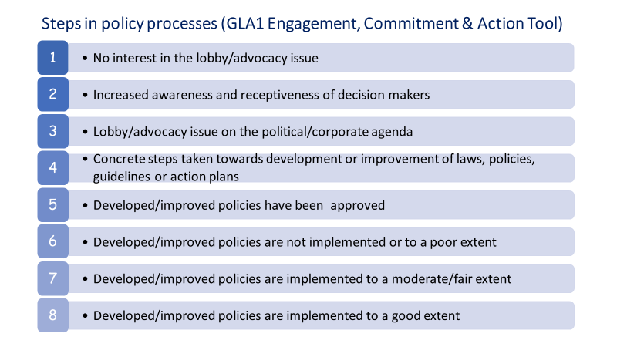

2.2 Civil Actor Participation (CAP) tool
This is the tool as it was used during GLA1. It is adapted from an existing tool (Arnstein’s Ladder of Participation’). It can help you distinguish and reflect on the different steps and target levels in participation and inclusion processes.

‘Civil actors’ can be local CSOs, CBOs, communities or specific local community groups (e.g. indigenous people, women, youth, etc.). But it can also be regional or national level CSOs that you train and/or connect with for L&A reasons.

This tool is different from the Engagement, Commitment and Action (ECA) tool that is used for public and private actors. The civil actor’s outcomes have to be assessed differently because public and private actors are usually the ‘power holders’ contrary to civil actors. This means that for civil actors other aspects have to be assessed than for public and private actors.

Like the ECA tool this CAP tool is not necessarily linear and sequential, the distinction between levels is gradual and a higher level in the scale is not always ‘better’! Levels for different aspects could differ, e.g. the legitimate operational space could be level 3 (limited), while the capacity of civil actors to use this space for meaningful influence/participation might be level 1 (non-existent) . The scale is merely meant as tool for setting/defining a baseline/starting and targets and as reflection for what has been achieved for the distinct aspects.

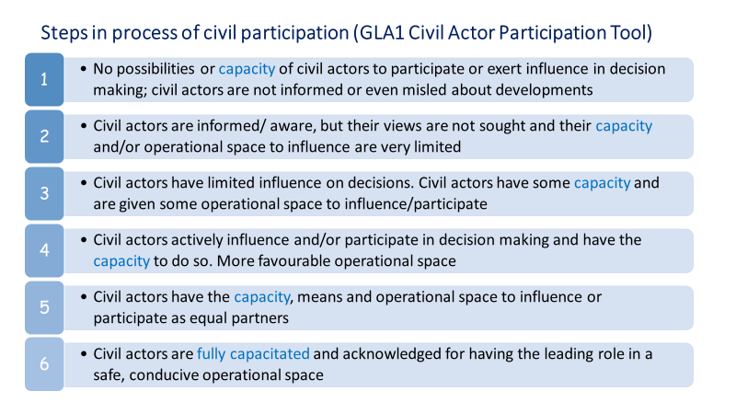

2.3: Climate-Smart Practice (CSP) tool
The CSP tool is a scale of 5 levels. The levels in the tool are formulated so that they can apply to different stakeholders, but will be most relevant for communities, smallholders and other civil actors that are actively targeted to improve their practices for adaptation and mitigation of a changing climate. This tool does not provide a single definition of what a climate-smart practice is, since this is highly dependent on local conditions, but rather gives indication of the process of moving from ‘climate unawareness’ to climate-smartness.
Scaling up
The levels on the CSP tool give an indication what steps can be considered as separate outcomes. For the CSP tool specifically, besides increasing in levels, an increase in scale, i.e. geographical or number of people, can also be considered a separate outcome. For example, a community adopted a climate-smart practice (level 5) that is consequently taken up and integrated on regional level.
Level | Description of level | Generic examples
Level 1 | The actor has no knowledge and/or interest in the issue | - Smallholder has no knowledge of the potential effects of climate change on their livelihoods and environment.
Level 2 | Increased awareness and receptiveness of the actor for climate consequences and alternative practices | - Smallholder is aware of how their practices contribute to climate change and how these effects can be mitigated.  - Smallholder knows of alternative practices that could reduce the impacts of climate change on their livelihoods and environment.
Level 3 | The actor indicates interest and shows initiative to investigate alternative practices | - Smallholder actively seeks for, and/or addresses and discusses alternative practices.
Level 4 | The actor has the capacity to adopt climate-smart practices that contribute to adaptation and/or mitigation | - Smallholder has the capacity to respond to changing conditions, by shifting to other or adapted cropping systems or other livelihood types.  - Smallholder has the capacity to respond to livelihood failure at their current location by moving/migrating.
Level 5 | The actor adopts and applies climate-smart practices | - Smallholder has adopted climate-smart practice

Annex III: Gender & youth (F/M) sensitivity assessment tool (of interventions):
The following is adapted from the Gender Marker Tool developed by CARE International, which is a tool to assess the level of gender sensitiveness/responsiveness of interventions on a scale of ‘harmful’ to ‘transformative’ (see table below). The same ‘markers’ can be applied for youth (F/M).

An outcome and its related interventions are gender and/or youth (F/M) sensitive when it ensures equal participation and benefits of men, women and/or youth (F/M). This can only be ensured if the interventions to achieve the outcome are:
- informed by analysis of gender and age differences in roles, needs, interests and capacities; and inequities or gaps in participation and benefits
- adapted to meet the distinct needs and interests of men, women and youth (F/M);
- ensuring meaningful participation of men, women and youth (F/M);
- monitored by gender (and age) disaggregated monitoring and analysis;

If none or only one of steps a-b-c-d are done for interventions related to an outcome, the interventions are potentially gender (and/or youth F/M) harmful, i.e. potentially increasing gender and age related inequities.

If only two or three of steps a-b-c-d are done, the interventions are at its best gender (and/or youth F/M) “neutral”, i.e. nor increasing nor diminishing gender and age related inequities. Gender ‘neutral’ as such doesn’t exist because everything we do will have different effects on men, women, and youth, because their different roles, needs, interests, positions in society, occupations etc. differ.

An outcome and its related interventions are gender (and/or youth F/M) responsive if, on top of being gender sensitive , the interventions related to the outcome actually improve the position, participation, benefits and/or rights of women and/or youth (F/M).

An outcome and its related interventions are gender (and/or youth F/M) transformative if the interventions are improving the position, participation and/or rights of women and/or youth (F/M) lead to a permanent change/ improvement for women and/or youth F/M (e.g. by law, or permanent change of traditional values and/or practices).

Figure X: From gender harmful to gender transformative change assessment tool
Scale/category/grade | Description | Intervention ‘markers’
A. Potentially Gender Harmful/ Negative | Program interventions are potentially reinforcing gender and age related inequities or stereotypes, or dis-empowering or marginalising women or youth in the process of achieving program goals; or the program/ organisation itself uses gender norms, roles and stereotypes that reinforce gender and youth related inequalities. | Gender and age related norms, values, roles and relations were not considered when developing the intervention; none or only one of the steps a-b-c-d to ensure gender sensitivity (see C below) were done for interventions related to an outcome.
B. Gender “Neutral” | Gender and age related norms, roles, relations or inequities are not affected (worsened or improved); or gender is not considered relevant to the development outcome; | Intervention works to some extent with gender or age related roles and relations for the benefit of achieving certain programme objectives; only 2 or 3 of the steps a-b-c-d to ensure gender sensitivity (see C below) apply
C. Gender Sensitive | Interventions ensure equal participation and benefits of men, women and/or youth (F/M) in programme activities; gender/youth sensitivity is seen as a means to reach set development goals; gender norms, roles and access to resources are addressed within the context of reaching programme goals | Interventions can only be marked as ‘gender/youth sensitive’ if the interventions to achieve the outcome are:  - informed by analysis of gender (and age) differences in roles, needs, interests, capacities; participation and benefits  - adapted to meet the distinct needs and interests of men, women and youth (F/M);  - ensuring meaningful participation of men, women and youth (F/M);  - gender (and age) disaggregated monitored and analysed;
D. Gender Responsive/ Positive | Interventions actually seek to improve the position, participation and/or rights of women and/or youth F/M as an objective in itself and is considered necessary to achieve positive development outcomes. | All of the steps a-b-c-d to ensure gender sensitivity (see C above) apply, and Interventions challenge existing gender and age related norms, values, roles, relations and inequities.
E. Gender Transformative | Program approaches or interventions actively seek to build equitable social norms and structures; promoting gender equality and transforming unequal gender relations to achieve shared power, control of resources, and decision-making, and support for women’s and youth empowerment are central to achieving positive development outcomes; | Interventions challenge existing gender and age related norms, values, roles, relations and (legal and organisational) structures seeking permanent, transformative equitable change; the monitoring system is collecting and analysing data and addressing all of the following: (1) changes in gender and/or youth (F/M) roles and relations; (2) gender and age disaggregated data; (3) unintended consequences, and (4) changing protection risks and needs

List the project numbers that this person will contribute to
In case there is field-based staff
There is no specific definition, but this applies to any budget item that may provoke a question for clarification
Challenging traditional norms and values for more equity can evoke violence

