TBI WORKING LANDSCAPES PARTNER PROGRESS REPORT 2023 - ETHIOPIA

With this Progress Report, your organisation accounts for your WL activities and achievements of 2023. The format focuses on learning about the strategies and achievements of your organization, relevant evaluation findings and recommendations, the extension to WL1.5, and related adaptations. In addition to strategic learning, the reporting on achieved outcomes and results will be used for accountability to the Dutch Ministry of Foreign Affairs.

Name of CSO | The Pastoral and Environmental Network in the Horn of Africa (PENHA)
Location of CSO | Addis Ababa, Ethiopia, and Hargeisa, Somaliland (regional headquarters)
Email address | penhasom@gmail.com
Primary Contact person | Amsale Shibeshi, PENHA regional programmes coordinator, Amsale.shibeshi@penhasom.org , +252 634416203
Name(s) of Harvester(s)
Location of activities | Tigray-Afar Border Landscape, Ethiopia, Working Landscapes/Restoration
Project Title | Dryland restoration and dry forest management in Ethiopia  – Sharing knowledge to meet local needs and national commitments

List of abbreviations_________________________________________________

.....

ANR Assisted natural regeneration
CBOs Community Based Organizations
CIFOR Center for International Forest Research
DRS Drylands Restoration Strategy
EFCCC Environment, Forest, and Climate Change Commission
EFD Ethiopian Forestry Development
FAO Food and Agriculture Organization of the United Nations
FFPOs Forest and farm producer organisations
FGD focus group discussion
FLR Forest Landscape Restoration
FMNR farmer managed natural regeneration
FFS Farmer Field School
FTC Farmer Training Center
GERD Grand Ethiopian Renaissance Dam
GLI Green Legacy Initiative
ICIPE The International Centre of Insect Physiology and Ecology
ICRAF International Centre for Research in Agroforestry (World Agroforestry)
IFAD International Fund for Agricultural Development
ILM Integrated Landscape Management
M&E Monitoring & Evaluation
MoA Ministry of Agriculture
MODIS Moderate Resolution Imaging Spectroradiometer
MSP Mult-Stakeholder Platform
MU Mekelle University
NDCs Nationally determined contributions
NDRS National Drylands Restoration Strategy
NGO Non-Government Organizations
NTFPs Non-Traditional Forest Products
PENHA Pastoral and Environmental Network in the Horn of Africa
PML&E Participatory Monitoring Learning & Evaluation
PPR Participatory Productive Restoration
RRC Rural Resource Center
TARI Tigray Agricultural Research Institute
VCs value chains
VSLA Village Savings & Loan Association
WGCF&NR Wondo Genet College of Forestry and Natural Resources

Important Ethiopian terms
Kebelle – The lowest level of local government (equivalent to county-level), very close to the communities and the principal actor in local-level development and environmental management activities.
Woreda – A higher level of local government, equivalent to district or regional administrations elsewhere.
Regional Government – The sub-national level of government, in a federal system. Regional governments have a degree of autonomy in setting policies and regulations.
The Federal Government – the central government.

Note: British English predominates, but many have adopted American spellings in naming their organizations. (Hence, “Rural Resource Center”.)

INTRODUCTION

This progress report provides your reflections on your 2023 achievements and progress. The content will be based on your harvested outcomes of 2023 (to be put in section 1.7), and on the results of the team Reflection and Learning meeting.

Please send your completed draft progress report at the latest Monday 15th of April to your country advisor with Luis in CC. TBI advisors will give their feedback then in the second half of April. In the same period you can organize a Reflection and Learning (R&L) meeting. After that you can still add/change things in your progress report when needed beginning of May. We need this information in time for the TBI network Learning Week we want to organise in May and to use the results to start writing the main body of the WL 2023 progress report.

Reflection and Learning meeting guidance
This section provides guidance for the WL in-country Reflection and Learning (R&L) meetings taking place in April 2023.
Please organise a R&L meeting with all relevant staff, your country advisor, and if applicable, with implementing partners prior to finalising the progress report. We don’t send separate Reflection and Learning Meeting guidelines. In general, the questions asked in each section of the progress report format can be used as guidance for reflection and discussion. In addition you can also reflect on your own specific learning questions if you have them.
The R&L meeting serves to agree on how much progress has been made in intended programme implementation and achieving your country specific ToC objectives, to discuss the main insights you have gained from programme implementation, outcome harvesting, other monitoring results (e.g. KPI’s), and relevant overall and country specific evaluation findings and recommendations. Based on these insights, also discuss the way you consider to make adaptations and move forward to reach intended objectives in the two year extension of the programme (WL1.5).

In summary discuss/reflect on:
- (Influence of) changes in context
- Key stakeholder changes (if any)
- Validity of WL1.5 ToC assumptions, targets and strategies
- Impact, KPIs and scaling*
- Key propositions and NDCs
- (Wildfire programme when relevant)
- Achieved and not-achieved outcomes
- Gender & youth progress*, challenges, expectations/reflection about G&Y responsiveness and transformative change in achievements and mainstreaming
- Thematic programmes
- Lessons learnt* and related adjustments
- Documenting* and communicating results*
*The subjects in bold are of special importance.

We expect that all country teams have harvested outcomes and collected other information needed for the R&L meeting and prepared a draft progress report with this information prior to the R&L meeting. Now, after 5 years of full programme implementation, the aim is to assess at what point you are, what progress you made towards end objectives/outcomes, which prevailing challenges and opportunities you faced, how you dealt with these and what can be learned from that, as well as the main implications for the country programme - all keeping in mind your intended end-outcomes, key propositions and assumptions that underlie your Theory of Change.
You can discuss the guiding questions in sections 1.1 to 1.6 and 1.8 of this progress report (PR) format, based on your outcomes in section 1.7, including unintended, unexpected and negative ones (tables 1a and 1b), and intended outcomes you didn’t achieve (yet) (table 1c).
For reference, also for (new) staff or partners that could not participate in the ToC refresher of 2022, you can watch the recordings of the ToC refresher webinars (session 1 on 3 May and session 2 on 10 May 2022) again and visit the ToC refresher Miro board.

2023 achievements and progress

Context
What changes in the social / political / environmental / operational space / landscape context did you see in in 2023 that have influenced the implementation of, and reaching the goals of your 2023 work plan? How? Which of these developments have led to increased risks or provided new opportunities for the programme? As a result, did you make changes in your 2023 goals, strategies or ToC targets and assumptions?

Summary
The return to peace in Northern Ethiopia at the end of 2022 allowed us to shift the focus from policy development at national level to implementation on the ground on our chosen Tigray-Afar Border Landscape. Accordingly, we have revised and expanded our ToC (as described below), while maintaining the core ideas and assumptions.

The political and security context has been stable. The operational space has also been favourable. NGOs and development programs resumed work in the region. The regional government was also strongly supportive of our work, having been involved in our national level policy work throughout. Despite challenging circumstances, communities maintained their commitment to landscape restoration, with a strong desire to move from humanitarian and recovery efforts to development.

Political and security context: Development and humanitarian programs are moving forward, in an improving, if still difficult political and security context. Following the December 2022 Peace Agreement between the Government of Ethiopia and the TPLF (Tigrayan People’s Liberation Front), an interim government was established in Tigray and development activities resumed, with a focus on humanitarian aid alongside rehabilitation and recovery efforts. Aid diversion has continued to be a significant problem, causing the suspension of humanitarian aid. But in December 2023, aid agencies resumed support, with new control measures, amid a deteriorating humanitarian situation. As 2024 begins, there are reports that hunger and famine have claimed lives in Tigray, while a stepped-up humanitarian response is beginning to address the situation.

With peace, development agencies are returning to Tigray and Afar regions with new programs. The on-going PENHA-TBI program has been complemented by major new restoration programs (World Vision and Menschen fur Menschen), with similar approaches and goals, in line with the Drylands Restoration Strategies, developed with PENHA-TBI and adopted by the governments of the Tigray and Afar regions. However, political and security challenges remain. The governments of Tigray and Afar regions are at loggerheads, and official travel and communications have been suspended, while informal trade and interaction continue. A new armed conflict has emerged in Amhara Region, to the west of Tigray, with a popular movement contesting the legitimacy of the Federal Government, and also claiming disputed territories from Tigray. While the ruling party dominates the federal government, unrest and insecurity is widespread across the country. Still, international development agencies, bilateral and multilateral, continue to have significant leverage.

Regional governments are strongly supportive of restoration efforts on the Tigray-Afar border landscape, and there is broad popular support for a green agenda, initiated by the previous government, that is also politically useful to the ruling party.

Economic context: Nationally, there has been a sharp rise in the cost of living over recent years, accompanied by a growing debt crisis, deepened by the two-year war in northern Ethiopia. Severe drought and a missed planting season (due to conflict) have aggravated the situation in the drylands. Two decades of strong economic growth, under a state-led development model, have led to modest increases in living standards, undercut by rapid population growth and unevenly distributed. Industrial development is hampered by inadequate power supply, which government has sought to address through a domestically-financed hydropower scheme, the Grand Ethiopian Renaissance Dam (GERD), located in the northwest, near the Sudanese border. Dependence on wood and charcoal to meet growing energy demand remains the principal driver of deforestation, alongside the expansion of low-productivity agriculture. Government aims to pursue economic liberalization, with a cautious opening up to foreign investment, which remains limited, and dominated by Chinese and Arab investment. Government is the ultimate owner of all land. Private land “owners” have use rights and large areas are communally owned or managed. Government can expropriate land “for the common good”. In practice, politically connected domestic and foreign investors can readily acquire land. In the face of sharply rising food prices, government aims to increase agricultural production, with irrigated wheat production in the drylands, risking salinization and potentially threatening pastoral livelihoods. Mining has huge potential, if it can be transparently regulated and conducted sustainably. Government is also, tentatively, opening up telecoms and banking to competition. Access to finance is a constraint for local enterprise and the country lags behind others in the region who have successfully promoted financial inclusion through mobile money, for payments and savings. Mobile money has long been well established in neighbouring Somaliland, and across East Africa. It is growing in Ethiopia’s Somali Region, but remains limited across the rest of Ethiopia. For women in particular, mobile savings facilities represent an under-exploited opportunity for financial inclusion. A Kenyan service provider, newly licenced to operate in Ethiopia, is now competing with government’s Ethio Telecom. In response, Ethio Telecom has now introduced a women’s empowerment package. Government also aims to address the pressing issue of youth unemployment - a political imperative, given Ethiopia’s demographics. Job creation is emphasised in Ethiopia’s Green Economy Strategy, and is one element in the Prime Minister’s massive tree planting program, the Green Legacy Initiative (GLI), which employs a large number of youth.

Environmental context: Two years of war, during which the curtailment of electricity supplies led to an increased reliance on wood to meet energy needs, reversed much of the gains of two decades of restoration efforts in Tigray. Traditional institutions, across Tigray and Afar regions, were able to cooperate to limit the damage to the environment and the shared Desa’a Forest. Water flows down from the Tigrayan highlands to the plains of Afar Region. Rainfall is erratic, but when the rains come, they are often heavy, bringing destructive floods to Afar Region. More effective water management is, thus, crucial, for livelihoods and the environment. Increasingly frequent and severe drought presents major challenges, for livelihoods, the environment and tree planting/restoration efforts, and necessitates greater attention to water harvesting and management. Population and economic pressures have been drivers of serious land degradation and deforestation, making wider economic development and rural-urban interaction important aspects of integrated landscape management.

Theory of Change, lessons learned and adaptations
Add the visual of the latest version of your ToC. For reference please include the numbers of the ToC outcomes and use the same numbering in section 1.7.

“making forests & restored landscapes pay” –
strengthening tenure, livelihoods, benefit sharing and the incentives for communities to sustain protection and restoration efforts

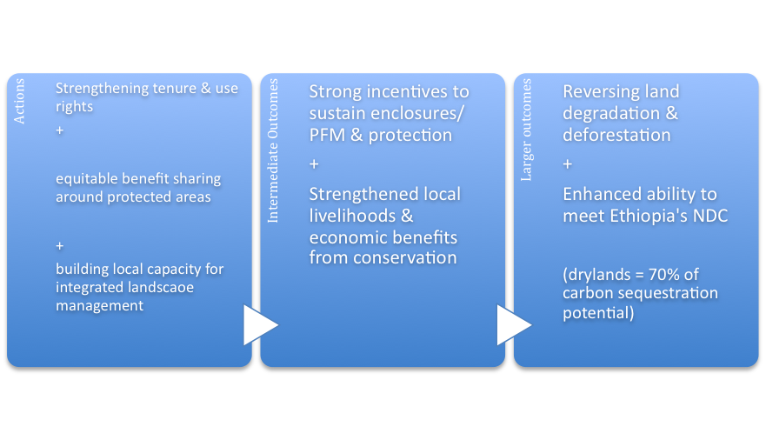
The core of the ToC is unchanged – livelihoods must be at the centre of integrated landscape management and landscape restoration must “make forests and restored landscapes pay”, with changes in policy and programs that enable local people to earn incomes in and around conservation areas, offsetting the opportunity costs of exclosures and forest protection.

Revised ToC
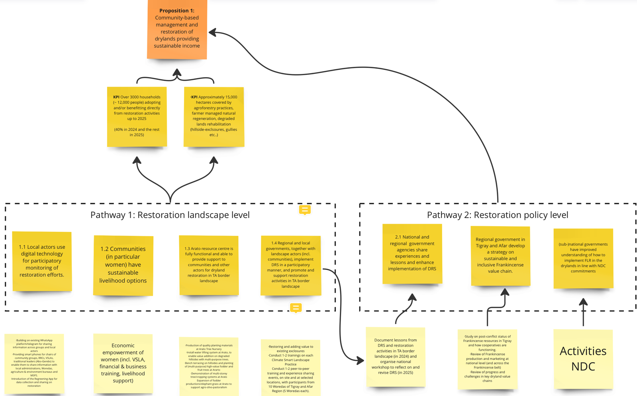

The revised ToC reflects the evolution of the program and involves three pathways:
- Pathway 1 – Restoration landscape level
- Pathway 2 - Restoration policy level
- Pathway 3 – inclusive and participatory fire management of fire prone drylands

The main focus of the program is on Participatory Productive Restoration (PPR), with the landscape and policy-level pathways:
- Pathway 1 - landscape-level restoration, piloting an integrated set of climate-smart practices, including homestead agroforestry and FMNR, with a greater emphasis on G&Y.
- Pathway 2 - restoration at policy level, supporting and enhancing the implementation of strategies developed with regional governments.

At the heart of Pathway 1, there is:

Proposition 1 - community-based management and restoration of drylands providing sustainable income

Pathway 1 involves a scaling strategy based on active collaboration with a Consortium of partners at our Arato site, and with the local Kebelle Administration, extension agents, and Farmer Training Centres across the region. This is reinforced by the backing of the Abogerebs, a highly influential association of traditional leaders, who oversee natural resource management and conflict resolution.

On the Tigray-Afar Border Landscape, the aims are to:

- Restore the degraded landscape around the Arato site
- Strengthen the livelihoods of local women and youth, based on climate-smart practices
- Develop the Arato Tree Nursery into a Rural Resource Center, a commercially self-sustaining source of quality planting materials and a learning hub, with the capacity to drive the scaling out of Participatory Productive Restoration activities across the broader Tigray-Afar Border Landscape, collaborating actively with multiple stakeholders under the Regional Drylands Restoration Strategy (DRS).
- Establish mechanisms for the implementation of the DRS in a participatory and inclusive manner.

Additionally, in Pathway 2, we aim to ensure that Federal and regional governments adopt strategies for inclusive drylands/gums and resins value chain development and the conservation of Frankincense tree resources. This outcome flows from reviews of the status of Frankincense resources post-conflict and of value chains for Frankincense and gums and resins, and workshops with government and other stakeholders.

Pathway 3 involves strategy development at the national level down to the regional level, working with EFD, Federal agencies and regional authorities to develop an Integrated National Fire Management System, which provides a framework to bring all relevant stakeholders together and ensure the coordination of actors at federal and regional levels, on the basis of a shared understanding of fire management, so that local actors can effectively mitigate fire impacts.

Reflection questions:
Stakeholder changes: Refer back to your baseline or other stakeholder analysis, notably step 2 (power, influence and interest analysis, see the guidelines in annex II). What changes did occur In the stakeholder ‘landscape’? Do you need to adjust your strategies to deal with changing stakeholders or changes in power, influence and/or interests?
There has not been any major change in the stakeholder landscape compared to 2022.

Powerful actors
- the Federal Government, Regional Governments, private sector investors, donor nations/agencies
- Power is unevenly distributed across ministries and regions, with the mining and extractive industries sector being, perhaps, the most powerful.
- Prime Ministerial backing, for tree planting (under the Prime Minister’s Green Legacy Initiative), restoration efforts and the “green economy” policy, has been important.
- An on-going food crisis incentivizes agricultural expansion and bolsters the relative strength of the agriculture ministry.
- On our Tigray-Afar Border Landscape, cement producing companies are quarrying, apparently, without regard to regulations. We will need to take this issue up with the regional government. In future, responsible mining and post-mining restoration will need to be addressed.

Intermediate actors
- Kebele administrations are the key actors in organising and delivering landscape level actions. They are tightly controlled by regional governments, but remain very close to the people and communities.
- Traditional Institutions are powerful and influential in Afar Region, playing important roles in natural resource management. An association of traditional leaders (the Abo Gereb), from both the Tigray and Afar sides of Desa’a Forest, also plays an important role in conflict resolution. However, traditional institutions are not inclusive of women and youth, and may be subject to elite capture, with respect to the intersection of political power and business interests.
- The Abo Gerebs will be important allies and partners in scaling out and in other aspects.
- Mekelle University (and its College of Dryland Agriculture) – an important actor in development efforts, with significant influence at regional and national levels.

Low power, high interest actors
- smallholders and pastoralists, community organisations, women & youth groups.
- Unemployed and disaffected youth

A core challenge is that the actors with the greatest interest in landscape restoration are also the most powerless – the smallholders, pastoralists, women and youth, whose livelihoods depend substantially on natural resources and ecosystem services.

Civil society organisations remain weak in both Tigray and Afar, with restoration activities almost entirely carried out by Kebele administrations and communities.

The poor in both Tigray and Afar are heavily dependent on the Dutch-supported Productive Safety Net Program (PSNP), which is intended to support inter alia environmental infrastructure and restoration efforts, with a Cash-for-Work approach.

Menschen fur Menschen, a Swiss NGO, plans to establish a program, with a restoration component, in a District that neighbours the one where we have initiated operations.

World Vision, a major international NGO, plans to develop a restoration program across Tigray and Afar regions, with its own national MSP. This would be a very significant development.

Collaboration: With which other organisations/partners did you collaborate in 2023 or did you start a collaboration?
Federal government – Ministry of Agriculture & Ethiopian Forestry Development (EFD)
Regional governments – Principally, the bureaus for environment and agriculture
Research institutions – Mekelle University, Samara University & Wondo Genet College of Forestry (under formal MoUs)

The universities are important sources of technical expertise, as well as being experienced implementation partners, with specific mandates for local development. They are also important in terms of knowledge generation and management, as well as program sustainability – acting as repositories for program lessons., so that the work we do feeds into future programs, at landscape and policy levels.

CIFOR-ICRAF is an implementing partner under the fire management program. WGC has been an indispensable technical partner on fire management studies and analysis.

PENHA and CIFOR-ICRAF have a formal MoU and collaborate actively on the ground and at policy level. PENHA has formed a Consortium of collaborating partners for project implementation at Arato.

The Consortium includes: CIFOR-ICRAF; Mekelle (Tigray) and Samara (Afar Region) universities; the Tigray Agricultural Research Institute (TARI); Kebelle and Woreda departments; Tigray’s Agriculture and Natural Resources Bureau; and the Tigray Biotechnology Center (with a plant tissue culture laboratory, producing high-quality planting materials on a commercial basis)

WeForest, an NGO headquartered in Belgium, plans to resume its project work in and around Desa’a Forest. PENHA and WeForest have continued to share information and ideas.

Assumptions: From implementation, can you prove certain assumptions underlying your ToC to be valid or invalid? Which ones and why?
Progress with implementation on the ground has shown that are core assumptions are valid. The set of specific climate-smart practices selected and FMNR are effective in this context. High levels of community participation and commitment are key, and continued community commitment is a fundamental assumption.

Strategies: Are there outcomes that you, with the experience you have until now, consider to be very difficult to achieve? Why? So what to do? What interventions/strategies worked well? Did you face any challenges?

On the technical side, things are very straightforward. Over 2022 and at the beginning of 2023, we invested a lot of time in designing and planning our interventions. The integrated set of interventions that we are implementing is based on experience, sound analysis and extensive local consultations. All the interventions are working well. The only technical challenge relates to inadequate water supply on degrade hillsides. In general, water scarcity presents challenges for restoration efforts in the drylands, requiring relatively expensive complementary water harvesting interventions.

The scaling strategy depends on the continued and effective collaboration of many different actors, as well as the participatory implementation of the Regional Drylands Restoration Strategy (DRS).

Developing women’s capacity and confidence for participation is a challenge. But our immediate G&Y targets are fairly modest, and so achievable. Gender transformative change is much more difficult to achieve, particularly in drylands communities.

Lessons learned:
Summarise what you learned about your strategies, assumptions, external influences, dealing with stakeholders, collaboration with other partners, and other challenges from implementation in 2023.

Implementation on the ground only began in early 2023, so there are no lessons specifically related to work carried out in 2022.

At policy level, a lot was learned about the nature of policy processes, the different actors and their inter-relationships. Challenges relating to turf wars between environment and agriculture departments were well understood in advance. But we now have a much better understanding of how the different regional states relate to the federal government.

There are also difficult issues with respect to relationships between development agencies, and disincentives to cooperate and share information.

Advisors at the Dutch Embassy have emphasised the need to achieve much greater levels of collaboration and coordination between the different agencies operating at landscape and regional levels, in order to generate impacts at scale.

Adaptations to ToC outcomes, assumptions, targets or strategies
Describe any adjustments you have made, or will make to the ToC (outcomes/targets and/or assumptions) and/or strategies in the table below and explain why. E.g changes you made for the WL1.5 ToC . For reference please include the numbers of the ToC outcomes and use the same numbering in section 1.7.
Pathway | Adjusted outcome, assumption, target or strategy | Explanation
Pathway 1  Restoration Landscape Level | Productive Participatory Restoration  Piloting an integrated set of climate-smart practices, including homestead agroforestry and FMNR, with a greater emphasis on G&Y. | The strategy has been fleshed out, with detailed implementation modalities  G&Y is central, with expanded roles for organized women’s and youth groups.  The establishment of a Consortium of implementing partners, involving local government, is at the centre of a scaling strategy.
Pathway 2  Restoration Policy Level | Supporting & enhancing the implementation of strategies developed with regional governments | This is critical to achieving the desired outcomes.  With restoration strategies in place, and new federal funding in the pipeline, we must ensure genuine participation in the design and implementation of interventions, with suitable (formal & informal) mechanisms and PML&E.
Pathway 3  Integrated National Fire Management System |  | No adjustments made

Impact/KPIs/scaling
This year's KPI reporting will mark a significant departure from previous approaches. As we embark on the WL1.5, we use the adapted KPI framework to report on the impact reached as of 2023, which will be accompanied by a mapping exercise aimed at building a joint spatial database for the programme. To smoothly navigating these changes, we have built a manual to guide/help all partners reporting on the adapted set of KPIs. Additionally, consultations/communication is ongoing with Alvaro and Luis, which will be further available to answer questions and for one-to-one assistance whenever needed.
In previous years, KPI reporting usually consisted of providing total estimates per subKPI and aggregated totals per country using the tables below. Now, we add a step in the process. Country partners are asked to map/provide spatial data of all areas reported, along with specific information related to the areas (including connecting people subKPIs to specific areas).
Alvaro (which is already in contact with most partners) will assist you in this process. Once all areas are mapped out and corroborating information is included, total aggregated figures per subKPI and level of impact can then be included in the table below, as done in previous years. We understand that this might seem a significant effort, but once this basis is done once, it will become very easy to adapt and report every year!
Important notes:
*WL reports on KPIs in a cumulative way. This means that you are asked to report and map all areas impacted by the programme as of the end of 2023. This means that you report on the total figures since 2019 up to 2023, so also include what you reported last year
*Note that certain targets have been adapted at the WL1.5 programme document. Consider those targets when reporting on your results. You can find the adapted targets submitted in the WL1.5 programme document.
* Provide impact in numbers of hectares or people (gender/age disaggregated)
* Only provide total estimates per KPI and subKPI in the table below once the mapping exercise has been completed. The tables below already present a few examples.

Initial spatial mapping conducted – to be revised in consultation with the TBI team.

Planned as of end 2022:
- Activities around the Arato site cover around 25 hectares.
- 1800 people benefitting directly, including smallholders, women and youth.
- Scaling out intended to cover some 2,000,000 ha and 200,000 people by the end of 2025

Scaling out across the Tigray-Afar landscape to be enabled by partners and collaboration with local Farmer training Centres (FTCs) managed by the Bureau of Agriculture & Natural Resources – linked to implementation of the DRS by regional government.

Table 1.3.1: cumulative estimated impact in hectares (direct and indirect)
Key performance sub-indicator | Description of observed changes in the landscape | TBI’s (your) Contribution | Direct/ Indirect | Estimated impact in #hectares at the end of 2023
Area SubKPI 1: restoration and transformation of partially damaged nursery …….. (describe) | An idle and partially damaged nursery area transformed to functional and productive area (production & distribution of seedlings. & planting materials) | Allocation of resources Coordination of consortium members to contribute and restore the nursery area  Coordination with local gov’t | Direct | 1.5
Area SubKPI 2: Homestead Agroforestry | Farmers are interested, motivated & active in tree planting in their homesteads | Capacity building through practice-oriented trainings; availing quality planting materials, inputs; Close follow up & technical backstopping | Direct | 20
Area SubKPI 3: FMNR | FMNR practices piloted on surrounding areas as demo plots for evidence generation and learnings | Provision of theoretical & hands-on trainings  Supervision of work on-site by youth  Coordination of participation by extension officers | Direct | 3.5
Etc.
Total KPI: Area affected by improved climate-smart landscape practices |  |  |  | 25

Table 1.3.2: cumulative estimated impact on people, gender and age disaggregated (direct and indirect)
Key performance sub-indicator | Description of observed changes in the landscape | TBI’s (your) Contribution | Direct/ Indirect | # Adult Women | # Adult Men | # Young Women | # Young Men
People sub-KPI1 …….. describe)  (Women and youth groups managing the nursery and benefiting from the income generated and activities) | The nursery is now functional and transformed with the RRC business model, owned by youth and women groups  Production and supply of quality planting materials realised.  The skills and knowledge of group members in nursery operation and management have improved greatly. | Piloting the RRC model  Facilitation in privatising the nursery and formation of the user group in consultation & collaboration with gov’t & relevant actors.  Provision of consecutive trainings to groups to fill skills and knowledge gaps on nursery management & operation + business plan development.  Provision of nursery materials, equipment & inputs | 65 direct | 15 | 11 | 23 | 16
People sub-KPI2: …….. (Women based homestead agroforestry participants) | Women and other farmers in the Arato site are highly motivated to plant multipurpose trees on their homesteads and in other areas.  Increased skills and knowledge for managing planted trees | Hands on training on homestead agroforestry systems, tree growing and management.  Provision of necessary inputs and materials including farm kits | 600 direct | 148 | 131 | 166 | 155
People sub-KPI1 …….. (Participating labourers who earned incomes during project implementation (FMNR, nursery maintenance etc.) | Able to create casual or temporary job opportunities for landless/unemployed youths and other community members, motivating the community after two years of crisis | Brought in project resources immediately after the peace agreement and able to create employment opportunities through various project activities | 648 direct | 88 | 45 | 135 | 380
People sub-KPI1 …….. Capacity building and knowledge sharing training participants | Farming communities, extension officers, experts & decision makers at various levels aware/ equipped with knowledge on productive landscape restoration, FMNR, RRCs, homestead agroforestry, land tenure/rights | Organising sensitization & awareness raising training workshop  Provision of practical trainings  Facilitation/hosting of experience sharing & knowledge exchange visits/events | 487 direct | 93 | 190 | 88 | 116
Total KPI: Number of beneficiaries impacted by improved climate-smart landscape practices =1800 |  |  |  | 344 | 377 | 412 | 667

The above is based on the fact that there are 13 user RRC members (the women’s group that is managing the nursery) and the assumption that each of them directly supported their 5 family members within the household with the incomes they earned. But it is very difficult to ascertain the exact breakdown by family member and disaggregate by age.

Progress: to what extent are you “on track” towards achieving the WL end targets for the different KPIs? Why or why not?

Work is progressing well on site. Results will be assessed in 2024.

With the return of peace to the region, PENHA was able to shift from strategy development to implementation on the ground. In 2022, PENHA worked with CIFOR-ICRAF to carry out an inception review to determine the nature and scope of the desired interventions. Substantial revisions were needed, with further on-the-ground assessments and discussions with partners and community groups. This included a damage assessment, to outline the requirements for the rehabilitation of the Arato Tree Nursery in Enderta, Tigray.

PENHA’s productive landscape restoration programme will expand from Arato and to other areas within the Tigray-Afar border landscape over the years ahead, with the aim of transforming degraded landscapes into productive landscapes for enhanced livelihoods and ecosystem services. To achieve these overarching objectives, we will establish a learning hub at Arato site and enable others to take lessons and good practices to scale.

The first step was to restore and make the Arato Tree Nursery functional. This nursery will serve smallholders in Tigray and Afar, with trees for agro-forestry, fuel, fruits and fodder. We are working with community groups and the local administration to turn the Arato site into a Rural Resource Center (RRC) that supports extension and scaling out. Farmer Managed Natural Regeneration (FMNR) will support environmental rehabilitation.

A foundational element was the identification of climate-smart practices for specific dryland areas. Working with partners CIFOR-ICRAF and local research institutions, we identified a set of agreed CSA practices/activities

Core activities involved:
- Planning the nature of and modalities for interventions on the Tigray-Afar Border Landscape, in collaboration with CIFOR-ICRAF.
- Rehabilitation of Arato Tree Nursery
- Management and supervision of on-going activities at the Arato site, in collaboration with Consortium partners.
- Establishment of women and youth groups to carry out specific activities.

In a short period of time, considerable progress has been made at the Arato site:

- PENHA has established a Consortium to manage the work on site, deepen impacts and support scaling out. Consortium members include PENHA, Tigray BoANR, CIFOR-ICRAF, Mekelle University, TARI, and the local administration, as well as Samara University of Afar Region. ICIPE and World Veg have also recently agreed to collaborate.
- Various capacity building and training activities have been provided to nursery workers, farmers, extension officers and experts.
- Nursery materials and equipment have been provided to the nursery and the nursery is now producing a significant quantity of Avocado seedlings and other high value quality planting materials.
- Women are promoting homestead agroforestry after receiving training and planting materials (fruit trees, coffee, etc.) from PENHA and its partners.
- FMNR plots are established to generate evidence and for use as demonstration sites for others.
- 120 households participating in the homestead agroforestry have received vegetable seeds and watering cans, provided by World Veg with PENHA’s facilitation.

On-going work involves further FMNR and an integrated set of activities for income generation and value addition (construction of bench terraces, honey production and planting of high value fruit/food/fodder trees) on the hillside exclosure, aiming to create green jobs for unemployed and landless youth and women through productive restoration practices and interventions.

Scaling: to what extent did you manage to scale up successful strategies, please describe what and how:

Adoption of similar approaches by regional governments under regional DRS.

Participation of Kebelle & Woreda extension agents in training events and work on site.

Key propositions, NDCs and Wildfire (where relevant)
For each describe:
- What progress has been made in 2023 towards the end goal(s)? Compared to the situation at the start of the programme, how far are you in achieving the end goal(s)?
- What challenges did you meet in 2023? Can you say that you are on track? If not, why not?
- What are your expectations/reflections for the near future? Should you change your strategies in order to achieve the end goal? How?

Provide your answers directly in the WL key propositions progress report on 2023 on google drive. This document has all key proposition information together for all countries in one document, including what you intended to do in 2023 for each key proposition (Wildfire programme included where relevant) and NDCs..
On the first page, in the ‘content’ table you can choose your country and go directly there. The areas you need to complete are blue. Use max 200 words per proposition.

desciption of proposition | Summary (i) progress; (ii) challenges; and (iii) expectations/reflection
- Progress:
- Challenge:
- Expectations/reflection:
Etc

NDCs, G&Y and Wildfire: Answer the same three questions for NDCs, G&Y and Wildfire when applicable and give the answers in the same table.

Pathway 1 – Restoration at landscape level

Proposition 1: community-based management and restoration of drylands providing sustainable income

Progress: The Arato Tree Nursery has been rehabilitated and is producing quality planting materials for local markets and to support homestead agroforestry with neighbouring households. FMNR plots have been established, restoring degraded landscapes around the site. A set of income generating activities have been initiated, with women and youth.
Challenge: Water scarcity on degraded hillsides presents challenges for income generation and can only be addressed by costly new interventions.
Expectations/reflection: The site will function as a “Rural Resource Center”, generating incomes and supporting learning and scaling out through partners and extension agents. Progress here is closely linked to the policy level, and the implementation of the DRS by regional government.

Pathway 2 – Restoration at policy level

Summary:
Progress: Contextualized regional strategies have now been developed and officially validated by four regional states (Afar, Oromia, Somali and Tigray.) The Federal government has committed to allocate 1% of the national budget to implementation.
Challenge: While strategies have been developed, insecurity prevented official validation in two regions – Amhara and Benishangul-Gumuz.
Expectations/reflection: There are good prospects for effective implementation in Tigray. PML&E and continued follow-up, with government and MSPs, will be vital to ensure genuine participation in the design and implementation of interventions.

Progress: Following the successful development of regional strategies for Afar Region, Oromia and Somali Region in 2022, PENHA worked with EFD and CIFOR-ICRAF to develop regional strategies for Amhara, Benishangul-Gumuz and Tigray regions. Work progressed well, despite major challenges posed by conflict and insecurity in Amhara and B-Gz. Contextualized regional strategies have been developed for Amhara, Benishangul-Gumuz & Tigray regions. Tigray’s Regional DRS has been validated and officially endorsed by the regional government. At the validation workshop in Mekelle, HE Dr Eyasu Abraha Alle, Head of the Tigray Bureau of Agriculture and Natural Resources, urged participants, representatives of NGOs, development agencies and government departments, to collaborate in implementing the strategy and to ensure that all programs and initiatives adhere to the principles and approaches outlined. The Federal Government has agreed to allocate 1% of the national budget to support restoration efforts by the regions.

Challenge: The process has not been finalized in Amahara and Benishangul-Gumuz, due to challenges related to conflict and insecurity. In spite of the difficulties, task teams have worked to produce draft strategies, to be validated when conditions allow. With regional strategies now backed by Federal funding, the central challenge will be to ensure that strategies are implemented effectively and in participatory ways. With new funding, the participatory design and selection of interventions is critical. It is also critical to strengthen communities vis-à-vis powerful stakeholders and economic actors.

Expectations/Reflection: In Tigray, the prospects for effective implementation are good. In Somali Region, the regional government has undertaken further meetings around the DRS and the alignment of related programs. In all regions, PML&E will be vital in ensuring effective and participatory implementation.

Frankincense value chain development & Gums and Resins in Somali Region
Frankincense, gums and resins are valuable drylands resources. Since 2020, PENHA has conducted a series of studies and workshops, aiming to promote inclusive value chains and link traders to cooperatives, enhancing local value addition and revenues.

In 2023, PENHA conducted a study that aimed to assess the state of the resources base, focusing on Somali Region. PENHA then conducted a consultative workshop, in collaboration with CIFOR-ICRAF and EFD, aiming to review and discuss study findings and outline a way forward. Important new understandings and ideas emerged. Gums and resins appear to be more important than previously thought. There is also a new challenge – a threat by CITES, the Convention on International Trade in Endangered Species of Wild Fauna and Flora, to ban trade in Ethiopian frankincense. While the intended aim of such a measure would be to protect frankincense trees, it would likely have the opposite effect – reducing incentives for sustainable management and threatening the resource. Instead, we aim to promote sustainable commercial exploitation as the best means of conservation.

Outcomes:
- Study/review conducted, with updated resource base assessment.
- National-level workshop conducted with stakeholders and Ethiopian Forestry Development (EFD), in collaboration with CIFOR-ICRAF.
- Study and workshop findings will be incorporated into an official EFD response to CITES.

Further work is needed to establish a suitable regulatory framework and address problems in supply and value chains.

Farmer Managed Natural Regeneration (FMNR)
PENHA-Ethiopia conducted an analytical review of Ethiopian experience with FMNR. The study was based on a comprehensive literature review as well as a series of interviews with local experts. The purpose of the review was to assess trends, strengths and weaknesses, as well as to identify opportunities to deepen and expand FMNR programs.

Outputs:
- Review/study conducted.
- Insights fed into FMNR component of work at Arato site, with youth engagement.

Pathway 3

Wildfire
description of proposition: Working with EFD, federal agencies and regional states to develop an Integrated National Fire Management System

Summary:
Progress: Proposed fire management system officially endorsed by EFD
Challenge: Limited capacity for implementation on the ground & the need to build the capacity of “community fire brigades” (groups of organized community volunteers that are mobilized for fire management and response).
Expectations/reflection: FSTU has begun to provide basic equipment for community fire brigades. Going forward, we will work with the regional authorities around the Desa’a Forest to build relevant understandings and awareness.

Fire Management System
In the face of wildfires aggravated by climate change and drought, activities carried out as part of a two-year program, led by CIFOR-ICRAF and PENHA, aimed to establish an effective National Fire Management System.

This involved a process of analysis, data collection and stakeholder consultations. After consultative workshops with key stakeholders across seven regions we produced a comprehensive analytical review on fire management in Ethiopia, identifying hotspots, challenges and opportunities. Mapping of fire trends and hotspots was carried out in collaboration with experts from Wondo College of Forestry & Natural Resources. Participation in the 8th International Wildland Fire Conference in Lisbon provided an opportunity to draw on international experience, as well as to highlight the issues facing Ethiopia. Analytical Reports and a draft strategy were submitted to EFD, the Environmental Protection Agency and the National Disaster Risk Reduction Commission.
After a validation workshop, EFD officially endorsed the proposed system. Federal and regional authorities will collaborate to implement a system that is intended to ensure adequate coordination across regions, on the basis of enhanced communication, and to foster community participation in fire management. Wondo Genet College and CIAT (The Alliance of Bioversity International and the International Center for Tropical Agriculture) have established a unit that will provide enhanced real-time information to support the system.

Publications:
- Managing wildfires in Ethiopia: experiences, gaps and actions towards an integrated national fire management system. Livingstone J, Kassa H, Yimam K, Zewdie S, Hagazi N, Shibeshi A Sahle K. 2023. PENHA, Addis Ababa, Ethiopia and Tropenbos International, Ede, the Netherlands.
- Wildfire patterns, frequency and intensity in Ethiopia: an assessment of MODIS data. Sahle K, Livingstone J, Kassa H, Yimam K, Zewdie S, Hagazi N, Shibeshi A. 2023. . PENHA, Addis Ababa, Ethiopia and Tropenbos International, Ede, the Netherlands.
- Fire management in Ethiopia: past, present and future. Livingstone J, Kassa H, Yimam K, Hagazi N, Shibeshi A, Zewdie S. In: Pasiecznik N, Goldammer GJ, 2022. Towards fire-smart landscape. Tropical Forest Issues 61. Tropenbos International, Ede, the Netherlands. DOI: doi.org/10.55515/AQVV3055
- Reducing wildfire risks and impacts through inclusive landscape governance in Ethiopia. The fire-smart landscape governance programme uses a landscape approach to agree and adopt effective fire management. TBI Infobrief
- National Fire Management System for Ethiopia: Principles and Steps. PENHA, CIFOR-ICRAF & EFD. 2023.

Outcomes:
- “Integrated National Fire Management System for Ethiopia”, in collaboration with CIFOR-ICRAF, completed and presented to EFD.
- National validation workshop conducted and System/Strategy validated and endorsed by EFD.

Gender & youth (F/M)
G&Y is at the centre of our restoration activities at landscape level. Women and youth actively implement core activities, earning incomes and gaining skills and knowledge. Local government (leadership, extension agents, women & youth representatives) participate with a view to scaling out this inclusive approach.

PENHA-Ethiopia carried out a study of Gender and Youth (G&Y) issues in the drylands. This study is intended to provide the basis for a comprehensive G&Y strategy, going beyond the current livelihoods and restoration interventions. As the program develops, we aim to support women and youth in the uptake of digital tools for agricultural extension, resource management and access to finance. We also aim to build the capacity of women and youth to participate. Establishing safe spaces for women will be part of this.

We are integrating G&Y issues into activities under the regional DRS and MSPs in Tigray and Afar regions and Organised women’s groups are central actors in PENHA’s work at the Arato site, in the management of the tree nursery and in homestead agroforestry. Youth are actively engaged in FMNR and income generating activities.

Outcomes:
- Comprehensive review/study conducted
- Insights fed into work on-site at Arato.
- G&Y study will be presented to policymakers, MSPs and wider networks

Progress, challenges, expectations/reflection
Achievements: What were your achievements towards gender and youth (F/M) priorities related to each of the five G&Y indicators/result areas related to the three main pathways:

Pathway | Indicator | Intended gender/youth (F/M) priority/ outcome for 2023 | Achievements in 2023
Inclusive landscape governance: | a. Level of access to land and ecosystem services; | - Increased by 5% in the WL piloting sites | - Increased access to land & ecosystem services for participating women & youth at Arato: E.g. About 1.5 ha (nursery area) transferred to youth & women groups
Inclusive landscape governance: | b. Level of land tenure rights/security; | - At least 500 people (at least 30% F) reached through capacity building-awareness creation on land/tree tenure rights/security | - Increased level of awareness on land/tree tenure rights/security – among participating women & youth, local government through awareness raising, sensitisation & knowledge sharing events with 487 people (181 F)
Inclusive landscape governance: | c. Level of participation in decision making about land & forest use and governance | - Increased by reaching at least 1000 people (at least 30% F) through provision of relevant training | - 850 people (315 F) reached with relevant trainings on sustainable land management, restored landscapes & forested land governance
Responsible business and finance: | d. Level of access to production resources, inputs and benefits | - Increased by 10% in the WL piloting sites | - Increased access to production resources such as quality planting materials, inputs and services for participating women & youth
Sustainable land-use practices: | e. Level of participation in, contribution to, and benefits of climate smart practices) | - Increased at least by reaching 1500 (30%F) through provision of relevant training on various topics of CSP | - About 1250 (420 F)* Women & youth, + extension officers, experts, MPS members trained in and engaged in selected CSPs and sharing of experiences and lessons to wider communities within the TA Border WL

* Please note that this figure involves a double counting of participants, as one woman/youth/farmer/expert might participate in 1 or more trainings, events etc. Generally, the total target number reached out is 1800 people (without double counting).

Please summarise:
- What progress has been made in 2023 towards G&Y objectives? Compared to the situation at the start of the programme, how far are you in achieving end goal(s) in priority G&Y issues? Are you satisfied or not? Why/why not?

Significant progress has been made at landscape level in 2023.

Participating women & youth have received:
- Training for selected CSPs and productive restoration
- Productive inputs
- Allocations of plots of land for nursery management, income generating activities & FMNR

An organised women’s group is managing the Arato Tree Nursery, producing quality planting materials and generating earnings on local markets. Local women have received training and planting materials for homestead agroforestry. Youth are engaged in FMNR and productive restoration/income generation on degraded lands surrounding the site,

Two years of war prevented progress from 2020 to 2022, so we are only beginning the journey towards the original end goals.

- What challenges did you meet in 2023? What did you do to overcome these challenges? Can you say that you are on track? If not, why not?

At the beginning of 2023, the priority for the region and local communities was humanitarian assistance and post-war recovery. The fact that there were no organised women’s or youth groups meant that we had to expend considerable effort to identify, select and train suitable participants.

- What are your expectations/reflections for the near future? Should you change your strategies in order to achieve the end goal? How?

After a delayed start, we have made rapid progress. We have worked with partners and communities to design an appropriate set of interventions, engaging women and youth in productive restoration.

We could reinforce our strategies with complementary interventions that enhance women’s confidence/ability to participate and women’s access to finance, including: safe spaces for women; VSLAs & links to local finance providers and mobile banking services (under a new Ethio-Telecom initiative).

It is vital to influence the implementation of the regional DRS (to be funded by the federal government) in order to ensure the effective participation of women and youth, in the design and implementation of interventions. (It is vital to prevent elite capture and top-down approaches that fail to take advantage of local knowledge.)

Post-war there is a new recognition of the need to engage with youth. We are engaging with the local government’s youth representative. Young graduates and university students might help to bridge the gap between urban and rural youth, enabling them to develop and present their views. Here, we can do more to leverage our relationships with Mekelle University and Samara University.

Progress in mainstreaming gender & youth (F/M)
Are you satisfied about mainstreaming gender and youth in:
- Activities, i.e. involving women, men and youth in the design, planning, implementation and monitoring of programme activities? Are you satisfied about progress? Why/why not? What needs to improve?

Our participatory and inclusive approach has involved wide consultations throughout. But women remain reticent in public settings. We need to devise alternative, informal channels and mechanism for gathering women’s views. It would also help to establish safe spaces for women, where they can discuss matters independently, plan and organize.

- Your own organisation, e.g. do you have organisational gender (equity) objectives, do you allocate time and budget for achieving more gender equity, youth engagement, etc.? Do you practice gender/age disaggregated monitoring? Are you satisfied or not? Why/why not? What needs to improve?

Gender equity and social inclusion are central to PENHA’s approach. Wherever possible, we disaggregate by gender and age,

Youth engagement is an area that needs strengthening. We need to shift the age profile of the organisation and we need to devise ways to bring young women and young men on board more effectively. Young men are central actors in many of the issues we seek to address. Youth unemployment is a pressing challenge. A challenge here is the absence of organised youth groups in rural areas.

Thematic programmes
Describe the most important achievements within the thematic programmes that apply to your country programme in the table below.
- To what extent did you contribute to the thematic outcomes formulated in the thematic workplans?

A. Agrocommodities
B. Landscape restoration
We have made solid progress at both landscape and policy levels. The most significant achievement is the official endorsement of regional strategies for landscape restoration in the drylands. These cover four regional states and are based on participatory productive restoration. These strategies will be implemented by regional states with federal funding. Our landscape level activities will be closely linked to DRS implementation as part of a scaling approach.
C. Business and finance
Our work on frankincense value chains aims to promote the sustainable exploitation of the resource, engaging with market actors along the value chain. Engagement with EFD and regional governments will work towards the development of coherent strategies that address the links between the international trade in frankincense and outcomes on the landscape.
NB NDCs and Wildfire are included in section 1.4.

2023 Outcomes

Outcome tables
We have split the outcome table in two parts: the first table (1a) has the basic elements of an outcome statement (i.e., description of the change; significance, contribution, evidence), the second table (1b) has the additional information for aggregation, and analytical or other purposes. You need to copy the first two columns (the outcome number + outcome title) of the first table to the second table.
- in the first table (1a) give a summary description (the ‘outcome title’) and a more elaborate description of who changed what and when (the ‘outcome description’). With this more elaborate description an outsider should be able to understand the change. We also ask which ‘evidence’ (sources of information) you have to substantiate/validate the outcome (columns 1, 5 and 11).
- In the second table (1b) indicate to which key proposition(s) the outcome contributes, and the gender or youth dimension of the outcome. We also ask about the confidentiality of the outcome (columns 15, 17, 18, 19).

Table 1a: 2023 outcomes
Describe all your harvested / achieved outcomes by completing tables Ia (outcome statement and evidence) and 1b (info for analysis). Fill in expected as well as unexpected or perhaps negative outcomes! Make ample use of the PMEL outcome table I in your 2023 work plan! Use one row for each achieved outcome for only one type of actor!

NB Alternatively you can provide the outcome tables in an Excel sheet. If you do so please ensure that the information is complete (1 columns) and use the same order of columns!

Table 1a: 2023 outcomes part one: outcome statements and evidence
Explanations of columns:
- #: number the outcomes for easy reference in table 1b.
- Outcome TITLE: Summarize the outcome in one sentence: who changed what, when and where, as precise (SMART) as possible. Include unexpected or negative outcomes and use one row for only one type of actor.
- ToC end outcome: To which longer term WL ToC/thematic end outcome the outcome in column 1 contributes? Refer to the number of the ToC outcome, unless the outcomes in the ToC are not numbered.
- Description of change: Elaborate on the who, what, when and where in the outcome title. Give additional facts so that an outsider can understand what your outcome title means. Describe the social actor (who) as specifically as possible and describe in max. 4 sentences what this actor did that was new or different. Be as specific as possible about when this happened and where.
- Expected /unexpected: was the outcome expected or unexpected? If the outcome was expected refer to the number of the outcome in your 2023 work plan, or a ‘yes’ if the outcome is not numbered. If the outcome was unexpected add a ‘No’.
- Positive or negative?: was the outcome a positive (put ‘+’) or negative change (put ‘-‘)?
- Significance: Explain the significance of the achieved outcome in relation to the end outcomes in the ToC briefly.
- Significance scale: How would you rate the significance of the change in relation to the goals of the programme? Please determine the level of significance and fill in a number between 0- 5: “The change/outcome is not significant” 0 - 1 - 2 - 3 - 4 - 5 “The change/outcome is vital for our long term ToC goals”.
- Contribution (Intervention(s)): Describe your interventions that contributed to the outcome, and the ones of other organisations that where relevant/important. NB: more than one activity/intervention can lead to an outcome, and one activity/ intervention can lead to more than one outcome.
- Type of interventions: to be able to categorize and analyse the type of interventions that are successful please indicate the (main) type of intervention(s) that has led to the outcome. Use the numbers to put in this column of the following categories, e.g. put ‘2.4’ if the main activity to achieve the outcome was documentation & research (e.g. case studies, evidence finding etc.) for dialogue:
Capacity building (1), e.g:
☐ 1.1 Trainings, workshops, technical assistance etc. aiming to build capacity & skills;
☐ 1.2 Coaching, consulting, mentoring etc. to build capacity & skills;
☐ 1.3 Field visits, exchange visits; exchange of lessons learned between actors
☐1.4 Development, implementation of- and capacity building through pilot projects;
☐ 1.5 Awareness raising, sensitization, social events, media outreach, etc., aiming at information dissemination, including the development of material for these purposes.
☐ 1.6 Documentation & research initiatives for capacity building interventions.
Dialogue and coalition building (2), e.g.:
☐ 2.1 Coalition building, networking, linking public, private and/or civil actors;
☐ 2.2 Dialogue, consultative meetings, participation in multi-stakeholder processes, (e.g. participatory planning, joint analysis, policy development, mediation etc.);
☐ 2.3 Collaborative actions with public, private and/or civil actors, including summits, conferences, etc.;
☐ 2.4 Documentation & research initiatives (e.g. case studies, evidence finding etc.) for dialogue
Lobby & advocacy (3),
☐ 3.1 Advocacy, mobilize public pressure, including demonstrations, petitions, campaigning, media outreach, etc.;
☐ 3.2 Lobby, including (in)formal meetings, the development & dissemination of policy briefs;
☐ 3.3 Litigation and the use of grievance mechanisms (e.g. formal hearings, appealing to existing mediation procedures);
☐ 3.4 Documentation & research initiatives (e.g. case studies, evidence finding etc.) for lobby, advocacy & litigation efforts.
- Contribution scale: How would you rate your organisations' contribution towards the outcome? Please determine the level of contribution and fill in a number between 0 - 5:. “The outcome would also have been achieved without our contribution“ 0 - 1 - 2 - 3 - 4 - 5 “The outcome would not have been achieved without our intervention(s)“
- Evidence: On what sources of information is above information based? Where relevant provide web links, videos, photos, news articles, sound recordings, lobby documents, meeting reports, contracts, field reports, official government communication, public corporate information, etc.

Table 1a: 2023 outcomes – part one: outcome statements and evidence
Please keep your entries in the tables below brief. For instructions, see above.
NB the first time you use an acronym/abbreviation, please write it in full
0 | 1 | 2 | 3 | 4 | 5 | 6 | 7 | 8 | 9 | 10 | 11
# | Outcome title | ToC (END) Outcome(s) to which the achieved outcome contributes | Expec-  ted? (Yes/  No) | Pos.  or neg.  (+/-) | Description of change | Significance (descriptive) | Significance  scale (1-5) | Contribution (interventions) | Type of intervention | Contribution  scale (1-5) | Evidence
 | 4 regional states endorse contextualized drylands restoration strategies (Afar, Oromia, Somali & Tigray regions) | Pathway 2  all | Yes | + | Supportive policy change  Regional states now have coherent strategies for restoration in their specific social, economic & ecological contexts | This represents a new commitment by states to an approach based on participatory productive restoration, with a G&Y component. | 5 | Participatory process with governments & stakeholders  Analytical inputs  Continuous engagement with regional task teams | 2.2  2.4 | 5 | Final strategy documents  Public statements  Blog posts
 | 2 regional task teams develop contextualized drylands restoration strategies to be validated and officially endorsed when security conditions allow (Amhara & Benishangul-Gumuz) |  | Yes | +/- |  |  | 3
 | The Federal government plans to allocate 1% of the national budget to the implementation of restoration strategies by the regional states |  | No | + | Regional states did not have the funds to implement their own strategies | Regional states will have the funds to implement their strategies | 5
 | PENHA and Consortium partners establish Arato site for participatory productive restoration on the Tigray-Afar Border Landscape, with women & youth | Pathway 1  Proposition 1 | Yes | + | PENHA and partners can resume restoration activities on the landscape after two years of war  Arato Tree Nursery equipped to serve communities in Tigray & Afar regions, with seedlings for fodder, fuel & fruits, supporting livelihoods (women & youth) and peacebuilding (“trees for peace”). | Our pilot-scale activities can begin to have impact on the ground, with a scaling out strategy linked to work by others and the regional state’s agriculture & environment bureaus  Piloting the RRC model & an inclusive approach, with the active engagement of local government. | 4 | Training  Providing equipment  Coordination with local stakeholders  Establishing a Consortium of implementing partners at Arato  Hosted various visitors including farmers, government officials, NGOs, Donor agencies, private sector on various occasions | 1.1  1.2  1.3  1.4  1.5  1.6 | 5  (Many actors contributing, but it wouldn’t have happened with the PENHA-TBI program.) | Photographic evidence  Project reports  WhatsApp communication  Raw video
 | EFD officially endorses an “Integrated National Fire Management System” developed by PENHA and partners CIFOR-ICRAF in collaboration with regional states | Pathway 3 | Yes | + | Now a roadmap exists for a coherent system to link the actions of national and regional agencies as well as communities.  Regional states will coordinate responses more effectively with federal authorities and accommodate the use of fire as a resource management tool by farmers & pastoralists.  Wondo Genet College will host a new centre for real-time information and communication on wildfires (with support from CIAT).  FSTU will provide support and capacity building for “community fire brigades”. | A coherent strategy now exists where none existed before  The different branches of government have clearly defined roles and responsibilities  Federal authorities and regional states have a shared understanding of fire management as an integral part of landscape management |  | Wide consultations  National workshops  Analytical review | 2.2  2.4 | 4  (Implemented in partnership with CIFOR-ICRAF as part of a TBI initiative. Substantial analytical contributions from Wondo Genet College.) | Published documents  Blogs  Public statements

Table 1b 2023 outcomes: information for aggregation, analysis or other purposes
Copy the first two columns of table 1a (# and outcome title) into table 1b.
Please read the following instructions carefully before completing the table!
Explanation of columns:
- Kind of actor: Please choose between (choose only one!): ☐ Public actor; ☐ Private actor; ☐ Civil actors, like community members, local leaders, community groups, individuals, etc.; ☐ Civil society actors, like networks, CSOs, NGO platforms etc.; ☐ Research Institute/ University; ☐ Media/ journalist(s)
- Geographic level of change: indicate the geographic level of change. Local; sub-national; national; regional; international (e.g. AU, ASEAN, EU or VN level). Elaborate by naming the location.
- WL ToC ‘pillar’: how would you categorize the outcome in one of the following three key WL pillars (if it’s more than one put the most important one first):
- Inclusive Landscape Governance
- Sustainable land use
- Responsible Business and Finance
- Key proposition(s): to which key proposition(s) does this outcome contribute? Please refer to the numbering you used in section 1.4.
- TBI network strategic impact areas and priority themes and approaches: indicate to which of the following TBI network strategic impact areas and/or priority theme(s) the outcome contributes: ICM (Inclusive Community forest Management and conservation; PR (Participatory forest and landscape Restoration); DP (Diversified Production systems including agroforestry, commodities and forest products); G (gender); Y (youth F/M)); ); BF (Local financial capacities and linkages, responsible Business & Finance); POL (Locally responsible policies, including NDCs and National Action Plans); LA (Landscape Approach); KML (Knowledge Management and collaborative Learning); CAP (Capacity strengthening/development); FM (Fire-smart Landscape Management); and/or B (Biodiversity).
For more details see Annex I. More than one impact area, theme, approach and/or a combination with G/Y is possible, but put the most important one first.
- Gender equality and empowerment: To what extent does the described outcome contribute to gender equality and empowerment? Score your contribution from 0-5, where 0 = no contribution and 5 = high contribution in the first sub column. Explain your scoring in the second sub-column.
- Youth issues and engagement: To what extent does the described outcome contribute to youth issues and engagement (boys and girls)? Score your contribution from 0-5, where 0 = no contribution and 5 = high contribution in the first sub column. Explain your scoring in the second sub-column.
- Confidentiality: (the reason for asking this is because these outcomes might be reported to the International Aid Transparency Initiative (IATI). IIATI is a publicly accessible database for third parties, and one of the monitoring instruments used by the Dutch Ministry of Foreign Affairs.)
Please select (1, 2 or 3):
- This outcome is not confidential and can be used for publishing outside the WL program, or
- this outcome is not confidential but the actors in this outcome should be anonymized when publishing the outcome outside the WL program, or
- this outcome is confidential: it contains information that can pose a risk to individuals or organisations, and cannot be published outside the WL program.

Table 1b: 2023 outcomes – part two: information for aggregation, analysis and other purposes
0 | 1 | 12 | 13 | 14 | 15 | 16 | 17 |  | 18 |  | 19
# | Outcome title | Kind of actor | Geographic level of change | WL ToC ‘pillars’ | Key proposition(s) | TBI network strategic impact areas and priority themes | Gender equality and empowerment |  | Youth issues and engagement |  | Confidentiality  (1, 2, or 3)
 | 4 regional states endorse contextualized drylands restoration strategies (Afar, Oromia, Somali & Tigray regions) | Public actor | Sub-national | B. Sustainable Land Use  A. Inclusive Landscape Governance  C. Responsible Business & Finance |  | ICM  PR  DP  G  Y  POL  LA  KML | 3 | Regional states commit to gender equality and empowerment under the strategy, but this is yet to be demonstrated (through PML&E) in implementation. | 3 | Regional states make specific commitments under the strategy, but this needs to be demonstrated (through PML&E) in implementation.
 | 2 regional task teams develop contextualized drylands restoration strategies to be validated and officially endorsed when security conditions allow (Amhara & Benishangul-Gumuz)
 | Federal government commits to allocate 1% of the national budget to the implementation of restoration strategies by the regional states
 | PENHA and Consortium partners establish Arato site for participatory productive restoration on the Tigray-Afar Border Landscape, with women & youth | Civil actors | Local | B. Sustainable Land Use |  | PR  DP  G  Y  LA  B | 5 | Women are central actors and beneficiaries | 5 | Youth implement FMNR and a set of income generating activities.
 | EFD officially endorses an “Integrated National Fire Management System” developed by PENHA and partners CIFOR-ICRAF in collaboration with regional states |  |  |  |  | POL  FM  KML |  |  | 3 | Youth are important actors in implementation on the ground

Table 1c: Intended outcome(s) that were not achieved (yet)
After completing table 1a, describe in table 1b intended outcome(s) included in the 2023 workplan that were not achieved (yet). This is important for learning, adapting strategies and planning; but also for the 2023 Progress report to be submitted to DGIS. There could be two explanations for outcomes that were not achieved: (1) the intervention(s) took place, but for some reason this did not lead to the intended outcome(s), or (2) for some reason the interventions did not take place (yet). Use one row for each intended outcome.
Please carefully read the footnotes when completing the table!

Table 1c: Intended outcome(s) that were not achieved (yet)
ToC outcome to which the intended outcome(s) in the next column would have contributed: | Intended outcome | Intervention(s) | Reason(s) the intended outcome was not achieved | Any follow-up?
Pathway 2 – restoration policy level | Inclusive Frankincense value chains supporting sustainable resource management | Analytical studies, with CIFOR-ICRAF and EFD  Multi-stakeholder workshops | Two years of war disrupted value chains and led to the burning of Frankincense trees  There are very complex social, cultural and economic/marketing issues  Uncertain tree tenure incentivizes destructive over-tapping.  International trade (with a major centre in Holland) is opaque | Further analysis, stakeholder consultation  Initiating a process with EFD & regional states to establish suitable policy & regulatory frameworks, to protect the resource as well as the substantial incomes & (export) earnings derived from gum & resin bearing trees.  Promoting awareness and understanding of sustainable exploitation as the best way of conserving the resource  Collaborate with EFD and partners on an official response to CITES.
 |  | (add rows as needed)

Documenting and Communicating results

Stories of change
You are invited to provide one or more stories of change on a particular area of success, a change of approach or a lesson learned (1 page max) here. Although this is not a requirement (it is optional), it is an opportunity to showcase your achievements from a story-telling angle and provides material for communication purposes.
You can use good stories for your own purposes,, while they may also be used for communication purposes on the on your own or TBI website or other communication channels!

Key communication about 2023: articles, videos, blogs, etc.
Please include hyperlinks, displaying as text the title(s) of published articles, videos, blogs, or other communications related to your WL related work/results.

Also provide descriptions of events, stories and/or pictures that can further explain or illustrate the outcomes. You may use news stories or annual report stories that you prepared for other purposes. NB: this is optional, so only add them if you have them in other reports or documents. It will be much appreciated!

A number of blogs were produced on the strategy development process, which was also highlighted on the CELEP (Coalition of European Lobbies for East African Pastoralism) website and the CIFOR-ICRAF website.
In future, we hope to highlight the ways in which the gains of past restoration efforts enabled people to cope with the impacts of war (boosted resilience) and the ways in which a shared commitment to landscape restoration brought people together after the war. This is not fully captured in our short story telling video.

Story telling Ethiopia
PENHA-Ethiopia, collaborating with TBI in the Netherlands, produced a short video on landscape restoration efforts in Tigray and Afar regions. The video is intended to contribute to communication efforts around “locally owned solutions”, explaining to an international audience how local knowledge and commitment can provide sustainable and effective approaches that are not dependent on external inputs.

Traditional institutions and local leaders have played important roles in restoration efforts, environmental rehabilitation and management in Tigray and Afar regions, with approaches such as FMNR that are based on local knowledge, supplemented by regional and international expertise.

The video involves interviews with “Local Champions” and filming was conducted on site in Tigray and at the Desa’a Forest.

Documenting results
Discus if you have documented your results in relation to your ToC sufficiently in an accessible way for the WL End Evaluation, and if not, how to do this then

Annex 1: TBI network strategic impact areas and priority themes and approaches
The list below is related to the TBI’s Strategic Plan2023-2027 and its impact areas, common/cross-cutting priority themes and approaches.

TBI network strategic impact areas:
- Inclusive Community forest Management and conservation (ICM) – inclusive and equitable governance of community managed forests, to ensure that communities benefit:
- promote inclusive, equitable and recognized access to land and resources by communities, support internal governance strengthening efforts, and promote effective inclusive and equitable participation in decision making processes; and
- work with local communities and smallholders to develop locally owned solutions to manage forests, food crops and trees according to the rights, aspirations and needs of the different stakeholders including women and youth.
- Participatory forest and landscape Restoration (PR) – bottom up restoration initiatives in degraded landscapes, based on improved livelihoods and economic opportunities for smallholders:
  - collaborate with communities to develop bottom up restoration initiatives in degraded forest and dry land areas based on the rights, aspirations and needs of the different stakeholders including women and youth, and demonstrate their effectiveness.
- Diversified Production systems (DP) – the use of agroforestry and incentives for the sustainable production of agro-commodities and forest products, to prevent deforestation and support food security and livelihoods:
- together with communities and stakeholders, support the development of smallholder models that prevent deforestation, integrate trees on farms (agroforestry) and in the landscape, and safeguard food security;
- develop incentives and conditions that promote the uptake of these landscape-wide sustainable practices in particular for cocoa, palm oil, coffee and timber;
- influence the development of policies that incentivise the establishment of landscape-wide standards for sustainable and inclusive agro-commodity production, in particular cocoa, palm oil, coffee and timber;
- Approval and effective implementation and monitoring of sustainability and inclusiveness standards, criteria and commitments at local, national and international levels

TBI Network strategic priority themes:
1. Gender (G) and youth (Y): (1) mainstream gender responsive and gender transformative action in all our activities and programmes; (2) carry out specific youth strategies in each of our programmes.
In particular for Gender:
- enable women to have a voice and participate in land-use decisions and landscape governance;
- facilitate balanced access and control over resources, opportunities and benefits;
- enhance the social, economic, and political position and leadership roles of women;
- support forms and concepts of equality that arise from the stakeholders’ needs, context and culture and can count on their commitment and ownership;
- identify and address inequalities, and address systems that support inequalities when needed;
- proactively and consciously act upon any (unintended) negative effect that may be caused by interventions for transformational change, e.g. gender based violence or increased work load for women;
- involve women as (local) change agents.
In particular for Youth:
- Carry out specific youth strategies, e.g. create income generating opportunities and/or collaborative advocacy/action for more access and control over resources, opportunities and benefits
- Involve youth - boys and girls – as (local) change agents in TBI’s activities, like in planning/design, implementation, monitoring and benefit sharing;
- Equity in participation/ involvement/ benefits between young men and young women;
- To a large extent same as Gender (see above)
2. Local financial capacities and linkages, responsible Business & Finance (BF) : Global and local financial institutions across tropical landscapes offer a variety of suitable financial products that stimulate smallholder driven and climate resilient forest and tree based businesses:
- contribute to mechanisms that increase investment in smallholder driven sustainable agro-commodity production models, forest and landscape restoration and community forest management; and
- work with the financial sector to design innovative and locally adapted financial mechanisms that remove barriers and increase smallholder access to finance.
- improved design and implementation of business models and financing instruments like, PES, REDD+, etc,
3. Locally responsible policies, including NDC and National Action Plans (POL): national and international policy frameworks, such as National Determined Contributions (NDCs), biodiversity policies and SDGs, that have positive impacts on climate resilient landscapes, and reflect the needs and interests of local people. Also, recognition of locally led landscape approaches as valid strategies to achieve climate, biodiversity and development goals, and have operationalised strategies in support of such approaches:
- advocate for adoption and implementation of inclusive forest (smart) public and private policies, plans, commitments and practices in the landscape / jurisdiction
- engage decision makers to propose and evaluate policies and regulatory action that support practical solutions for transformative change towards thriving and climate resilient landscapes, locally, nationally and internationally;
- partner with advocacy NGOs, science for policy institutes and networks to influence selected international policy making processes with a significant potential impact on landscapes;
- engage in related national policy dialogues and/or NDCs

TBI Network strategic approaches:
Landscape Approach (LA): an integrated landscape approach underpins all of TBI’s work. Landscape approaches have the potential to become an implementation mechanism that connects local and global ambitions to realise integrated climate, conservation and development goals, and are applicable to a wide range of natural resource governance and management challenges, such as peatland restoration, fire management and others:
- provide proof of concept of integrated landscape approaches, and promote their adoption by communities, businesses, civil society and decision-makers;
- ensure the inclusiveness of local communities/marginalized/indigenous groups, including women and youth;
- establish cross sectoral coordination and collaboration with an integrated perspective (instead of one-issue), looking at landscape connectivity, multi-stakeholder dialogue, working towards/identifying a joint vision, integrated and collaborative landscape planning, and collaborative managements of public goods.
Knowledge Management and collaborative Learning (KML): create, collect and analyse evidence from diverse knowledge systems and engage stakeholders in evidence-based dialogue and collaborative learning in order to drive transformative change towards thriving and climate resilient landscapes:
- applied research and dissemination of results, translation of knowledge;
- connecting knowledge-users and –producers in dialogue;
- analysis and understanding before proposing an intervention
Capacity strengthening/development (CAP): strengthen the capacity of communities, organizations and (local) governments to apply knowledge and evidence, driving equitable governance and better landscape management:
- Identify capacity needs of actors or target groups in line with ToC, including of women and youth;
- (institutional) capacity strengthening of actors or target groups, including of women and youth;
- Joint/blended learning (not just training), with other actors and/or target groups to analyse issues and become more effective in addressing them.
Fire-smart landscape management (FM): reduce the risks of catastrophic wildfires through a fire-smart landscape governance approach:
- make landscape stakeholders support and adopt some or all components of the fire-smart landscape governance approach to reduce the risk of extreme wildfires as part of resilient and thriving landscapes, taking into account the needs and interests of men, women and youth;
- make national and international practitioners, policymakers and international processes recognize the importance of adopting the fire-smart landscape approach to reduce wildfire risks and to support climate change mitigation and adaptation in the tropics.
Biodiversity (B): conserve or increase biodiversity through:
- restoration efforts;
- diversified production systems, e.g. agroforestry;
- harmonizing and synchronizing NDCs with National Biodiversity Action Plans (NBSAPs) and other policies pertaining to land and biodiversity at the local level;
- systematic and data-driven assessment of biodiversity impacts within landscapes.

Annex II: Stakeholder analysis

Step 1: identification of (change in) stakeholders:
The stakeholder ‘landscape is dynamic: are you still dealing with the same stakeholders or did changes occur: any new stakeholders have become important, including women and/or youth stakeholders? Others less?

Step 2: Power, influence and interest analysis
What are the levels of interest and influence the different actual stakeholders have on the key outcomes of the landscape ToC (e.g. inclusive landscape governance; sustainable land use; responsible business finance). This analysis is necessary to identify the key stakeholders, i.e. the stakeholders with a high interest and/or influence, and subsequently in which way the stakeholder needs to be engaged, e.g. as ally, to keep informed, to target with L&A, to empower, to keep satisfied, to monitor, etc. The stakeholders to consider are all stakeholders identified in step 1, i.e. including the stakeholders identified in the gender (B) and youth (C) analysis.
There are different tools to visualize this:

Tool 1: The most common tool used to visualize this, is to place the stakeholders in a matrix with two different axes, e.g: in the example below these are the level of influence of each stakeholder and the level of interest:
‘level of Interest’ is defined as how much a stakeholder cares about the outcomes or to what extent the stakeholder will be effected by the outcomes of the programme. Are they beneficiaries or will there be negative effects?
Level of Influence – The power a stakeholder has to make or break the programme. For example through funding, legislation, resistence, influencing other stakeholders, etc..
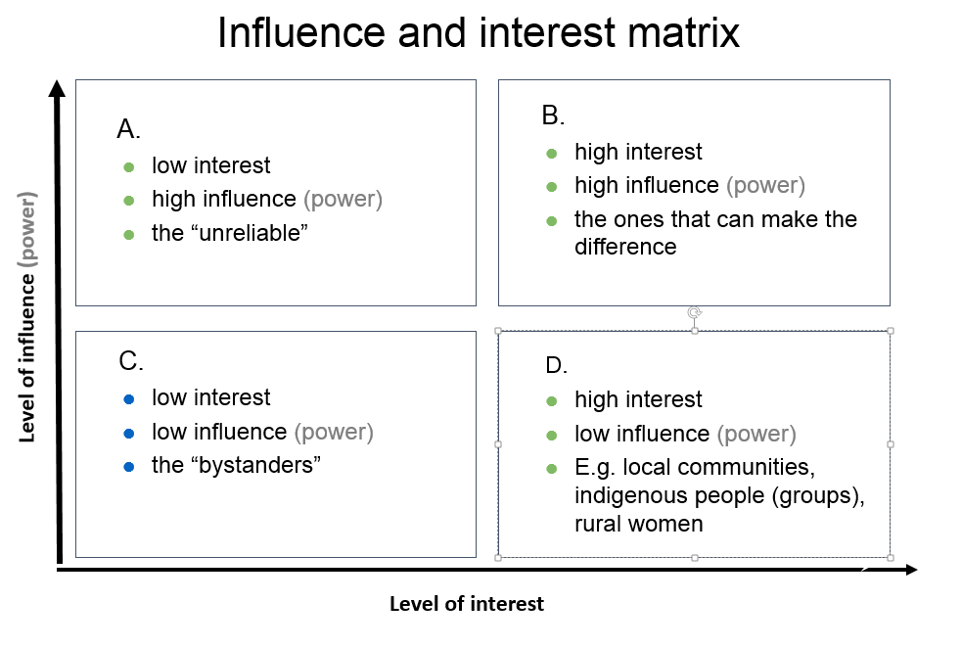
The placement in the different quadrants helps to identify how to approach or engage the stakeholder. E.g. the stakeholders in quadrant B might be the key actors to engage with for success. Stakeholders in quadrant D are probably targeted stakeholders (‘beneficiaries’) of the programme and the ones in A might be important to befriend for positive influence or consult to avoid negative influence. The stakeholders in quadrant C are the least important but there might be a need to keep them informed, or to monitor them occasionally. Or you might need information, (media) support or legitimacy from them.
In this diagram you can to give an idea of the importance of the stakeholder too. ‘Importance’ is defined as the priority the programme gives to satisfying stakeholders’ needs and interests:

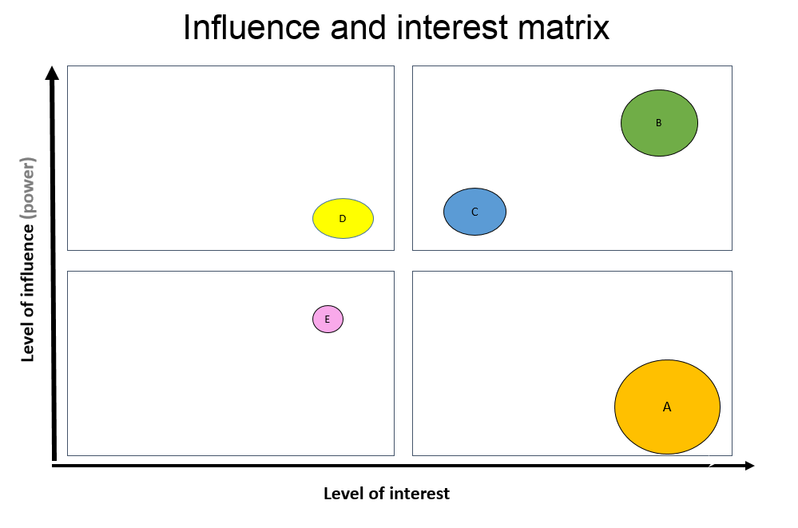
The circles with the capital letters in the matrix above stand for different stakeholders. You can relate the size of the circle to the importance of the stakeholder in relation to the desired outcomes of the programme. You might also use the diagram to reflect on if and how you want to change the position of the stakeholder in the diagram and how to achieve this (e.g. the level of influence of a certain women group) when (further) developing the ToC.
You can also use the diagram for other dimensions you might find relevant. For example, level of positive/negative commitment, level of support (advocate or adversary), relation/attitude to content of the programme, legitimacy, etc.
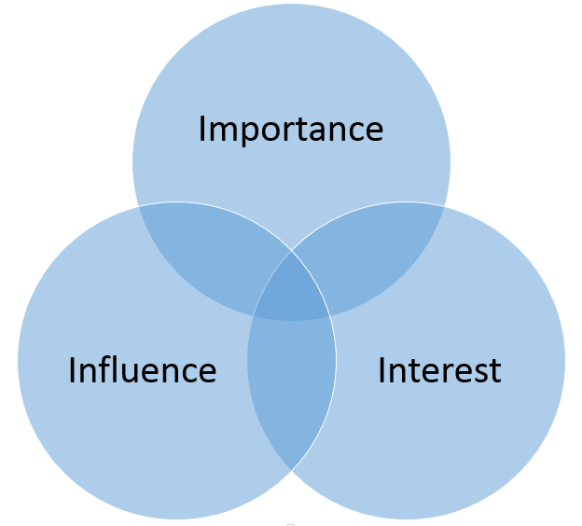
Tool 2: Another method to identify how important it is to engage the stakeholder is by placing them in a (Venn) diagram as here to the right:
The distance to the center might signify the level of interest, influence, etc. Logically, the stakeholder with most overlap in dimensions are most important to engage with. the placement in which (combination of) circle(s) should also give you clues of how to engage or address the stakeholder. Like tool 1, you can also use other dimensions you might find relevant, e.g. legitimacy. And you may want to ‘move’ stakeholders when (further) developing the ToC.

Step 3: engagement strategies for key stakeholders
From step 2 you should identify the most important, key stakeholders necessary to engage with for achieving the end outcomes for a climate smart landscape (inclusive governance, sustainable practices, responsible finance and business) or strategies to achieve this.
Some key stakeholders might be allies for success, or opponents, some stakeholders who have little influence you might want to give more influence. In this step you describe in which way these key stakeholders need to be engaged, e.g. as ally, to keep informed, to target with lobby & advocacy, to empower, to keep satisfied, to monitor, etc. and what actions are required to achieve this.

To identify possible allies and opponents place the stakeholders in the following table:
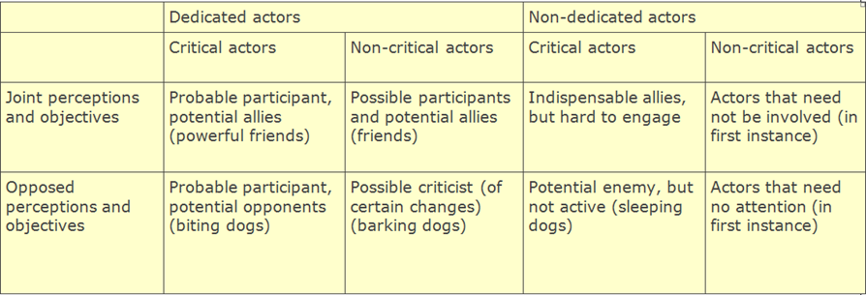

Key questions to ask to identify engagement strategies for key stakeholder:
- Which stakeholders have potentially the biggest influence (+ or -) or are mostly affected (have the ‘highest stakes’) by the programme (the ‘key stakeholders’), with regard to the intended changes sought in the landscape ToC? How important are they for the success of the programme (implementation and intended outcomes)?
- What is their influence now and would we like to see changes in the influence of this stakeholder in a ‘clmate’ smart landscape?
- How are they or will they be affected?
- What are potential allies, which stakeholders could be champions/agents of change for success? Which stakeholders could be potential opponents?
- What are challenges in relation to this stakeholder?
- What can the stakeholder/actor possibly contribute to the success of the programme, e.g. information; human resources (personnel, expertise); a network; financial resources; material, facilities and/or equipment; mandate, policies, etc. (= resources)
- What action needs to be undertaken to engage, inform, befriend, monitor, etc. the stakeholder?

Now you should have enough information to define how the different stakeholders should be approached and what actions should be undertaken. Put the results in the following table:

Key Stakeholder/  actor | Present level of influence | Desired level of influence | ally/ champion/ opponent | Challenges | Resources | Required action
Women
Young men/ boys
Young women/ girls

Annex III: Engagement, Commitment and Action (ECA) Tool
This is the tool as it was used during GLA1. It can help to distinguish and reflect on the starting and targets levels, and the different steps in L&A processes.
With the tool you can:
- Assess the baseline or starting situation
- Set targets for the full programme period and each year of the programme
- Track progress, assess achievements

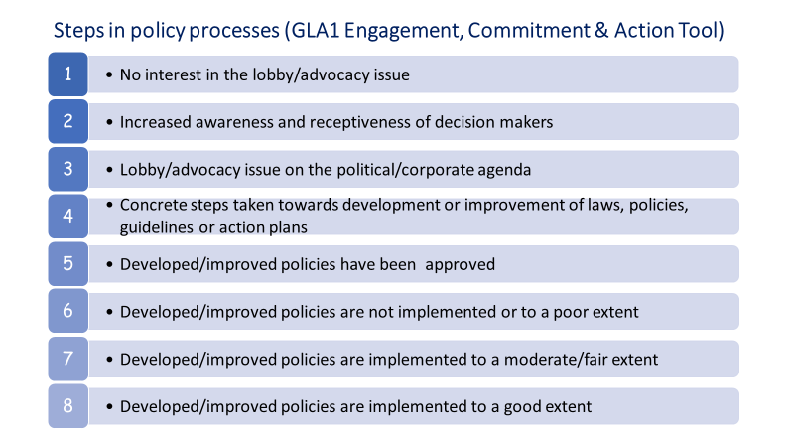
NB Policy/practice influencing processes are by their nature complex. The tool is therefore not necessarily linear and sequential, for instance certain levels could be jumped-over or levels could happen simultaneously. The tool has an inherent element of subjectivity and does not give a direct measure of only GLA-partner influencing result: the level might have been reached through a variety of actors besides GLA partners. That means that being higher in the scale is not always better. The scale is merely meant as tool for setting targets and as reflection for what has been achieved.

Annex IV: Civil Actor Participation (CAP) tool
This is the tool as it was used during GLA1. It is adapted from an existing tool (Arnstein’s Ladder of Participation’). It can help you to distinguish and reflect on the starting and targets levels, and the different steps in participation and inclusion processes.

‘Civil actors’ can be local CSOs, CBOs, communities or specific local community groups (e.g. indigenous people, women, youth, etc.). But it can also be regional or national level CSOs that GLA southern partners train and/or connect with for L&A reasons.

This tool is different from the Engagement, Commitment and Action (ECA) tool that GLA uses for public and private actors. The civil actor’s outcomes have to be assessed differently because public and private actors are usually the ‘power holders’ contrary to civil actors. This means that for civil actors other aspects have to be assessed than for public and private actors.

The tool is intended for :
- assess the baseline or starting situation;
- set targets for the full programme period and each year of the programme;
- track progress, assess achievements

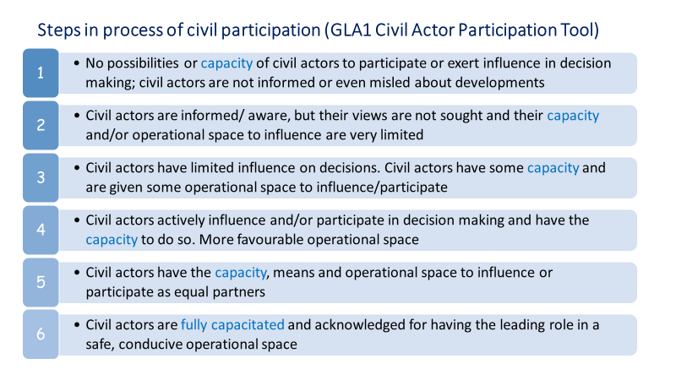
NB: Influencing processes are by nature complex. Like the ECA tool this CAP tool is not necessarily linear and sequential, the distinction between levels is gradual and a higher level in the scale is not always ‘better’! Levels for different aspects could differ, e.g. the legitimate operational space could be level 3 (limited), while the capacity of civil actors to use this space for meaningful influence/participation might be level 1 (non-existent) . The scale is merely meant as tool for setting/defining a baseline/starting and targets and as reflection for what has been achieved for the distinct aspects.

NB: Information in this report may be used for online publishing on the internet (IATI), or in TBI reporting or communications. In case you have an objection to this or if you think information in this report should be made anonymous or be excluded, please inform your country contact person or include a note stating the information is confidential. For further information on IATI, contact Luis.Gomesprimo@tropenbos.org.
You can use the list of abbreviations used in earlier reports
Indicate the (country/thematic) longer term ToC outcome to which the intended outcome(s) in the next column would have contributed. Refer to the number of the outcome in the country/thematic ToC, unless the outcomes in the ToC are not numbered.
Provide the description of the intended outcome, referring to the number of the outcome in your 2023 work plan, if these were numbered. Start by listing the intended outcomes for which interventions have taken place (reason 1, just copy and paste this from your 2023 Work Plan / PMEL framework), followed by intended outcomes for which no interventions have taken place (reason 2).
Short but specific description of intervention/activity (what, when, where, with or for whom) that did take place (but did not lead to an outcome (yet). Refer to the numbers of the activities of the outcome in your 2023 work plan, if these were numbered . If intended activities did not take place, indicate ‘did not take place’
Explain why the interventions did not lead to the intended outcome (yet)(1), or, why the interventions did/could not take place (2).
So what does this mean? What action will be taken, will the issue be dropped, is there a need to adapt the strategy?

