TBI WORKING LANDSCAPES PARTNER PROGRESS REPORT 2022 (………….)

With this Progress Report, your organisation accounts for your WL activities and achievements of 2022. The format focuses on learning about the strategies and achievements of your organization, and related adaptations. In addition to strategic learning, the reporting on achieved outcomes and results will be used for accountability to the Dutch Ministry of Foreign Affairs.

Name of CSO | PENHA
Location of CSO | Ethiopia
Email address | amsale.shibeshi@penhasom.org
Primary Contact person | Amsale Shibeshi
Name(s) of Harvester(s)
Location of activities | Ethiopia
Project Title | Working Landscapes

List of abbreviations_________________________________________________

.....

INTRODUCTION

This progress report provides your reflections on your 2022 achievements and progress. The content will be based on your harvested outcomes of 2022 (to be put in section 1.7), and on the results of the team Reflection and Learning meeting.

Please send your completed draft progress report at the latest Thursday 27th of April to your country coordinator with Luis and me in CC. We will give our feedback then and you can still add/change when needed. We need this information in time for both the WL Evaluation and the progress report 2022. So we would like to have country reflection (R&L) meetings organized in the course of April so that we can use May for network exchange of the results and writing the main body of the progress report.

Reflection and Learning meeting guidance
This section aims to provide some guidance for the WL in-country Reflection and Learning (R&L) meetings taking place in April 2023.
Please organise an R&L meeting with all relevant staff, your country coordinator, and if applicable, with implementing partners prior to finalising the progress report. We don’t send separate Reflection and Learning Meeting guidelines. In general, the questions asked in each section of the progress report format can be used as guidance for reflection and discussion. Of course, in addition you can also reflect on your own specific learning questions if you have them.
The R&L meeting serves to agree on how much progress has been made in intended programme implementation and achieving ToC objectives, to discuss the main insights you have gained from programme implementation, outcome harvesting and other monitoring results, and the way you consider to make adaptations and move forward to reach intended objectives.

In summary discuss/reflect on:
- (Influence of) changes in context
- Key stakeholder changes (if any)
- Validity of ToC assumptions, targets and strategies
- Impact, KPIs and scaling*
- Key propositions and NDCs
- (wildfire programme when relevant)
- Achieved and not-achieved outcomes
- Gender & youth progress, challenges, expectations/reflection in achievements and mainstreaming
- Thematic programmes
- Lessons learnt* and adjustments
- Documenting* and communicating results*
*The subjects in bold are of special importance for the WL End Evaluation.

We expect that all country teams have harvested outcomes and collected other information needed for the R&L meeting and prepared a draft progress report with this information prior to the R&L meeting. Now, after 4 years of full programme implementation, the aim is to assess at what point you are, how things are going, which prevailing challenges and opportunities you faced, how you dealt with it and what can be learned from that, as well as the main implications for the programme - all keeping in mind your intended end-outcomes and key propositions that underlie your Theory of Change.
You can discuss the guiding questions in sections 1.1 to 1.6 and 1.8 of this progress report (PR) format, based on your outcomes in section 1.7, including unintended, unexpected and negative ones (tables 1a and 1b), and intended outcomes you didn’t achieve (yet) (table 1c).
For reference, also for staff or partners that could not participate in the ToC refresher last year, you can watch the recordings of the ToC refresher webinars (session 1 on 3 May and session 2 on 10 May 2022) again and visit the ToC refresher Miro board.

2022 achievements and progress

Context
What changes in context did you see in the social / political / environmental / operational space / landscape situation in 2022 that have influenced the implementation of, and reaching the goals of your 2022 work plan? How? Which of these developments have led to increased risks or provided new opportunities for the programme? As a result, did you make changes in your 2022 goals, strategies or ToC targets and assumptions?

The War in Tigray (2020-22) prevented work on our Tigray-Afar landscape and had devastating impacts on people, the economy and the environment.

As a result, we made major changes to our goals and strategies, opting to focus on knowledge generation/management and on developing policies and practices that would enable and shape future landscape restoration efforts. At the same time, we conducted scoping studies on possible alternative landscapes in eastern Ethiopia. These have enabled us to broaden our collaboration partnerships, in particular with the Wondo Genet College of Forestry (on fire management and on gender training), and with the universities of Samara (Afar Region) and Jigjiga (Somali Region).

The development, through a participatory process, of a National Drylands Restoration Strategy, endorsed by the Ministry of Agriculture and Ethiopian Forestry Development (EFD), was a major success. This was followed by the further development of contextualized strategies for 3 regions, with enhanced access to government funding for the coordinated implementation of activities under the strategy through multi-stakeholder platforms.

In partnership with CIFOR-ICRAF, we have conducted a series of policy and practice oriented studies on community rights (tenure security and benefit sharing), Frankincense value chains, charcoal production, invasive species, carbon finance and Ethiopia’s revised NDCS. These studies address critical restoration priorities, identified early on in our multi-stakeholder workshops. With a focus on the livelihoods issues that must be addressed in order for communities to sustain restoration efforts, these studies have been conducted in collaboration with EFD and have generated recommendations policy and practice. The community rights study, in close collaboration with CIFOR-ICRAF and EFD, generated recommendations and insights that were fed into the revision of the Forest Law and related regulations, strengthening use rights and for the first time tabling the transfer of ownership to communities, under certain conditions. A major step forward.

The shift to a focus on policies and regulations enabled us to deepen our relationship with EFD and make real progress at the national and regional levels.

Still, we have maintained our relationships with landscape level actors in Tigray and Afar regions. With the return to peace, we are well placed to move ahead with pilot activities in 2023, notably with the Abo Gereb traditional leaders of Tigray and Afar, who oversee natural resource management and are responsible for community-level conflict resolution.

The impacts of the war make livelihoods development an even more import part of restoration efforts. So, the validity of the core assumption of our ToC (“making forests pay”) has been reinforced. People whose livelihoods are in crisis will not be able to sustain restoration activities that require them to forego the short-run economic benefits of the intensive exploitation of forests, woodlands and rangelands.

Theory of Change, lessons learned and adaptations
Add the visual of the latest version of your ToC. For reference please include the numbers of the ToC outcomes and use the same numbering in section 1.7.

Note: We do not have a well worked out, detailed Theory of Change for the program. But the program is based on an Inception Report that provided solid analytical foundations.

“making forests pay” –
strengthening tenure, livelihoods, benefit sharing and the incentives for communities to sustain protection and restoration efforts
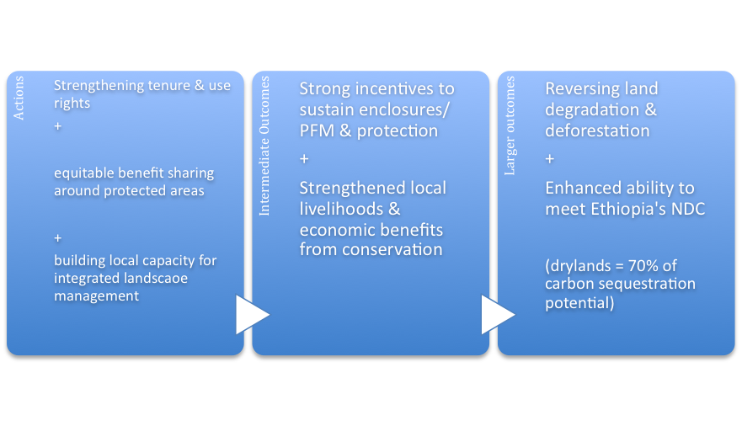

Reflection questions:
Stakeholder changes: Refer back to your baseline stakeholder analysis, notably step 2 (power, influence and interest analysis, see the guidelines in annex II). What changes did occur In the stakeholder ‘landscape’? Do you need to adjust your strategies to deal with changing stakeholders or changes in power, influence and/or interests?
The two years of war have altered the distribution of political power within Tigray and Afar regions, and between the federal and regional levels. Central authority has been weakened in certain respects. And the powerful donor nations and agencies (notably the EU, USAID, GIZ, the Norwegian Embassy & the World Bank) have been re-evaluating their relationship with the central government and the delivery of their core programs include those that support the drylands, restoration efforts and forest protection. [As of May 2023, there are appears to be a return almost to the status quo ante.]
Powerful actors – the Federal Government, Regional Governments, private sector investors, donor nations/agencies
Intermediate – Kebele administrations are the key actors in organising and delivering landscape level actions. They are tightly controlled by regional governments, but remain very close to the people and communities.
Traditional Institutions, particularly in Afar Region, remain powerful and influential, particularly on issues of local resource management. Elite capture remains an issue, with respect to the intersection of political power and business interests. Traditional institutions (the Abo Gereb) from both the Tigray and Afar sides of Desa’a Forest have (bravely) continued to meet throughout the war to discuss the control of illegal tree cutting, as well as ways to maintain local livelihoods and meet humanitarian needs.
Mekelle University remains a key development actor, with highly capable staff across several relevant departments (principally the College of Dryland Agriculture), and has played a major role in restoration efforts over three decades, providing technical support and project management capabilities. Before the onset of war, PENHA and Mekelle University secured funding for a small homestead tree planting project (providing tree seedlings for “economic trees”, fuel and fodder trees, as well as training. Mekelle University was able to implement this project in spite of the on-going war.
Low power, high interest actors – smallholders and pastoralist, community organisations, women & youth groups. Livelihoods are heavily dependent on natural resources, rangelands, woodlands and forests. Local people are, therefore, strongly committed to restoration and conservation. Women, particularly in Afar Region (where gender inequality is acute), but also in Tigray, remain powerless, with limited ability to participate in multi-stakeholder platforms. Young men have been on the frontlines of the war. Before the war, high levels of youth unemployment meant that young men were primarily responsible for the expansion of low productivity agriculture onto woodlands and forests, and to some degree were beginning to challenge the authority of traditional institutions.
Civil society organisations are weak in both Tigray and Afar, with restoration activities almost entirely carried out by Kebele administrations and communities. (In Afar Region, the very low level of human development has hindered the development of civil society organisations.)
WeForest, an NGO headquartered in Belgium, has done excellent analytical and project work around Desa’a Forest. WeForest have participated in all of PENHA’s strategy development workshops and are eager to participate in collaborative landscape level work – with peace restored.
Collaboration: With which other organisations/partners did you collaborate in 2022 or did you start a collaboration?
Federal government – Ministry of Agriculture & Ethiopian Forestry Development (EFD)
Regional governments – Principally, the bureaus for environment and agriculture
Research institutions – Mekelle University & Wondo Genet College of Forestry
Research & development agencies – CIFOR-ICRAF (close partnership at policy level & on the ground), GIZ & USAID (participation in policy workshops), ICRAF’s “PATSPO” program on tree seed supply (collaboration on tree seed selection and support for the Enderta (Arato) tree nursery, including distribution of tree seedlings and training on seedling management, nursery operations and gender)
PENHA has signed MoUs with Mekelle University, Samara University (Afar Region) and the Wondo Genet College of Forestry. Ethiopian universities are mandated to carry out local development projects (“community outreach”), in collaboration with local CSOs and Kebele Administrations. The National Dryland Restoration Strategy specifies the role of Mekelle University as a national “center of excellence”, supporting and coordinating actions across the drylands. Its “climate-smart village” provides a site for the development and promotion of climate-smart practices. Our collaboration with these institutions makes us well placed to implement interventions under the Dryland Restoration Strategy, in collaboration with Kebele Administrations and local communities.
Assumptions: From implementation, can you prove certain assumptions underlying your ToC valid or invalid? Which ones and why?
The suspension of activities due to the war makes it impossible to substantiate our assumptions in this way.
Strategies: Are there outcomes that, with the experience you have until now, consider to be very difficult to achieve? Why? So what to do? What interventions/strategies worked well? Did you face any challenges?

Low and erratic rainfall, as well as periodic drought, present major challenges in the drylands. This picture is complicated by a vulnerability to flash floods, coming from the Tigrayan highlands down to the Afar lowlands. Water supply and water management are therefore important (if very expensive) elements in effective programs. Restoration through a combination of exclosures, with assisted natural regeneration and SWC structures, has proved to be effective over the years in generating recharge and enhanced ecosystem services.

The persistence of the Abo Gereb traditional leaders in meeting and taking positive action throughout the war has demonstrated to us that they can be effective partners in a range of activities going forward.

The desired gender outcomes will be difficult to achieve in a context of deep and sharp gender inequality. Social attitudes change only slowly, in spite of a very positive policy context. Gender training (building on materials developed by Wondo Genet College and PATSPO) will help. And livelihoods activities that empower women economically will be central.

Lessons learned:
Summarise what you learned about your strategies, assumptions, external influences, dealing with stakeholders, collaboration with other partners, and other challenges from implementation in 2022.

The success of our participatory approach to strategy development, securing the endorsement of both agriculture and environment departments, has added to what we know from related experience in Somaliland and Uganda. A lengthy, iterative process involving several rounds of consultation and feedback across multiple levels with multiple actors promotes deeper participation, buy-in and commitment in developing locally owned solutions. And this may involve letting go of some of your own cherished ideas.

Developing a shared strategy is a fundamental first step, that lays the basis for real and potentially lasting medium to long-term progress. But implementation on the ground and at landscape level presents another set of challenges. In particular, it will be necessary to pay careful attention to the power dynamics of multi-stakeholder platforms. And, while the powerful Ministry of Planning helped to develop the framework for coordination and policy harmonization under our Strategy, powerful interest groups in mining and extractive industries may generate overwhelming pressures, particularly in the context of an emerging new debt crisis. Two years of war have dramatically expanded an already large hole in the government’s finances. Institutional rivalries, turf wars and competition over limited budgets, between, say, water and environment, or agriculture and industry departments, can frustrate coordination, with negative impacts on the delivery of restoration programs. As ever, the incentives for institutional coordination are weak.

In the case of the two very different communities that share our Tigray-Afar landscape, there are major power imbalances. Afar Region is predominantly pastoralist and Islamic, with low levels of human development (literacy and educational attainment). It is politically weak and, unlike the pastoral Somali Region, lacks a culture of enterprise outside of livestock sales. Tigrayan entrepreneurs dominate business and investment in the towns of Afar Region’s north. Tigray is predominantly Christian, with much higher levels of human development, despite widespread and deep poverty. Tigray was politically dominant for three decades and has a wealthy, entrepreneurial elite and a highly educated political class. Tigray is more able to push its own priorities in relationships with donors, and has much more capable institutions.

More generally, it is also the case that interests and incentives are likely to diverge across stakeholders and institutions, as well as across and within community groups.

Our studies on charcoal production, invasives and Frankincense identified a whole series of inter-related and seemingly intractable challenges. Gums and resins are important dryland products. Frankincense is a very significant economic tree, and the Frankincense belt runs from Tigray across the pastoral east and into neighbouring countries. But its production and marketing are undermined by a complex set of challenges that involve international and domestic, as well as cultural and organisational aspects. Our studies and the supporting consultative workshops have involved a range of stakeholders, including key policymakers. If sound, new approaches can be developed, the pay-offs will be very large, in terms of improved outcomes for people and for the environment.

A major challenge in Ethiopia is the need to enhance dissemination and knowledge management, as well as developing effective communication strategies for different levels of the federal structures, for different social and ethno-linguistic groups, and for different kinds of actors for different purposes. Blogs, infographics and targeted presentations are useful tools for selected, professional audiences. But well-produced, short videos are increasingly important tools in a multimedia age of diminished attention spans and intense competition for “eyeballs”. (This is something that other TBI partners and country offices do well, and a capability that we are actively seeking to develop here in Ethiopia.)

Adaptations to ToC outcomes, assumptions, targets or strategies
Describe any adjustments you have made, or will make to the ToC (outcomes/targets and/or assumptions) and/or strategies in the table below and explain why. For reference please include the numbers of the ToC outcomes and use the same numbering in section 1.7.
Pathway | Adjusted outcome, assumption, target or strategy | Explanation

Impact/KPIs/scaling
Describe to what extent your interventions and outcomes contributed to impactful changes, using the selected key performance indicators (KPIs). Refer to the sub-KPIs for which you have set targets during the inception phase (first column). NB. Describe these in words! Please give an estimation of the quantitative impact in numbers of hectares (table 1.3.1) or people (gender/age disaggregated, table 1.3.2). Distinguish between direct and indirect impact, For the definitions of direct and indirect impact see the KPI infographic in google drive. Provide cumulative numbers per sub-KPI in the last column (this means that you report on the total figures since 2019 up to 2022, so also include what you reported last year). Use the setup of your baseline to describe the changes. The first three rows (in blue) in the table below are just an example.

Table 1.3.1: cumulative estimated impact in hectares (direct and indirect)
Key performance sub-indicator | Description of observed changes in the landscape | TBI’s (your) Contribution | Direct/ Indirect | Estimated impact in #hectares at the end of 2022
E.g. Area SubKPI 1 …….. (describe) |  |  | Direct | 300
E.g. Area SubKPI 1 |  |  | Indirect | 3000
Area SubKPI 2 |  |  | Direct | 500
Etc.
Total KPI: Area affected by improved climate-smart landscape practices |  |  |  | 3800

Table 1.3.2: cumulative estimated impact on people, gender and age disaggregated (direct and indirect)
Key performance sub-indicator | Description of observed changes in the landscape | TBI’s (your) Contribution | Direct/ Indirect | # Adult Women | # Adult Men | # Young Women | # Young Men
People sub-KPI1 …….. (describe)
Etc.
Total KPI: Number of beneficiaries impacted by improved climate-smart landscape practices

Progress: to what extent are you “on track” towards achieving the 5 year targets for the different KPIs? Why or why not?
…………………..

Scaling: to what extent did you manage to scale up successful strategies, please describe what and how:
…………………..

Key propositions, NDCs and Wildfire (where relevant)
For each describe:
- What progress has been made in 2022 towards the end goal(s)? Compared to the situation at the start of the programme, how far are you in achieving the end goal(s)?
- What challenges did you meet in 2022? Can you say that you are on track? If not, why not?
- What are your expectations/reflections for the near future? Should you change your strategies in order to achieve the end goal? How?

- Ethiopia’s revised NDC recognizes the importance of the drylands, which hold 70% of Ethiopia’s carbon sequestration potential.

3. Implementation of restoration programs (based on ANR & FMNR) in the drylands will be crucial to success and depends on an improved understanding of what works in the drylands. At present, there is still a relatively poor understanding of the drylands among many people working in key agencies. Accordingly, we will engage with the main agencies and programs to enhance understanding and implementation.

In 2022, the Wildfire program focused on establishing an analytical foundation for policy work that will aim to establish an Integrated Fire Management System in 2023.

We would like you to provide your answers directly in a document on google drive like last year but this needs to be updated first with your 2022 work plans for these subjects. We will send the link plus further instructions next week (week 15)!

Gender & youth (F/M)

Progress, challenges, expectations/reflection
Achievements: What were your achievements towards gender and youth (F/M) priorities related to each of the five baseline indicators/three main pathways:

Pathway | Indicator | Intended gender/youth (F/M) priority/ outcome for 2022 | Achievements in 2022
Inclusive landscape governance: | a. Level of access to land and ecosystem services;
Inclusive landscape governance: | b. Level of land tenure rights/security;
Inclusive landscape governance: | c. Level of participation in decision making about land & forest use and governance
Responsible business and finance: | d. Level of access to production resources, inputs and benefits
Sustainable land-use practices: | e. Level of participation in, contribution to, and benefits of climate smart practices)

Please summarise:
- What progress has been made in 2022 towards G&Y objectives? Compared to the situation at the start of the programme, how far are you in achieving end goal(s) in priority G&Y issues? Are you satisfied or not? Why/why not?

Each of these indicators is addressed in our National Drylands Restoration Strategy, but war in Tigray has prevented landscape-level implementation. Nevertheless, we expect to see progress in the coming years, through enhanced policy and practice, particularly in terms of inclusive landscape governance. Here our community rights review has been fed into strengthened community use rights and benefit sharing mechanisms, with explicit mention of women and youth.

- What challenges did you meet in 2022? Can you say that you are on track? If not, why not?

Sharp gender inequality remains an obstacle to women’s (effective) participation in multi-stakeholder platforms and in programs. Little or no progress has been made in increasing access to production resources, inputs and benefits. Yet this is probably the area where the most significant progress can be made in the shorter term.

On a very small scale, the homestead tree planting project implemented by Mekelle University in Tigray was able to deliver direct benefits to women, without shifting gender relations. In both Tigray and Afar regions, war has placed a greater burden on women for livelihoods and resource management. Women’s growing role in local economic activity may ultimately lead to social change that enhances gender equality.

- What are your expectations/reflections for the near future? Should you change your strategies in order to achieve the end goal? How?

The way forward is clear: more training on gender in (agro-) forestry and resource management around tree nurseries, establishing targets for the participation of women and youth in the tree nurseries that we support, and

Progress in mainstreaming gender & youth (F/M)
Are you satisfied about mainstreaming gender and youth in:
- Activities, i.e. involving women, men and youth in the design, planning, implementation and monitoring of programme activities? Are you satisfied about progress? Why/why not? What needs to improve?

Women’s participation in policy development needs to be strengthened. There is a longstanding set of seemingly intractable issues with respect to women’s participation in policy and research related to forestry programs.

At landscape level - women and youth are active participants, but have limited ability to participate in shaping programs. We have endeavoured to ensure that women and youth are consulted throughout. Our policy development work began with consultations on the ground involving women and youth.

- Your own organisation, e.g. do you have organisational gender (equity) objectives, do you allocate time and budget for achieving more gender equity, youth engagement, etc.? Do you practice gender/age disaggregated monitoring? Are you satisfied or not? Why/why not? What needs to improve?

PENHA has strong gender & social inclusion policies and practices. Youth engagement has been identified as an area that needs strengthening.

Thematic programmes
Describe the most important achievements within the thematic programmes that apply to your country programme in the table below.
- To what extent did you contribute to the thematic outcomes formulated in the thematic workplans?

A. Agrocommodities
B. Landscape restoration
Development of a National Drylands Restoration Strategy and its endorsement and adoption by the Ministry of Agriculture and Ethiopian Forest Development (the former Environment, Forests and Climate Change Commission).

Engagement with six regional states to adapt the national strategy to local contexts and develop modalities for coordinated implementation through multi-stakeholder platforms.
C. Business and finance
Studies on inclusive value chains for Frankincense and workshops with producers, traders’ associations and relevant public bodies, resulting in strengthened EFD commitment to address serious challenges in a participatory way (i.e. to engage with all stakeholders).
NB NDCs and Wildfire are included in section 1.4.

2022 Outcomes

Outcome tables
We have split the outcome table in two parts: the first table (1a) has the basic elements of an outcome statement (i.e., description of the change; significance, contribution, evidence), the second table (1b) has the additional information for aggregation, and analytical or other purposes. You need to copy the first two columns (the outcome number + outcome title) of the first table to the second table.
- in the first table (1a) give a summary description (the ‘outcome title’) and a more elaborate description of who changed what and when (the ‘outcome description’). With this more elaborate description an outsider should be able to understand the change. We also ask which ‘evidence’ (sources of information) you have to substantiate/validate the outcome (columns 1, 5 and 11).
- In the second table (1b) indicate to which key proposition(s) the outcome contributes, and the gender or youth dimension of the outcome. We also ask about the confidentiality of the outcome (columns 15, 17, 18, 19).

Table 1a: 2022 outcomes
Describe all your harvested / achieved outcomes by completing tables Ia (outcome statement and evidence) and 1b (info for analysis). Fill in expected as well as unexpected or perhaps negative outcomes! Make ample use of the PMEL outcome table I in your 2022 work plan! Use one row for each achieved outcome for only one type of actor!

NB Alternatively you can provide the outcome tables in an Excel sheet. If you do so please ensure that the information is complete (1 columns) and use the same order of columns!

Please read the following instructions carefully before completing the table!

Table 1a: 2022 outcomes part one: outcome statements and evidence
Explanations of columns:
- #: number the outcomes for easy reference in table 1b.
- Outcome title: Summarize the outcome in one sentence: who changed what, when and where, as precise (SMART) as possible. Include unexpected or negative outcomes and use one row for only one type of actor.
- ToC end outcome: To which longer term WL ToC/thematic end outcome the outcome in column 1 contributes? Refer to the number of the ToC outcome, unless the outcomes in the ToC are not numbered.
- Description of change: Elaborate on the who, what, when and where in the outcome title. Give additional facts so that an outsider can understand what your outcome title means. Describe the social actor (who) as specifically as possible and describe in max. 4 sentences what this actor did that was new or different. Be as specific as possible about when this happened and where.
- Expected /unexpected: was the outcome expected or unexpected? If the outcome was expected refer to the number of the outcome in your 2022 work plan, or a ‘yes’ if the outcome is not numbered. If the outcome was unexpected add a ‘No’.
- Positive or negative?: was the outcome a positive (put ‘+’) or negative change (put ‘-‘)?
- Significance: Explain the significance of the achieved outcome in relation to the end outcomes in the ToC briefly.
- Significance scale: How would you rate the significance of the change in relation to the goals of the programme? Please determine the level of significance and fill in a number between 0- 5: “The change/outcome is not significant” 0 - 1 - 2 - 3 - 4 - 5 “The change/outcome is vital for our long term ToC goals”.
- Contribution (Intervention(s)): Describe your interventions that contributed to the outcome, and the ones of other organisations that where relevant/important. NB: more than one activity/intervention can lead to an outcome, and one activity/ intervention can lead to more than one outcome.
- Type of interventions: to be able to categorize and analyse the type of interventions that are successful please indicate the (main) type of intervention(s) that has led to the outcome. Use the numbers to put in this column of the following categories, e.g. put ‘2.4’ if the main activity to achieve the outcome was documentation & research (e.g. case studies, evidence finding etc.) for dialogue:
Capacity building (1), e.g:
☐ 1.1 Trainings, workshops, technical assistance etc. aiming to build capacity & skills;
☐ 1.2 Coaching, consulting, mentoring etc. to build capacity & skills;
☐ 1.3 Field visits, exchange visits; exchange of lessons learned between actors
☐1.4 Development, implementation of- and capacity building through pilot projects;
☐ 1.5 Awareness raising, sensitization, social events, media outreach, etc., aiming at information dissemination, including the development of material for these purposes.
☐ 1.6 Documentation & research initiatives for capacity building interventions.
Dialogue and coalition building (2), e.g.:
☐ 2.1 Coalition building, networking, linking public, private and/or civil actors;
☐ 2.2 Dialogue, consultative meetings, participation in multi-stakeholder processes, (e.g. participatory planning, joint analysis, policy development, mediation etc.);
☐ 2.3 Collaborative actions with public, private and/or civil actors, including summits, conferences, etc.;
☐ 2.4 Documentation & research initiatives (e.g. case studies, evidence finding etc.) for dialogue
Lobby & advocacy (3),
☐ 3.1 Advocacy, mobilize public pressure, including demonstrations, petitions, campaigning, media outreach, etc.;
☐ 3.2 Lobby, including (in)formal meetings, the development & dissemination of policy briefs;
☐ 3.3 Litigation and the use of grievance mechanisms (e.g. formal hearings, appealing to existing mediation procedures);
☐ 3.4 Documentation & research initiatives (e.g. case studies, evidence finding etc.) for lobby, advocacy & litigation efforts.
- Contribution scale: How would you rate your organisations' contribution towards the outcome? Please determine the level of contribution and fill in a number between 0 - 5:. “The outcome would also have been achieved without our contribution“ 0 - 1 - 2 - 3 - 4 - 5 “The outcome would not have been achieved without our intervention(s)“
- Evidence: On what sources of information is above information based? Where relevant provide web links, videos, photos, news articles, sound recordings, lobby documents, meeting reports, contracts, field reports, official government communication, public corporate information, etc.

PENHA-TBI Program Outcomes - in sum

National Drylands Restoration Strategy endorsed by MoA and EFD – a strategy that combines livelihoods and conservation, with a set of agreed priorities and approaches, and a framework for coordinated implementation.

This breaks the longstanding divergence between agriculture and environment, and between agriculture and the ministry responsible for the pastoral lowlands.

It establishes official backing for the core approaches advanced by PENHA and TBI, in a way that is difficult to reverse.

At the same time, our community rights study fed into the revision of the Forest Law and the associated federal regulations, with strengthened use rights (notably for sustainable timber harvesting) and a pathway to conditional community ownership of forests.

This progress on policy and regulations is highly significant – perhaps worth a rank of 5 on the scale, given the potentially game changing implications (even if implementation does not follow swiftly).

Already, stepped up attention to the drylands and recognition of their importance to the achievement of Ethiopia’s NDC is being reflected in the design of the major donor supported programs.

Our policy-oriented studies, while very useful contributions, are much less significant. Perhaps ranking 1 or 2 on the scale. They advance the debate, and present solid recommendations that are largely supported by EFD. But they do not provide clear paths to positive changes in policy and practice.

Our efforts towards establishing an effective fire management system are timely and plug a gap. Outlining a more effective and efficient system, with clarified roles for EFD, the Environmental Protection Agency and the National Disaster Risk Management commission will be a significant contribution. The work in 2022, in partnership with CIFOR-ICRAF and with inputs from Wondo Genet College, was the analytical phase of the program. This lays the basis for a consultative process in 2023, involving national and regional stakeholders, that will develop an integrated national system, with provisions for community responders, fire-smart practices and financing mechanisms. In terms of significance, this work rates a ranking of 2 or 3.

Table 1a: 2022 outcomes – part one: outcome statements and evidence
Please keep your entries in the tables below brief. For instructions, see above.
NB the first time you use an acronym/abbreviation, please write it in full
0 | 1 | 2 | 3 | 4 | 5 | 6 | 7 | 8 | 9 | 10 | 11
# | Outcome title | ToC (END) Outcome(s) to which the achieved outcome contributes | Expec-  ted? (Yes/  No) | Pos.  or neg.  (+/-) | Description of change | Significance (descriptive) | Significance  scale (1-5) | Contribution (interventions) | Type of intervention | Contribution  scale (1-5) | Evidence
 | MoA and EFD endorse National Drylands Restoration Strategy | all | No | + | Supportive policy change | This breaks the longstanding divergence between agriculture and environment, and between agriculture and the ministry responsible for the pastoral lowlands.  It establishes official backing for the core approaches advanced by PENHA and TBI, in a way that is difficult to reverse. | 5 | Participatory process with govt & stakeholders across 6 regions  Series of multi-stakeholder workshops  Continuous engagement with ministries, analytical studies, book on drylands restoration in Ethiopia | 2.2  2.4 | 5 | Published Strategy (jointly with MoA)  Reports/blog on participatory strategy development process
 | EFD revised the Forest Law and the associated federal regulations, including inputs from the community rights review. | Strengthened community rights | No | + | Regulations permit greater use of forest resources for income generation,  Divergence between regional & national regulations addressed | Revised forest law strengthens use rights (notably for sustainable timber harvesting) and provides a pathway to conditional community ownership of forests. | 5 | Private/side meetings alongside participatory strategy development process  Study on community rights | 2.2  2.4 | 4 | Revised regulations (EFD/GoE)  Community rights review (published study)
 | Major donor supported programs (REDD+ & Sustainable Land Management programs in the regions) adjust design to give more attention to drylands and their importance to the achievement of Ethiopia’s NDC |  | Yes | + | Programs to be extended to cover drylands (with suitable adaptations) | Major national programs will now cover the drylands (70% of the country’s landmass) that were previously not covered, or poorly understood. | 5 | Continuous engagement, personal contacts with key players  Workshops | 2.2  2.4 | 3 | Public statements by the agencies concerned
 | EFD supports recommendations from policy-oriented studies (EFD has requested concise policy briefs as a basis for further discussions within EFD and through multi-stakeholder platforms) |  | No | + | EFD to initiate/strengthen development of policies/strategies to address critical issues in the drylands. | The studies advance the debate, and present solid recommendations, but do not provide clear paths to positive changes in policy and practice. | 2 | Policy-oriented studies on identified critical issues – charcoal production, revised NDC, invasive species, gums & resins/Frankincense value chains, carbon finance, community rights. | 2.4 | 1 | Published studies
 | EFD & Ethiopian national Disaster Risk Management Commission engaged in a process aimed at establishing an Integrated National Fire Management System |  | Yes | + | No coherent system exists that links up the actions of national and regional agencies as well as communities.  Establishing an Integrated Fire Management System will make responses more effective and accommodate the use of fire as a resource management tool by farmers & pastoralists. | Key gov’t agencies participated in the workshop (they are responsible for developing & implementing preparedness & responses) | 3 | Wide consultations  National workshop  Analytical review | 2.2  2.4 | 4 | National review to be published shortly
 | Green Legacy Initiative (GLI), major tree planting programme led by the Prime Minister, will pay greater attention to selection & management of seedlings, enhancing effectiveness nation-wide & in the drylands. |  | No | + | It is suspected that seedling survival rates have been low. With careful attention to management, this huge national program will potentially be more effective.  “The right trees, in the right places, with the right management.” | We were among the first people to push this issue.  The issue was highlighted in our workshops, National Drylands Restoration Strategy and on radio. | 3 |  |  | 2
 | EFD and regional governments will engage with stakeholders on Frankincense production & value chains | Enhanced, inclusive value chains | Yes | + | Concerted given attention to an important drylands value chain and a tree that is threatened by intensive exploitation.  EFD to carry out an assessment. | Frankincense is “the coffee of the drylands”, but the resource is poorly managed and value chains are underdeveloped. EFD will engage with regional gov’t & stakeholders (women, youth, traders & exporters) to address challenges. | 1 | Analytical studies  Workshops with traders, producer associations, chamber of commerce, gov’t | 2.2  2.4 | 3 | Published studies  Workshop reports
 | Regional governments will develop context-specific restoration strategies, cascading the national strategy to regions (2023) and outlining implementation modalities through multi-stakeholder platforms | all | Yes | + | Socially & ecologically diverse regions will have context-specific restoration strategies | Regional gov’ts will have clear strategies, with implementation plans, and will be well placed to access available central gov’t funding (1% of the national budget has been allocated for this). | 5 |  | 2.2  2.4 | 5 | Published strategies  Statements by Presidents & parliaments of regional states
 | BoANR of Tigray committed to support restoration activities in pilot sites (2023) | Landscape restoration | Yes | + | BoANR will support actions by multiple actors at landscape level, including community groups organised by local Kebele administrations. |  |  | Supporting Strategy development  Building local capacity  Engaging with stakeholders |  | 3
 | PENHA, CIFOR-ICRAF & local gov’t will rehabilitate/equip a nursery site (2023) and provide training to support home gardens and FMNR in conflict-affected communities of Tigray & Afar regions. |  | Yes | + | Arato Tree Nursery equipped to serve communities in Tigray & Afar regions, with seedlings for fodder, fuel & fruits, supporting livelihoods (women & youth) and peacebuilding (“trees for peace”). |  |  | Training  Providing equipment  Coordination with local stakeholders | 1.1  1.3 | 3

Table 1b 2022 outcomes: information for aggregation, analysis or other purposes
Copy the first two columns of table 1a (# and outcome title) into table 1b.
Please read the following instructions carefully before completing the table!
Explanation of columns:
- Kind of actor: Please choose between (choose only one!): ☐ Public actor; ☐ Private actor; ☐ Civil actors, like community members, local leaders, community groups, individuals, etc.; ☐ Civil society actors, like networks, CSOs, NGO platforms etc.; ☐ Research Institute/ University; ☐ Media/ journalist(s)
- Geographic level of change: indicate the geographic level of change. Local; sub-national; national; regional; international (e.g. AU, ASEAN, EU or VN level). Elaborate by naming the location.
- WL ToC ‘pillar’: how would you categorize the outcome in one of the following three key WL pillars (if it’s more than one put the most important one first):
- Inclusive Landscape Governance
- Sustainable land use
- Responsible Business and Finance
- Key proposition(s): to which key proposition(s) does this outcome contribute? Please refer to the numbering you used in section 1.4.
- Cross-cutting themes and TBI priorities: Refer to which cross-cutting theme(s) and/or TBI prioritie(s) (see annex I) the outcome relates to (contributed to, changed, etc.). Refer to the numbers in annex I, no descriptions are needed. A combination of numbers is possible, e.g. 1.1a and 2.3 (only use numbers, no words!). You may also just mention the main topic(s), e.g., 1 and 3.
- Gender equality and empowerment: To what extent does the described outcome contribute to gender equality and empowerment? Score your contribution from 0-5, where 0 = no contribution and 5 = high contribution in the first sub column. Explain your scoring in the second sub-column.
- Youth issues and empowerment: To what extent does the described outcome contribute to youth (boys and girls) issues and empowerment? Score your contribution from 0-5, where 0 = no contribution and 5 = high contribution in the first sub column. Explain your scoring in the second sub-column.
- Confidentiality: (the reason for asking this is because these outcomes might be reported to the International Aid Transparency Initiative (IATI). IIATI is a publicly accessible database for third parties, and one of the monitoring instruments used by the Dutch Ministry of Foreign Affairs.)
Please select (1, 2 or 3):
- This outcome is not confidential and can be used for publishing outside the WL program, or
- this outcome is not confidential but the actors in this outcome should be anonymized when publishing the outcome outside the WL program, or
- this outcome is confidential: it contains information that can pose a risk to individuals or organisations, and cannot be published outside the WL program.

Table 1b: 2022 outcomes – part two: information for aggregation, analysis and other purposes
0 | 1 | 12 | 13 | 14 | 15 | 16 | 17 |  | 18 |  | 19
# | Outcome title | Kind of actor | Geographic level of change | WL ToC ‘pillars’ | Key proposition(s) | Cross-cutting themes and priorities | Gender equality and empowerment |  | Youth issues and empowerment |  | Confidentiality  (1, 2, or 3)
 | MoA and EFD endorse National Drylands Restoration Strategy | Public | National | A. Inclusive Landscape Governance  B. Sustainable Land Use  C. Responsible Business & Finance |  | 1 (1b, 1c, 1d)  2(2b, 2c, 2d, 2e)  3 (3a, 3b, 3d)  4 (4a, 4b, 4c, 4d, 4e, 4f)  5 (5a, 5b, 5c)  6 (6a, 6b)  7d.  8c.  9c. | 5 | Gender is identified as central in the Strategy.  (But there are no clear pathways to implementation and social attitudes in the drylands change slowly.) | 4 | Youth employment and enterprise development are emphasised.  (But implementation is challenging.) | 1
 | EFD revised the Forest Law and the associated federal regulations, including inputs from the community rights review. | Public | National | A & B |  | 2d. 2e.  6. | 3 | We pushed for increased participation and greater recognition of women’s rights/roles  Women are important economic actors, but struggle to participate in local governance. | 3 | Youth will benefit from expanded economic activities.  (But youth are unlikely to participate as entrepreneurs, e.g. in eco-tourism or higher along value chains for wood products, etc.) | 1
 | Major donor supported programs (REDD+ & Sustainable Land Management programs in the regions) adjust design to give more attention to drylands and their importance to the achievement of Ethiopia’s NDC | Public | Sub-national  (Regions with major dryland areas – particularly Afar & Somali regions and parts of Oromia) | B |  | 1.  2. | 0 | The major programs have gender & social inclusion elements. | 0 | The major programs aim to address youth issues. | 2
 | EFD supports recommendations from policy-oriented studies (EFD has requested concise policy briefs as a basis for further discussions within EFD and through multi-stakeholder platforms) | Public | National  Sub-national (particularly Afar, Somali & Tigray regions, for gums & resins, Frankincense, invasive species) | B, A & C |  | 1.  2.  3a, 3b, 3d.  4.  5b, 5c  7d  8a, 8b, 8c  9c | 3 | The studies all address gender dimensions and most put forward specific recommendations on gender. But designing and implementing supportive actions will be difficult. | 3 | Youth issues are addressed in most of the studies and gov’t recognizes youth employment/opportunities for youth as a priority. But the scale of the challenge is daunting and policy tools are limited. | 1
 | EFD & Ethiopian National Disaster Risk Management Commission engaged in a process aimed at establishing an Integrated National Fire Management System |  | National  &  Sub-national | B |  | 10.  6a. | 0 | Women’s participation is limited and has not been discussed in any depth.  More attention will need to be given to women’s roles in natural resource management. | 3 | Youth participation is important (in community brigades, local responses and in resource management).  Youth will play major roles in whatever system emerges from the process. | 1
 | Green Legacy Initiative (GLI), major tree planting programme led by the Prime Minister, will pay greater attention to selection & management of seedlings, enhancing effectiveness nation-wide & in the drylands. | Public | National | B |  | 2b, 2c  8 | 0 | Women and women’s groups participate in the GLI across the country. | 0 | Youth are important participants across the country. | 3
 | EFD and regional governments will engage with stakeholders on Frankincense production & value chains | Public | Sub-national  (Tigray, Somali and Afar regions) | B & C |  | 2c  3a, 3c, 3d  5c  6a  8  9b  9c | 3 | Women’s roles in processing are emphasized and recommendations are made for their participation in efforts to upgrade the value chain.  A number of women participated in a national workshop with value chain actors. | 3 | Studies address the major role of youth in Frankincense collection and make recommendations for their inclusion in training & value chain enhancement. | 1
 | Regional governments will develop context-specific restoration strategies, cascading the national strategy to regions (2023) and outlining implementation modalities through multi-stakeholder platforms | Public | Sub-national  (Six regions with major dryland areas) | B, A & C |  | 1.  2.  4d., 4e.  5b., 5c.  6.  8c.  9b. | 3 | Strategies address the roles of women and the need for greater inclusion. | 2 | Strategies address the role of youth & the issue of youth employment in particular. | 1
 | BoANR of Tigray committed to support restoration activities in pilot sites (2023) | Public | Sub-national  (Tigray region) | B |  | 2b, 2c |  |  |  |  | 1
 | PENHA, CIFOR-ICRAF & local gov’t will rehabilitate/equip a nursery site (2023) and provide training to support home gardens and FMNR in conflict-affected communities of Tigray & Afar regions. | Civil | Sub-national  (Tigray & Afar regions) | B |  | 2b, 2c  4d, 4e  5b  9a, 9c | 2 | Women play important roles in activities at the tree nursery and will be direct beneficiaries of the homestead tree planting component. | 0 | Local stakeholders are particularly focused on the need to involve youth and support their livelihoods. | 1

Table 1c: Intended outcome(s) that were not achieved (yet)
After completing table 1a, describe in table 1b intended outcome(s) included in the 2022 workplan that were not achieved (yet). This is important for learning, adapting strategies and planning; but also for the 2022 Progress report to be submitted to DGIS. There could be two explanations for outcomes that were not achieved: (1) the intervention(s) took place, but for some reason this did not lead to the intended outcome(s), or (2) for some reason the interventions did not take place (yet). Use one row for each intended outcome.
Please carefully read the footnotes when completing the table!

Table 1c: Intended outcome(s) that were not achieved (yet)
ToC outcome to which the intended outcome(s) in the next column would have contributed: | Intended outcome | Intervention(s) | Reason(s) the intended outcome was not achieved | Any follow-up?
 |  | (add rows as needed)

Documenting and Communicating results

Stories of change
You are invited to provide one or more stories of change on a particular area of success, a change of approach or a lesson learned (1 page max) here. Although this is not a requirement (it is optional), it is an opportunity to showcase your achievements from a story-telling angle and provides material for communication purposes.
You can use good stories for your own purposes,, while they may also be used for communication purposes on the on your own or TBI website or other communication channels!
The participatory process used to develop the National Drylands restoration Strategy is described in a short article by Koen Kusters for TBI and in a blog post.
A key point is that other agencies have been inspired to take up our approach, giving more time for wider consultations and participation, with studies and analysis integrated into an iterative process, rather than a one-off study that is presented for validation.
………..

Key communication about 2022: articles, videos, blogs, etc.
Please include hyperlinks, displaying as text the title(s) of published articles, videos, blogs, or other communications related to your WL related work/results.

A blog has been produced describing our participatory process in developing the National Drylands Restoration Strategy. The blog has now been published. A revised and/or supplementary blog/article is being developed that more fully describes the process and lessons. This is in response to requests from two international development agencies.

An associated PowerPoint presentation will also be developed for an upcoming EU learning event in Addis.

Also provide descriptions of events, stories and/or pictures that can further explain or illustrate the outcomes. You may use news stories or annual report stories that you prepared for other purposes. NB: this is optional, so only add them if you have them in other reports or documents. It will be much appreciated!
………..

Documenting results
Discus if you have documented your results in relation to your ToC sufficiently in an accessible way for the WL End Evaluation, and if not, how to do this then

Annex I: TBI thematic & strategic priorities
The list below is a mix of priorities and themes identified for GLA and WL. Please add if there is a thematic or strategic priority unmentioned.

Interventions or outcome contribute(d) to:
- Landscape approach/ Inclusive landscape governance:
1a. Inclusive decision-making or ensured the inclusiveness of local communities/marginalized/indigenous groups.
1b. Cross sectoral coordination and collaboration.
1c. An integrated perspective (instead of one-issue), looking at landscape connectivity, multi-stakeholder dialogue, working towards/identifying a joint vision, integrated and collaborative landscape planning, collaborative managements of public goods.
1d: networking/ collaboration/ strategy development between different groups of CSOs and/or other stakeholders in the landscape.
- Sustainable land use/restoration/halt deforestation:
2a. Smallholder agroforestry/Diversified production systems
2b. Forest and landscape restoration
2c. Combat (further) deforestation
2d. Legal timber: e.g. (il)legal logging, access to timber resources, domestic market, FLEGT, certification, charcoal, etc.
2e Community forest management and conservation
- Responsible business and finance:
3a. Fair and equitable integration of smallholders in value chains
3b. Improved design and implementation of business models and financing instruments like, PES, REDD+, etc,
3c. Effective implementation of private sector sustainability and inclusiveness standards, criteria and commitments
3d. Inclusive business and finance; access to finance, responsible financing,
3d. Support to producer organisations, cooperatives, SMFE associations (plantations, NTFPs), etc.
- Gender:
4a. Access to land and ecosystem services
4b. Land tenure rights/security
4c. Participation in decision making about land & forest use and governance
4d. Access to production resources, inputs and benefits
4e. Participation in, contribution to, and benefits of climate smart practices
4f. Transformative change in values/norms/power balances leading to (more) equity; representation in leadership positions by women.
- Youth (F/M):
5a Participation/ involvement/ benefits of land & forest use and governance
5b Participation in, contribution to, and benefits of climate smart practices;
5c Income generating opportunities created for youth.
5d Equity in participation/ involvement/ benefits between young men and young women
- Development/approval of public policy instruments to promote sustainable and inclusive practices,:
6a. National policy dialogue and/or NDC
6b. improved understanding of the link between landscape and national decision making; national lobby & advocacy; translate local and international themes to make them nationally relevant.
- Agro-commodities, e.g.
7a Effective implementation of sustainability and inclusiveness standards, criteria and commitments
7b policy development/approval;
7c sustainable practices at local, national and international levels
7d other, sector specific ( e.g. Palm Oil; Cacao; Coffee; Soy, …..) …..
- Making knowledge work for forests and people:
8a.applied research and dissemination of results, translation of knowledge,
8b connecting knowledge-users and –producers in dialogue,
8c analysis and understanding before proposing an intervention
- Capacity strengthening of other actors or target groups:
9a (institutional) capacity strengthening of other actors or target groups;
9b Identify capacity needs of other actors or target groups in line with ToC;
9c Joint/blended learning (not just training), with other actors and/or target groups to analyse issues and become more effective in addressing them;.
- Fire-smart landscape governance
- ?????

Annex II: Stakeholder analysis

Step 1: identification of (change in) stakeholders:
The stakeholder ‘landscape is dynamic: are you still dealing with the same stakeholders or did changes occur: any new stakeholders have become important, including women and/or youth stakeholders? Others less?

Step 2: Power, influence and interest analysis
What are the levels of interest and influence the different actual stakeholders have on the key outcomes of the landscape ToC (e.g. inclusive landscape governance; sustainable land use; responsible business finance). This analysis is necessary to identify the key stakeholders, i.e. the stakeholders with a high interest and/or influence, and subsequently in which way the stakeholder needs to be engaged, e.g. as ally, to keep informed, to target with L&A, to empower, to keep satisfied, to monitor, etc. The stakeholders to consider are all stakeholders identified in step 1, i.e. including the stakeholders identified in the gender (B) and youth (C) analysis.
There are different tools to visualize this:

Tool 1: The most common tool used to visualize this, is to place the stakeholders in a matrix with two different axes, e.g: in the example below these are the level of influence of each stakeholder and the level of interest:
‘level of Interest’ is defined as how much a stakeholder cares about the outcomes or to what extent the stakeholder will be effected by the outcomes of the programme. Are they beneficiaries or will there be negative effects?
Level of Influence – The power a stakeholder has to make or break the programme. For example through funding, legislation, resistence, influencing other stakeholders, etc..
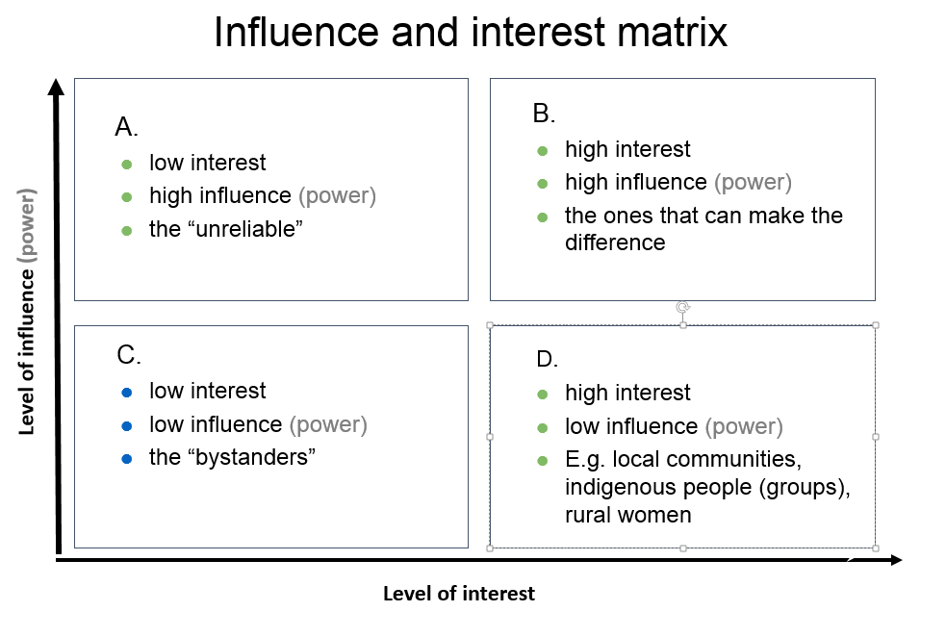
The placement in the different quadrants helps to identify how to approach or engage the stakeholder. E.g. the stakeholders in quadrant B might be the key actors to engage with for success. Stakeholders in quadrant D are probably targeted stakeholders (‘beneficiaries’) of the programme and the ones in A might be important to befriend for positive influence or consult to avoid negative influence. The stakeholders in quadrant C are the least important but there might be a need to keep them informed, or to monitor them occasionally. Or you might need information, (media) support or legitimacy from them.
In this diagram you can to give an idea of the importance of the stakeholder too. ‘Importance’ is defined as the priority the programme gives to satisfying stakeholders’ needs and interests:

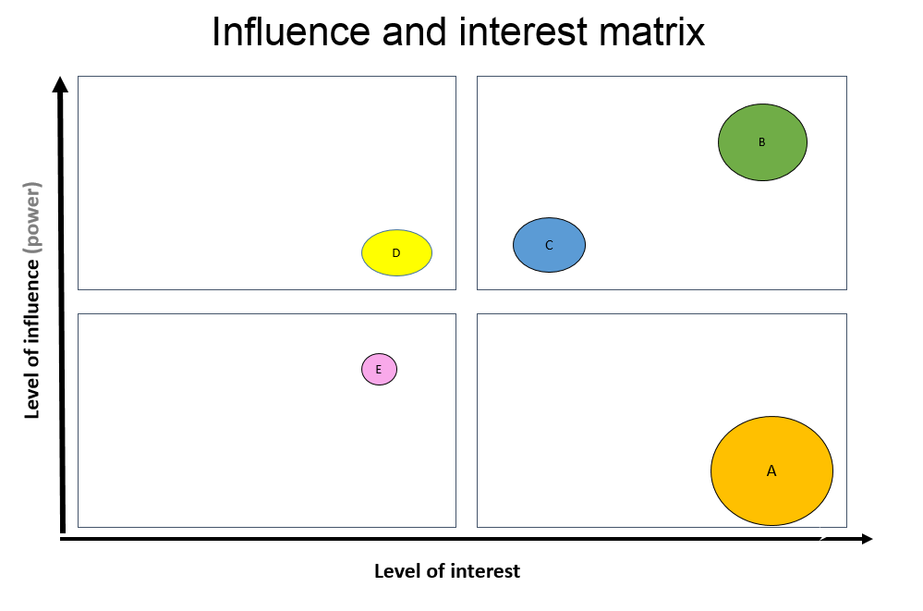
The circles with the capital letters in the matrix above stand for different stakeholders. You can relate the size of the circle to the importance of the stakeholder in relation to the desired outcomes of the programme. You might also use the diagram to reflect on if and how you want to change the position of the stakeholder in the diagram and how to achieve this (e.g. the level of influence of a certain women group) when (further) developing the ToC.
You can also use the diagram for other dimensions you might find relevant. For example, level of positive/negative commitment, level of support (advocate or adversary), relation/attitude to content of the programme, legitimacy, etc.
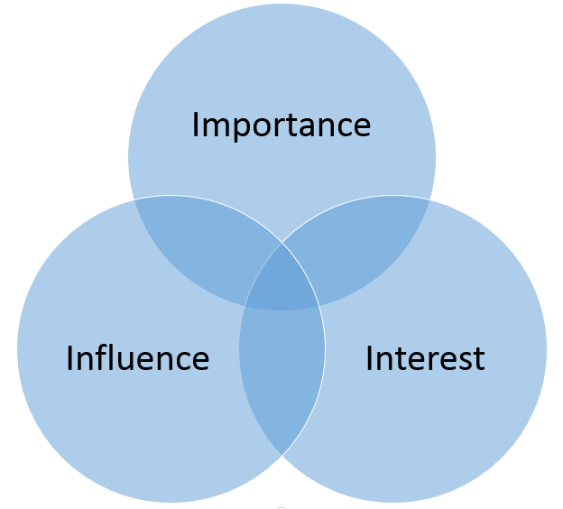
Tool 2: Another method to identify how important it is to engage the stakeholder is by placing them in a (Venn) diagram as here to the right:
The distance to the center might signify the level of interest, influence, etc. Logically, the stakeholder with most overlap in dimensions are most important to engage with. the placement in which (combination of) circle(s) should also give you clues of how to engage or address the stakeholder. Like tool 1, you can also use other dimensions you might find relevant, e.g. legitimacy. And you may want to ‘move’ stakeholders when (further) developing the ToC.

Step 3: engagement strategies for key stakeholders
From step 2 you should identify the most important, key stakeholders necessary to engage with for achieving the end outcomes for a climate smart landscape (inclusive governance, sustainable practices, responsible finance and business) or strategies to achieve this.
Some key stakeholders might be allies for success, or opponents, some stakeholders who have little influence you might want to give more influence. In this step you describe in which way these key stakeholders need to be engaged, e.g. as ally, to keep informed, to target with lobby & advocacy, to empower, to keep satisfied, to monitor, etc. and what actions are required to achieve this.
To identify possible allies and opponents place the stakeholders in the following table:
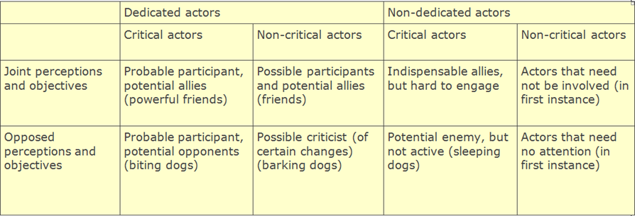

Key questions to ask to identify engagement strategies for key stakeholder:
- Which stakeholders have potentially the biggest influence (+ or -) or are mostly affected (have the ‘highest stakes’) by the programme (the ‘key stakeholders’), with regard to the intended changes sought in the landscape ToC? How important are they for the success of the programme (implementation and intended outcomes)?
- What is their influence now and would we like to see changes in the influence of this stakeholder in a ‘clmate’ smart landscape?
- How are they or will they be affected?
- What are potential allies, which stakeholders could be champions/agents of change for success? Which stakeholders could be potential opponents?
- What are challenges in relation to this stakeholder?
- What can the stakeholder/actor possibly contribute to the success of the programme, e.g. information; human resources (personnel, expertise); a network; financial resources; material, facilities and/or equipment; mandate, policies, etc. (= resources)
- What action needs to be undertaken to engage, inform, befriend, monitor, etc. the stakeholder?

Now you should have enough information to define how the different stakeholders should be approached and what actions should be undertaken. Put the results in the following table:

Key Stakeholder/  actor | Present level of influence | Desired level of influence | ally/ champion/ opponent | Challenges | Resources | Required action
Women
Young men/ boys
Young women/ girls

Annex III: Engagement, Commitment and Action (ECA) Tool
This is the tool as it was used during GLA1. It can help to distinguish and reflect on the starting and targets levels, and the different steps in L&A processes.
With the tool you can:
- Assess the baseline or starting situation
- Set targets for the full programme period and each year of the programme
- Track progress, assess achievements

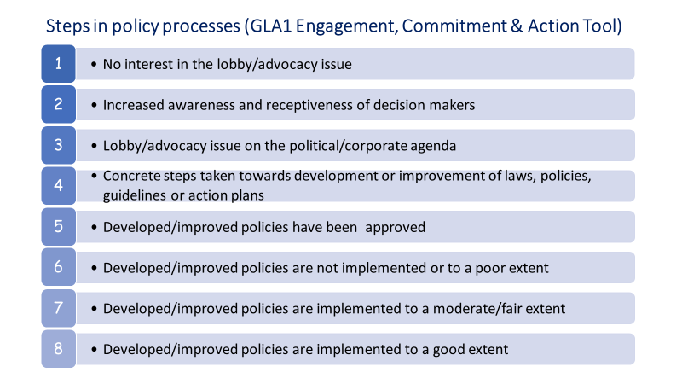
NB Policy/practice influencing processes are by their nature complex. The tool is therefore not necessarily linear and sequential, for instance certain levels could be jumped-over or levels could happen simultaneously. The tool has an inherent element of subjectivity and does not give a direct measure of only GLA-partner influencing result: the level might have been reached through a variety of actors besides GLA partners. That means that being higher in the scale is not always better. The scale is merely meant as tool for setting targets and as reflection for what has been achieved.

Annex IV: Civil Actor Participation (CAP) tool
This is the tool as it was used during GLA1. It is adapted from an existing tool (Arnstein’s Ladder of Participation’). It can help you to distinguish and reflect on the starting and targets levels, and the different steps in participation and inclusion processes.

‘Civil actors’ can be local CSOs, CBOs, communities or specific local community groups (e.g. indigenous people, women, youth, etc.). But it can also be regional or national level CSOs that GLA southern partners train and/or connect with for L&A reasons.

This tool is different from the Engagement, Commitment and Action (ECA) tool that GLA uses for public and private actors. The civil actor’s outcomes have to be assessed differently because public and private actors are usually the ‘power holders’ contrary to civil actors. This means that for civil actors other aspects have to be assessed than for public and private actors.

The tool is intended for :
- assess the baseline or starting situation;
- set targets for the full programme period and each year of the programme;
- track progress, assess achievements

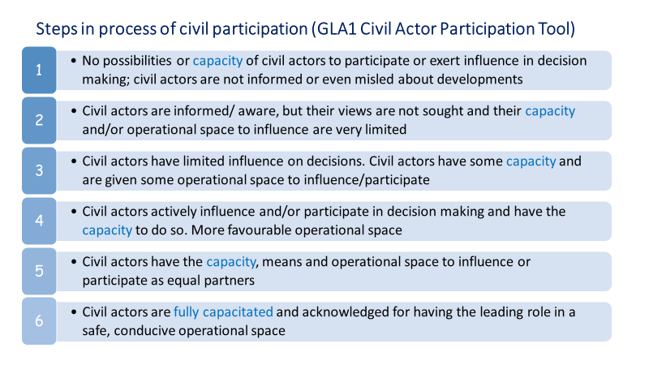
NB: Influencing processes are by nature complex. Like the ECA tool this CAP tool is not necessarily linear and sequential, the distinction between levels is gradual and a higher level in the scale is not always ‘better’! Levels for different aspects could differ, e.g. the legitimate operational space could be level 3 (limited), while the capacity of civil actors to use this space for meaningful influence/participation might be level 1 (non-existent) . The scale is merely meant as tool for setting/defining a baseline/starting and targets and as reflection for what has been achieved for the distinct aspects.

Indicate country.
NB: Information in this report may be used for online publishing on the internet (IATI), or in TBI reporting or communications. In case you have an objection to this or if you think information in this report should be made anonymous or be excluded, please inform your country contact person or include a note stating the information is confidential. For further information on IATI, contact trudi.vaningen@tropenbos.org.
You can use the list of abbreviations used in earlier reports
Indicate the (country/thematic) longer term ToC outcome to which the intended outcome(s) in the next column would have contributed. Refer to the number of the outcome in the country/thematic ToC, unless the outcomes in the ToC are not numbered.
Provide the description of the intended outcome, referring to the number of the outcome in your 2022 work plan, if these were numbered. Start by listing the intended outcomes for which interventions have taken place (reason 1, just copy and paste this from your 2022 Work Plan / PMEL framework), followed by intended outcomes for which no interventions have taken place (reason 2).
Short but specific description of intervention/activity (what, when, where, with or for whom) that did take place (but did not lead to an outcome (yet). Refer to the numbers of the activities of the outcome in your 2022 work plan, if these were numbered . If intended activities did not take place, indicate ‘did not take place’
Explain why the interventions did not lead to the intended outcome (yet)(1), or, why the interventions did/could not take place (2).
So what does this mean? What action will be taken, will the issue be dropped, is there a need to adapt the strategy?

