TBI WORKING LANDSCAPES PARTNER PROGRESS REPORT 2021 INDONESIA

With this Progress Report, your organisation accounts for your WL activities and achievements of 2021. The format focuses on learning about the strategies and achievements of your organization, and related adaptations. In addition to strategic learning, the reporting on achieved outcomes and results will be used for accountability to the Dutch Ministry of Foreign Affairs.

Name of CSO | Tropenbos Indonesia
Location of CSO | Taman Cimanggu, Jl. Akasia I Block PI No.6, Tanah Sareal, Bogor, Indonesia
Email address | edipurwanto@tropenbos-indonesia.org; + (62) 81 296 55 233
Primary Contact person | Edi Purwanto
Name(s) of Harvester(s) | Edi Purwanto, Dia Mawesti
Location of activities | Ketapang and Kayong Utara Districts (abbreviated as K-KU), West Kalimantan, Indonesia
Project Title | Working Landscape Programme: Promoting sustainable use of forest and trees for people and climate

List of abbreviations_________________________________________________

AEW  APL  Apkasindo  BAPPEDA  B&F  BKSDA  BRGM  BUMDes  CPO  CSR  CSO  CU  Distanakbun  DG PII  ESG  ES  FFB  FFI  FFS  FST  FGD  FPIC  GAP  GAPKI  GHG  GIZ  GLA  GPNP  GJPF  HCV  HD  IDH  IDM  ISP  ISPO  IPLC  Kalfor  KEE  KKU  KHG  KPH  KUPS  L&A  LC  LIPI  LM  LPHD  MoEF  MSWG  MSP  NDC  NTFP  OP  PES  PP  PPL  PG  PETI  PLUP  PM  PMP  PUPR  Pokdarwis  Proklim  PT. BGA  PT. PAS  PT. DAS  PT. GMS  PT. KAL  PT. MPK  RaCP  RSPO  RPPLH  TI  ToT  SB  SD  SP  SF  SFL  SPM  STDB  UPPB  UNDP  WK  YIARI | Agriculture Extension workers  Land outside state forest areas (non-forest land-uses)  Asosiasi Petani Kelapa Sawit Indonesia (Association of Indonesian smallholder Palm Oil)  Badan Perencanaan dan Pembangunan Daerah, Agency for Development Planning  Business and Finance  Balai Konservasi Sumber Daya Alam, Natural Resource Conservation Agency, Ministry of Environment and Forestry (MoEF)  Badan Restorasi Gambut dan Mangrove, Peatland and Mangrove Restoration Agency  Badan Usaha Milik Desa, Village Business Units  Crude palm oil  Corporate Social Responsibility  Civil society organization  Credit Union  Dinas Pertanian dan Perkebunan, Agency on Agriculture and Plantation.  Directorate General of Climate Change Control, MoEF  Environmental, Social and Governance  Environmental Services  Fresh Fruit Bunches  Fauna & flora international Indonesia  Farmer Field School  Fire Smart Territory  Focused Group Discussion  Free Prior Informed Concern  Good Agricultural Practices  Gabungan Pengusaha Kelapa Sawit Indonesia, Indonesian Palm Oil Association (IPOA)  Greenhouse Gas  Deutsche Gesellschaft für Internationale Zusammenarbeit GmbH  Green Livelihoods Alliance  Gunung Palung National Park  Gunung Juring Protection Forest  High Conservation Value  Hutan Desa/Village Forest  Inisiatif Dagang Hijau, The Sustainable Trade Initiative  Index Desa Membangun, Village Development Index  Independent smallholder oil palm plantations  Indonesian Sustainable Palm Oil System  Indigenous Community and Local Community  Kalimantan Forestry Programme  Kawasan Ekosistem Esensial, Essential Ecosystem Areas/wildlife corridor  Ketapang and Kayong Utara  Kawasan Hidrologi Gambut/Peatland Hydrological Unit.  Forest Management Unit  Kelompok Usaha Perhutanan Sosial, Social Forestry Business Group  Lobby and Advocacy  Lestari Capital  Indonesia Institute of Science (National Research and Innovation Agency/Badan Research dan Inovasi Nasional/BRIN)  Laman Mining  Lembaga Pengelola Hutan Desa, Village Forest Management Body  Ministry of Environment and Forestry  Multi-stakeholder working groups  Multi-stakeholder Platform  National Determent Contribution  Non timber forest product  Oil palm  Payment for Environmental Services  Pawan-Kepulu-Pesaguhan Landscape/Peatland Hydrological Unit (PHU)  Penyuluh Pertanian Lapangan/Agriculture extension workers  Pematang Gadung Village  Penambangan Emas Tanpa Ijin, illegal gold mining  Participatory land use planning  Participatory Mapping  Perkumpulan Mitra Pembangunan/local NGO.  Public Work and Community Settlement Agency  Kelompok Sadar Wisata, Village organization to manage ecotourism  Program Kampung Iklim, Climate Resilience Village Program  PT. Bumitama Gunajaya Agro, oil-palm management unit  PT. Pacific Agro Sentosa, oil-palm management unit  PT. Damai Agro Sejahtera, oil-palm management unit  PT. Gema Makmur Sentosa, oil-palm management unit  PT. Kayong Agro Lestari, oil-palm management unit  PT. Muharison Pawan Katulistiwa, natural forest concession holders  Remediation and Compensation Procedure  Roundtable on Sustainable Palm Oil  Rencana Perlindungan dan Pengelolaan Lingkungan Hidup, Planning for protection and management of life environment.  Tropenbos Indonesia  Training of Trainers  Sungai Besar Village  Simpang Dua  Sungai Pelang Village  Social Forestry  State Forest Landscape  Social Performance Management  Surat Tanda Daftar Budidaya Perkebunan, Cultivation Registration Certificate  Unit Pengolahan dan Pemasaran Bahan Olahan Karet/Collective Rubber Processing and Marketing Organization  United nations development programme  West Kalimantan  Yayasan Inisiasi Alam Rehabilitasi Indonesia/International Animal Rescue (IARI)

INTRODUCTION

This progress report provides your reflections on your 2021 achievements and progress. The content will be based on your harvested outcomes of 2021 (to be put in section 1.7), and on the results of the team Reflection and Learning meeting.

Please upload your completed draft progress report before the first of June in this WL google drive folder and let your country coordinator and us (Luis and me) know! This way we can give our feedback and you can still add/change when needed.

Reflection and Learning meeting

This section aims to provide some guidance for the WL in-country Reflection and Learning (R&L) meetings taking place in May 2022.
Please organise a R&L meeting with all relevant staff, your country coordinator, and if applicable, with implementing partners prior to finalising the progress report. We don’t send separate Reflection and Learning Meeting guidelines. In general, the questions asked in each section of the progress report format can be used as guidance for reflection and discussion. Of course, in addition you can also reflect on your own specific learning questions if you have them.
The R&L meeting serves to agree on how much progress has been made in intended programme implementation and achieving ToC objectives, to discuss the main insights you have gained from programme implementation, outcome harvesting and other monitoring results, and the way you consider to make adaptations and move forward to reach intended objectives.

This year, the R&L meeting also serves as a kick off of for reflecting about two key elements of the WL Mid Term Review (MTR):
- Achieving indirect impacts (scaling)
- Validity of Programme Assumptions
Instructions on the conduct of these two MTR topics will be provided by your country coordinator (who is your MTR contact person as well).

We expect that all country teams have harvested outcomes and collected other information needed for the R&L meeting and prepared a draft progress report with this information prior to the R&L meeting. Now, after almost 3 years of full programme implementation, the aim is to assess at what point you are, how things are going, which prevailing challenges and opportunities you faced, how you dealt with it and what can be learned from that, as well as the main implications for the programme - all keeping in mind your intended end-outcomes and key propositions that underlie your Theory of Change.
You can discuss the guiding questions in sections 1.1 to 1.6 of this progress report (PR) format, based on your outcomes in section 1.7, including unintended, unexpected and negative ones (tables 1a and 1b), and intended outcomes you didn’t achieve (yet) (table 1c).

For reference, also for staff or partners that could not participate in the ToC refresher, you can watch the recordings of the ToC refresher webinars (session 1 on 3 May and session 2 on 10 May 2022) again and visit the ToC refresher Miro board.

2021 achievements and progress

Context
What changes in context did you see in the social / political / environmental / operational space / landscape situation in 2021 that have influenced the implementation of, and reaching the goals of your 2021 work plan? How? Which of these developments have led to increased risks or provided new opportunities for the programme? As a result, did you make changes in your 2021 goals, strategies or ToC targets and assumptions?

No | Context changes | Impacts to WL in K-KU
1 | The national plan of Food Estate Establishment at the expense of state forest | Affects positively that it covers illegal gold mining areas, but negatively for the forested areas
2 | New programs in Ketapang and such as USAID Sustainable Environmental Governance Across Regions (SEGAR), COPLI funded by IFAD, that incorporate peatland issues | Complementary for various interventions under Fire project. However, so far the impacts of the new programs have not been clear yet.
3 | New project at TI starting in 2022 funded by Kalimantan Forest (KalFor) in four villages in Ketapang District and three villages in Sintang District | Opportunity to scale up WL business best practices to women and youth.
4 | The steadily high price of palm oil price leading to conversion of rubber gardens into oil palm plantations | Affecting negatively efforts to improve rubber farming/AF
5 | The creation of Agrobusiness and Canal Recreation Sites under district government program around peatland areas | Possibly as positive effects to the peripheral areas for communities to implement no-burning management, while it might affect negatively the peatland rewetting planning.
6 | The issuance of the regulation by the Ministry of ‘Village, Underdeveloped village development and Transmigration’ No 13/2021 which endorses the use of Village Fund for environmental or social forestry management. | Affects positively that the internal financing mechanism in the village can be utilised for village-based SF scheme such as Village Forest.
7 | Presidential Regulation No 44/2020 on New Indonesian Sustainable Palm Oil certification systems which mandates ISPs to be ISPO certified in 2024 | It should affect the spirits of local government to speed up ISPO certification of ISP, which has been targeted by the regulation that all ISP should be ISPO certified in 2024.
8 | Presidential Regulation 98/2021 on carbon values and NDC which mandates subnational governments to develop action plans for CC mitigation and adaptation | Opportunities for WL to L&A District govt to develop the action plan on CC adaptation based on our vulnerability assessments and landscape implementation models. There are still big uncertainties on the intentions by the district govt as well as how much time it takes to pursue the action plan development, considering the preconditional regulations that need to be in place prior to action plan development
9 | Government Regulation No. 21/2021, roles of Forest Management Unit (KPH) have been changed from business unit actor to facilitators. | Positively affects TI facilitation to acheve MoEF’s Social Forestry schemes in Simpang Dua villages (Mekar Raya, Kamora and Batu Daya) Landscape. Previously KPH did not support TI facilitation for Social Forestry rights, as KPH prefered to include the community areas to be under its management area with partnership scheme.

Theory of Change, lessons learned and adaptations

Add the visual of the latest version of your ToC. For reference please include the numbers of the ToC outcomes and use the same numbering in section 1.7.

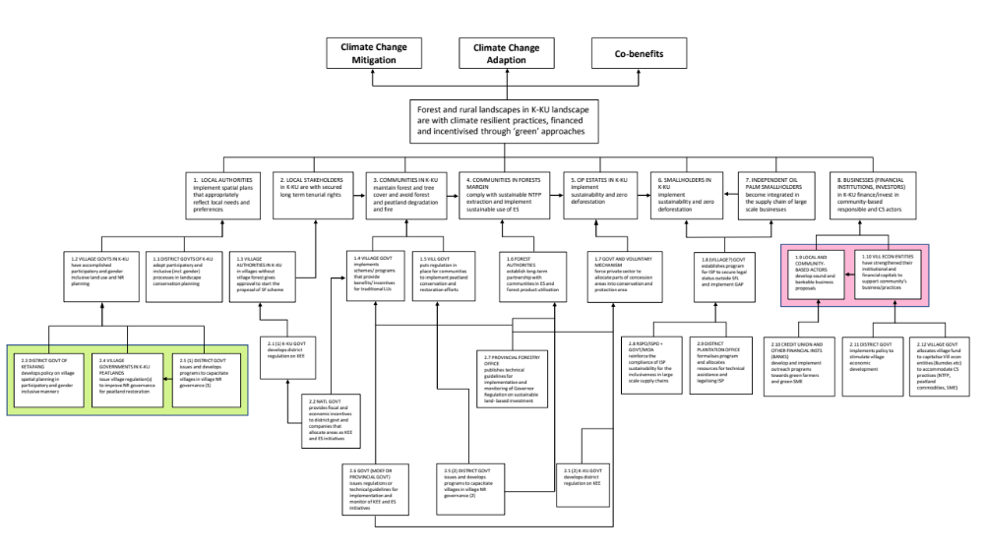

Figure 1a. ToC Working Landscape 2019

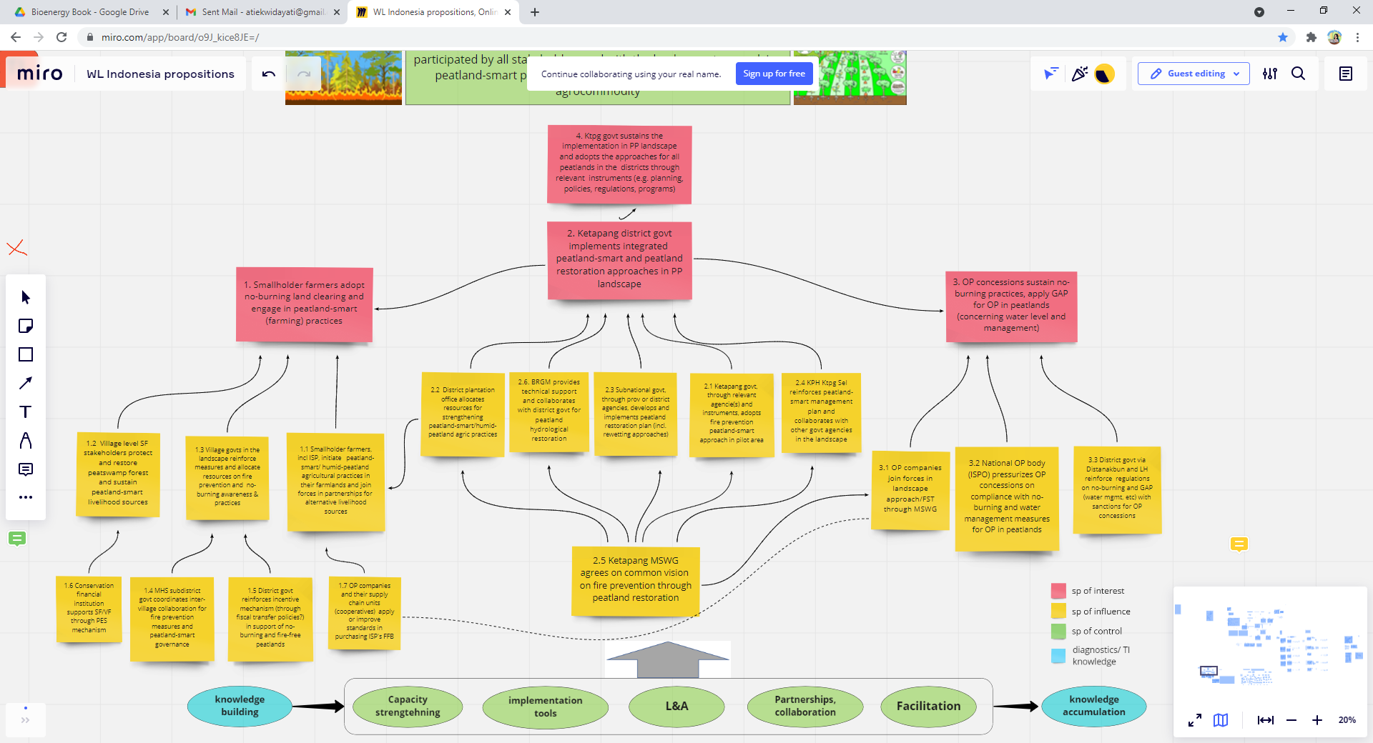

Figure 1b. ToC Wildfire 2021

Reflection questions:
Stakeholder changes: Refer back to your baseline stakeholder analysis, notably step 2 (power, influence and interest analysis, see the guidelines in annex III). What changes did occur In the stakeholder ‘landscape’? Do you need to adjust your strategies to deal with changing stakeholders or changes in power, influence and/or interests?
By the end of 2021, there were tour of duty (reshuffle) of key government officials in Ketapang District, this has been affecting our team who involved on District level MSWG, in particular affecting the speed of works in MSWG.
Since early 2021, after we have started working on peatland restoration, we started to build relations with BRGM, as organization who received mandate from the President to design canal blocking and conduct peatland restoration. This finally resulted to the signing of MoU with BRGM in September 2021 (with Deputy on Community Empowerment) and in February 2022 (with Secretary of BRGM) which cover all the deputies within the BRGM body, followed by the signing of collaborative workplan 2022-2024 in April 2022. In mid-May 2022, the BRGM and TI has started working to map of the topography of the PP PHU (Peatland Hydrological Unit) as a basis to develop canal blocking.
The aims of the collaboration with BRGM are: First, to have their authority (power) to design canal blocking, so TI does not need to design the canal blocking design ourselves with the risks of being blamed by the local community if the design is improper. Second, to use the leverage of their influence as national agency to the local government and community in the surrounding peatland areas on the awareness and commitment raising on the importance of peatland restoration to prevent fire incidents.
The power and influence of BRGM, MSWG at district, level and MSWG ‘Formad Lingkar’ at the landscape level are necessary to conduct peatland restoration and wildfire prevention at the PP landscape. While for the Simpang Dua Landscape, MSWG ‘Gunung Juring Bersatu’ need to be strengthened to support facilitation of regular patrol to Gunung Juring Protection Forest and to enhance the commitment of the villages to establish UPPB in 2022.
In 2021, with the facilitation of the West Kalimantan Environment and Forestry Agency (WKEFA), we were successful in reactivating the Multi Stakeholders Platform (MSP) after more than one year of inactivity. We kept WKEFA as our key stakeholders to organize meetings of the Ketapang Essential Ecosystem Area (KEE) connecting wildlife corridor between Sungai Putri and Gunung Palung National Park and Gunung Tarak Protection Forest, as by the rule the KEE in under the domain of WKEFA.
Collaboration: With which other organisations/partners did you collaborate in 2021 or did you start a collaboration?
In November 2021, we submitted Project Proposal to Kalfor (Kalimantan Forest, a program under UNDP), entitled ‘Building sustainable livelihoods to protect remaining forest in non-state-owned forest areas.’. The proposal has been accepted by Kalfor to be implemented during the period of April 2022 to March 2023 with a possibility of extension. The overall objective of the project is to change the behaviour of local community to improve framework of the businesses managed by local community. The project is implemented in seven villages in the two districts: Ensaid Panjang Village, Bangun Village, Sungai Buluh Village (Sintang District) and Sungai Kuri Village, Riam Bunut Village, Pangkalan Suka Village, Tanjung Pasar Village (Ketapang District).
Kalfor is our old partner in developing MSWG (Sekber) in Ketapang District in 2020, now is being a new partner for collaboration to scale-up our visions and outcomes which have been developed and achieved in the Working Landscape, such as ‘Farmer Field School’ which will be modified to ‘Farmers Business School’, capacity strengthening for women and youth on business development, as the scale-up of MoMo4C Call. Kalfor hopefully will be our excellent partner to strengthen our capacity to scale-up our visions and outcomes.
Other potential collaboration is with new projects which supporting Ketapang District, such as ‘USAID Segar’ in PP landscape, however so far it is not yet clear about the potential collaborative actions plans.
Assumptions: From implementation, can you prove certain assumptions underlying your ToC valid or invalid? Which ones and why?
The validity of the assumptions has been checked based on the intervention strategies applied in the course of 2 years project implementation, as summarised in the table below
In Graphic ToC (Figure 1a) | Assumption | Validity by 2021
From 1>vision | Assumption #1: Consideration of local interests in decision making leads to more climate smart decisions; local people are in favour of small-scale land use patterns including tree-based systems that can sustain or improve livelihoods | To some extent the assumption is valid in the case of traditional LU managed through generation (which is CS) and the communities are attached to the traditional tenurial system. In some other cases, the alluring oil palm representing less CS practice are more preferred.
From 3, 4, 5,6>vision | Assumption #2: Traditional LUs and peatland LUs that adhere to tree-cover maintenance, and zero-deforestation OP estates and ISP that are upscaled throughout the landscape and sustained in long term create CS landscape/C resilient landscape | We think that the assumption is valid, although the achievements towards creating CS landscape is still a work in progress
From 7, 8 > Vision | Assumption #3: The financing and inclusiveness through formal mechanism and/or large-scale businesses for the community-based practices and local green businesses lead to long-term and wider application of CS practices | We think that this is still the right assumptions. However, there’s not yet evidence to prove the validity of this assumption as no existing formal mechanism and/ or large-scale business for community-based practices
1.1, 1.2>1 | Assumption #4: Participatory and inclusive processes by the representatives from all stakeholders at (1) the village level and (2) district level will include community needs and aspirations | This assumption has been proven valid. With participatory and inclusive approaches that we have implemented, needs and aspiration of diverse groups (including women, youth, and marginal groups) within the local community at the village and district level have been appropriately addressed and incorporated
2.1>2 | Assumption #5: Approval from village authority to go for SF scheme (against other options) is key for village stakeholders to proceed with SF scheme processes which will ultimately bring the tenurial security that the communities need | This assumption has been proven valid. And throughout the project period we successfully facilitated village stakeholders to propose SF scheme and got supports from the village authority to submit the proposal to the MoEF
2>3 | Assumption #6: Secured access to lands makes local stakeholders maintain sustainable (climate smart) choices with long term investments (such as trees), because they will reap the long-term benefits | We found that the validity of this assumption is proven true for communities occupying state forest lands. SF rights as tenurial forum proves that communities are eager to maintain sustainable practice.
3.1/3.2>3 | Assumption #7: If the scheme and benefits are in line with what community’s need, e.g. income and customary law, they are more likely to maintain the traditional gardens/tembawang with tree-cover | We found that under the current strategy of supporting rubber market, local communities are willing to maintain traditional gardens/ tembawang with tree-cover as the source of their livelihood options, especially with additional incentives to protect tembawang that serves their needs
4.1>4 | Assumption #8: The long-term partnership brings trust and secured access to forest for communities which make it more likely for them to commit to sustainable practices and green operations | We found the indication that the assumption is proven true. With long term financial support in partnership with Lestari Capital to maintain village forest areas and secured sustainable practices and livelihood for local communities
5.1>5 | Assumption #9: Requirement for allocation of conservation/protection area combined with regulation that has deterrent effect to their permits will lead to compliance with sustainability and zero deforestation | Insufficient to check the validity of this assumption as Proposition 3 is dropped
6.1/7.1>6 | Assumption #10: ISP with GAP will have increased yield (and thus income) and therefore are willing to comply with sustainability standards that are adapted to smallholder | We are still testing the assumptions through improvements of GAP. Adaptation of the sustainability standards that are suitable for smallholders need to be defined first before we’re talking about compliance
6.1/7.1>7 | Assumption #11: ISP that meet the sustainable requirements will attract large-scale businesses/OP companies as buyers | Insufficient to check the validity of this assumption as Proposition 3 is dropped
7>6 (changed to Fire no 3 (or F3) | Assumption #12: Inclusive ISP, financially supported CS entrepreneurs and strengthened village business sustain in the landscape, so that the dreamed sustainable LU practices can also sustain | When smallholders are inclusive in supply chain, they are willing to implement GAP and sustainable practices. However, we are still testing this assumption on the ISP inclusivity in the supply chain.
8.1>8 | Assumption #13: Sound and bankable businesses by local actors/ communities attract financial institutions/ banks and make them commit to support the community-based businesses | We found that this assumption is valid as strongly established profitable businesses are more appealing to financial institutions. One of the horticulture businesses gets financial support from Credit Union. Commitment to support the community-businesses however depends on the type of the business, the type of the commodity, and its potential market opportunity
8.2>8.1/8 | Assumption #14: Strengthened Village economy entities will be effective support/hub for local businesses, and with that role they become attractive to banks/financial institutions to support them | There is indication that this assumption is partly valid that (inter-) village level economic entities such as UPPB for rubber collective marketing can be effective as a hub for local farmers and attract social investors. Questions regarding whether such business will be able to attract bank and other financial institutions due to the requirements on credit history and other additional legal supporting documents (that might be more complicated for business owned by community groups) can be barriers to access financing from private entities

Strategies: Are there outcomes that, with the experience you have until now, consider to be very difficult to achieve? Why? So what to do? What interventions/strategies worked well? Did you face any challenges?

Lessons learned: Summarise what you learned about your strategies, assumptions, external influences, dealing with stakeholders, collaboration with other partners, and other challenges from implementation in 2021.

Proposition 1 – KEE and HCV

Challenges:
After reactivating the Multi-stakeholders Platform (MSP), facilitated by West Kalimantan Environment and Forestry Agency (WKEFA) since October 2021, and so far has been running for more than half year, we still have difficulties to manage and protect the Ketapang Essential Ecosystem Area (KEE).

KEE was designated by the Governor Regulation No. 718/2017, which connects High Conservation Value Areas (HCVA) of large-scale oil-palm plantations (PT. KAL and PT. GMS) to form wildlife ecological corridor between two landscapes, i.e. Sungai Putri Landscape with Gunung Palung National Park and Gunung Tarak Protection Forest Landscape. So, it could bridge the orangutan (Pongo pigmeous) population of the two habitats, which had been disconnected since 2008, due to the establishment of large-scale oil-palm plantations. The facilitation pathway is aimed to reach the end outcome: Oil-Palm Estates in KKU implement sustainability and zero deforestation (ToC#5).

Due to the intensive operation of Laman Mining since 2018, after half-year the KEE has been declared, which conducts bauxite mining operation and opened the mining roads of 30-meter width across the Ketapang KEE. Now, the wide road has being a short-cut of public road of Ketapang-Pontianak.

Since mining is being one of the most promising sectors for business and investment that received the top priority from the Indonesian government above oil-palm plantation investment, the expansion of its proposed smelter development at the expense of HCVA of large-scale oil-palm plantation (PT. KAL and PT. GMS) seems to be unstoppable.

Lesson learned:
1. We need to involve the West Kalimantan Province and Ketapang District Government to review the validity of their regulation (Governor Regulation No. 718/2017) as a way to reflect to their past commitment. What the concequence to the protection of the KEE if it is still considered as a valid regulation.

Our assumption:
By reviewing the regulation, it will raise spirits of West Kalimantan Province and Ketapang District government to protect of the minimum areas of the KEE. At least, there will be the way to align with the existing regulation, Governor Regulation No. 6/2018 on sustainable land-based investments, where concession holders (large-scale oil-palm plantation) have to allocate a minimum 7% out of their concession as HCVA.

Collaboration:
For the review facilitation, we will collaborate with Kalfor and Teraju Institute.

Future strategy:
Considering the above, we will organize the review meetings of the Governor Regulation No. 718/2017 involving the West Kalimantan Province government and Ketapang District government together with all KEE stakeholders, The meeting is aim to facilitate reflections of the Province and Ketapang District government commitment on the establishment the wildlife and ecological protection (KEE) regulation in 2017. If both governments still have committed to the regulation, this should be actions to protect KEE or at least they will protect the minimum (core) areas of the existing KEE. This is aligned with the West Kalimantan Governor Regulation No. 6/2018 on sustainable land-based investments, where concession holders (large-scale oil-palm plantation) have to allocate a minimum 7% out of their concession area as HCVA. If the governments are still committed to the regulations, actions should be taken by the government to protect the core areas of the KEE.

Proposition 2-Peatlands and Fire Project

Challenges:
Despite the large areas of peat domes (>4 m deep), the major parts of the peatlands in our landscape have long been designated as private lands, allocated for transmigration land allocation, back in 1970s-1980s. And even after there are improved understanding on peatlands in the past decade and numerous regulations to protect peat domes, there have been no concerted efforts from national to district level to fix the issues, even after fires become major problems. Fire suppression and fire-fighting methods are still favoured instead of restoring the peatlands. Smallholders’ farmers also prefer to keep the peat dry due to production and management reasons. They prefer to be equipped for fire-fighting efforts rather than managing the lands under wet condition, or even the risk of flood. These are the major challenges for key Outcome of (ToC 1): Smallholder farmers adopt no-burning land clearing and engage in peatland-smart (farming) practice.

There are two large-scale private oil-palm plantations in PP PHU, i.e. PT. Artu and PT. Limpah Sejahtera, who should be active as the MSWG members and working together with us to ensure that the management of the concession areas have conducted no-burning practices and applied GAP. However so far, efforts to conduct dialogues to them are still challenging. The major reasons are all the operations at the field level are operated from the centre office in Jakarta, while all the staff on the field have no decision-making power and developing contacts to the head-office have not been successful. This resulted in unachieved outcome for ToC 3: Oil-Palm (OP) concession sustains no-burning practices and apply GAP for OP in peatland.

Lesson learned:
2. We realised that collaborative efforts with the right actors and through the right structure (MS platforms) provide enabling conditions such as trust for TI as an NGO/CSO to lobby the major actors: government, communities and private sector, to conduct awareness raising and other facilitation
3. From the difficulty in dealing with the large-scale oil palm plantations in the landscape, we learn that we need to develop relations with the higher-level actors that have decision-making power and/or influential powers, i.e. the head office and the Association of Oil Palm Corporation (GAPKI).

Our assumptions:
Involving the right actors in charge as well as with the right infrastructure of MS platforms, the trust that TI has got will be maintained and we are able to continue our facilitation to improve the target actors and eventually contribute to the reduced fire and peatland-adaptive practices

Future strategy:
We are working together with BRGM and MSWG (at district level) and will conduct awareness rising to Ketapang District government on the need to manage peatland landscape on the basis of wet-peatland adaptive agriculture. Together with MSWG, we will urge Ketapang District government to develop regulation (instruments) on managing PP landscape. Development of demo-plots of peatland-adaptive practice will also help improve awareness and build intention of farmers to adopt.

We need to communicate with the Centre Offices of both large-scale oil-palm plantation and also communicate through GAPKI (Indonesian Palm Oil Association/IPOA) at Province level.

Proposition 4 - Agroforestry

Challenges
During the last three years, the price of oil-palm plantation has been continuously increased, this has been triggering the conversion of traditional (rubber) agroforestry (tembawang) into oil-palm plantation which led to the failure to protect indigenous land-use in Simpang Dua landscape. This is related to (ToC#3): Communities in K-KU maintain forest and tree cover and avoid forest and peatland degradation and fire.

Lesson learned
4. The establishment of UPPB is expected to raise benefit to smallholder rubber farmers, so they will return to their rubber garden cultivation to manage and enhance their rubber production and prevent the conversion to oil-palm plantation.
5. Establishment of Demo-plots for rubber agroforestry and permanent agriculture will be expected as living laboratory and those can be copied by smallholder farmers within and surrounding Simpang Dua landscape.

Our assumptions
- UPPB as a government program, if it is properly initiated and managed, will maintain their rubber agroforestry from smallholder oil-palm plantation conversion.
- Exposure of demo-pilots on rubber agroforestry and permanent agriculture to local farmers will be easily copied by smallholder farmers.

Future strategy:
We have conducted Farmers Field School (FFS) to improve existing ‘rubber jungle’ into rubber agroforestry, together with improved tapping method and post-harvest treatment rubber materials. This has been proven to improve rubber agroforestry yield, those efforts together with developing rubber farmers groups at village level would be the beginning stage to establish UPPB to change the role of middle men to link the marketing of smallholder’s rubber to PT. NKP. It is expected that UPPB will raise benefit to rubber farmers, so they will return to their rubber garden to manage and enhance their rubber production and prevent the conversion to oil-palm plantation.

FFS will also developing demo-plots for rubber agroforestry and permanent agriculture as an example to be copied by smallholder farmers within and surrounding Simpang Dua landscape.

NDC

Challenges
The issuance of Presidential Regulation 98/2021 on carbon values and NDC has created opportunity to facilitate the development of adaptation action plan at the district level as part of NDC efforts at local level. However, there is unclarity of the prerequisite prior to the development of action plans, i.e. regulations at the provincial as well as at the district level (Planning document on Environmental Protection and Management - RPPLH). In addition, there seems to be lack of urgency by the district government on addressing climate change issues and to respond to the Presidential Regulation.

Lesson learned
6. We learned that prior to facilitating the climate change adaptation action plan development (to respond to the Presidential Regulation), we must understand the overarching/prerequisite policy framework to be able to lobby the district government.

Future strategy
We will clarify this to the office in charge, i.e. District Planning Agency, as well as conduct rapid policy assessments on the policy and regulation structure. We will weigh on the possibility of facilitating the development of the prerequisite regulation (RPPLH), or we may collaborate with other partners (USAID Segar?) to develop this document.

We will replicate Village Proclim Program (MoEF’s Climate Resilience Village Program¹) which is now only in Sungai Pelang Village to surrounding villages in PP Landscape and villages in Simpang Dua Landscape.

Note: Proklim is the National Movement for Climate Change Control at the Community-Based Site Level in Indonesia. TI supports MoEF to build 20,000 Proklim Village sites in 2024, in which in 2021 was still registered 3.270 sites.

Adaptations to ToC outcomes, assumptions, targets or strategies
Describe any adjustments you have made, or will make to the ToC (outcomes/targets and/or assumptions) and/or strategies in the table below and explain why. For reference please include the numbers of the ToC outcomes and use the same numbering in section 1.7.
Pathway | Adjusted outcome, assumption, target or strategy | Explanation
1. | Additional Outcome:  As pre-condition to achieve Outcome: ToC#5: Oil-Palm Estates in KKU implement sustainability and zero deforestation, we need to achieve the following Outcome: Province and Ketapang District Governments review the validity of the implementation of the existing regulation (Governor Regulation No. 718/2017), after the operation of Laman mining since 2018.  Assumption:  By reviewing the regulation, it will raise spirits of West Kalimantan Province and Ketapang District government to protect of the minimum areas of the KEE. At least, there will be the way to align with the existing regulation, Governor Regulation No. 6/2018 on sustainable land-based investments, where concession holders (large-scale oil-palm plantation) have to allocate a minimum 7% out of their concession as HCVA. | If those government still have committed to the past regulation, this should be the minimum areas of the existing KEE should be protected.
2. | Additional Outcomes:  To achieve Outcome of (ToC 1): Smallholder farmers adopt no-burning land clearing and engage in peatland-smart (farming) practice. We need to have the following Outcome: Government (BRGM, District Government, MSWG), communities (Formad Lingkar) and private sector have actively conducted awareness raising and other necessary facilitation to local community.  From the difficulty in dealing with ToC 3: Oil-Palm (OP) concession sustains no-burning practices and apply GAP for OP in peatland. We need to have the following Outcome: GAPKI involve to improve relations with decision-making power of the large-scale Oil Palm Corporation in PP landscape.  Assumption:  Involving the right actors in charge as well as with the right infrastructure of MS platforms, the trust that TI has got will be maintained and we are able to continue our facilitation to improve the target actors and eventually contribute to the reduced fire and peatland-adaptive practices. | TI is working with BRGM and MSWG (at district level) and conduct awareness rising to Ketapang District government to manage peatland in PP landscape
4. | Additional Outcome:  The price of oil-palm has been continuously increased, which led to the failure to protect indigenous land-use. This is related to (ToC#3): Communities in K-KU maintain forest and tree cover and avoid forest and peatland degradation and fire. To address the problem, we need the following Outcome: UPPB is collaboratively established which link the smallholder rubber supply-change to the end buyers.  Assumption:  UPPB as a government program, if it is properly initiated and managed, will maintain their rubber agroforestry from smallholder oil-palm plantation conversion. | It is expected that UPPB will raise benefit to rubber farmers, so they will return to their rubber garden to manage and enhance their rubber production and prevent the conversion to oil-palm plantation.

Impact/KPIs
Describe to what extent your interventions and outcomes contributed to impactful changes, using the selected key performance indicators (KPIs). Refer to the sub-KPIs for which you have set targets during the inception phase (first column). NB. Describe these in words! Please give an estimation of the quantitative impact in numbers of hectares (table 1.3.1) or people (gender/age disaggregated, table 1.3.2). Distinguish between direct and indirect impact, For the definitions of direct and indirect impact see the KPI infographic in google drive. Provide cumulative numbers per sub-KPI in the last column (this means that you report on the total figures since 2019 up to 2021, so also include what you reported last year). Use the setup of your baseline to describe the changes. The first three rows (in blue) in the table below are just an example.

Table 1.3.1: cumulative estimated impact in hectares (direct and indirect)
Key performance sub-indicator | Target 2023 | Description of observed changes in the landscape | TBI’s (your) Contribution | Direct/ Indirect | Estimated impact in #hectares at the end of 2021
KPI #0. Forest cover |  | Forest cover | - | = baseline | -
KPI#1. Area that has been restored or reforested | 45,000 | Agricultural lands/degraded lands with improved tree cover | Facilitation for LPHD to conduct forest restoration | Indirect | 135
KPI#2. Area under improved smallholder agroforestry and community forestry | 25,000 | Degraded peatlands that are improved with peatland smart agriculture, agroforestry, and no burning practices  Social Forestry Area  Increase agroforestry/ tembawang | Farmers Field School | Direct | 179
KPI#3. Area under improved environmental and social standards | 160,000 | Forest and AF that are maintained and can resist from conversion to monoculture, HD areas, HCV/KEE patches, Tembawang (national parks)  Oil palm estates that identify and protect HCV areas  Area under PES mechanism  Tembawang, peatland area with improved practice and or green entrepreneur and or market/mechanism sustainable sourcing | Farmers Field School | Direct | 102
KPI#4. Area under improved company commitments | 170,000 | Villages where green entrepreneurs/farmers/SMEs received business contracts and or improved market  Villages with ecotourism destination received business contracts and or improved market | Facilitation of green businesses | Indirect | 18,604
KPI#5. Area under local control | 21,000 | Social forestry area | Facilitation for SF proposal submission to MoEF | Direct | 7,040
KPI#6. Area subject to more inclusive governance and participatory planning (landscape approaches, participatory land use plans) | 150,000 | Jurisdictional areas that are facilitated/assisted in their planning and governance processes, i.e. at District and village levels | Facilitation of PM and PLUP | Direct | 36,154
 | Total KPI: Area affected by improved climate-smart landscape practices achieved in 2021 |  |  |  | 62.214

Table 1.3.2: cumulative estimated impact on people, gender and age disaggregated (direct and indirect)
Key performance sub-indicator | Target 2023 | Description of observed changes in the landscape | TBI’s (your) Contribution | Direct/ Indirect | #  Adult Women | # Adult Men | #  Young Women | # Young Men
KPI#7. Number of men and women with improved access to forest and tree resources | 21,000 | Number of villagers in Social Forestry Area (local control) | Facilitation for SF proposal submission to MoeF | Indirect | 1678 | 1816 | - | -
KPI#8. Number of men and women that adopted climate-smart practices and management | 400 | Number or farming households/farmers for, #1, #2, #3  Number or farming households/farmers that adopted climate smart practices and management outside WL landscapes | Farmers Field School | Direct and indirect | 53 | 258 | - | -
KPI#9. Number of men and women involved in inclusive landscape governance initiatives | 250 | Number of individuals involved in participatory and inclusive planning processes, at district and village levels | Facilitation of MSWG  Facilitation of PM and PLUP | Direct | 330 | 272 | - | -
KPI#10. Number of men and women included in inclusive business arrangements | 300 | Number of farmers/HH and villagers involved in planning, discussions, consultation, for inclusive business arrangements | Facilitation of green business | Direct | 63 | 9 | - | -
 | Total KPI: Number of beneficiaries impacted by improved climate-smart landscape practices achieved in 2021 |  |  |  |  |  | 4,479

Progress: to what extent are you “on track” towards achieving the 5 year targets for the different KPIs? Why or why not?

We’re on-track towards achieving the 5 years target considering that within the first half of project implementation some of the KPIs have been achieved with considerably satisfying proportion compared to the proposed target in particular related to estimated impacts on people within KPI #7, #8, #9, and #10. For KPI#9 Number of men and women involved in inclusive landscape governance initiatives, achieved impacts of 2021 is higher than the 2023 target. As for KPI#1. And KPI #3 are expected to be achieved in 2023 with the support of Lestari Capital in PP landscape.

Key propositions and NDCs

For each key proposition describe:
- What progress has been made in 2021 towards the end goal(s)? Compared to the situation at the start of the programme, how far are you in achieving the end goal(s)?
- What challenges did you meet in 2021? Can you say that you are on track? If not, why not?
- What are your expectations/reflections for the near future? Should you change your strategies in order to achieve the end goal? How?

Provide your answers directly in the WL key propositions 2021 progress document on google drive. This document has all key proposition information together for all countries in one document, including what you intended to do in 2021 for each key proposition.
Each country has different sub-sections in this document, you can find the table (see example of the table below) in sub-section 3, e.g. for Colombia it’s subsection 1.3, for Bolivia it’s 4.3. The areas you need to complete are blue. Use max 200 words per proposition.

NDCs: Answer the same three questions for NDCs and give the answers in the same table.

Wildfire programme: Do the same for the wildfire programme when relevant. If you have a wildfire programme add row(s) to enable a short but meaningful report on progress made, like here below:

Answers are provided directly in the WL key propositions 2021 progress document

Gender & youth (F/M)

Progress, challenges, expectations/reflection
Achievements: What were your achievements towards gender and youth (F/M) priorities related to each of the five baseline indicators/three main pathways:

Pathway | Indicator | Gender/youth (F/M) priority/ outcome for 2021 | Achievements in 2021
Inclusive landscape governance: | a. Level of access to land and ecosystem services; | Women and youth are involved on the Village Forest Management Body (LPHD) and Village Forest program and or Social Forestry Business Group (KUPS).  Youth (and women) have options to take part on forest patrol and fire prevention action. | Since 2021, Village forest management Body (LPHD) has been formed in Sungai Pelang, Sungai Besar and Pematang Gadung Villages, involving woman and youth. They are developing 25 years (one generation) of protection plan in the village forest together with TI and Lestari Capital.  Women's access to environment protection scheme were improved since the recruitment of women as village forest management body committee in Sungai Pelang and Sungai Besar, while in Pematang Gadung Villages.  Moreover, young generation has been also significantly involved in inter-village joint patrol in 4 villages in Simpang Dua and 4 villages in PP Landscape, including Smart Patrol Team in degraded peatland areas.
Inclusive landscape governance: | b. Level of land tenure rights/security; | Women and youth are involved on the PM and PLUP decision making process.  Women and youth are involved on the VFMB/LPHD and Village Forest program. | Enhancing Pematang Gadung village forest status (as Village Forest) in March, 2021 has impacted to the access and control of the women and young male to the state forest land.
Inclusive landscape governance: | c. Level of participation in decision making about land & forest use and governance | Women and youth are involved on the VFMG/LPHD and Village Forest program and or Social Forestry Business Group | Women participation in decision making have been improved after Women involvement in the Village Forest Management Body in Sungai Pelang, Sungai Besar dan Pematang Gadung Villages since 2021. Also, involvement of women as rubber farmers group in Gema, Mekar Raya, Batu Daya and Kamora towards UPPB establishment. To withdraw women interest and participation the meetings were held in the evening.
Responsible business and finance: | d. Level of access to production resources, inputs and benefits | Women and youth are involved on the village business and hold strategic position within ecotourism management group and NTFP group. | Small-scale business of women woven groups (NTFP) were formed and we organized establishment of the marketing channel.  Those were held in Gema village (named ‘Nek Krenio’) (Male 1, Female 12), Mekar Raya Village (named ‘Putri Bekarya’) (all women, 7 person), Kamora village (named ‘Nek Murai’) (Male 1, Female 13). The marketing has been established along the restaurant in the Trans-Kalimantan and in several kiosk in Ketapang Town.
Sustainable land-use practices: | e. Level of participation in, contribution to, and benefits of climate smart practices) | Youth (and women) take part on the activity in improving agroforestry farming systems | Some training on agricultural and agroforestry improvement through Farmer Field School (FFS) has improved women (senior and young) and young generation access to production resources, inputs and benefits from the rubber agroforestry, permanent agriculture and horticulture organic farming. In Simpang Dua, women participation is approx. 44% from all the total participants. Involvement of women in Sungai Besar relatively high (40%), but in Sungai Pelang still low (less than 10%).  On the FFS topic on permanent agriculture through organic farming in Simpang Dua Landscape, 6 women champions have tried to implement the best practices successfully on their land. Those become the pioneer of permanent agriculture in the Villages (Kamora and Mekar Raya).

Please summarise:
- What progress has been made in 2021 towards G&Y objectives? Compared to the situation at the start of the programme, how far are you in achieving end goal(s) in priority G&Y issues? Are you satisfied or not? Why/why not?

On the indicator related to land, the progress on social forestry application were progressing quite well with Pematang Gadung has been approved as Village Forest ( ca. 7,000 ha) and Mekar Raya (ca. 1000 ha) in wating for MoEF approval, If we compared to the situation in early of project, it has some significantly improvement and so far, we have been satisfied. The role of women and youth in the village management body have increased. While the roles of women on FFS and the further implementation of organic farming on improving rubber agroforestry, post-harvest rubber treatment, permanent agriculture and horticulture farming in both landscapes have been satisfying.

- What challenges did you meet in 2021? Can you say that you are on track? If not, why not?

Develop connection with other related stakeholder in integrating gender issues. We need to ensure that the stakeholder working on gender and youth issues has the same agenda with our program.

At the moment, we do not see that particular stakeholders have relevant agenda or similar concern with ours. So we have not made any connection yet.

However, we are still on track as we work with other stakeholder and show them that we are really concern on gender and youth aspects.

- What are your expectations/reflections for the near future? Should you change your strategies in order to achieve the end goal? How?

In the future, we need to improve our strategy to achieve the goal. With support of MDF, we set up our end goal to be transformative. We have identified some key action that must be conducted as part of the transformative strategy.
Some of the strategies are:

- Series of trainings or refreshment training to improve women’s and youth skill on knowledge in forest protection, fire management, and business development.
- Develop events for sharing of experiences with other organisations, village government and other stakeholder on mainstreaming gender and youth in their activities. This might be integrated to inter-village forum session.
- Producing brief on social forestry and business group in the community that include women and youth aspect

Progress in mainstreaming gender & youth (F/M)
Are you satisfied about mainstreaming gender and youth in:
- Activities, i.e. involving women, men and youth in the design, planning, implementation and monitoring of programme activities? Are you satisfied about progress? Why/why not? What needs to improve?

Yes, we satisfied with the progress. Gender mainstreaming were taking in place, though in some ways, we still need to remind the gender target and indicator to field staff. Annual event on gender refreshment, training or monitoring still need to implement to ensure that all the activities have already meet the target on gender mainstreaming.

- Your own organisation, e.g. do you have organisational gender (equity) objectives, do you allocate time and budget for achieving more gender equity, youth engagement, etc.? Do you practice gender/age disaggregated monitoring? Are you satisfied or not? Why/why not? What needs to improve?

In 2021, we condcuted special gender refreshment and monitoring with some community groups in PP and Simpang Dua Landscapes. We allocated time and budget for improving gender equity and youth engagement.

Thematic programmes

Describe the most important achievements within the thematic programmes that apply to your country programme in the table below.
- To what extent did you contribute to the thematic outcomes formulated in the thematic workplans?

A. Agrocommodities
- Serial discussions on key characteristics of the Indonesian oil-palm sector that must be considered in the EU legislative framework on deforestation free supply-change. Explore lessons learned, based on Tropenbos Indonesia’s ongoing work in West Kalimantan, leading to key considerations that EU policymakers should take on board when developing their ambitious plans for more sustainable agrocommodity supply chains.
- Facilitated farmer group (Payak Makmur) in Sungai Pelang Village to arrange STDB of ISP Farmer Group which composed of 21 households’ members) and 57 ha (30 plantation units.
- Facilitated Farmer Fiedl Schools (FFS) on organic farming in 4 villages (Gema, Mekar Raya, Batu Daya and Kamora) in Simpang Dua Landscae, and two villages (Sungai Pelang and Sungai Besar Villages) in Pawan-Pesaguhan Landscape.
- In Simpang Dua, FFS has resulted on transforming jungle rubber into the rubber agroforestry with widen space amoing trees, improved tapping method and post harvesting treatments and also permanent agriculture using organic farming.
- In PP landscape FFS has resulted horticultural organic production towards certification in 2023.
B. Landscape restoration
- Facilitated Village Forest Management Units (LPHD) and FFS to conduct state forest restoration.
- Active MS platforms at district and landscape level as consultation and negotiation platforms and to reach common vision on peatland restoration efforts
- MoU and formal collaboration with national agency on Peatland Restoration which leads to incorporation of our peat landscape as part of national target of peatland restoration and thus receiving state budget for 2022 onwards
- Establishment of Peatland Monitoring Patrol for water level, dryness and fire patrol
C. Business and finance
- In Simpang Dua sub-lanscapes, to improve market for rubber produces as to eliminate the role of middleman in rubber supply chain, initiative to conduct collective marketing has been started by conducting facilitation, dissemination, and coordination for the establishment of UPPB (Rubber Collective and Marketing Unit). Support from village governments involved in MSWG Forum Juring Bersatu as well as comittment from the Head of Subdistrict has encouraged farmers to establish rubber farmers group as the initial step towards the establishment of UPPB. With UPPB, farmers will be able to obtain higher price while increasing the qualty of the rubber produce. Connection to PT. NKP, a rubber factory, as the resposible buyer has also been develop.

- Moreover, the commitment of village governments to support community businesses have also increased showed by the allocation of village funds for local business initiatives. Mekar Raya village has reactivate its Village Business Unit (BUMDES) to manage mineral water business sourced from Gunung Juring meaning that they combine protection of the Headwater with economic benefits for the local community. In Batu Daya, village government has allocated village funds to build access road from waterfall ecotourism destination with the main road of Trans Kalimantan.
NB NDCs are included in section 1.4.

2021 Outcomes

Outcome tables
We have split the outcome table in two parts: the first table (1a) has the basic elements of an outcome statement (i.e., description of the change; significance, contribution, evidence), the second table (1b) has the additional information for aggregation, and analytical or other purposes. You need to copy the first two columns (the outcome number + outcome title) of the first table to the second table.
- in the first table (1a) give a summary description (the ‘outcome title’) and a more elaborate description of who changed what and when (the ‘outcome description’). With this more elaborate description an outsider should be able to understand the change. We also ask which ‘evidence’ (sources of information) you have to substantiate/validate the outcome (columns 1, 5 and 11).
- In the second table (1b) indicate to which key proposition(s) the outcome contributes, and the gender or youth dimension of the outcome. We also ask about the confidentiality of the outcome (columns 15, 17, 18, 19).

Table 1a: 2021 outcomes
Describe all your harvested / achieved outcomes by completing tables Ia (outcome statement and evidence) and 1b (info for analysis). Fill in expected as well as unexpected or perhaps negative outcomes! Make ample use of the PMEL outcome table I in your 2021 work plan! Use one row for each achieved outcome for only one type of actor!

Please read the following instructions carefully before completing the table!

Table 1a: 2021 outcomes part one: outcome statements and evidence
Explanations of columns:
- #: number the outcomes for easy reference in table 1b.
- Outcome title: Summarize the outcome in one sentence: who changed what, when and where, as precise (SMART) as possible. Include unexpected or negative outcomes and use one row for only one type of actor.
- ToC end outcome: To which longer term WL ToC/thematic end outcome the outcome in column 1 contributes? Refer to the number of the ToC outcome, unless the outcomes in the ToC are not numbered.
- Description of change: Elaborate on the who, what, when and where in the outcome title. Give additional facts so that an outsider can understand what your outcome title means. Describe the social actor (who) as specifically as possible and describe in max. 4 sentences what this actor did that was new or different. Be as specific as possible about when this happened and where.
- Expected /unexpected: was the outcome expected or unexpected? If the outcome was expected refer to the number of the outcome in your 2021 work plan, or a ‘yes’ if the outcome is not numbered. If the outcome was unexpected add a ‘No’.
- Positive or negative?: was the outcome a positive (put ‘+’) or negative change (put ‘-‘)?
- Significance: Explain the significance of the achieved outcome in relation to the end outcomes in the ToC briefly.
- Significance scale: How would you rate the significance of the change in relation to the goals of the programme? Please determine the level of significance and fill in a number between 0- 5: “The change/outcome is not significant” 0 - 1 - 2 - 3 - 4 - 5 “The change/outcome is vital for our long term ToC goals”.
- Contribution (Intervention(s)): Describe your interventions that contributed to the outcome, and the ones of other organisations that where relevant/important. NB: more than one activity/intervention can lead to an outcome, and one activity/ intervention can lead to more than one outcome.
- Type of interventions: to be able to categorize and analyse the type of interventions that are successful please indicate the (main) type of intervention(s) that has led to the outcome. Use the numbers to put in this column of the following categories, e.g. put ‘2.4’ if the main activity to achieve the outcome was documentation & research (e.g. case studies, evidence finding etc.) for dialogue:
Capacity building (1), e.g.:
☐ 1.1 Trainings, workshops, technical assistance etc. aiming to build capacity & skills;
☐ 1.2 Coaching, consulting, mentoring etc. to build capacity & skills;
☐ 1.3 Field visits, exchange visits; exchange of lessons learned between actors
☐1.4 Development, implementation of- and capacity building through pilot projects;
☐ 1.5 Awareness raising, sensitization, social events, media outreach, etc., aiming at information dissemination, including the development of material for these purposes.
☐ 1.6 Documentation & research initiatives for capacity building interventions.
Dialogue and coalition building (2), e.g.:
☐ 2.1 Coalition building, networking, linking public, private and/or civil actors;
☐ 2.2 Dialogue, consultative meetings, participation in multi-stakeholder processes, (e.g. participatory planning, joint analysis, policy development, mediation etc.);
☐ 2.3 Collaborative actions with public, private and/or civil actors, including summits, conferences, etc.;
☐ 2.4 Documentation & research initiatives (e.g. case studies, evidence finding etc.) for dialogue
Lobby & advocacy (3),
☐ 3.1 Advocacy, mobilize public pressure, including demonstrations, petitions, campaigning, media outreach, etc.;
☐ 3.2 Lobby, including (in)formal meetings, the development & dissemination of policy briefs;
☐ 3.3 Litigation and the use of grievance mechanisms (e.g. formal hearings, appealing to existing mediation procedures);
☐ 3.4 Documentation & research initiatives (e.g. case studies, evidence finding etc.) for lobby, advocacy & litigation efforts.
- Contribution scale: How would you rate your organisations' contribution towards the outcome? Please determine the level of contribution and fill in a number between 0 - 5:. “The outcome would also have been achieved without our contribution“ 0 - 1 - 2 - 3 - 4 - 5 “The outcome would not have been achieved without our intervention(s)“
- Evidence: On what sources of information is above information based? Where relevant provide web links, videos, photos, news articles, sound recordings, lobby documents, meeting reports, contracts, field reports, official government communication, public corporate information, etc.

Table 1a: 2021 outcomes – part one: outcome statements and evidence
Please keep your entries in the tables below brief. For instructions, see above.
NB the first time you use an acronym/abbreviation, please write it in full
[Table 1a-1b are presented in a separate excel file, to be able to present the entire columns (column 1 to column 19) for each outcome on one sheet]

Table 1b 2021 outcomes: information for aggregation, analysis or other purposes
Copy the first two columns of table 1a (# and outcome title) into table 1b.
Please read the following instructions carefully before completing the table!
Explanation of columns:
- Kind of actor: Please choose between (choose only one!): ☐ Public actor; ☐ Private actor; ☐ Civil actors, like community members, local leaders, community groups, individuals, etc.; ☐ Civil society actors, like networks, CSOs, NGO platforms etc.; ☐ Research Institute/ University; ☐ Media/ journalist(s)
- Geographic level of change: indicate the geographic level of change. Local; sub-national; national; regional; international (e.g. AU, ASEAN, EU or VN level). Elaborate by naming the location.
- WL ToC ‘pillar’: how would you categorize the outcome in one of the following three key WL pillars (if it’s more than one put the most important one first):
- Inclusive Landscape Governance
- Sustainable land use
- Responsible Business and Finance
- Key proposition(s): to which key proposition(s) does this outcome contribute? Please refer to the numbering you used in section 1.4.
- Cross-cutting themes and TBI priorities: Refer to which cross-cutting theme(s) and/or TBI prioritie(s) (see annex I) the outcome relates to (contributed to, changed, etc.). Refer to the numbers in annex I, no descriptions are needed. A combination of numbers is possible, e.g. 1.1a and 2.3 (only use numbers, no words!). You may also just mention the main topic(s), e.g., 1 and 3.
- Gender equality and empowerment: To what extent does the described outcome contribute to gender equality and empowerment? Score your contribution from 0-5, where 0 = no contribution and 5 = high contribution. Explain your scoring.
- Youth issues and empowerment: To what extent does the described outcome contribute to youth (boys and girls) issues and empowerment? Score your contribution from 0-5, where 0 = no contribution and 5 = high contribution. Explain your scoring.
- Confidentiality: (the reason for asking this is because these outcomes might be reported to the International Aid Transparency Initiative (IATI). IIATI is a publicly accessible database for third parties, and one of the monitoring instruments used by the Dutch Ministry of Foreign Affairs.)
Please select (1, 2 or 3):
- This outcome is not confidential and can be used for publishing outside the WL program, or
- this outcome is not confidential but the actors in this outcome should be anonymized when publishing the outcome outside the WL program, or
- this outcome is confidential: it contains information that can pose a risk to individuals or organizations, and cannot be published outside the WL program.

[Table 1a-1b are presented in a separate excel file, to be able to present the entire columns (column 1 to column 19) for each outcome on one sheet]

Narratives: If you have narratives/stories (e.g. descriptions of events and/or pictures) that further explain or illustrate the outcomes, kindly attach these in annex II. It is not strictly necessary to provide narratives, only add them if you have them in other reports, it will be much appreciated!

Table 1c: Intended outcome(s) that were not achieved (yet)
After completing table 1a, describe in table 1b intended outcome(s) included in the 2021 workplan that were not achieved (yet). This is important for learning, adapting strategies and planning; but also for the 2021 Progress report to be submitted to DGIS. There could be two explanations for outcomes that were not achieved: (1) the intervention(s) took place, but for some reason this did not lead to the intended outcome(s), or (2) for some reason the interventions did not take place (yet). Use one row for each intended outcome.
Please carefully read the footnotes when completing the table!

Table 1c: Intended outcome(s) that were not achieved (yet)

[Table 1c is presented in a separate excel file]

Annex I: TBI thematic & strategic priorities
The list below is a mix of priorities and themes identified for GLA and WL. Please add if there is a thematic or strategic priority unmentioned.

Interventions or outcome contribute(d) to:
  - Landscape approach/ Inclusive landscape governance:
1a. Inclusive decision-making or ensured the inclusiveness of local communities/marginalized/indigenous groups
1b. Cross sectoral coordination and collaboration
1c. An integrated perspective (instead of one-issue), looking at landscape connectivity, multi-stakeholder dialogue, working towards/identifying a joint vision, integrated and collaborative landscape planning, collaborative managements of public goods.
1d: networking/ collaboration/ strategy development between different groups of CSOs and/or other stakeholders in the landscape?
  - Sustainable land use/restoration/halt deforestation:
2a. Smallholder agroforestry
2b. Forest and landscape restoration
2c. Combat (further) deforestation
2d. Legal timber : e.g. (il)legal logging, access to timber resources, domestic market, FLEGT, certification, charcoal, etc.
  - Responsible business and finance:
3a. Integration of smallholders in value chains
3b. Innovative business models and financing mechanisms, PES, REDD+, etc.
3c. Private sector standards and commitments
3d. Inclusive business and finance; access to finance, responsible financing,
3d. Support to producer organisations, cooperatives, SMFE associations (plantations, NTFPs), etc.
  - Gender:
4a. More equity in access to land and ecosystem services
4b More equity in land tenure rights/security
4c. More equity in participation in decision making about land & forest use and governance
4d. More equity in access to production resources, inputs and benefits
4e. More equity in participation in, contribution to, and benefits of climate smart practices
4f. Transformative change in values/norms/power balances leading to (more) equity
  - Youth (F/M):
5a improved participation/ involvement/ benefits of land & forest use and governance
5b improved participation in, contribution to, and benefits of climate smart practices;
5c Improved (job or other) opportunities created for youth.
5d More equity in participation/ involvement/ benefits between young men and young women
  - Nationally Determined Contributions (NDCs):
6a. National policy dialogue and/or NDC
6b. improved understanding of the link between landscape and national decision making; national lobby & advocacy; translate local and international themes to make them nationally relevant.
  - Agro-commodities, e.g.
7a sustainability and inclusiveness standards;
7b policy development/approval;
7c sustainable practices at local, national and international levels
7d other, sector specific ( e.g. Palm Oil; Cacao; Coffee; Soy, …..) …..
  - Knowledge broker role:
8a.applied research and dissemination of results, translation of knowledge,
8b connecting knowledge-users and –producers in dialogue,
8c analysis and understanding before proposing an intervention
  - Capacity strengthening: e.g.
9a (institutional) capacity development of other actors;
9b Identify capacity needs of other actors in line with ToC;
9c blended learning (not just training), capacity strengthening in collaboration with target audience, etc.
- ?????

Annex II: Narratives/stories (optional)

These could be descriptions of events, stories and/or pictures that further explain or illustrate the outcomes. You may use news stories or annual report stories that you prepared for other purposes. NB: this is optional, but please add them when you have them available (in other reports or documents).

Annex III: Stakeholder analysis

(NB Step 1 was about identification of stakeholders, which is of less interest here now)

Step 2: Power, influence and interest analysis
In this step you identify the levels of interest and influence the different stakeholders have on the key outcomes of the landscape ToC (e.g. inclusive landscape governance; sustainable land use; responsible business finance).This analysis is necessary to identify the key stakeholders, i.e. the stakeholders with a high interest and/or influence, and subsequently in which way the stakeholder needs to be engaged, e.g. as ally, to keep informed, to target with L&A, to empower, to keep satisfied, to monitor, etc. The stakeholders to consider are all stakeholders identified in step 1, i.e. including the stakeholders identified in the gender (B) and youth (C) analysis.
There are different tools to visualize this:

Tool 1: The most common tool used to visualize this, is to place the stakeholders in a matrix with two different axes, e.g: in the example below these are the level of influence of each stakeholder and the level of interest:
‘level of Interest’ is defined as how much a stakeholder cares about the outcomes or to what extent the stakeholder will be effected by the outcomes of the programme. Are they beneficiaries or will there be negative effects?
Level of Influence – The power a stakeholder has to make or break the programme. For example through funding, legislation, resistence, influencing other stakeholders, etc..
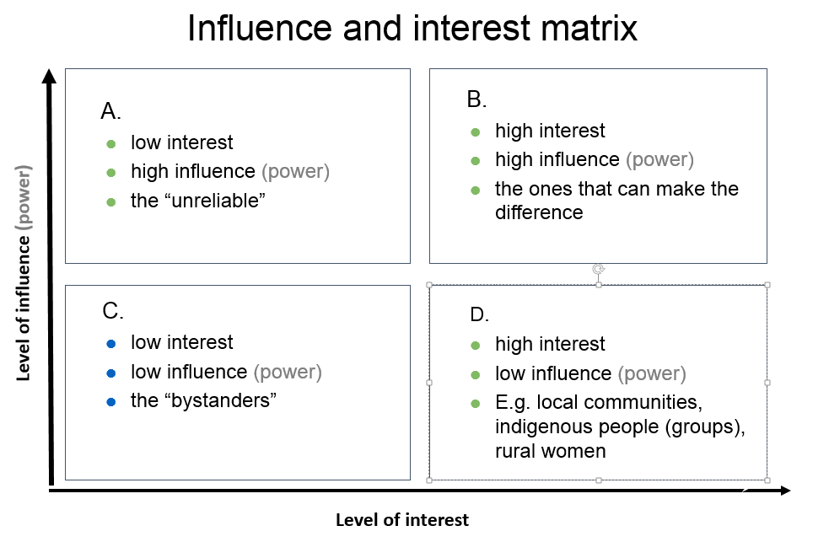
The placement in the different quadrants helps to identify how to approach or engage the stakeholder. E.g. the stakeholders in quadrant B might be the key actors to engage with for success. Stakeholders in quadrant D are probably targeted stakeholders (‘beneficiaries’) of the programme and the ones in A might be important to befriend for positive influence or consult to avoid negative influence. The stakeholders in quadrant C are the least important but there might be a need to keep them informed, or to monitor them occasionally. Or you might need information, (media) support or legitimacy from them.
In this diagram you can to give an idea of the importance of the stakeholder too. ‘Importance’ is defined as the priority the programme gives to satisfying stakeholders’ needs and interests:

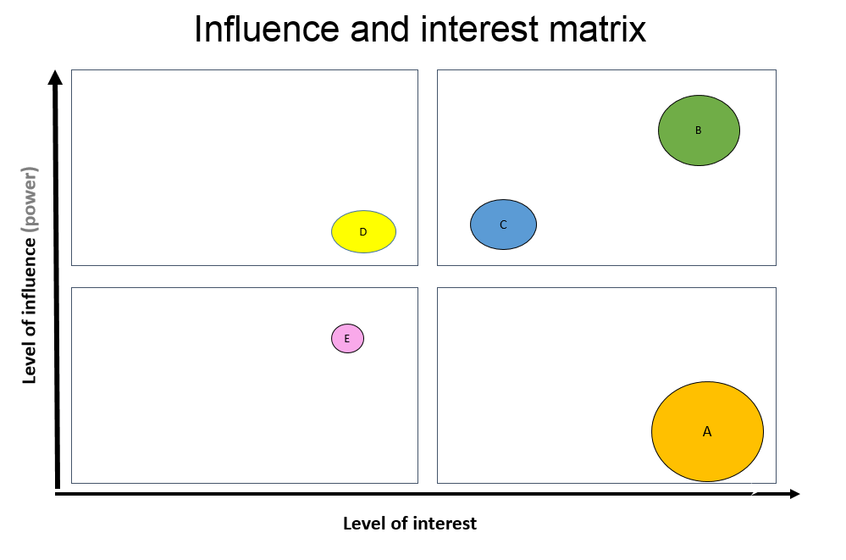
The circles with the capital letters in the matrix above stand for different stakeholders. You can relate the size of the circle to the importance of the stakeholder in relation to the desired outcomes of the programme. You might also use the diagram to reflect on if and how you want to change the position of the stakeholder in the diagram and how to achieve this (e.g. the level of influence of a certain women group) when (further) developing the ToC.
You can also use the diagram for other dimensions you might find relevant. For example, level of positive/negative commitment, level of support (advocate or adversary), relation/attitude to content of the programme, legitimacy, etc.
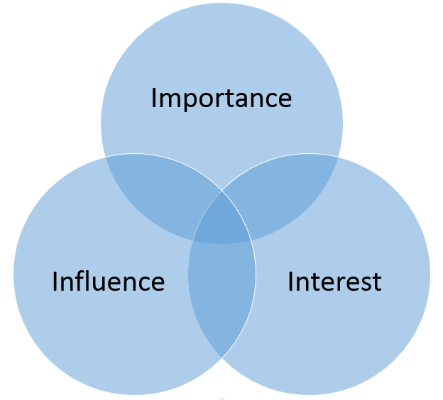
Tool 2: Another method to identify how important it is to engage the stakeholder is by placing them in a (Venn) diagram as here to the right:
The distance to the center might signify the level of interest, influence, etc. Logically, the stakeholder with most overlap in dimensions are most important to engage with. the placement in which (combination of) circle(s) should also give you clues of how to engage or address the stakeholder. Like tool 1, you can also use other dimensions you might find relevant, e.g. legitimacy. And you may want to ‘move’ stakeholders when (further) developing the ToC.

Step 3: identify engagement strategies for key stakeholders
From step 2 you should identify the most important, key stakeholders necessary to engage with for achieving the end outcomes for a climate smart landscape (inclusive governance, sustainable practices, responsible finance and business) or strategies to achieve this.
Some key stakeholders might be allies for success, or opponents, some stakeholders who have little influence you might want to give more influence. In this step you describe in which way these key stakeholders need to be engaged, e.g. as ally, to keep informed, to target with lobby & advocacy, to empower, to keep satisfied, to monitor, etc. and what actions are required to achieve this.
To identify possible allies and opponents place the stakeholders in the following table:
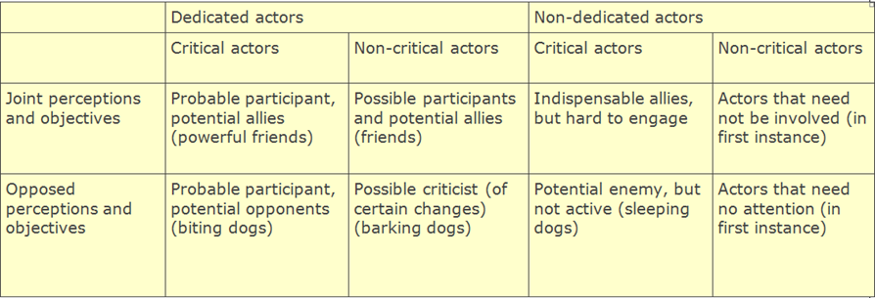

Key questions to ask to identify engagement strategies for key stakeholder:
- Which stakeholders have potentially the biggest influence (+ or -) or are mostly affected (have the ‘highest stakes’) by the programme (the ‘key stakeholders’), with regard to the intended changes sought in the landscape ToC? How important are they for the success of the programme (implementation and intended outcomes)?
- What is their influence now and would we like to see changes in the influence of this stakeholder in a ‘climate’ smart landscape?
- How are they or will they be affected?
- What are potential allies, which stakeholders could be champions/agents of change for success? Which stakeholders could be potential opponents?
- What are challenges in relation to this stakeholder?
- What can the stakeholder/actor possibly contribute to the success of the programme, e.g. information; human resources (personnel, expertise); a network; financial resources; material, facilities and/or equipment; mandate, policies, etc. (= resources)
- What action needs to be undertaken to engage, inform, befriend, monitor, etc. the stakeholder?

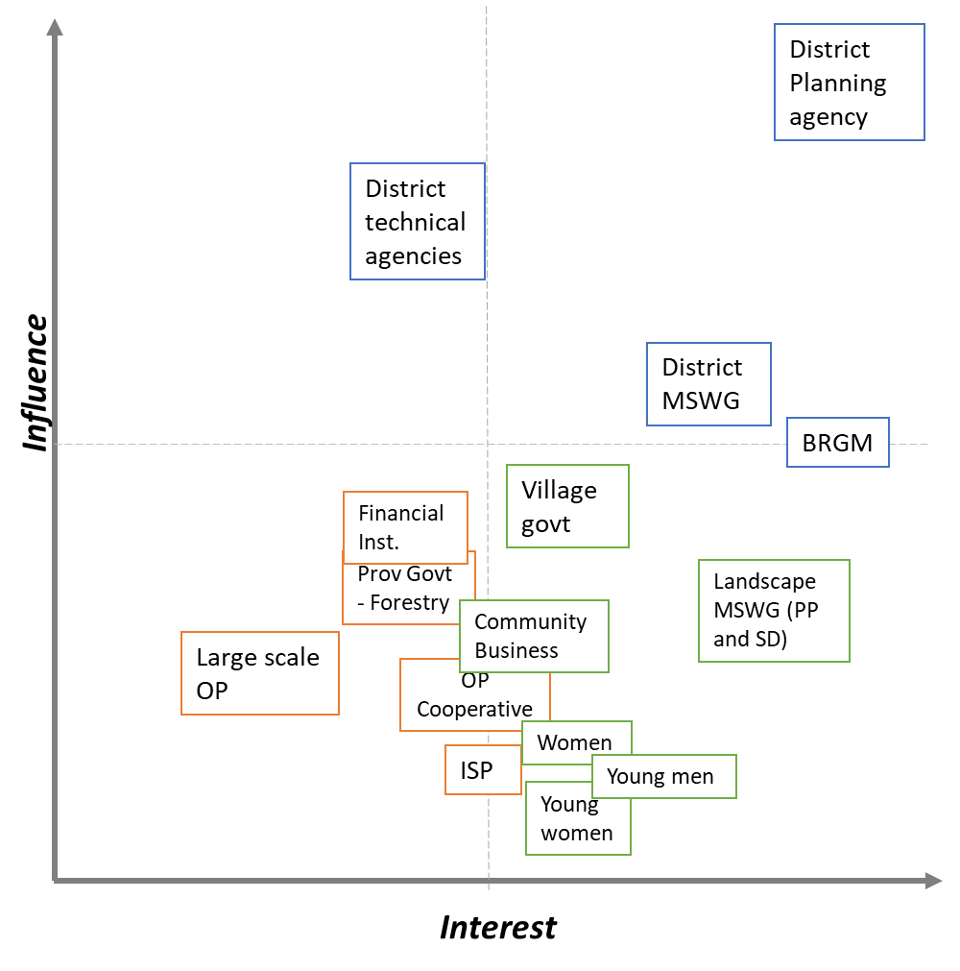
Figure 1c.. Current stage of stakeholder mapping

Now you should have enough information to define how the different stakeholders should be approached and what actions should be undertaken. Put the results in the following table:

Key Stakeholder/  actor | Present level of influence | Desired level of influence | ally/ champion/ opponent | Challenges | Resources | Required action
Province Government | Facilitate MSP of Ketapang KEE.  Forestry Office/FMU on fire prevention: Medium interest, Low interest | Actively develop HCV sanction for oil palm plantation who held HCV less than 7% of the whole concession area. And being the initiator to review Ketapang KEE governor decree NO. 718/2017.  More active in advocating protection function in peatlands | Ally with national, district government, private sectors, and CSOs. | Existing gap with national government (MoEF) regarding conservation issues and affairs.  Improving the better interactions with District govt who have the authority on the peatlands (APL) | Actually, have sufficient resource from national government. | To educate, do L&As, and invite them to MSP thus inclusively participate and contribute to decision making process.  L&A to be active in establishing protection function for peatdome
District Government – Planning Agency  District technical agencies | Establish regulation and contribute to MSP.  (Relatively low interest, actually high influence). Still inactive, in ‘wait and see’ mode from the planning aspects | Actively promote their needs to develop regulations to protect and manage their natural resources in a sustainable manner.  Active in brainstorming on options for solutions and collaborative efforts, including to propose programs | Ally with national, provincial government, private sectors, CSOs, and community. | Limited vision (only 5 years) due to the end of the (reagent) elected period leading to them only focus to developments that are only most beneficial to them both economically and politically (e.g. mining, and oil palm investments). | Actually, have sufficient resource from national government. | To educate, do L&As, and invite them to MSP thus inclusively participate and contribute to decision making process.
BRGM | (High interest, medium influence) Providing technical support on peatland restoration design, including canal blocking engineering design. | To influence district government and local community to improve land governance and canal management to prevent wildfire in peatland areas. | Working together with district level and sub-district level MSP and all stakeholder involved on peatland restoration. | The tight schedule of BRGM to work on national level has limited their time to focus on PP landscape. | Their own allocated National fund. | To influence them to assist PP landscape.
District Level MSWG | (Relatively high interest & influence) As the bridge between TI and Ketapang district government. | A forum that functioned as a melting pot that compiles all stakeholder’s aspiration on wildfire prevention and peatland restoration. | Together with government, private sector, CSOs, and local community. | The MSWG needs aspirations, ideas, and propositions from TI in order to work, and couldn’t move forward independently. | Depends on CSO’s resources. | To capacitate them to do their proper job as a joint forum.
Village Government | (Medium interest, relatively low influence)  As the main supporter of CSO activities and L&A. Rally community to willingly cooperate with facilitations, and activities. Un-Independent and have low initiative to develop the village. Most of them rely on CSOs initiatives to make a concrete development plan and in developing the village. | Expected to be more active to independently formulate village development plans through PM & PLUP while also resolve and established village boundaries. Actively pursue the establishment of village mid-term development plan (RPJM). More initiative on protecting their landscape from wildfire, and extensive illegal gold mining. | Ally with higher level government, CSOs, MSP, Private Sectors, and the community as actors who give and receive benefits. | To solve polarization of sustainable and unsustainable land use actors. Dealing with reconciliation of pro and anti-sustainability (oil palm and illegal gold mining expansion at the expense of state forest areas).  Have low spatial planning knowledge and methods especially the boundaries of state forest areas.  Have low awareness on using their national fund to address the real needs of their village. | Village fund from national government are mostly not used in a proper manner.  Have low awareness on using their national fund to address the real needs of their village. | To educate all of the issues and weaknesses of the village.
PP Landscape Sub-district Level MSWG (FORMAD LINGKAR) | (High interest, low influence). As representatives at inter-village level | A forum that functioned as a melting pot that compiles all stakeholder’s aspiration on wildfire prevention and peatland restoration. Actively do regular joint peat patrol. | Work together with government, private sector, CSOs, and local community. | The MSWG needs aspirations, incentives, ideas, and propositions from TI in order to work, and couldn’t move forward independently. | Depends on CSO’s resources. | To capacitate them to do their proper job as a joint forum and peat patrol task force.
Simpang Dua Landscape Sub-district Level MSWG (Mount Juring Forum) | As representatives at inter-village level. | As task force to protect Mount Juring protection forest, and as the main force to develop and establish UPPB. | Together with government, CSOs, and local community. | The MSWG needs aspirations, incentives, ideas, and propositions from TI in order to work, and couldn’t move forward independently. | Depends on CSO’s resources. | To capacitate them to do their proper job as a joint forum and UPPB developers.
Large Scale Oil Palm Plantation (Private Sector) | (Low interest and influence) Inactive communication with all district level stakeholders. | High influence—  Influencing ISP GAP within OP supply chain, providing resources  High interest- They could act as an active actor to together contribute with stakeholders on wildfire prevention initiatives. | Currently act as a passive ally to the MSWG with no associates. | They acted as isolated actors and don’t have any interest to contribute to the District Level MSWG as all decisions are decided by their center offices outside the landscape, while representatives in the landscape have no power. | They have massive income to protect their own business from wildfire. | To persuade and influence them to work together with us on wildfire preventions.
Financial Institution  (Credit Union, BRI) | (Low interest and influence) They don’t have any interest to invest or give loans to an agroforestry-based business model because it seems unpromising. | They invest and give loans to smallholder agricultural and agroforestry community businesses. | They ally with promising business that usually follow the current business trends. | Its difficult to convinced them that agroforestry-based business are profitable and promising because they prefer trending businesses.  Community business demands funding and loans for processing yields and create processed products instead of cultivation and production. | They have their own funding from their investment and bank activities. | Formulate a convincing business model for agroforestry-based business in order to obtain loans and investment.
Community Businesses, incl OP Cooperative in PP | (Medium interest and low influence) Expect support, facilitation, and funding from CSOs while independently only giving low economic, environmental, and social impact and contribution to the community. | Community businesses are able to strive, grow, and give wide and significant economic, environmental, and social to their surroundings with little to no support from CSOs. | Ally with CSOs and the community in order to sustain their business activities, circulate production and income. | Lacking financial literacy, thus being uninitiative, and unkeen to detailed business activities, and opportunities.  Have insufficient income to significantly scale, develop and grow business, thus demand support from external parties. Need support to link with wider markets. For side business (woven craft), they are lacking time, energy, and spirit to work on their side businesses because the community already has other main source of income. | For side businesses (woven craft), has low income and depend on CSOs to buy their products with little to none actual market interest/engagements. | To support product enhancement and link to wider market so products are widely distributed and desired.
Women | Low influence in decision making process; relatively low interest | Expected to be women representatives that is equally active with men in decision making process, and forum that discusses village and inter-village development. | Ally with men to equally contribute on decision making process. | Have dominant household (domestic) tasks that mostly not aligned with collective discussion schedules thus generally inactive in decision making process. | They don’t need resources to be active. | Increase their influence on decision making process by making discussions fit their daily task schedule, encourage them to be active in forums, and others.
Young men/ boys | Low influence in decision making process.; relatively low interest | Expected to be active in decision making process, since they have plenty of energy and the future care taker of village development. | Ally with other age groups to equally contribute on decision making process. | Generally, have low interest on collaborate in a decision-making process. Low interest on agricultural activities. | They don’t need resources to be active. | Increase their influence on decision making process by encouraging them and involved them in village organizations.
Young women/ girls | Low influence in decision making process.; relatively low interest | Expected to be active in decision making process, since they have plenty of energy and the future care taker of village development. | Ally with other age groups to equally contribute on decision making process. | Generally, have low interest on collaborate in a decision-making process. Low interest on a usually men-dominated activities. | They don’t need resources to be active. | Increase their influence on decision making process by encouraging them and involved them in village organizations.

NB: Information in this report may be used for online publishing on the internet (IATI), or in TBI reporting or communications. In case you have an objection to this or if you think information in this report should be made anonymous or be excluded, please inform your country contact person or include a note stating the information is confidential. For further information on IATI, contact trudi.vaningen@tropenbos.org.
You can use the list of abbreviations used in earlier reports

