TBI WORKING LANDSCAPES PARTNER PROGRESS REPORT 2021 (Ghana )

With this Progress Report, your organisation accounts for your WL activities and achievements of 2021. The format focuses on learning about the strategies and achievements of your organization, and related adaptations. In addition to strategic learning, the reporting on achieved outcomes and results will be used for accountability to the Dutch Ministry of Foreign Affairs.

Name of CSO | Tropenbos Ghana
Location of CSO | Forestry Research Institute of Ghana (FORIG) Campus, Fumesua
Email address | info@tropenbosgh.org / trobosgh@gmail.com
Primary Contact person | Kwame Appiah Owusu, kaowusu@tropenbosgh.org
Name(s) of Harvester(s)
Location of activities | Juabeso-Bia (J  B) and Sefwi-Wiawso (SW) landscapes, Ghana
Project Title | Transforming Juabeso-Bia and Sefwi Wiawso from high climate risk into climate-smart landscapes

List of abbreviations_________________________________________________

.....

INTRODUCTION

This progress report provides your reflections on your 2021 achievements and progress. The content will be based on your harvested outcomes of 2021 (to be put in section 1.7), and on the results of the team Reflection and Learning meeting.

Please upload your completed draft progress report before the first of June in this WL google drive folder and let your country coordinator and us (Luis and me) know! This way we can give our feedback and you can still add/change when needed.

Reflection and Learning meeting
This section aims to provide some guidance for the WL in-country Reflection and Learning (R&L) meetings taking place in May 2022.
Please organise a R&L meeting with all relevant staff, your country coordinator, and if applicable, with implementing partners prior to finalising the progress report. We don’t send separate Reflection and Learning Meeting guidelines. In general, the questions asked in each section of the progress report format can be used as guidance for reflection and discussion. Of course, in addition you can also reflect on your own specific learning questions if you have them.
The R&L meeting serves to agree on how much progress has been made in intended programme implementation and achieving ToC objectives, to discuss the main insights you have gained from programme implementation, outcome harvesting and other monitoring results, and the way you consider to make adaptations and move forward to reach intended objectives.

This year, the R&L meeting also serves as a kick off of for reflecting about two key elements of the WL Mid Term Review (MTR):
- Achieving indirect impacts (scaling)
- Validity of Programme Assumptions
Instructions on the conduct of these two MTR topics will be provided by your country coordinator (who is your MTR contact person as well).

We expect that all country teams have harvested outcomes and collected other information needed for the R&L meeting and prepared a draft progress report with this information prior to the R&L meeting. Now, after almost 3 years of full programme implementation, the aim is to assess at what point you are, how things are going, which prevailing challenges and opportunities you faced, how you dealt with it and what can be learned from that, as well as the main implications for the programme - all keeping in mind your intended end-outcomes and key propositions that underlie your Theory of Change.
You can discuss the guiding questions in sections 1.1 to 1.6 of this progress report (PR) format, based on your outcomes in section 1.7, including unintended, unexpected and negative ones (tables 1a and 1b), and intended outcomes you didn’t achieve (yet) (table 1c).

For reference, also for staff or partners that could not participate in the ToC refresher, you can watch the recordings of the ToC refresher webinars (session 1 on 3 May and session 2 on 10 May 2022) again and visit the ToC refresher Miro board.

2021 achievements and progress

Context
What changes in context did you see in the social / political / environmental / operational space / landscape situation in 2021 that have influenced the implementation of, and reaching the goals of your 2021 work plan? How? Which of these developments have led to increased risks or provided new opportunities for the programme? As a result, did you make changes in your 2021 goals, strategies or ToC targets and assumptions?

Ghana has submitted updated Nationally Determined Contributions (NDCs) under the Paris Agreement (2020-2030). This updated NDCs has 19 policy actions that translate into 13 adaptation and 34 mitigation measures toward seven outcomes that include enhancing landscape restoration, enhancing responsible production and consumption, foster social inclusion focusing on youth and women, among others. These priority outcomes align with the four pillars of the Working Landscapes Programme and therefore provide enhanced opportunities for us to align interventions with those of national development partners and collaborators. Thus, we will continue to collaborate with the agriculture and forestry sector institutions for the strategic implementation of interventions within the JB and SW landscapes.
The President of Ghana was re-elected and sworn -in January 2021. This led to the appointment or re-appointment of new chief executives for metropolitan, municipal, and district assemblies (MMDAs) as well as sector minister appointments. With new MMDAs appointments and transfers in SW and JB landscapes new relationships needed to be built to continue the progress made. The new sector minister for land and natural resources is an opportunity for the WL project to continue the dialogue and lobby for revising forest laws to provide tree ownership right for nurtured trees to farmers. A related new development in the MLNR is the launching of nationwide Green Ghana Day on 11th June, 2021, which had massive support of diverse stakeholders across the nation. This will be a further boost to outcomes to increase tree cover in the landscapes.
In a related development, Metropolitan, municipal, and district assemblies (MMDAs) reviewed their medium-term development plans (MTDPs) in 2021. This was carried out with the active inclusion of inputs from stakeholders for the next four years MTDPs. This provided opportunity for TBG to make inputs to MTDP on themes related to environment and climate change mitigation strategies for SW and JB landscapes

Theory of Change, lessons learned and adaptations
Add the visual of the latest version of your ToC. For reference please include the numbers of the ToC outcomes and use the same numbering in section 1.7.

1.4 MLNR through the FC use feasible forest restoration and tree planting investment models as implementation strategy of Ghana’s NDC at the landscape level (2020)
1.5 MLNR /FC provide secured rights to trees in farming systems (2020)
1. Landowners and cocoa farmers increase forest cover and the number of trees in the landscape to enhance climate change mitigation and adaptation by improving attractiveness and reducing disincentives of trees to farmers.

2. Farmers stop encroachment of forest reserves for cocoa farming through accelerated implementation of sustainable and climate-smart cocoa supply chain by cocoa producers, cocoa bean LBCs and governments by exclusion of illegal cocoa and harmonization of deforestation-free cocoa standards.

4. Smallholder farmers (men, women and youth) in local communities of JB and SW participate in Ghana’s updated NDCs processes and actions related to agriculture and forest land use, with support from EPA and FC.

4.2 EPA revises the SLU and SFM strategies of the NDCs in an inclusive way, together with community groups, farmer representatives, women and youth for inclusive implementation (2020)
(2020)
3. Smallholder farmers (men and women) are resilient through the adoption of climate-smart practices that ensure crop diversification and income diversification.
3.4 Farmers apply climate smart practices to increase resilience to climate vulnerabilities and safeguard their productivity (2020 & beyond)
4.1 Smallholder farmers, women and youth participate and benefit from Ghana's NDCs achievements (2022)
Climate Resilient Juabeso Bia (JB) and Sefwi-Wiawso (SW) Landscapes
1.1 Farmers plant and nurture shade trees in cocoa farms (2021-2023)
1.3 Local communities support FC to restore degraded forests (2020-2023)
1.2Local communities and industry adhere to forest resources (Timber & NTFPs) harvesting standards (2022)
2.3 CSOs demand accountability of LBCs on implementation of deforestation free cocoa commitments under the CFI 2021)
3.2a Smallholder famers and SMEs are integrated into product value (2022)
3.1 Smallholder farmers have diversified and sustainable incomes from investment in climate smart practices (2023)
2.4 HIA Management Board (HMB) have capacity to facilitate implementation of DFCM at the community and landscape level (2021)
2.5 Cocoa stakeholders develop and implement deforestation free cocoa measures (DFCM) (2021)
2.1 Local communities and farmers cease farming in forest reserves (2023)
2.2a. FC initiate measures to reduce forest reserve encroachment (2021)
2.2b. LBCs outlines clear steps and timelines to stop purchasing cocoa beans from illegal farms in forest reserves (2022)
2.2c. COCOBOD support and develop measures to stop cocoa deforestation (2022))
4.2.b Local communities and farmers participate in implementation of mitigation and adaptation actions in the 2021-2025 NDCs
(2021)
3.2b Smallholder famers establish functional village savings and loans associations for climate smart initiatives (VSLAs) (2021)

Reflection questions:
Stakeholder changes: Refer back to your baseline stakeholder analysis, notably step 2 (power, influence and interest analysis, see the guidelines in annex III). What changes did occur In the stakeholder ‘landscape’? Do you need to adjust your strategies to deal with changing stakeholders or changes in power, influence and/or interests?

DAs
TAs
EPA
FC
CCB
MLNR
TC
CO
Comms
HMB
FMRS
LBCs
CSO
CHED

INFLUENCE
LEVEL OF INTEREST
The influence and interest of stakeholders related to achieving outcomes on inclusive landscape governance, sustainable land-use, and responsible business finance has not changed much since the project inception in 2019. Government institutions such as MLNR and FC has power and influence over policies related to tree ownership right and associated issues that give motivation for smallholder farmers to adopt climate-smart practices to increase tree cover in SW-JB landscapes as well as commitment to implement Ghana NDCs. These have affected farmers' interest to increase tree cover in addition to the cost of planting and nurturing trees on the farm. CSOs, CHED and LBC's interest has increased over the years for climate-smart agriculture practices and stopping deforestation through agro-commodities. Interest of CSOs, CHED and LBCs can be attributed to coming to force EU due diligence regulation in 2025.
Collaboration: With which other organisations/partners did you collaborate in 2021 or did you start a collaboration?
In 2021 TBG had a good collaboration with Olam Ghana, HIA consortium members and CHED field staff in the SW-JB landscape strengthening the capacity of smallholder farmers on climate-smart practices including crop diversification and agroforestry systems. CHED field staff were lead facilitators that conducted the climate-smart cocoa production training with support from TGB in terms of planning. In 2021 within the SW-JB landscapes WL created a platform for learning and reflecting on agroforestry systems where CSOs, LBCs and government agencies shared experience on agroforestry best practices and this will continue as a strategy for learning and reflections to harmonize agroforestry system practices in SW-JB landscapes.
Assumptions: From implementation, can you prove certain assumptions underlying your ToC valid or invalid? Which ones and why?
ToC | Assumptions | Valid/invalid | Reasons
1. Landowners and cocoa farmers increase forest cover and the number of trees in the landscape to enhance climate change mitigation and adaptation by improving attractiveness and reducing disincentives of trees to farmers. | A key incentive for land owners and cocoa farmers in the JB and SW landscapes to increase forest and tree cover is to have secured benefit and ownership to planted and nurtured trees on farms including cocoa farms. This will motivate smallholder farmers to change their current practices that have reduced tree and forest cover. | Valid | Over the years farmers have been asking and pushing to own plants they plant or nurture. Ownership right for planted or nurtured tree motivate farmers to plant more trees and maintain on farm.
2. Farmers stop encroachment of forest reserves for cocoa farming through accelerated implementation of sustainable and climate-smart cocoa supply chain by cocoa producers, cocoa bean LBCs and governments by exclusion of illegal cocoa and harmonization of deforestation-free cocoa standards. | -Barriers and precondition for deforestation free cocoa are known by all social actors.  -There is operational national forest monitoring system (NFMS) in place to monitor inclusive zero deforestation agenda. | Valid | - Need to know the barriers and preconditions making people encroach the forest reserves and what safeguards measures need to be put in place.  -There should be effective national monitoring system in place to ensure no one encroach the forest again.
3. Smallholder farmers (men and women) are resilient through the adoption of climate-smart practices that ensure crop diversification and income diversification. | Capacity to adopt climate-smart practices and income diversification. | Valid | For Smallholder farmers to be resilient they need to have strengthened capacity (knowledge and skills) to adopt climate-smart practices and income diversification.
4. Smallholder farmers (men, women and youth) in local communities of JB and SW participate in Ghana’s updated NDCs processes and actions related to agriculture and forest land use, with support from EPA and FC. | Smallholder farmers must be knowledgeable about Ghana NDC mechanisms and processes to make effective inputs to Ghana NDCs strategies and commitment | Valid | Local communities, farmers and local CSOs with strengthened capacity (knowledge and skills) can effectively participate in NDCs implementation strategies on forest and agriculture sectors of Ghana NDCs programme.

Strategies: Are there outcomes that, with the experience you have until now, consider to be very difficult to achieve? Why? So what to do? What interventions/strategies worked well? Did you face any challenges?

Outcome difficult to achieve is MLNR /FC providing secured rights to trees in farming systems as this is a political commitment from MLNR and WL need to continue lobbying and advocating for this change.

Refer back to the assumptions in your Work Plan. Were you able to validate or invalidate assumptions that underpin your work? Please explain.
What insights have you got? Is there a need to change the assumptions, because of how the programme is developing?

There is no need to change current assumptions as they are valid as the project is developing.

Beside the baseline assessment, TBG engagement the EPA and FC CCD in a number of meetings regarding updating and implement of Ghana’s NDCs towards climate goals. A formal process has begun with TBG officially expressing her interest in participating in forestry and sustainable agricultural sectors of the NDCs. TBG approached the EPA to seek collaboration on the NDCS: first on the update processes and second on implementation roles after the updates have been completed.

Lessons learned:
Summarise what you learned about your strategies, assumptions, external influences, dealing with stakeholders, collaboration with other partners, and other challenges from implementation in 2021.

Improving collaboration with key stakeholders in 2021 enhanced capacity building for target beneficiaries especially on climate smart best practices. Support for district assemblies within the SW-JB landscapes to review their MTDPs provided opportunity for strategies and interventions that contribute to making the SW-JB landscapes resilient. Assumptions to achieve intended outcomes proved valid as well as positive actions emanated from consultative meetings. For example, the need to harmonize agroforestry systems as agreed by landscape actors. TBG engagement with MLNR and EPA were positive towards commitment to implement Ghana NDC strategies. The COVID 19 pandemic was a challenge implementing certain indoor activities such as conducting classroom trainings and meetings but these were managed observing the COVID 19 preventive protocols.

Adaptations to ToC outcomes, assumptions, targets or strategies
Describe any adjustments you have made, or will make to the ToC (outcomes/targets and/or assumptions) and/or strategies in the table below and explain why. For reference, please include the numbers of the ToC outcomes and use the same numbering in section 1.7.

Pathway | Adjusted outcome, assumption, target or strategy | Explanation

The ToC has not changed as reflection and lessons learnt did not require any significant changes to the ToC and its associated targets and assumptions.

Impact/KPIs
Describe to what extent your interventions and outcomes contributed to impactful changes, using the selected key performance indicators (KPIs). Refer to the sub-KPIs for which you have set targets during the inception phase (first column). NB. Describe these in words! Please give an estimation of the quantitative impact in numbers of hectares (table 1.3.1) or people (gender/age disaggregated, table 1.3.2). Distinguish between direct and indirect impact, For the definitions of direct and indirect impact see the KPI infographic in google drive. Provide cumulative numbers per sub-KPI in the last column (this means that you report on the total figures since 2019 up to 2021, so also include what you reported last year). Use the setup of your baseline to describe the changes. The first three rows (in blue) in the table below are just an example.

Table 1.3.1: cumulative estimated impact in hectares (direct and indirect)
Key performance sub-indicator | Description of observed changes in the landscape | TBI’s (your) Contribution | Direct/ Indirect | Estimated impact in #hectares at the end of 2021
Area under improved environmental and social standards | Community members and small holder cocoa farmers applying climate best practices and tree management skills to increase tree cover. | TBG conducted classroom and hands-on field trainings on agroforestry in 16 WL participating communities. | Direct | 600 ha
Forest area conserved | Not ascertained yet
Area that has been restored or reforested | Chiefs and individuals in WL participating communities have shown commitment to restore degraded forest land by allocation of significant sites for restoration. | TBG capacity building trainings and support to map allocated degraded areas. | Direct | 17 ha
Area under improved smallholder agroforestry and community forestry | Small holder cocoa farmers in 16 WL communities apply skills acquired during capacity trainings in agroforestry practices in cocoa and food crop farms. | TBG conducted agroforestry trainings | Direct | 1,100 ha
Area under improved company commitments | NA
Area subject to more inclusive governance and participatory planning (landscape approaches, participatory land use plans) | HMB identified and secured a degraded land site for restoration in JB landscape. | TBG capacity building trainings and support to map restoration sites | Direct | 4 ha
Total KPI: Area affected by improved climate-smart landscape practices |  |  |  | 1,721ha

Table 1.3.2: cumulative estimated impact on people, gender and age disaggregated (direct and indirect)
Key performance sub-indicator | Description of observed changes in the landscape | TBI’s (your) Contribution | Direct/ Indirect | # Adult Women | # Adult Men | # Young Women | # Young Men
Number of men and women with improved access to forest and tree resources | To be determined in 2022 | TBG documented smallholder farmers committed to plant tree and monitoring tree on farm | Direct | 532 | 468
Number of men and women that adopted climate-smart practices and management. | Smallholder cocoa farmers adopt climate smart best practices on farms. | TBI supported CHED to conduct CSC trainings | Direct | 505 | 728
Number of men and women involved in inclusive landscape governance initiatives | Women cocoa farmers dialogued on issues affecting their farming activities and productivity due to climate change. | TBG organized workshop for women in cocoa and also sensitized communities about national processes for addressing climate change. | Direct | 6,000
Number of men and women included in inclusive business arrangements | 12 functional VSLAs groups saving and giving out loans to finance household climate smart business | TBG engaged a VSLA consultant to facilitate formation of VSLA groups and building capacity to strengthening VSLA groups | Direct | 144 | 39
Total KPI: Number of beneficiaries impacted by improved climate-smart landscape practices |  |  |  | 7,181 | 1235

Progress: to what extent are you “on track” towards achieving the 5 year targets for the different KPIs? Why or why not?

Transforming SW-JB into a climate smart landscape involves multiple stakeholders’ commitment, stakeholders’ capacity to deliver on their roles and responsibilities and need for stakeholders to work together to address SW-JB landscapes complex issues. Per KPIs achieved to date signifies the WL project over the years since its inception had developed capacity of local communities, government agencies such as district assemblies and CHED and improved working collaboration with FC, EPA and MLNR as policy decision makers. These achievements set the path towards the situation where smallholder farmers will have ownership right to planted and nurtured trees on farm as incentive to increase tree cover. For example, Green Ghana initiative which seeks to create a collective action towards restoration of degraded landscapes in the country, mitigate climate change and inculcate in the youth the value of planting and nurturing trees is also based on underlying assumption that farmers have ownership right to nurtured and planted trees and their associated benefits. There are also other related interventions strategies similar to WL such as climate smart cocoa production and agroforestry system practices that are being implemented by other organizations operating in the landscapes complementing WL project towards a climate resilient landscape. Also, the incoming enforcement of EU due diligence and new regulations in 2025 gives impetus to the WL project especially on stopping encroachment to forest reserves.

Key propositions and NDCs

For each key proposition describe:
- What progress has been made in 2021 towards the end goal(s)? Compared to the situation at the start of the programme, how far are you in achieving the end goal(s)?

- What challenges did you meet in 2021? Can you say that you are on track? If not, why not?

- What are your expectations/reflections for the near future? Should you change your strategies in order to achieve the end goal? How?

Provide your answers directly in the WL key propositions 2021 progress document on google drive. This document has all key proposition information together for all countries in one document, including what you intended to do in 2021 for each key proposition.
Each country has different sub-sections in this document, you can find the table (see example of the table below) in sub-section 3, e.g. for Colombia it’s subsection 1.3, for Bolivia it’s 4.3. The areas you need to complete are blue. Use max 200 words per proposition.

desciption of proposition | Summary (i) progress; (ii) challenges; and (iii) expectations/reflection
- Progress:
- Challenge:
- Expectations/reflection:
etc

NDCs: Answer the same three questions for NDCs and give the answers in the same table.

Wildfire programme: Do the same for the wildfire programme when relevant. If you have a wildfire programme add row(s) to enable a short but meaningful report on progress made, like here below:

Wildfire programme
Please provide a description of the workplan 2021 | - Progress:  - Challenge:  - Expectations/reflection:

Gender & youth (F/M)
  - Gender and youth (F/M) priorities and mainstreaming activities

Progress, challenges, expectations/reflection
Achievements: What were your achievements towards gender and youth (F/M) priorities related to each of the five baseline indicators/three main pathways:

Pathway | Indicator | Gender/youth (F/M) priority/ outcome for 2021 | Achievements in 2021
Inclusive landscape governance: | a. Level of access to land and ecosystem services; | - Creating opportunities for youth and engage women and youth in climate-smart agriculture and forest activities.  - Tailored trainings of climate smart agriculture for women in cocoa farming and youth in afforestation. | - Facilitated selection of 48 CSA champions from 16 WL participating communities to be trained in CSA best practices and coach peer farmers in respective communities  - Trained youth in 16 WL participating communities in Climate Smart Cocoa production and agroforestry systems.
Inclusive landscape governance: | b. Level of land tenure rights/security;
Inclusive landscape governance: | c. Level of participation in decision making about land & forest use and governance | - The youth and women will have knowledge and skills to engage FC and other NDCs implementation agencies to push for inclusion of their interests and priorities in NDC related programmes | - Through GLA II capacity development and WL project engagements in WL participating communities, community members have acquired knowledge related to laws governing trees and forest in Ghana and in position to enagage FC and other NDCs implementations agencies for their interests.
Responsible business and finance: | d. Level of access to production resources, inputs and benefits | - Smaller holder have access to financial, business, training and other development opportunities and benefits | Evolution of 12 functional VSLAs groups saving and giving out loans to groups members to finance climate smart green businesses.
Sustainable land-use practices: | e. Level of participation in, contribution to, and benefits of climate smart practices) | - 30-50 % of YM and YW in 18 communities have knowledge on different climate smart agricultural practices suited to their landscape. | - Training needs assessment conducted for 48 CSA champions to be trained in 2022 on CSC and agroforestry systems

Please summarise:
- What progress has been made in 2021 towards G&Y objectives? Compared to the situation at the start of the programme, how far are you in achieving end goal(s) in priority G&Y issues? Are you satisfied or not? Why/why not?

Priorities on gender and youth under the WL project became clear in 2021 and as such concrete interventions were formulated in the WL 2021 Ghana work plan to address gender and youth challenges in SW-JB landscapes. Some interventions were implemented in 2021 and while others are ongoing to address gender and youth issues such as limited access to productive resources and ecosystem reserves, low involvement in decision making on land and forest use, and low capacity to adopt climate resilience practices. There have been improvement and change as compared to 2019 when the project started. From 2021 to date youth in WL participating communities have acquired skills and knowledge in climate smart cocoa production and agroforestry systems.

- What challenges did you meet in 2021? Can you say that you are on track? If not, why not?

The project is on track towards achieving desired change for gender and youth in SW-JB landscape.

- What are your expectations/reflections for the near future? Should you change your strategies in order to achieve the end goal? How?

Expectation or reflection for the near future is how the youth will be incentivised to sustain current commitment and enthusiasm and scale up to coach other peer farmers and nearby communities with the knowledge and skills acquired under the project. In this direction the WL project need to strategize and position the youth to sustain the gains after end of project. WL can do this by encouraging the youth to be part of the VSLA groups and also enagage in other income generating activities such as MoMo green businesses initiatives.

Progress in mainstreaming gender & youth (F/M)
Are you satisfied about mainstreaming gender and youth in:
- Activities, i.e. involving women, men and youth in the design, planning, implementation and monitoring of programme activities? Are you satisfied about progress? Why/why not? What needs to improve?

Satisfied with the progress made mainstreaming gender and youth in the WL project because they will support scaling up strategies to farmers and nearby communities where the project does not cover with the capacity and knowledge acquired under the project. What needs to improve is women and youth have access to land and other resources to keep them active in WL interventions towards resilient landscape.

- Your own organisation, e.g. do you have organisational gender (equity) objectives, do you allocate time and budget for achieving more gender equity, youth engagement, etc.? Do you practice gender/age disaggregated monitoring? Are you satisfied or not? Why/why not? What needs to improve?

…………………..

Thematic programmes
Describe the most important achievements within the thematic programmes that apply to your country programme in the table below.
- To what extent did you contribute to the thematic outcomes formulated in the thematic workplans?

A. Agrocommodities
Local communities, governments, LBCs and CSOs participated in dialogues to jointly develop viable, inclusive, climate smart agrocommodity production models in the JB and SW landscapes. In addition JB and SW landscapes actors are aware of the need for effective monitoring of agrocommodity impacts on local livelihoods and deforestation and the active role they can take in this. In last quarter of 2021 TBG engaged a consultant to assess and document socio-economics of encroachment in forest reserves through participatory research to guide agrocommodity policy development and voluntary relocation of illegal farmers. Research finding will be shared in 2022.

B. Landscape restoration
Facilitated participatory identification, mapping and planning of restoration with local communities who have allocated 17 hectares of land degraded land for restoration while the HMBs in JB landscape has allocted 4 hectares for restoration outside forest reserves.

C. Business and finance
Collaboration are ongoing with FC, LBCS, COCOBOD, CFI members, Hotspot Intervention Areas (HIA ) consortium members as well as capacity strengthening of CSOs and HIA board members and members of Community Resource Management Areas (CREMAs) to curtail cocoa related deforestation while FC adheres to environmental and social safeguards in forest reverses threatened by cocoa farm encroachment.
NB NDCs are included in section 1.4.

2021 Outcomes

Outcome tables
We have split the outcome table in two parts: the first table (1a) has the basic elements of an outcome statement (i.e., description of the change; significance, contribution, evidence), the second table (1b) has the additional information for aggregation, and analytical or other purposes. You need to copy the first two columns (the outcome number + outcome title) of the first table to the second table.
- in the first table (1a) give a summary description (the ‘outcome title’) and a more elaborate description of who changed what and when (the ‘outcome description’). With this more elaborate description an outsider should be able to understand the change. We also ask which ‘evidence’ (sources of information) you have to substantiate/validate the outcome (columns 1, 5 and 11).
- In the second table (1b) indicate to which key proposition(s) the outcome contributes, and the gender or youth dimension of the outcome. We also ask about the confidentiality of the outcome (columns 15, 17, 18, 19).

Table 1a: 2021 outcomes
Describe all your harvested / achieved outcomes by completing tables Ia (outcome statement and evidence) and 1b (info for analysis). Fill in expected as well as unexpected or perhaps negative outcomes! Make ample use of the PMEL outcome table I in your 2021 work plan! Use one row for each achieved outcome for only one type of actor!

Please read the following instructions carefully before completing the table!

Table 1a: 2021 outcomes part one: outcome statements and evidence
Explanations of columns:
- #: number the outcomes for easy reference in table 1b.
- Outcome title: Summarize the outcome in one sentence: who changed what, when and where, as precise (SMART) as possible. Include unexpected or negative outcomes and use one row for only one type of actor.
- ToC end outcome: To which longer term WL ToC/thematic end outcome the outcome in column 1 contributes? Refer to the number of the ToC outcome, unless the outcomes in the ToC are not numbered.
- Description of change: Elaborate on the who, what, when and where in the outcome title. Give additional facts so that an outsider can understand what your outcome title means. Describe the social actor (who) as specifically as possible and describe in max. 4 sentences what this actor did that was new or different. Be as specific as possible about when this happened and where.
- Expected /unexpected: was the outcome expected or unexpected? If the outcome was expected refer to the number of the outcome in your 2021 work plan, or a ‘yes’ if the outcome is not numbered. If the outcome was unexpected add a ‘No’.
- Positive or negative?: was the outcome a positive (put ‘+’) or negative change (put ‘-‘)?
- Significance: Explain the significance of the achieved outcome in relation to the end outcomes in the ToC briefly.
- Significance scale: How would you rate the significance of the change in relation to the goals of the programme? Please determine the level of significance and fill in a number between 0- 5: “The change/outcome is not significant” 0 - 1 - 2 - 3 - 4 - 5 “The change/outcome is vital for our long term ToC goals”.
- Contribution (Intervention(s)): Describe your interventions that contributed to the outcome, and the ones of other organisations that where relevant/important. NB: more than one activity/intervention can lead to an outcome, and one activity/ intervention can lead to more than one outcome.
- Type of interventions: to be able to categorize and analyse the type of interventions that are successful please indicate the (main) type of intervention(s) that has led to the outcome. Use the numbers to put in this column of the following categories, e.g. put ‘2.4’ if the main activity to achieve the outcome was documentation & research (e.g. case studies, evidence finding etc.) for dialogue:
Capacity building (1), e.g:
☐ 1.1 Trainings, workshops, technical assistance etc. aiming to build capacity & skills;
☐ 1.2 Coaching, consulting, mentoring etc. to build capacity & skills;
☐ 1.3 Field visits, exchange visits; exchange of lessons learned between actors
☐1.4 Development, implementation of- and capacity building through pilot projects;
☐ 1.5 Awareness raising, sensitization, social events, media outreach, etc., aiming at information dissemination, including the development of material for these purposes.
☐ 1.6 Documentation & research initiatives for capacity building interventions.
Dialogue and coalition building (2), e.g.:
☐ 2.1 Coalition building, networking, linking public, private and/or civil actors;
☐ 2.2 Dialogue, consultative meetings, participation in multi-stakeholder processes, (e.g. participatory planning, joint analysis, policy development, mediation etc.);
☐ 2.3 Collaborative actions with public, private and/or civil actors, including summits, conferences, etc.;
☐ 2.4 Documentation & research initiatives (e.g. case studies, evidence finding etc.) for dialogue
Lobby & advocacy (3),
☐ 3.1 Advocacy, mobilize public pressure, including demonstrations, petitions, campaigning, media outreach, etc.;
☐ 3.2 Lobby, including (in)formal meetings, the development & dissemination of policy briefs;
☐ 3.3 Litigation and the use of grievance mechanisms (e.g. formal hearings, appealing to existing mediation procedures);
☐ 3.4 Documentation & research initiatives (e.g. case studies, evidence finding etc.) for lobby, advocacy & litigation efforts.
- Contribution scale: How would you rate your organisations' contribution towards the outcome? Please determine the level of contribution and fill in a number between 0 - 5:. “The outcome would also have been achieved without our contribution“ 0 - 1 - 2 - 3 - 4 - 5 “The outcome would not have been achieved without our intervention(s)“
- Evidence: On what sources of information is above information based? Where relevant provide web links, videos, photos, news articles, sound recordings, lobby documents, meeting reports, contracts, field reports, official government communication, public corporate information, etc.

Table 1a: 2021 outcomes – part one: outcome statements and evidence
Please keep your entries in the tables below brief. For instructions, see above.
NB the first time you use an acronym/abbreviation, please write it in full
0 | 1 | 2 | 3 | 4 | 5 | 6 | 7 | 8 | 9 | 10 | 11
# | Outcome title | ToC (END) Outcome(s) to which the achieved outcome contributes | Description of change | Expec-  ted? (Yes/  No) | Pos.  or neg.  (+/-) | Significance (descriptive) | Significance  scale (1-5) | Contribution (interventions) | Type of intervention | Contribution  scale (1-5) | Evidence
 | In 2021 (From June to December) 1233 smallholder cocoa farmers from 16 WL participating communities, field staff from CHED and Olam operating in SW-JB landscapes have knowledge and skills to adopt agroforestry systems and climate cocoa production practices to increase tree cover in SW-JB landscapes. | 1. Landowners and cocoa farmers increase forest cover and the number of trees in the landscape to enhance climate change mitigation and adaptation by improving attractiveness and reducing disincentives of trees to farmers. | Small holder farmers from WL participating communities and other stakeholders (Field staff of CHED and Olam through training and coaching have acquired additional skills to practice agroforestry and climate smart practices in SW-JB landscapes | Yes | + | Knowledge and skills acquired in agroforestry and climate smart cocoa production enhance tree planting and management of naturally growing trees on farm that leads to increase tree cover, and adaptation and mitigation amid climate change. CHED and Olam  supporting, sustaining and providing backstopping to scale up in other communities in SW-JB landscapes where WL is not covering | 5 | Agroforestry and climate smart cocoa production capacity building trainings and hands-on field trainings. | 1.1.1.2 | 4 | List of training participants  Field Pictures
 | In 2021, Chiefs and individuals from 6 WL participating communities allocated 17 hectares of degraded forest areas for restoration and reforestation. | Landowners and cocoa farmers increase forest cover and the number of trees in the landscape to enhance climate change mitigation and adaptation by improving attractiveness and reducing disincentives of trees to farmers. | Chiefs from WL participating communities who own lands and individual farmers committed degraded lands areas for restoration | Yes | + | This led to increase tree cover under areas restored or reforested in the SW-JB landscapes | 5 | Agroforestry and climate smart cocoa production capacity building trainings and hands-on field trainings with emphasis on need to increase tree cover as climate change adaption and mitigation measures. | 1.1.1.2 | 4 | GPS coordinates of allocated degraded land areas
 | From July 2021 to date 12 functional VSLAs are giving out loans to group members to support household businesses and climate smart practices on farm. | Smallholder farmers (men and women) are resilient through the adoption of climate-smart practices that ensure crop diversification and income diversification. | VSLA group members(Women in majority) make regular savings and take loans to finance climate smart best practices. For example purchasing of improved seeds, organic fertilizers etc. | Yes | + | Smaller holder farmers have access to regular financial support to invest in cocoa farms as main source of income and diversify income sources by engaging in other alternative livelihoods such as petty trading. | 5 | Formation of VSLA groups from selected communities in WL participating communities with provision of VSLA start-up logistics | 3.1.2.1/3.1.2.2 | 5 | VSLA formation report
 | In 2021, CSOs, LBCs, and government agencies in SW-JB landscapes reflected on need to harmonize agroforestry system in SW-JB landscapes and GCCP as platform for advocating for best practices in cocoa production and forestry management made inputs to EU cocoa talks on deforestation - free agro-commodities. | Farmers stop encroachment of forest reserves for cocoa farming through accelerated implementation of sustainable and climate-smart cocoa supply chain by cocoa producers, cocoa bean LBCs and governments by exclusion of illegal cocoa and harmonization of deforestation-free cocoa standards. | Key actors in SW-JB learned and reflected on multiplicity of agroforestry intervention strategies and need to harmonized agroforestry systems interventions in SW-JB landscapes as common path towards achieving agroforestry systems goal  GCCP (CSOs, farmers, Experts and practitioners, lawyers etc) as national platform on cocoa and forest management made significant inputs to the EU cocoa talks. | Yes | + | Harmonising agroforestry systems interventions amongst organizations operating in SW-JB landscapes provides common vision, coordination and partnership to achieve great impact in agroforestry since working with same smallholder farmers and communities.  inputs of GCCP at early stage of EU cocoa talks stimulated awareness on issues related to cocoa and forest in Ghana. | 5 | Organize workshops and trainings on deforestation free cocoa production for TAs, FC, CHED, HMBS, and cocoa farmers’ groups  Support organization of consultative meetings and workshops for developing operational measures. | 2.1.1.2/2.2.3.1 | 4 | Workshop reports  List of participants
 | In 2021, TBG supported CSOs with relevant information to guide effective CSO contribution to the Ghana NDC process. | EPA and FC actively include local communities, smallholder farmers, women and the youth to participate in sustainable land use and sustainable forest management decision making and implementation through Ghana’s NDCs processes and actions.

Table 1b 2021 outcomes: information for aggregation, analysis or other purposes
Copy the first two columns of table 1a (# and outcome title) into table 1b.
Please read the following instructions carefully before completing the table!
Explanation of columns:
- Kind of actor: Please choose between (choose only one!): ☐ Public actor; ☐ Private actor; ☐ Civil actors, like community members, local leaders, community groups, individuals, etc.; ☐ Civil society actors, like networks, CSOs, NGO platforms etc.; ☐ Research Institute/ University; ☐ Media/ journalist(s)
- Geographic level of change: indicate the geographic level of change. Local; sub-national; national; regional; international (e.g. AU, ASEAN, EU or VN level). Elaborate by naming the location.
- WL ToC ‘pillar’: how would you categorize the outcome in one of the following three key WL pillars (if it’s more than one put the most important one first):
- Inclusive Landscape Governance
- Sustainable land use
- Responsible Business and Finance
- Key proposition(s): to which key proposition(s) does this outcome contribute? Please refer to the numbering you used in section 1.4.
- Cross-cutting themes and TBI priorities: Refer to which cross-cutting theme(s) and/or TBI prioritie(s) (see annex I) the outcome relates to (contributed to, changed, etc.). Refer to the numbers in annex I, no descriptions are needed. A combination of numbers is possible, e.g. 1.1a and 2.3 (only use numbers, no words!). You may also just mention the main topic(s), e.g., 1 and 3.
- Gender equality and empowerment: To what extent does the described outcome contribute to gender equality and empowerment? Score your contribution from 0-5, where 0 = no contribution and 5 = high contribution. Explain your scoring.
- Youth issues and empowerment: To what extent does the described outcome contribute to youth (boys and girls) issues and empowerment? Score your contribution from 0-5, where 0 = no contribution and 5 = high contribution. Explain your scoring.
- Confidentiality: (the reason for asking this is because these outcomes might be reported to the International Aid Transparency Initiative (IATI). IIATI is a publicly accessible database for third parties, and one of the monitoring instruments used by the Dutch Ministry of Foreign Affairs.)
Please select (1, 2 or 3):
- This outcome is not confidential and can be used for publishing outside the WL program, or
- this outcome is not confidential but the actors in this outcome should be anonymized when publishing the outcome outside the WL program, or
- this outcome is confidential: it contains information that can pose a risk to individuals or organisations, and cannot be published outside the WL program.

Table 1b: 2021 outcomes – part two: information for aggregation, analysis and other purposes
0 | 1 | 12 | 13 | 14 | 15 | 16 | 17 |  | 18 |  | 19
# | Outcome title | Kind of actor | Geographic level of change | WL ToC ‘pillars’ | Key proposition(s) | Cross-cutting themes and priorities | Gender equality and empowerment |  | Youth issues and empowerment |  | Confidentiality  (1, 2, or 3)
 | In 2021 (From June to December) 1233 smallholder cocoa farmers from 16 WL participating communities, field staff from CHED and Olam operating in SW-JB landscapes have knowledge and skills to adopt agroforestry systems and climate cocoa production practices to increase tree cover in SW-JB landscapes. | Civil actors | Local; SW-JB landscapes | B |  | 2a | 5 | Equal opportunities for men, women, boys and girls to participate in the capacity building training in agroforestry and climate smart cocoa production | 4 | This is part of the training developing the youth as CSA champions | 1
 | In 2021, Chiefs and individuals from 6 WL participating communities allocated 17 hectares of degraded forest areas for restoration and reforestation. | Civil actors | Local; SW-JB landscapes | B |  | 2a, 2b, 2c | 5 | Women, men, boys and girls have equal opportunities to allocate land for restoration and reforestation. | 5 | Youth have limited access to land but will play greater role in restoration and reforestation. | 1
 | From July 2021 to date 12 functional VSLAs are giving out loans to group members to support household businesses and climate smart practices on farm. | Civil actors | Local; SW-JB landscapes | C |  | 3a | 4 | Women in majority as VSLA group members compared to men membership | 4 | VSLA groups provide access for youth to save and get loans to finance farm enterprise initiated by the youth. | 1
 | In 2021, CSOs, LBCs, and government agencies in SW-JB landscapes reflected on need to harmonize agroforestry system in SW-JB landscapes and GCCP as platform for advocating for best practices in cocoa production and forestry management in Ghana made inputs to EU cocoa talks on deforestation - free agro-commodities. | Civil actors, | Local; SW-JB landscape, Sub-national-Accra | A |  | 1a, 1b and 1d | 3 | This has no bearing on gender equality as when it comes to relocation, or enforcing no encroachment into forest reserves everybody is affected. | 3 | This can have negative effect on livelihood for youth who have encroached forest reserves and no longer able to have access to farm in forest reserves. | 1
 | In 2021, TBG supported CSOs with relevant information to guide effective CSO contribution to the Ghana NDC process.

Narratives: If you have narratives/stories (e.g. descriptions of events and/or pictures) that further explain or illustrate the outcomes, kindly attach these in annex II. It is not strictly necessary to provide narratives, only add them if you have them in other reports, it will be much appreciated!

Table 1c: Intended outcome(s) that were not achieved (yet)
After completing table 1a, describe in table 1b intended outcome(s) included in the 2021 workplan that were not achieved (yet). This is important for learning, adapting strategies and planning; but also for the 2021 Progress report to be submitted to DGIS. There could be two explanations for outcomes that were not achieved: (1) the intervention(s) took place, but for some reason this did not lead to the intended outcome(s), or (2) for some reason the interventions did not take place (yet). Use one row for each intended outcome.

Please carefully read the footnotes when completing the table!

This table is not applicable to the reporting period

Table 1c: Intended outcome(s) that were not achieved (yet)

Annex I: TBI thematic & strategic priorities
The list below is a mix of priorities and themes identified for GLA and WL. Please add if there is a thematic or strategic priority unmentioned.

Interventions or outcome contribute(d) to:
- Landscape approach/ Inclusive landscape governance:
1a. Inclusive decision-making or ensured the inclusiveness of local communities/marginalized/indigenous groups
1b. Cross sectoral coordination and collaboration
1c. An integrated perspective (instead of one-issue), looking at landscape connectivity, multi-stakeholder dialogue, working towards/identifying a joint vision, integrated and collaborative landscape planning, collaborative managements of public goods.
1d: networking/ collaboration/ strategy development between different groups of CSOs and/or other stakeholders in the landscape?
- Sustainable land use/restoration/halt deforestation:
2a. Smallholder agroforestry
2b. Forest and landscape restoration
2c. Combat (further) deforestation
2d. Legal timber : e.g. (il)legal logging, access to timber resources, domestic market, FLEGT, certification, charcoal, etc.
- Responsible business and finance:
3a. Integration of smallholders in value chains
3b. Innovative business models and financing mechanisms, PES, REDD+, etc.
3c. Private sector standards and commitments
3d. Inclusive business and finance; access to finance, responsible financing,
3d. Support to producer organisations, cooperatives, SMFE associations (plantations, NTFPs), etc.
- Gender:
4a. More equity in access to land and ecosystem services
4b More equity in land tenure rights/security
4c. More equity in participation in decision making about land & forest use and governance
4d. More equity in access to production resources, inputs and benefits
4e. More equity in participation in, contribution to, and benefits of climate smart practices
4f. Transformative change in values/norms/power balances leading to (more) equity
- Youth (F/M):
5a improved participation/ involvement/ benefits of land & forest use and governance
5b improved participation in, contribution to, and benefits of climate smart practices;
5c Improved (job or other) opportunities created for youth.
5d More equity in participation/ involvement/ benefits between young men and young women
- Nationally Determined Contributions (NDCs):
6a. National policy dialogue and/or NDC
6b. improved understanding of the link between landscape and national decision making; national lobby & advocacy; translate local and international themes to make them nationally relevant.
- Agro-commodities, e.g.
7a sustainability and inclusiveness standards;
7b policy development/approval;
7c sustainable practices at local, national and international levels
7d other, sector specific ( e.g. Palm Oil; Cacao; Coffee; Soy, …..) …..
- Knowledge broker role:
9a.applied research and dissemination of results, translation of knowledge,
9b connecting knowledge-users and –producers in dialogue,
9c analysis and understanding before proposing an intervention
- Capacity strengthening: e.g.
10a (institutional) capacity development of other actors;
10b Identify capacity needs of other actors in line with ToC;
10c blended learning (not just training), capacity strengthening in collaboration with target audience, etc.
- ?????

Annex II: Narratives/stories (optional)

These could be descriptions of events, stories and/or pictures that further explain or illustrate the outcomes. You may use news stories or annual report stories that you prepared for other purposes. NB: this is optional, but please add them when you have them available (in other reports or documents).

Annex III: Stakeholder analysis

(NB Step 1 was about identification of stakeholders, which is of less interest here now)

Step 2: Power, influence and interest analysis
In this step you identify the levels of interest and influence the different stakeholders have on the key outcomes of the landscape ToC (e.g. inclusive landscape governance; sustainable land use; responsible business finance).This analysis is necessary to identify the key stakeholders, i.e. the stakeholders with a high interest and/or influence, and subsequently in which way the stakeholder needs to be engaged, e.g. as ally, to keep informed, to target with L&A, to empower, to keep satisfied, to monitor, etc. The stakeholders to consider are all stakeholders identified in step 1, i.e. including the stakeholders identified in the gender (B) and youth (C) analysis.
There are different tools to visualize this:

Tool 1: The most common tool used to visualize this, is to place the stakeholders in a matrix with two different axes, e.g: in the example below these are the level of influence of each stakeholder and the level of interest:
‘level of Interest’ is defined as how much a stakeholder cares about the outcomes or to what extent the stakeholder will be effected by the outcomes of the programme. Are they beneficiaries or will there be negative effects?
Level of Influence – The power a stakeholder has to make or break the programme. For example through funding, legislation, resistence, influencing other stakeholders, etc..
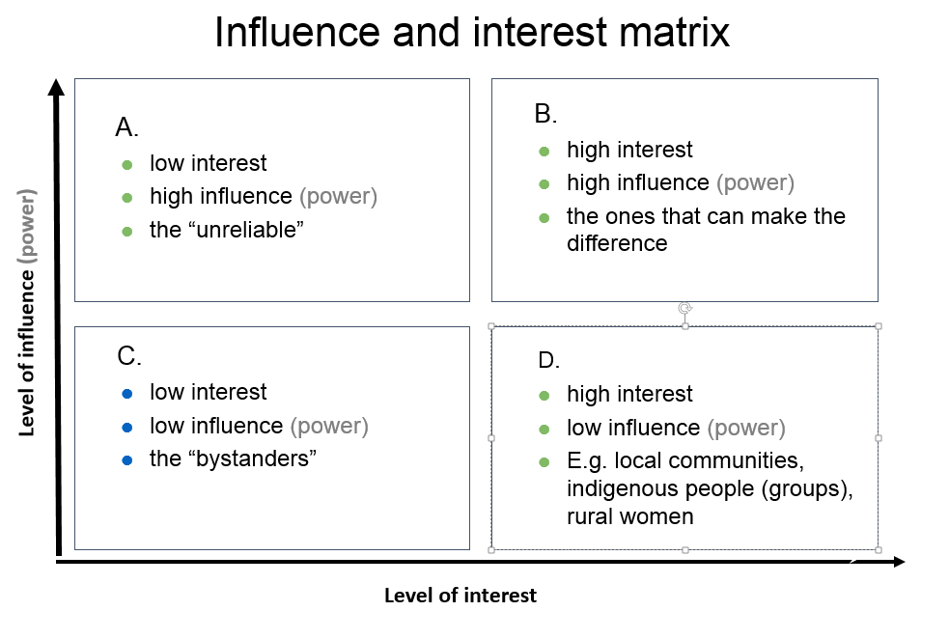
The placement in the different quadrants helps to identify how to approach or engage the stakeholder. E.g. the stakeholders in quadrant B might be the key actors to engage with for success. Stakeholders in quadrant D are probably targeted stakeholders (‘beneficiaries’) of the programme and the ones in A might be important to befriend for positive influence or consult to avoid negative influence. The stakeholders in quadrant C are the least important but there might be a need to keep them informed, or to monitor them occasionally. Or you might need information, (media) support or legitimacy from them.
In this diagram you can to give an idea of the importance of the stakeholder too. ‘Importance’ is defined as the priority the programme gives to satisfying stakeholders’ needs and interests:

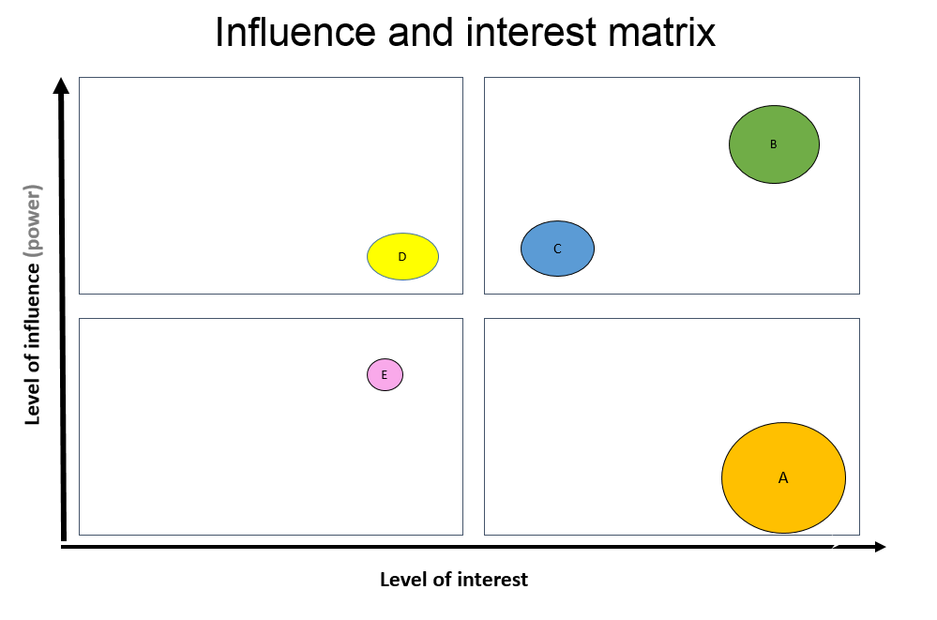
The circles with the capital letters in the matrix above stand for different stakeholders. You can relate the size of the circle to the importance of the stakeholder in relation to the desired outcomes of the programme. You might also use the diagram to reflect on if and how you want to change the position of the stakeholder in the diagram and how to achieve this (e.g. the level of influence of a certain women group) when (further) developing the ToC.
You can also use the diagram for other dimensions you might find relevant. For example, level of positive/negative commitment, level of support (advocate or adversary), relation/attitude to content of the programme, legitimacy, etc.
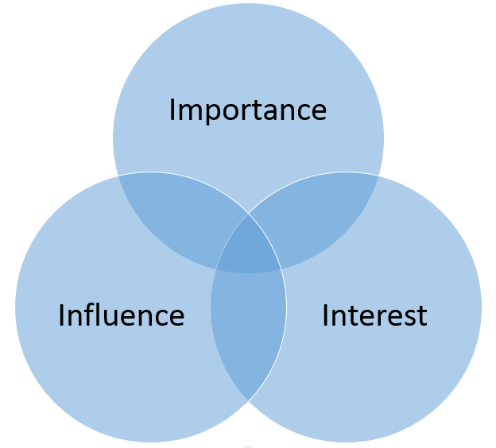
Tool 2: Another method to identify how important it is to engage the stakeholder is by placing them in a (Venn) diagram as here to the right:
The distance to the center might signify the level of interest, influence, etc. Logically, the stakeholder with most overlap in dimensions are most important to engage with. the placement in which (combination of) circle(s) should also give you clues of how to engage or address the stakeholder. Like tool 1, you can also use other dimensions you might find relevant, e.g. legitimacy. And you may want to ‘move’ stakeholders when (further) developing the ToC.

Step 3: identify engagement strategies for key stakeholders
From step 2 you should identify the most important, key stakeholders necessary to engage with for achieving the end outcomes for a climate smart landscape (inclusive governance, sustainable practices, responsible finance and business) or strategies to achieve this.
Some key stakeholders might be allies for success, or opponents, some stakeholders who have little influence you might want to give more influence. In this step you describe in which way these key stakeholders need to be engaged, e.g. as ally, to keep informed, to target with lobby & advocacy, to empower, to keep satisfied, to monitor, etc. and what actions are required to achieve this.
To identify possible allies and opponents place the stakeholders in the following table:
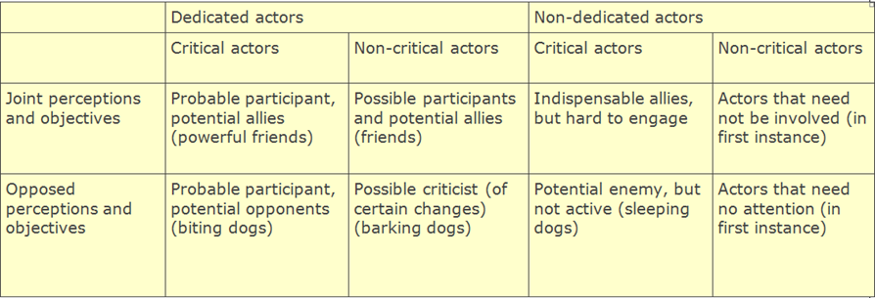

Key questions to ask to identify engagement strategies for key stakeholder:
- Which stakeholders have potentially the biggest influence (+ or -) or are mostly affected (have the ‘highest stakes’) by the programme (the ‘key stakeholders’), with regard to the intended changes sought in the landscape ToC? How important are they for the success of the programme (implementation and intended outcomes)?
- What is their influence now and would we like to see changes in the influence of this stakeholder in a ‘clmate’ smart landscape?
- How are they or will they be affected?
- What are potential allies, which stakeholders could be champions/agents of change for success? Which stakeholders could be potential opponents?
- What are challenges in relation to this stakeholder?
- What can the stakeholder/actor possibly contribute to the success of the programme, e.g. information; human resources (personnel, expertise); a network; financial resources; material, facilities and/or equipment; mandate, policies, etc. (= resources)
- What action needs to be undertaken to engage, inform, befriend, monitor, etc. the stakeholder?

Now you should have enough information to define how the different stakeholders should be approached and what actions should be undertaken. Put the results in the following table:

Key Stakeholder/  actor | Present level of influence | Desired level of influence | ally/ champion/ opponent | Challenges | Resources | Required action
Women
Young men/ boys
Young women/ girls

Indicate country.
NB: Information in this report may be used for online publishing on the internet (IATI), or in TBI reporting or communications. In case you have an objection to this or if you think information in this report should be made anonymous or be excluded, please inform your country contact person or include a note stating the information is confidential. For further information on IATI, contact trudi.vaningen@tropenbos.org.
You can use the list of abbreviations used in earlier reports

